**Department of Botany**

University of Wisconsin–Madison 341 Birge Hall 430 Lincoln Street Madison, Wisconsin 53706

808-688-3478 Email: cdmuir@wisc.edu cdmuir.netlify.app

Dear *Science* Editorial Office,

My coauthors and I are excited to submit “*Plasticity and adaptation to high light intensity amplify the advantage of amphistomatous leaves*” for consideration at *Science*. Despite decades of intense interest stomata, the “mouths” of plants that are gate ways for CO2 uptake and water loss, the reason stomata are usually confined to the lower leaf surface (hypostomy) has remained a mystery. We resolve a major part of this problem by revealing that both plasticity and adaptation explain the ecological distribution of leaves with stomata on both surfaces (amphistomy. We demonstrate for the first time that plants grown under high light from species adapted to open, sunny habitats benefit most from amphistomatous leaves in terms of increased photosynthesis. This could explain why amphistomatous leaves are predominant in plants adapted to high light intensity, but rare in shaded understories. Overall, amphistomy increases photosynthesis by an average of 5-10% without additional water loss, implying that many plant communities dominated by hypostomatous leaves pay a significant hydraulic penalty to achieve the same CO2 assimilation as an otherwise equivalent amphistomatous community would. The distribution of hypo- and amphistomatous leaves may play a heretofore underappreciated role in vegetative carbon and water fluxes.

This paper was invited as a ‘late-breaking’ talk at the Gordon Research Conference on “CO2 Assimilation in Plants from Genomes to Biomes”, a prestigious meeting of plant ecophysiologists. I discussed these results enthusiastically with many leaders in that field, such as Tracy Lawson, Lawren Sack, Alistair Rogers, and Tom Buckley. I also shared a draft manuscript with my colleague Kate McCulloh.

None of the material has been published or is under consideration for publication elsewhere. All data will be deposited on Dryad and the GitHub repository will be archived on Zenodo. A current version of the GitHub repository is included for review. Thank you for strongly considering our work for publication in *Science*.

Sincerely,

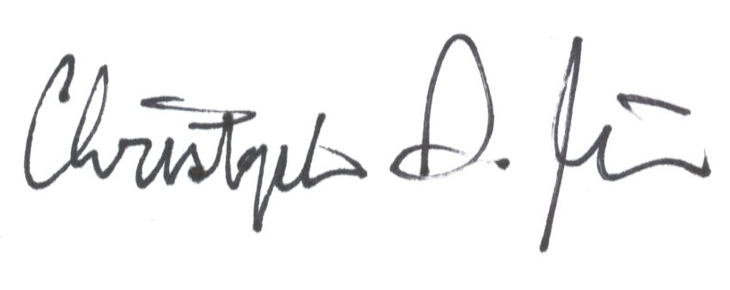

Christopher D. Muir

cdmuir@wisc.edu