M4U1（P3）

Class ________ Name ___________ No. _________

**Task 1: Listen and tick**

What musical instrument can the…play?

How does it sound?

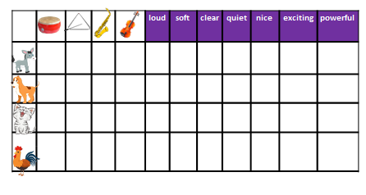

**Task 2:Read and fill in the blanks**

**Sheet B**

**Sheet A**

Questions:

1.Where does the cat play the violin?

2.Where does the rooster play the triangle?

Questions:

1.Where does the donkey play the trumpet?

2.Where does the dog play the drum?

Fill in the blanks:

The donkey plays the trumpet in the _____.

The dog _____the drum in the _______.

The cat ___________under the ______.

The rooster_______________________.

Fill in the blanks:

The donkey plays the trumpet in the _____.

The dog _____the drum in the _______.

The cat ___________under the ______.

The rooster_______________________.

Step1:Read your material

Step2:Ask and answer: Where does the…play the…?

Step3:Fill in the blanks

**Task 3:Discuss and act**

Step1:Choose one of the animals you like

Step2:Ask and answer

What’s your favourite mousic? Why do you enjoy the music?

Step3:Act

***Hi, I’m …***

***I can play the …and I enjoy music so much.***

***My favourite music is…***

***It sounds…***

***I usually play the…***

***When I feel …, music can…***

***I love music.***

