Screenshot command:
Avro-tools tojson output/part-r-00000.avro
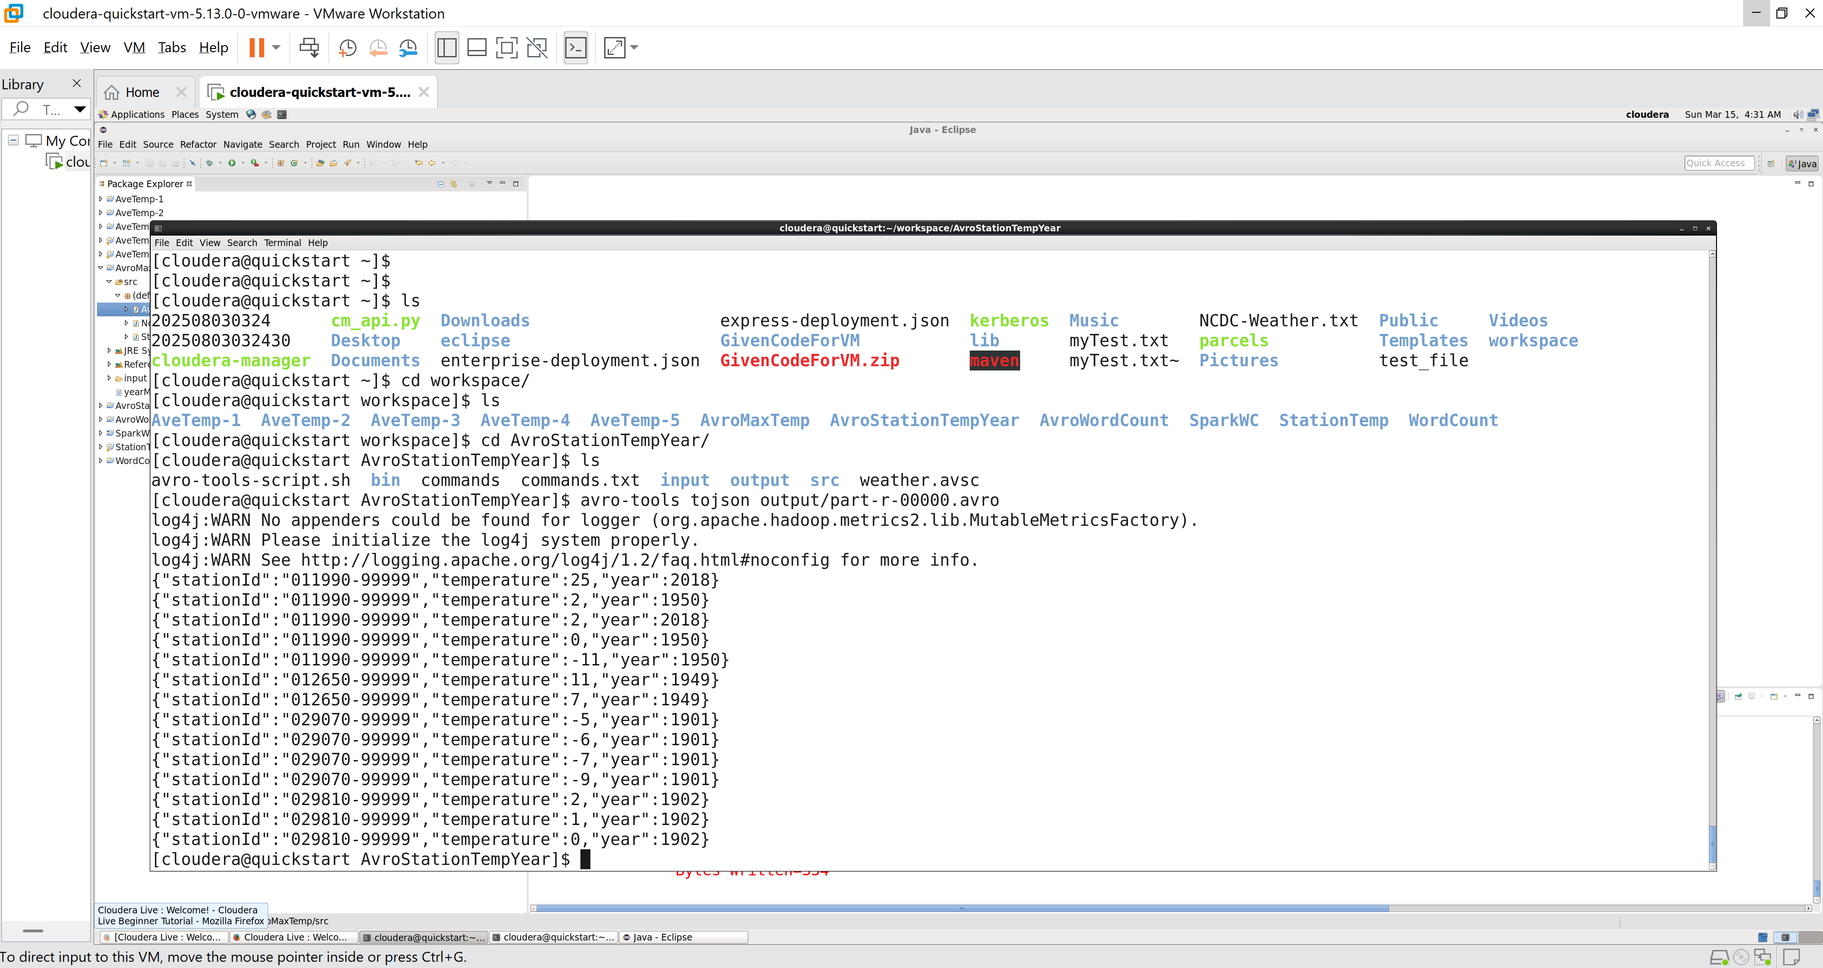

Screenshot command:
Avro-tools tojson –pretty output/part-r-00000.avro
