Screenshot command:
avro-tools tojson output/part-r-00000.avro
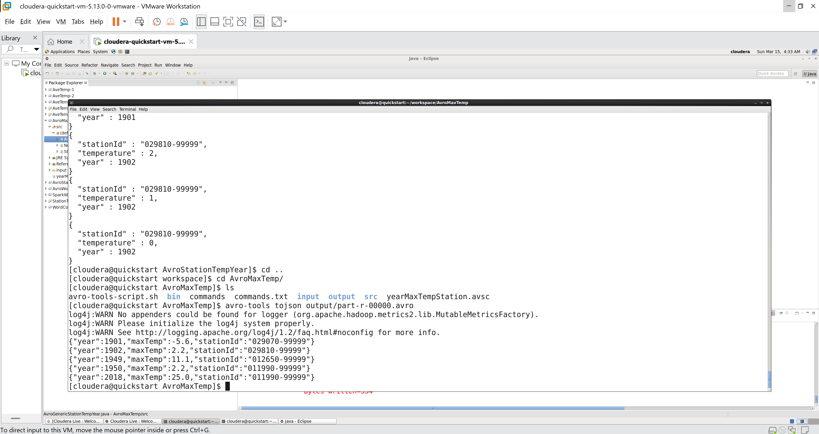
Screenshot command:
Avro-tools tojson –pretty output/part-r-0000.avro
