Software Requirements Specification

for

Hotel Room Reservation System

Version 1.0 approved

Prepared by:

Tanishka Dodiya

Chirag Dodiya

Vishwa Babariya

SVKM’s NMIMS MPSTME

25.03.2021

Table of Contents

Table of Contents 2

Revision History 2

1. Introduction 3

1.1 Purpose 3

1.2 Intended Audience and Reading Suggestions 3

1.3 Product Scope 3

1.4 References 3

2. Overall Description 4

2.1 Product Perspective 4

2.2 Product Functions 4

2.3 User Classes and Characteristics 5

2.4 Operating Environment 5

2.5 Design and Implementation Constraints 5

2.6 User Documentation 5

2.7 Assumptions and Dependencies 6

3. External Interface Requirements 6

3.1 User Interfaces 6

3.1.1 WireFrame 6

3.2 Hardware Interfaces 7

3.3 Software Interfaces 7

3.4 Communications Interfaces 7

4. Functional Requirements 7

4.1 Use Case 7

4.2 Logging In 8

4.3 Availabililty check 8

4.4 Room Selection 8

4.5 Customer details 8

4.6 Payment 8

4.7 Confirmation 9

5. Other Nonfunctional Requirements 9

5.1 Performance Requirements 9

5.2 Safety Requirements 9

5.3 Security Requirements 9

5.4 Software Quality Attributes 10

5.5 Business Rules 10

6. Other Requirements 10

Appendix A: Glossary 11

Appendix B: Analysis Models 12

B1 Activity Diagram 12

B2 E-R Diagram 13

B3 Data Flow Diagram - Level 0 13

B4 Data Flow Diagram - Level 2 14

B5 State Diagram 15

**Revision History**

|  |  |  |  |
| --- | --- | --- | --- |
| **Name** | **Date** | **Reason for Changes** | **Version** |
|  |  |  |  |
|  |  |  |  |

# Introduction

This Document provides a total description of the purpose, functionalities, system scope and specifications of Hotel Room Reservation System.

## Purpose

The purpose of this document is to present detailed requirements for Hotel Room Reservation system. This document will capture interactions between different functional and non-functional requirements of the system, interfaces of the system, environment scenarios of usage, constraints, and system prototype. This SRS will provide a clear knowledge of what is needed by customer in the proposed system. It will be a solid base to the Hotel Room Reservation system. The main Goal of the design is extensible system for managing the hotel reservation system. The system will be designed with the user-centric approach that will ensure that the user requirements mentioned in the documents must be full-filled and must confirm to the required standards. The new system will operate efficiently by providing better and much enhanced services to the customers as well as manager, hotel staff and admin. The proposed software is multi-platform which can be worked upon different operating systems.

## Intended Audience and Reading Suggestions

This document keeps in mind all stakeholders' preferences, conflicts, and their resolution. And this document can be used by developers, design engineers, testers, project manager, etc. It can also be used while making user manual for the system. When approved by the stakeholders it can also be used as a reference guide in different phases of system development.

## Product Scope

The scope of this project is to create an online web-interface for the users to check the availability and book rooms from any part of the world. There are three types of users for this Hotel Reservation System they are - Customers, Manager and Admin. Customer uses the system to book rooms. Admin and Manager are given separate authentication to the Hotel Reservation System. The booking system is used to reserve rooms. The customer needs to pay 25 percent of the total payment to confirm booking. An email containing the booking confirmation would be sent to customers' registered email address.

## References

1. Retrieved from Courses.cs  
<https://courses.cs.ut.ee/MTAT.03.306/2018_fall/uploads/Main/team5.pdf>

2. Retrieved from StudyLib.

<https://studylib.net/doc/7011876/srs-document---e>

3. SRS IEEE Template retrieved from  
ieee.dochttps://web.cs.dal.ca/~hawkey/3130/srs_template

# Overall Description

This section will provide overview of the system, its perspective and main functions. HRRS- Hotel Room Reservation System serves as a website of a hotel, through which customers can check available rooms, select rooms, select date of arrival and departure. They can enter their personal and card details and confirm booking. The system sends a confirmation mail to customer as an acknowledgement.

## Product Perspective

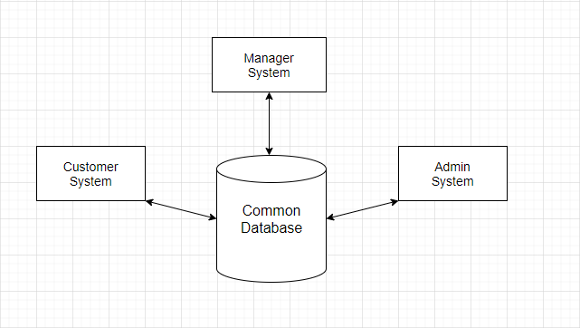

The System considers customer, manager, and admin approach. It has HRRS – where customers can book the rooms and use product functions mentioned in this document, and manager can allot the rooms, receive payment, and use product functions mentioned in this document, while the admin have there is a separate environment, where managing, accounting, and all relevant operations run. All three systems are based on the common database. They are integrated with each other, meaning the relevant data is exchanged. The subsystem “User Interface” is an element of HRRS, and it represents the web-interface for customer to book rooms online according to their choice of selection.

## Product Functions

Product functions are:

* Check availability status.
* Customer registration
* Email confirmation
* Payment
* Payment confirmation
* Manage booking details.
* Customer service

## User Classes and Characteristics

There are 3 user levels in our Hotel Reservation System:

1. Customer
2. Manager
3. Admin

**Customer:**

Customer is the most important part of this system. Customer would be able to check available rooms. They should be able to book a room or cancel it if necessary. They should enter personal and payment details while booking a room. Customer should at least be able to use web UI interface.

**Manager:**

Manager’s sole purpose is to provide quality service to the customer. They have less access than Admin. They can manage booking details. After customer chooses a room, they enter room details in the system. They should have a good command over English language and good communication skill. They should have basic IT knowledge.

**Admin:**

Admins have every access to the reservation system. They are solely responsible for managing hotel resources and staffs. They can check availability status of rooms. They always check whether the customer is registered or not. They give option to customer to pay by cash or by card. They send confirmation mail to the customer after successful reservation.

## Operating Environment

The operating environment is any cloud service provider platform.

## Design and Implementation Constraints

1. Memory Constraint: System will have space as much as cloud server have.
2. Language Constraint: Software must be only in English.
3. Implementation Constraint: Application would be in Python only.
4. Reliability Constraints: System should have good internet connection to connect with provided cloud interface.

## User Documentation

The User documentation components used are Online user manual in the form of FAQ and online help through contact mail address.

## Assumptions and Dependencies

It is assumed that the system would run perfectly which is going to be developed on Windows OS, Apache Tomcat Server, and Oracle database. The process and algorithm for calculating available rooms are assumed to be given prior. The requirements for the user interface are developed under the assumption that user interface is a subsystem of existing larger system for hotel reservation management, which keeps and processes information about existing, booked, and free rooms at the hotel, including the data about room type, number of total rooms at hotel, time of checkouts and other factors that influence the room availability at any given time.

# External Interface Requirements

This system will use the standard input/output devices for a personal computer. This includes the following: Keyboard, Mouse, Monitor.

## User Interfaces

The user interface of the system would be compatible to any type of web browser such as Google Chrome, Internet Explorer, and Mozilla Firefox.

### Wireframe

## Hardware Interfaces

The system would run on Microsoft Windows based any system.

## Software Interfaces

Operating System is Microsoft Windows.

Web Server in the system is Apache Tomcat Server.

Database Server used in the system is Oracle database.

For developing the website HTML, XML, JavaScript, Java, JSP.

## Communications Interfaces

The System would be using HTTP/HTTPS for communication over Internet and for intranet communications, it would use TCP/IP protocol.

# System Features

## Use Case Diagram

A Use Case specifies the behavior of a system or a part of a system and is a description of a set of sequences of actions. Use case diagram shows the relationship among use cases within a system or semantic entity and their actors. The relationships area associations between the actors and the use cases, generalization between the actors.

## Logging In

1. The system should verify the customer email & password against the member database when logging in.
2. After login, member should be directed to Home screen.

## Check Availability

1. This page shall have a field for arrival and departure dates selection.
2. This page shall have an option for selecting room type.
3. This page shall have an option for selecting number of rooms.
4. This page shall have an option for selecting number of adults.
5. This page shall have an option for selecting number of children.
6. Page shall show check availability and rates button to redirect customer to select a room page.

## Select Room

1. Check the availability of rooms.
2. Page shall display available rooms according to rule 9.
3. Page shall display room pictures of all types of available rooms.
4. Page shall display room prices per night of all available rooms.
5. Page shall display select & continue button which will redirect the customer-to-customer details page.
6. Page shall have sorting function to sort by price.
7. Price shall be displayed in Rupees.
8. Page shall display button to previous page with previous page name on the button.
9. Page shall display cancel button which will redirect the customer to hotel home page.

## Customer Details

1. Page shall display text field for First name.
2. Page shall display text field for Last name.
3. Page shall display field for Mobile number.
4. Page shall display field for E-mail address.
5. Page shall display mandatory checkbox field for agreement of terms and conditions.
6. Page shall display submit details button which will redirect to payment page.
7. Page shall display button to previous page with previous page name on the button.
8. Page shall display cancel button which will redirect the customer to hotel home page.

## Payment

1. Page shall display Total price of selected room for selected number of nights.
2. Page shall display field for Credit card number.
3. Page shall display field for expiration date of credit card.
4. Page shall display mandatory checkbox field for agreement of terms and conditions.
5. Page shall display a Note: Card details will be used for authentication purposes only and the payment will be charged upon customer check-in.
6. Page shall display continue button which will redirect to confirmation page.
7. Page shall display button to previous page with previous page name on the button.
8. Page shall display cancel button which will redirect the customer to hotel home page.

## Confirmation

1. Page shall display previous inputs by customer given from rule 18 to 21.
2. Page shall display arrival and departure dates according to customer selection in rule 3.
3. Page shall display room selection details chosen by customer according rule 13.
4. Page shall display total price according to rule 26.
5. Page shall display customer payment details entered by customer according to rule 27-28.
6. Page shall display confirm button which will redirect to Home page.
7. Page shall display a pop-up with a message: Thank you for your booking.
8. When customer clicks confirm button, all details from confirmation page will be stored in the hotel’s common database.
9. Upon clicking confirmation button, an email will be sent out with all details according rule 34 to 37.
10. Email shall be sent out to customer’s email address according to rule 21.
11. Page shall display button to previous page with previous page name on the button.
12. Page shall display cancel button which will redirect the customer to hotel home page.
13. Upon Confirmation “Thank you for your booking” message shall be displayed.

# Other Nonfunctional Requirements

## Performance Requirements

1. Every booking submission & modification should be updated in Hotel’s common database within 2 seconds after each submission & modification activity.
2. Results for cross checking of availability of rooms in internal database and customer’s choice shall be in 5 seconds.
3. Webpage UI load time should be within 2 secs.
4. Redirection page load time shall be within 2 secs.
5. Login Validation should be done within 3 seconds.
6. Confirmation email shall be sent into customer’s mentioned email within 2 secs after confirmation page termination.

## Safety Requirements

1. Database should be synchronized to cloud every 3 minutes.
2. System shall be accessible 98% of the time.
3. Under failure, system should be able to come back at normal operation under an hour.

## Security Requirements

1. All external communications between the data’s server and client must be encrypted.
2. All data must be stored, protected, or protectively marked.
3. Payment Process should use HTTP over Secure protocol to secure the payment transactions.
4. Customer’s credit card details shall be deleted from database after checkout date.

## Software Quality Attributes

1. **Correctness:** This system should satisfy the normal regular Hotel Management operations precisely to fulfil the end user objectives.
2. **Efficiency:** Enough resources to be implemented to achieve the task efficiently without any hassle.
3. **Flexibility:** System should be flexible enough to provide space to add new features and to handle them conveniently.
4. **Integrity:** System should focus on securing the customer information and avoid data losses as much as possible.
5. **Portability:** The system should run in any Microsoft windows environment.
6. **Usability:** The system should provide user manual to every level of users.
7. **Testability:** The system should be able to be tested to confirm the performance and client’s specifications.
8. **Maintainability:** The system should be maintainable.

## Business Rules

1. Room Type: Single Room; Double Room.
   * 1 single room can accommodate either 1 adult or 1 child.
   * 1 double room can accommodate 2 adults, 2 children or 1 adult and 1 child.
2. Deleting Customer’s Credit card information within 24 hrs. after checkout.
3. Breakfast meal would be complementary.

# Other Requirements

1. Customer shall be notified by email after checkout with a message: “Thank you for your stay, Hope we will see you back again and receive 15% discount”.
2. System shall be able to translate into customer’s choice of language using inbuilt google translator API.

Appendix A: Glossary

*User-Centric Approach:* it refers to users having more control, more choices or more flexibility.

*Admin:* administrator who have the access to all the system.

*Multi-platform:* Multiplatform typically means capable of running on two or more different hardware platforms.

*Stakeholders:* A stakeholder is a party that has an interest in a company and can either affect or be affected by the business

*HRRS:* Hotel Room Reservation System

*Web Interface:* A Web user interface or Web app allows the user to interact with content or software running on a remote server through a Web browser.

*User Interface:* how the user and a computer system interact, the use of input devices and software.

*FAQ:* frequently asked questions

*HTML:* Hyper Text Markup Language

*XML:* Extensible Markup Language

*JSP:* Jakarta Server Pages

*HTTP/HTTPS:* Hypertext Transfer Protocol Secure

*TCP/IP:* Transmission Control Protocol/Internet Protocol

*Intranet:* An intranet is a computer network for sharing information, collaboration tools, operational systems, and other computing services within an organization, usually to the exclusion of access by outsiders

*API:* Application programming interface

Appendix B: Analysis Models

**B.1 Activity Diagram:**

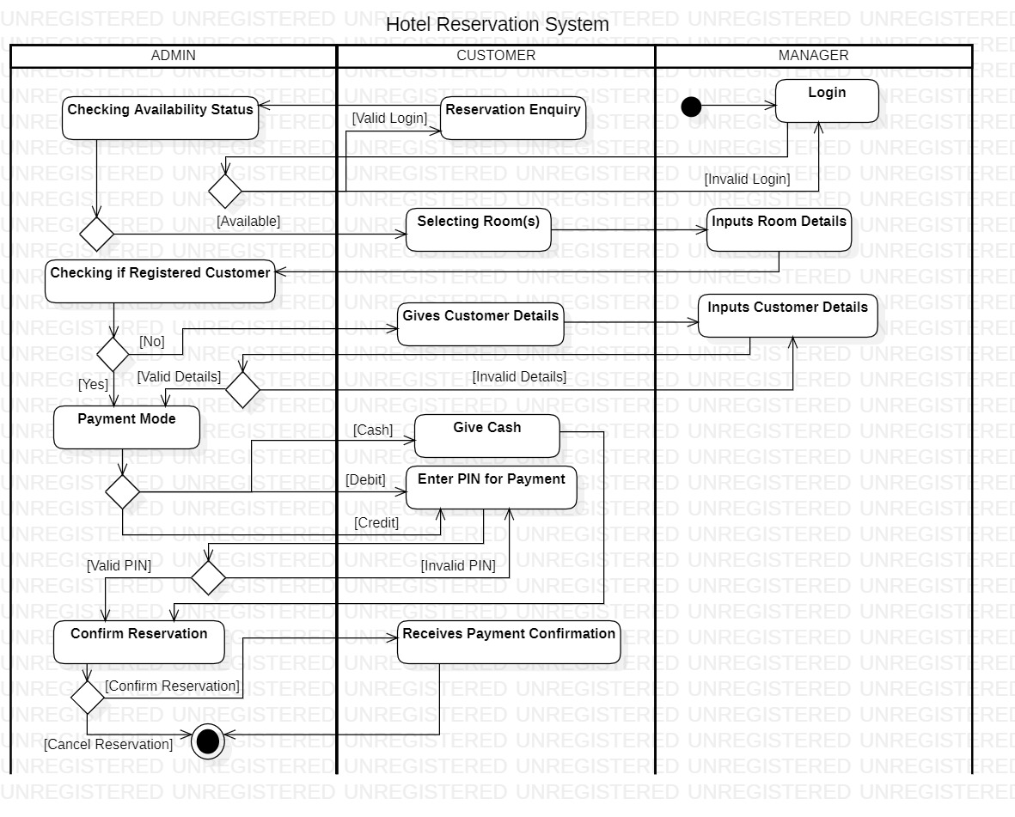

**B.2 E-R Diagram:**

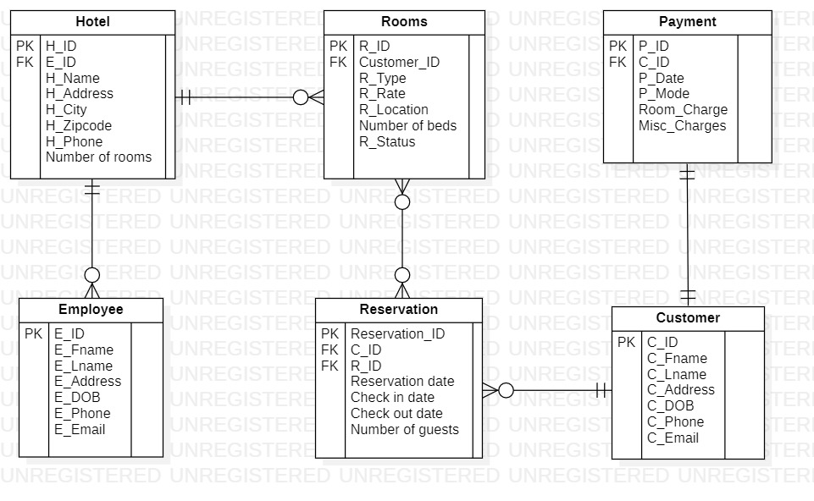

**B.3 Data Flow Diagram- Level 0:**

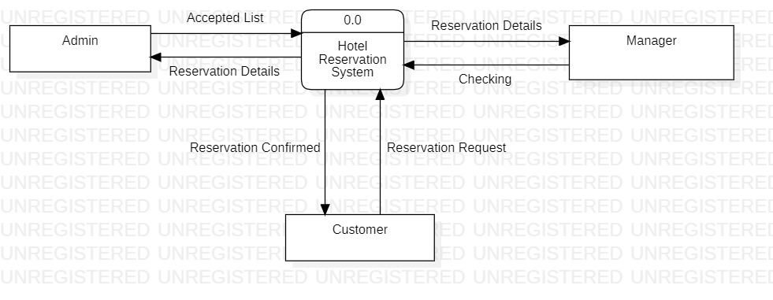

**B.4 Data Flow Diagram- Level 2:**

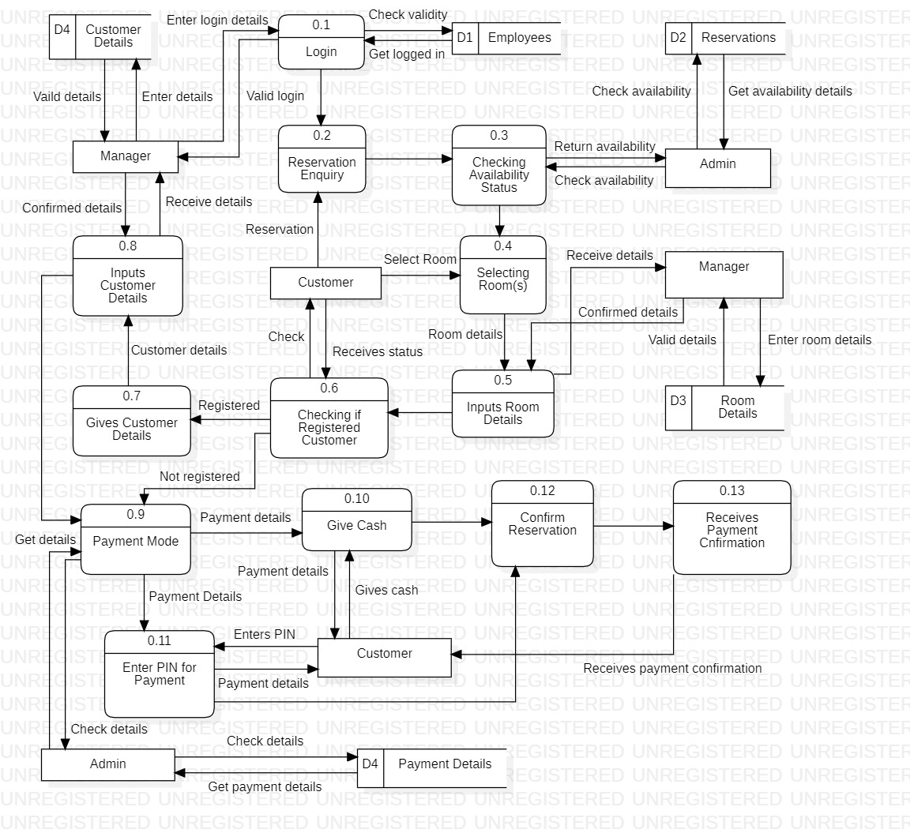

**B.5 State Diagram:**

