Scanning Transmission X-ray Microscopy with Efficient X-ray Fluorescence Detection (STXM-XRF) for Biomedical Applications in the Soft and Tender Energy Range

**Lars Lühla*, Konstantin Andrianovb, Hanna Dierksa, Andreas Haidlb, Aurelie Dehlingera, Thomas Wilheinb and Birgit Kanngießera**

aInstitute of Optics and Atomic Physics, Technische Universität Berlin, Hardenbergstr. 36, Berlin, 10623  
bInstitute for X-Optics, University of Applied Science, Joseph-Rovan-Allee 2, Remagen, 53424

Correspondence email: lars.luehl@physik.tu-berlin.de

1. One or two sentences suitable for the Journal contents listing (style: IUCr synopsis).
2. Scanning transmission X-ray microscopy, especially in combination with X-ray fluorescence detection (STXM-XRF) in the soft X-ray energy range, is becoming an increasingly important tool for life sciences. With X-ray fluorescence detection also bio-chemical mechanisms become accessible. As biological matrices generally have a low fluorescence yield and correspondingly a low fluorescence signal, high detector efficiency (e.g large solid angle) is indispensable to avoid long measurement times and radiation damage. We present the new AnImaX STXM-XRF microscope equipped with a large solid angle of detection enabling fastest scans and first proof of principle measurements on biomedical samples. In addition, characterisation measurements for future quantitative elemental imaging are presented.
3. X-ray Microscopy; X-ray Fluorescence; Biomedical Applications
4. Introduction

X-ray microscopy (XRM) can be performed either in full-field (FF) or in scanning mode. In full-field mode, the whole field of view is illuminated at once, whereas in scanning mode, the sample is scanned by a focused beam and the signal for each point is recorded by an area detector. This makes scanning XRM a more time-consuming method than FF-XRM but has the advantage that a larger variety of contrast modes, such as absorption contrast (as is scanning transmission X-ray microscopy: STXM), differential phase contrast and dark field contrast can be performed simultaneously. Furthermore, the incoming radiation not only crosses each scanning point, but also excites the atoms in the sample. The emitted fluorescence signal can therefore be collected by a silicon-drift-detector, so that the elemental composition of the sample can also be determined. FF-XRM on the other hand, is not suitable for fluorescence microscopy, whereas phase retrieval is feasible but would require the implementation of additional optical elements, such as Zernicke-optics (Holt et al., 2013). This is a complex task, since these optics (also known as phase rings) have to be adapted to every sample and the alignment as well as the phase matching can be challenging. While FF-XRM can be performed at both synchrotron facilities and in the laboratory, scanning XRM depends on high excitation intensities to avoid very long measuring times and is therefore available at synchrotron facilities only.

Synchrotron facilities at which FF-XRM in the soft and tender energy range has been established are: ALBA, ALS, Astrid, BESSY, Elettra, NSRL and Ritsumeikan. Measurements with a STXM can be performed at ALS, BESSY, CLS, Diamond, Elettra, Photon Factory, SLS, SSRF and SSRL (Obst M. et al., 2014). STXM in combination with fluorescence detection (STXM-XRF) can be found at CLS, Diamond and Elettra (TwinMic). CLS and Diamond use conventional SDDs with small angles of detection for fluorescence detection. The TwinMic-setup at Elettra includes a detector system of 8 conventional SDDs disposed circularly around the sample. A new system with a larger solid angle of detection is also in development and is planned to be operational soon (Gianoncelli et al., 2016, Bufon et al. 2018).

The soft and tender energy range is particularly well suited for applications in life science, as it provides a higher sensitivity for the lighter elements. As biological matrices generally have a low fluorescence yield and correspondingly a low fluorescence signal, a high detector efficiency (achievable through a large solid angle) is indispensable to avoid long measurement times and radiation damage.

Our novel AnImaX (Analytical Imaging with X-rays) endstation, that has been tested at the high brilliance beamline P04 at PETRA III (DESY, Hamburg), features an integrated 4-channel fluorescence detector with a large solid angle of detection of up to 1.1 sr and can therefore combine STXM with fluorescence microscopy. The AnImaX microscope is designed as a flexible endstation and so that it is adaptable to any beamline. Alignment and first resolution tests with test patterns can be carried out within a day and a quick change between FF-XRM and STXM-XRF is possible (similar to TwinMic at Elettra (Kaulich et al., 2006)). However, the focus of this work will be laid on the characteristics and applications of the STXM-XRF mode.

In order to develop the fluorescence microscopy mode towards analytical imaging, i.e. towards the quantitative evaluation of fluorescence signals, the limit of detection (LOD) for some selected elements has been determined through the measurement of thin-layered samples (Hönicke et al., 2018). These samples, with layer thicknesses in the nanometre regime, were specially designed and produced for this purpose and possess a very homogeneous lateral distribution.

First proof of principle experiments with respect to fluorescence microscopy were carried out to determine the iron distribution in brown adipose tissue (BAT). In response to cold exposure, BAT generates heat by a process called adaptive thermogenesis to maintain body temperature in cold environments (Scheja and Heeren, Current Opinion in Lipidology 2018). Accordingly, BAT has a high demand of energy-rich fuels and we used BAT activation to visualize the uptake of lipoproteins that were labelled with superparamagnetic iron oxide nanoparticles (Bruns et al., Nature Nanotechnology 2009)

First proof of principle experiments with respect to fluorescence microscopy for biomedical applications were carried out on mice cells and involve the investigation of the iron distribution in cold-activated brown adipose tissue (BAT) labelled with superparamagnetic iron oxide nanoparticles.

As radiation damage is often an issue for biological samples, we will provide an estimation of the radiation dose in different biomedically relevant matrices. In combination with our experimental results, these considerations demonstrate the necessity of a cryogenic environment for the samples.

1. Scanning Transmission X-ray Microscopy (STXM)

Due to its flexible design, the presented Scanning Transmission X-ray Microscope with X-ray fluorescence detection (STXM-XRF) is compatible with different beamlines. Since the resolution of a microscope in scanning mode depends on the size of the illumination spot, it is important to achieve a small X-ray focus on the sample. For this, our STXM-XRF is equipped with a zone plate (ZP) optic in combination with a central stop and an order sorting aperture (OSA) (Figure 1). For each scanning point, the transmitted signal is captured by a CCD area detector, so that additional contrast modes such as differential phase contrast can also be exploited.

Furthermore, a 4-chanell SDD detector has been implemented into the setup so that simultaneous XRF-measurement can be performed by recording the fluorescence emission spectrum for each scanning point. The detector consists of 4 independent SDDs aligned around a central hole through which the excitation beam is focussed onto the sample. This geometry represents a unique feature of the AnImaX endstation, as it results in a very small distance between the detector and the sample, inducing a large angle of detection (Figure 2).

* 1. AnImaX Endstation

The AnImaX endstation is flexible in two ways. Firstly, it allows a quick change between full field transmission (FF-XRM) and the STXM-XRF mode. Secondly, it can easily be adapted, connected and transported to various beamlines and without the need of special equipment. For experienced users, connecting the endstation to the beamline and align the STXM-XRF to the beam can be carried out within approximately12 hours.

In Figure 1, an outline of the experimental setup depicts the arrangement of the optical elements. Figure 2 (left) shows a picture of the setup inside the vacuum chamber. The beam is focused by a Fresnel zone plate with an outer diameter of 333 µm, an outer zone width of 40 nm and a central stop of 160 µm in diameter. At a distance of approximately 2/3 of the focal length, a circular pinhole with a diameter of 150 µm serves as order sorting aperture to suppress unwanted diffraction orders. The 4-channel SDD is mounted from the top and is provided with a manual manipulator in 3 dimensions. This allows us to precisely align the 4-channel SDD with the optical axis (manipulator in x- and y-direction) and adjust its distance to the sample (manipulator in z-direction). The manipulator provides a high setting range, so that the 4-channel SDD can be fully removed from the optical alignment by using the x and y direction.

The sample is mounted on a scanner with a positioning accuracy of 0.1 nm and a total range of 100 µm x 100 µm. The scanner itself is mounted on a positioning frame that can be moved by step motors in a range of 50 mm x 50 mm and a theoretical accuracy of 10 nm. Up to 5 samples can be placed onto the sample holder, allowing the user to quickly switch between samples.

Placed behind the sample, a phosphor screen (P43) is excited by the transmitted X-rays and emits visible light. Due to the combination of the zoneplate’s central stop and the order sorting aperture (OSA), the illumination has the shape of a hollow cone, resulting in a characteristic ring-shaped intensity distribution on the phosphor screen. The visible radiation emitted by the phosphor screen is collected by an optical lens and detected by a fast readout CCD camera (Andor IXon3 860, 128 x 128 active pixel with 24 µm x 24 µm) located outside the vacuum chamber.

For STXM-XRF mapping, the sample is scanned through the optical axis. This can be carried out either step-by step, where the sample position is fixed for each measurement, or on-the-fly, for which the sample continuously moves during the measurements. On-the-fly scans can be controlled based either on time or position. For time-controlled measurements, the scanning positions and step widths are calculated based on acquisition time and velocity, whereas position-controlled measurements require encoder signals from the scanner, so that each measurement can be started when the sample has reached a certain position. The results presented in this paper have been acquired in time-controlled mode.

One of the main challenges for successful STXM-XRF measurements is the proper synchronisation of the scanner and the detectors for both the transmission and the fluorescence measurements. Small mismatches of scanner to detector synchronisation might render time-consuming measurements completely unusable. Furthermore, it is necessary to synchronise the detectors with each other in order to compare the morphology of a sample (obtained by transmission measurements) with the elemental distribution in the sample (obtained by fluorescence detection).

The time-controlled scans in the presented STXM-XRF are based on transistor-transistor logic (TTL). At the start of each line, a signal is sent from the scanner to the transmission CCD. The CCD then collects a defined number of images with a defined acquisition time and waits for the next signal. For the acquisition time of the CCD a constant TTL signal for the SDD is provided (???). Time delays are in the range of <10 µs due to the electric connections (≈ ns), and response times of the CCD (2-6 µs) and the SDD (≈ 1-2 µs).

As shown in Figure 3, a time controlled on-the-fly scan of a Siemens star test pattern (smallest structures: 50 nm) was performed without any artefacts, which indicates that the synchronisation of scanner and CCD operates correctly. The Siemens star consists of ca. 150 nm thick tungsten layer on top of a 100 nm Si3N4 window. Figure 3 shows an image recorded with an excitation energy of 720 eV in transmission mode only. As even the smallest structures are discernible, we can report a spatial resolution of <100 nm. The synchronisation of the CCD detector with the 4-channel SDD was tested for several other samples, e.g. for the biomedical application, which will be discussed below.

* 1. XRF: 4-channel SDD

Our 4-channel SDD (Bruker AXS) was built with a special geometry: 4 independent kidney-shaped SDD-cells are arranged like a cloverleaf around a central pinhole through which the excitation beam can reach the sample (Figure 2 right). Each SDD-cell has an active area of about 15 mm2, resulting in an overall active area of 60 mm2.

Exciting radiation passes the central pinhole on the way to the sample and fluorescence radiation in backscatter geometry (Figure 2, left) is detected on each of the 4 individual SDD cells. This geometry in combination with the central pinhole and flat design allows the detector to be positioned close to the sample and thus reach very high fluorescence yields.

To shield the silicon chip from photoelectrons, it is equipped with a Mylar window of 0.5 µm thickness. Due to this comparably thin window, the threshold energy of the 4-chanell SDD is pushed down to 140 eV, assuming ~15 % transmission through the Mylar window for a mean incidence angle of 45.5° at the optimum distance to the sample. Electrons up to approximately 3 keV are trapped, which limits the effective energy range to the high energy side (???).

In contrast to the CCD, the readout time of the 4-channel SDD is not the limiting factor. In theory readout times can be set close to the response time (≈ 1-2 µs), but would be too short to gather meaningful XRF spectra. Estimation of reasonable minimal acquisition times can be carried out based on the maximum throughput of the 4-channel SDD. Assuming fluorescence intensities close to the maximum throughput (≈ 2x106 photons/s according to the manufacturer) and at least 500 – 1000 events in the XRF spectrum, the minimum acquisition time would amount to 0.5 ms. This is in the same range than the minimum acquisition time of the transmission detection system consisting of CCD (2 ms without binning) and phosphor screen (1 ms). However, since the quantitative evaluation of elemental maps strongly depends on good counting statistics, higher acquisition times are recommended.

In order to facilitate short measurement times, the 4-channel SDD is operated in live-stream mode, where each event of the multi-channel analyser (MCA) is transferred to the PC according to the sequence of the incoming photons. During the measurement, this live-stream is transferred to the spectra, so that pre-selected regions of interest (ROI) within these spectra can be summed up. The ROIs, i.e. the elements of interest, are plotted once a scanned line is completed. We obtain one map for each element, showing its occurrence and distribution within the sample.

A more precise spectrum evaluation requires a deconvolution of the characteristic lines, background stripping, and the consideration of detector effects (escape peaks, pile-up, sensitivity etc.) and has to be carried out after the experiments. Well known experimental conditions combined with a careful fit of the spectra with a backwards calculation approach based on a reference sample and using the fundamental parameter (FP) will in principle enable quantitative imaging. However, absorption effects of the fluorescence radiation for large solid angles of detection in inhomogeneous samples need be taken into account and present a challenge for real quantification.

* + 1. Large solid angle of detection – optimum detector position

Due to its ring-like shape (see Figure 2, right) the solid angle of detection as a function of the distance to the sample can be determined by using the formula for circular detectors (Zaluzec, 2014). Therefore, we subtract the solid angle for the inner radius from the solid angle for the outer radius of the detector and obtain:

The factor є [0; 1[ describes the reduction of the active area by obstacles in the beam path, e.g. stabilization grids on the detector surface.

This function has a global maximum of = 1.1 sr at the distance = 1.42 mm, where is the distance of the mounting of the 4-channel SDD (not the active crystals) to the sample surface. Due to the very tight geometry of the setup, the distance to the active crystals of the 4-channel SDD cannot be estimated during the alignment procedure. slightly varies in an interval of around the calculated value, so that in the range between = 0.81 mm and = 2.28 mm the solid angle of detection still exceeds 95 % ( =1.05 sr). It is therefore favourable to position the detector within this distance interval to the sample surface.

To verify the assumptions resulting from these calculations, a homogeneous sample (Table 1) was measured with an excitation energy of 1.5 keV and XRF spectra were collected for different sample-to-detector distances. The results are presented in Figure 4, where the intensity in counts per second (in the energy range of 0.253-1.341 keV) has been plotted as a function of the distance between the sample surface and the surface of the active chips from the 4-channel SDD. The fitted curve (red) was obtained by adapting the distance-offset mentioned above and the maximum solid angle of detection was correlated to the maximum detected intensity.

* + 1. Large solid angle of detection - Absorption effects

A large solid angle of detection is directly associated with a variation of the observation angle. In the common approaches for XRF quantification relying on the Sherman-equation, the entrance and exit beams are considered to be well collimated. In particular the detector is assumed to subtend only a small solid angle of detection (Sherman, 1955). Of course, this assumption is not valid for solid angles of detection of up to 1.1 sr.

Although the problem of divergent angles and explicitly large solid angles of detection has been researched with various approaches ever since Sherman published his article in 1955 (Bonizoni et al., 2006; Chang and Wittry, 1994; Malzer and Kanngießer, 2003; Mantler and Kawahara, 2004; Pavlinsky and Kitov, 1979), no full analytical incorporation of divergent angles into the Sherman equation has been published or adopted by standard quantification algorithms yet. Nevertheless, for homogeneous samples the equivalent angle approach, like the equivalent angle model by Malzer and Kanngießer (Malzer and Kanngießer, 2003), is applicable for our STXM-XRF.

In case of inhomogeneous samples, where the fluorescence radiation is not only attenuated by different path ways through the same sample but also by different matrices, approaches like the equivalent angle model by Malzer and Kanngießer (Malzer and Kanngießer, 2003) become obsolete. Here a reliable quantification approach has still to be developed.

1. Experimental section

Experiments were primarily carried out at the variable polarization XUV beamline P04 of PETRA III (Viefhaus et al., 2013). For the time being P04 is one of the world’s most brilliant beamlines in the soft and tender X-ray range. The source brilliance is 1020 ph /s/mm2/mrad2/0.1%bw/100mA and the resolving power exceeds 10,000 for the whole energy range of 250 eV – 3000 eV. For our demands a quasi-parallel beam with 5 mm x 2 mm (h x v) spot size on the ZP was chosen.

* 1. Limit of detection

A laterally homogeneous XRF calibration sample (Hönicke et al., 2018) was used to estimate the limit of detection (LOD) for La, Cu and Fe. The XRF calibration sample consists of thin deposition layers of these elements on a commercially available silicon nitride membrane. The layer sequence, the average mass depositions and the fluorescence lines with their corresponding absorption edges for an excitation energy of 1 keV are listed in Table 1. To increase their stability, XRF calibration samples are always covered with a thin C layer, but since no mass deposition for C was determined, it is not listed in this table.

We recorded several lateral maps with varying acquisition times and step widths, as presented in Table 2. For 5 ms, 10 ms and 20 ms, single XRF spectra were used to estimate the LOD and were summed up for “long time spectra”. For example, 5 spectra from different positions with 20 ms acquisition time were summed up in order to obtain the XRF spectrum for 100 ms. Our estimation of the LODs is based on the common definition (Streli et al., 2006; Rousseau, 2001):

with representing the raw peak intensity, the net peak intensity and the acquisition time. The expression corresponds to the mass, the concentration or the mass deposition, depending on the method.

However, it is important to keep in mind that LODs only provide a rough estimation of detectable traces in samples. For strong overlapping fluorescence lines this procedure cannot be applied.

The intensities and were determined by using the ROI (regions of interest) procedure of PyMCA (Sole et al, 2007). As shown in Table 1 and Figure 5, the elements La, Cu and Fe generate intense L- or M-fluorescence lines for an excitation energy of 1 keV. Figure 5 shows XRF-spectra for 5 ms, 50 ms and 500 ms. The peaks are assigned to the respective elements. The additional elements which are not mentioned in Table 1 are C (stabilisation layer) and O. The latter originates from the Fe-layer, since iron oxide was used as target material for the Fe deposition layer.

The estimated LODs are presented in Table 3. The results reveal that the LODs get smaller with longer acquisition times. The combination of the very brilliant P04 beamline and the large solid angle of detection yields LODs in the range of 1ng/mm2 for an acquisition time of 20 ms for Cu, 50 ms for Fe and 500 ms for La. Due to the reduced photoproduction cross section of the M-fluorescence, the acquisition time for La must be higher to obtain the same LOD. The excitation energy of 1 keV is very close to the Cu LIII/II-edge and thus Cu is the most sensitive element from this selection.

* 1. Biomedical application

Imaging is an important tool for biological and bio-medical research and optical light microscopy is a well-established tool in laboratories all over the world. However, the spatial resolution of a microscope is limited by the wavelength of the probing radiation, which corresponds to a minimum of approximately 200 nm for visible light microscopy (not taking into account novel super-resolution techniques). Therefore, methods with higher spatial resolution are desirable. Even though electron microscopy can provide very high spatial resolutions in the Angstrom-range, depth information can only be gained at the price of extensive sample preparation. X-ray microscopy, due to its relatively high penetration depth, is a promising approach here, especially when combined with fluorescence detection.

* + 1. Biomedical application – proof of principle

The bio-chemical mechanisms governing the transport of lipids from blood vessels across the endothelial layer into parenchymal cells of the brown adipose tissue (BAT) of mammals is not yet understood in detail. Better insights into the involved parameters is expected to yield relevant information to understand and, on the long run, efficiently treat metabolic diseases, as e.g. diabetes.

In this study we present first proof of principle measurements on mice tissue samples. For this purpose, C57BL/6J mice were cold-exposed to stimulate fuel uptake into brown adipocytes (Bartelt et al., Nat Medicine 2011; Schlein et al., Cell Metabolism 2016) and lipoproteins labelled with fluorescent Super Paramagnetic Iron Oxide (SPIO) nanoparticles (Bruns et al., Nature Nanotechnology 2009) were injected into mice.

The tissue samples were cut into slices of 4-8 µm thickness, dried and fixated on a Si3N4 widow (100 nm thickness) with 2.5% formaldehyde. An excitation energy of 1 keV was chosen, which is above and close to the Fe LI-edge (0.8446 keV). The nominal SPIO particle size was specified to be 10 nm, but agglomerations of the attached lipids were expected.

The tissue was scanned with 100 nm step size and 50 ms acquisition time in a range of 400 x 400 pixel. The resulting maps are shown in Figure 6 where the detected C intensity is depicted in blue whereas red represents the occurrence of Fe. Figure 7 shows a transmission image of the exact same area, so that structural and elemental information can be correlated. Since we know that BAT contains more C than blood vessels we can conclude that the areas where high concentrations of C are detected correspond to BAT. Furthermore, as the natural concentration of Fe in organic tissue lies below the detection limit and, the detected Fe fluorescence must correspond to the occurrence of SPIO-lipoproteins.

For the cold activated tissue in Figure 7, the area in the black rectangle was scanned 3 times with 50 ms each. In the transmission image, this area appears much brighter than the rest, indicating that radiation damage has taken place.

For a well-grounded study of this biomedical research question, further measurements with higher statistics have to be performed.

Nevertheless, this example demonstrates the potential and possibilities of the AnImaX endstation with a large solid angle of detection in combination with the very brilliant beamline P04 at Petra III. To the best of our knowledge, 50 ms acquisition time for the imaging of biomedical applications in the soft and tender X-ray range have not yet been achieved elsewhere.

* 1. Radiation damage - absorbed dose estimation

As shown in the previous section, radiation damage in life science samples can already be observed for very short measurement times of 50 ms to 150 ms per pixel. A first indicator for the estimation of radiation damage is the absorbed dose . Depending on the application, signs of radiation damage were observed for =104 Gy for unfixed hydrated biological samples (Schneider et al., 1998), for =105 Gy for ascidian blood cells (Fayard et al. 2009) and ≈ 107 Gy for formalin fixed cells (Gianoncelli et al., 2015). The absorbed dose is defined as the ratio of the absorbed energy and the mass :

where is the number of absorbed photons and their energy. can be calculated based on the chemical composition, the density ρ and the thickness of the sample. The mass can be estimated by assuming a rectangular illumination (Volume ≈ 100 nm x 100 nm x ) and the sample’s density ρ.

Table 4 shows the elemental formulas and densities used for the dose estimation as well as the results of the calculated absorbed doses for 5 µm and 10 µm thick samples and 100 ms acquisition time. The results in table 4 demonstrate that for all examples, the absorbed dose lies in the range between 5.5*105 and 9.5*105 Gy. As mentioned above, these are values for which radiation damage would already occur.

These considerations show the necessity of a cryogenic atmosphere for applications in live science. Under cryogenic conditions, radiation damage is strongly reduced and would only occur for absorbed doses in the range of 108 – 109 Gy (Schneider et al., 1998). Hence a cryogenic atmosphere would allow much better statistics and is therefore mandatory for quantitative analysis.

1. Conclusion

The AnImaX endstation is a flexible X-ray Microscope, which can be operated in full-field as well as in scanning mode. Since we have enabled on-the-fly mapping for the scanning mode, very time-efficient mappings of dose-sensitive samples are achievable, which is of great advantage for the investigation of biological samples. Furthermore, an energy-dispersive detector (4-channel SDD) provides additional elemental information.

The implementation of the 4-channel SDD detector, which was specially adapted for our setup, has been an important step to deliver correlated imaging and investigate the connection between structural and functional information in biological samples. With its large solid angle of detection of up to 1.1 sr, acquisition times of less than 100 ms become possible. With the help of well-defined reference samples, it was possible to specify the LOD for La, Cu and Fe for different acquisition times. As a result, we could determine that a LOD of 1ng/mm requires acquisition times of 2500 ms for La, 20 ms for Cu and 50 ms for Fe.

The potential of AnImaX for biomedical applications in life science was shown as a proof-of-principle for measurements of SPIO-lipoprotein enriched BAT of cold activated versus control mice. We were able to measure trace elements in these biomatrices with very short acquisition times of 50 ms, which is unprecedented in this energy range. Thus, AnImaX opens possibilities for various research fields such as the investigation of the toxicity of nanoparticles, the development of drug carriers or the processes of food production.

Nevertheless, even for this very short measurement times, radiation damage was observed. Hence, AnImaX will soon be equipped with a cryo-tomography-station. Cryogenic environment reduces radiation damage significantly and the rotation stage will allow us to perform FF-XRM tomography as a first step, followed by experiments to establish tomographic measurements in the STXM mode. Longer measurement times facilitated by the cryogenic environment will also help to further develop our quantitative approach for large solid angles of detection.

1. Acknowledgements

We acknowledge the BMBF for funding the AnImaX (Verbundprojekt 05K2016) and the predecessor (FlexIX – Flexible Imaging with X-rays: Verbundprojekt 05K2013) project. We also thank AXO DRESDEN GmbH for providing the XRF calibration sample.

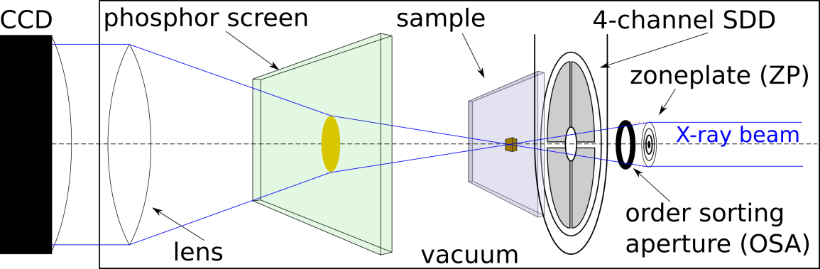Figures:

1. Sketch of the STXM setup.

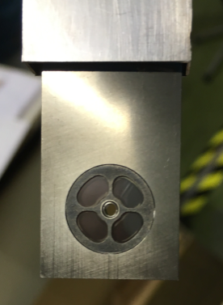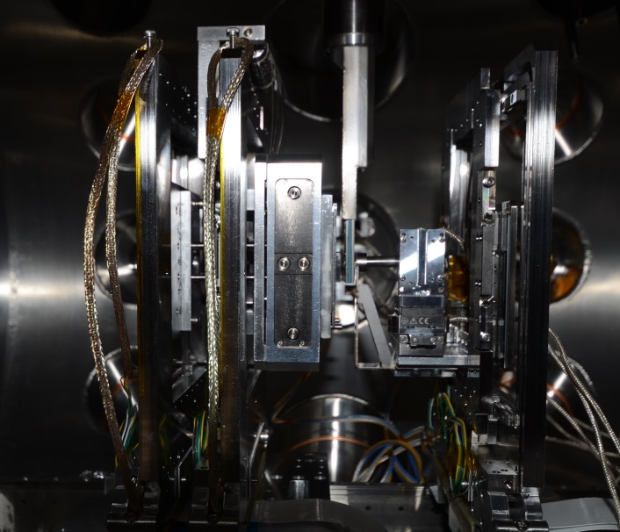

1. 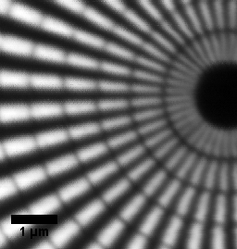Left: STXM Setup with 4-channel SDD entering from top. Right: Front view of 4-channel SDD.
2. Transmission signal of a test pattern acquired in on-the-fly mode
3. 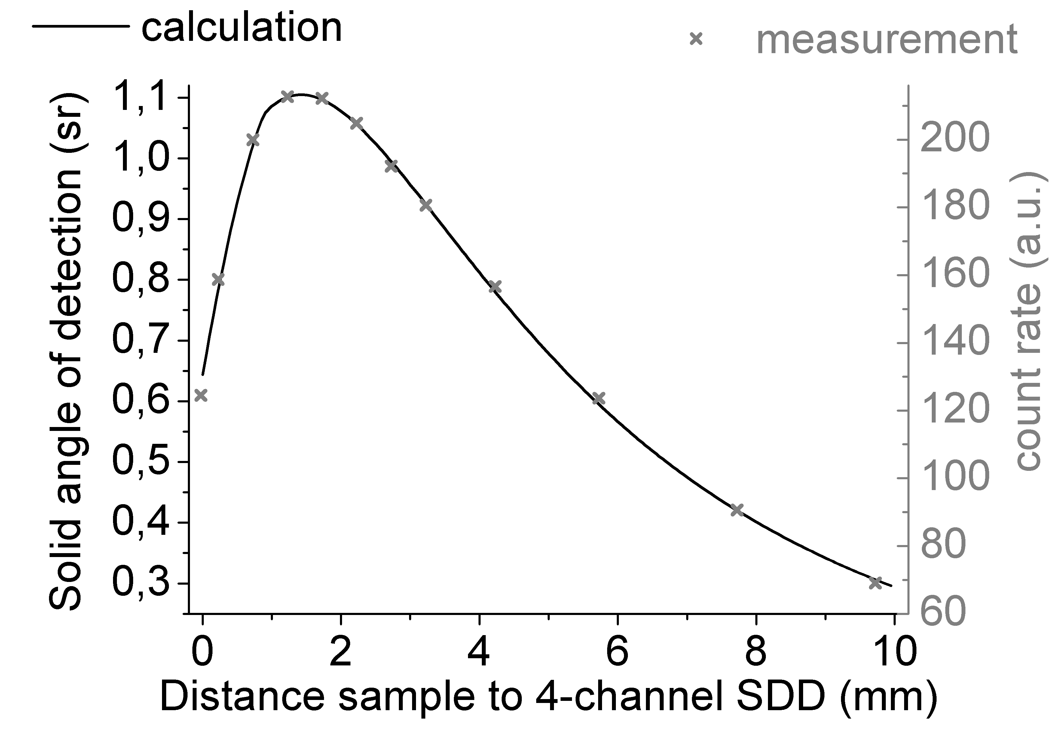Measured intensity dependant on distance of 4-channel SDD to sample
4. 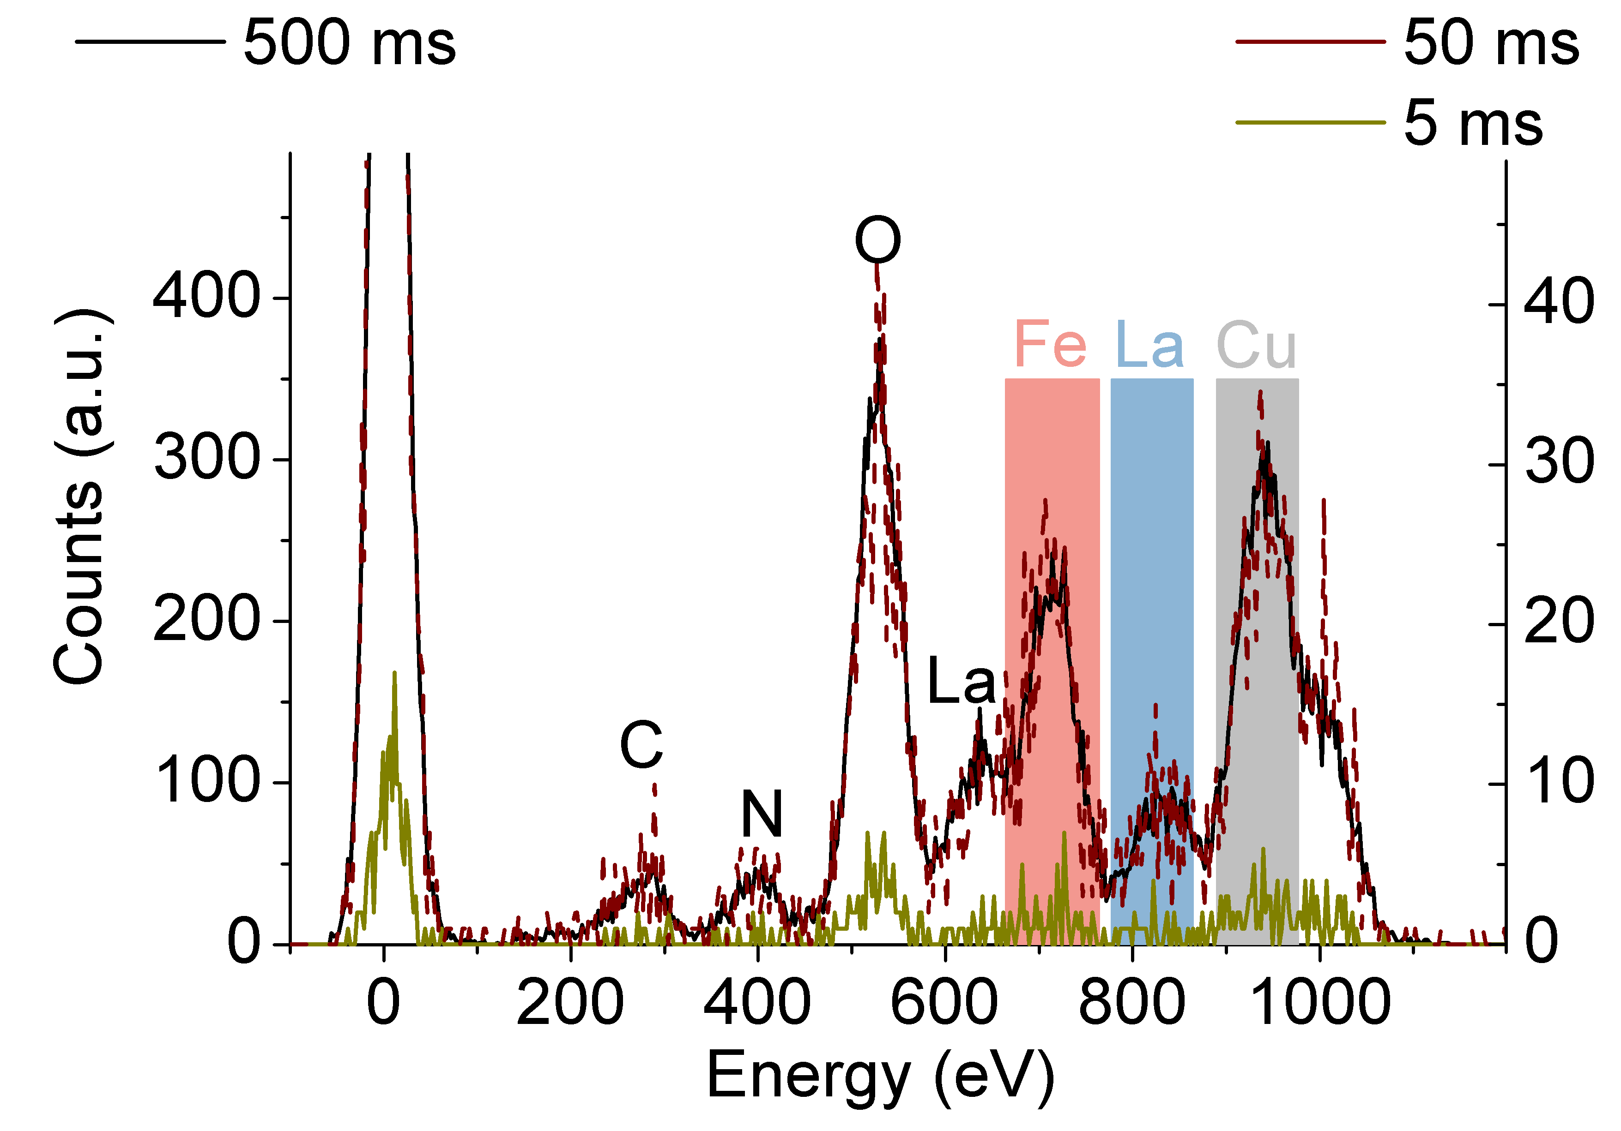XRF-spectra for 5 ms, 10 ms, 20 ms 50 ms and 500 ms. ROIs used for the calculation of LOD are highlighted with red (Fe), blue (La) and grey (Cu).

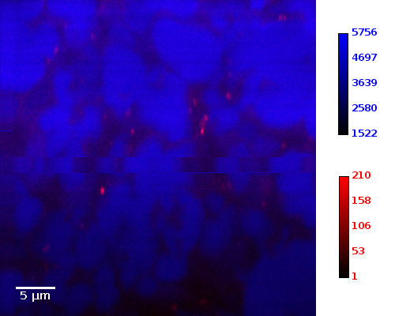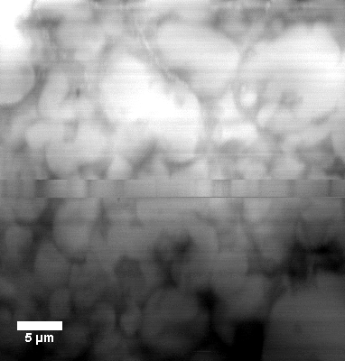

1. Transmission image (left) and pseudo-colour image (right) for C (blue, BAT) and Fe (red, SPIO) for control tissue.
2. Transmission image (left) and pseudo-colour image (right) for C (blue, BAT) and Fe (red, SPIO) for cold activated tissue.

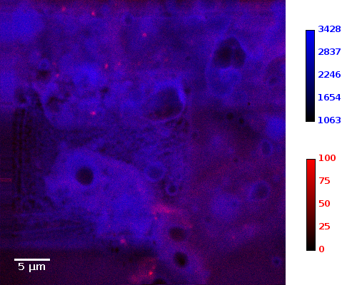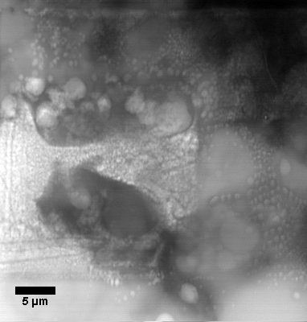

Tables:

|  |  |  |
| --- | --- | --- |
| Element / Composition | Mass deposition (ng / mm2) | Significant Fluorescence lines with corresponding absorption edges excited by 1 keV (IUPACK notation; energies from ELAM database [REFERENZ]) |
| Pb | 84.9 ± 12.3 |  |
| La | 121.4 ± 14.5 | M5-N6,7 (836 eV); M4-N6 (853 eV); M4,5-N2,3 (647.2 eV) |
| Pd | 23.3 ± 4.5 | M4,5-N2,3 (284.8 eV) |
| Mo | 8.6 ± 0.9 | M4,5-N2,3 (193.5 eV) |
| Cu | 22.2 ± 3.3 | L3-M5 (927.7 eV); L3-M1 (810.2 eV); L2-M5 (947.3 eV); L2-M1 (829.8 eV) |
| Fe | 433.9 ± 5.9 | L3-M5 (704.8 eV); L2-M4 (717.9 eV) |
| Si3N4 | Substrate | Si: L1-M2 (147.7 eV)  N: K-L2 (392.4 eV); K-L1 (372.6 eV) |

1. Elemental composition of the XRF calibration sample. Mass depositions are average values measured independently by GAAS, FAAS, ICP-OES and TXRF. Not all fluorescence lines listed here can be found in the XRF spectrum due to very low cross sections and absorption in the 0.5 µm mylar window in front of the 4-channel SDD. Fluorescence energies below the cut-off energy of ~140 eV of the system are not listed.

|  |  |  |
| --- | --- | --- |
| Number of measurement points (h x v) | Step width (nm) | Acquisition time (ms) |
| 100 x 100 | 1000 | 15 |
| 100 x 100 | 1000 | 5 |
| 100 x 100 | 1000 | 10 |
| 200 x 200 | 500 | 10 |
| 200 x 200 | 100 | 20 |

1. Scan parameters at different spots on the XRF calibration sample.

|  |  |  |  |
| --- | --- | --- | --- |
| Acquisition time (ms) | LODLa (ng/mm2) | LODCu (ng/mm2) | LODFe (ng/mm2) |
| 5 |  | 10.42 ± 1.55 | 22.09 ± 2.96 |
| 10 | 30.04 ± 3.58 | 3.47 ± 0.52 |  |
| 20 | 25.59 ± 3.05 | 0.69 ± 0.10 | 2.00 ± 0.27 |
| 50 | 6.30 ± 0.75 | 0.41 ± 0.06 | 0.64 ± 0.09 |
| 100 | 3.58 ± 0.43 | 0.31 ± 0.05 | 0.57 ± 0.08 |
| 200 | 2.01 ± 0.24 | 0.18 ± 0.03 | 0.23 ± 0.03 |
| 500 | 0.83 ± 0.10 | 0.07 ± 0.01 | 0.12 ± 0.02 |
| 1000 | 0.44 ± 0.05 | 0.03 ± 0.01 | 0.06 ±0.01 |
| 2000 | 0.24 ± 0.03 | 0.02 ± <0.01 | 0.04 ± <0.01 |
| 5000 | 0.10 ± 0.01 | 0.01 ± <0.01 | 0.01 ± <0.01 |
| 10000 | 0.05 ± 0.01 | <0.01 | 0.01 ± <0.01 |
| 20000 | 0.02 ± <0.01 | <0.01 | <0.01 |
| 50000 | 0.01 ± <0.01 | <0.01 | <0.01 |
| 100000 | <0.01 | <0.01 | <0.01 |
| 200000 | <0.01 | <0.01 | <0.01 |
| 500000 | <0.01 | <0.01 | <0.01 |
| 800000 | <0.01 | <0.01 | <0.01 |

1. LOD for La, Cu and Fe for acquisition times varying from 5 ms to 800 s and an excitation energy of 1 keV. Missing values are due to little statistics and a calculation of the background intensity of zero (IR-IN=0).

|  |  |  |  |  |
| --- | --- | --- | --- | --- |
| Application | Elemental formula | Density (g/cm3) | Dose for d=5 µm and t=100 ms (*105 Gy) | Dose for d=10 µm and t=100 ms (*105 Gy) |
| Adipose | C57H104O6 | 0.94 | 6.6 | 8.9 |
| Bone | O1702 H429 P372 Ca620 N34 C134 | 1.70 | 5.5 | 5.6 |
| Water | H2O | 1.00 | 8.4 | 9.4 |
| Proteine | C94H139N24O31S | 1.35 | 6.1 | 7.0 |

1. Absorbed dose estimation for some applications in life science for 5 µm and 10 µm thick samples, an excitation energy of 1000 eV at P04 and 100 ms acquisition time.

References:

Bonizzoni L., Maloni A., and Milazzo M. (2006) *X-Ray Spectrometry* 35(6), 390 – 399

Chang W.Z. and Wittry D.B. (1994) *Microbeam Analysis* 3, 23 – 32

Eichert D. (2015) X-Ray Microscopy. In: Mobilio S., Boscherini F., Meneghini C. (eds) Synchrotron Radiation. Springer, Berlin, Heidelberg

Fayard B., Salomé M., Takemoto K., Kihara H., Susini J. (2009) *Journal of Electron Spectroscopy and Related Phenomena* 170, 19–24

Gianoncelli A., Bufon J., Ahangarianabhari M., Altissimo M., Bellutti P., Bertuccio G., Borghes R., Carrato S., Cautero G., Fabiani S., Giacomini G., Giuressi D., Kourousias G., Menk R. H., Picciotto A., Piemonte C., Rachevski A., Rashevskaya I., Stolfa A., Vacchi A., Zampa G., Zampa N., Zorzi N. (2016) *Nuclear Instruments and Methods in Physics Research A* 816, 113–118

Gianoncelli A., Vaccari L., Kourousias G., Cassese D., Bedolla D. E., Kenig S., Storici P., Lazzarino M. & Kiskinova M. (2015) *Scientific Reports* 5:10250, 1 – 11

Hönicke P., Krämer M., Lühl L., Andrianov K., Beckhoff B., Dietsch R., Holz T., Kanngießer B., Weißbach D., Wilhein T (2018) *Spectrochimica Acta Part B* 145, 36–42

Holt M., Harder R., Winarski R., RoseV. (2013) *Annu. Rev. Mater. Res*. 43, 183–211

Lider V. V. (2017) *Physics - Uspekhi* 60, 187 – 203

W. Malzer. and Kanngießer B. (2003) *X-Ray Spectrom.* 32, 106 – 112

Mantler M. and Kawahara N. (2004) *The Rigaku Journal*, 21(2) 17 – 25

Obst M., Schmid G. (2014) 3D Chemical Mapping: Application of Scanning Transmission (Soft) X-ray Microscopy (STXM) in Combination with Angle-Scan Tomography in Bio-, Geo-, and Environmental Sciences. In: John Kuo, Electron Microscopy: Methods and Protocols

Pavlinsky G. V. and Kitov B.I. (1979) *X-Ray Spectrometry* 8(3), 96 – 101

Rousseau, R. M. (2001) *The Rigaku Journal*, 18(2), 33 – 47

Sherman J. (1955) *Spectrochimica Acta*, 7(Supplement C), 283 – 306

Schneider G. (1998) *Ultramicroscopy* 75, 85 – 104

Streli C., Wobrauschek P., Fabry L., Pahlke S., Comin F., Barrett R., Pianetta P., Lüning K. , Beckhoff B. (2006) Total-Reflection X-Ray Fluorescence (TXRF) Wafer Analysis. In: Beckhoff B., Kanngießer B., Langhoff N., Wedell R., Wolff H., Handbook of Practical X-Ray Fluorescence Analysis

Viefhaus J., Scholz F., Deinert S., Glaser L., Ilchen M., Seltmann J., Walter P., Siewert F. (2013) *Nuclear instruments & methods in physics research A* 710, 151 - 154

Zaluzec N. J. (2014) *Microscopy and Microanalysis* 20(4), 1318 - 1326