RUFit Design Document

**Authors:**

Naomi Wombough

Catherine Dougherty

Shiv Patel

Klaydon Balicanta

Erin Quigley

**Table of Contents**

**1. Introduction** **3**

1.1 Purpose 3

1.2 Scope 3

1.3 Assumptions and Limitations 3

**2 Design Specification** **4**

2.1 Software Description 4

2.2 RESTful Service 4

2.3 Database Design 6

2.4 Design Prototype 7

**3 Roles and Responsibilities** **8**

# 

# 1. Introduction

This Application Design Document has been created to outline the design for the new RUFit Android application, where RUFit is short for “Rowan University Fit”. The RUFit app is intended to be a unique alternative to other similar applications that already exist for Android devices.

## 1.1 Purpose

The purpose of this document is to outline the software design of the RUfit application described in the Specification Document. The RUfit application is a run tracking application targeted to competitive runners. The application will run on the Android operation system.

## 1.2 Scope

This document aims to be a guide for the developers to implement the prospective RUfit application. This document contains details about the application’s usage and implementation.

## 1.3 Assumptions and Limitations

The application will track user's workout using GPS from the devices and allow them to analyze and share their workouts to improve their health habits. The RUfit app will only track a user’s running/walking. And the application will be supported by devices running Android OS.

# 2 Design Specification

## 2.1 Software Description

RUFit App will be using Google Firebase tools to help with database and authentication for the app.

## 2.2 Firebase Service

The RESTful API is the program interface which uses HTTP requests to describe the architecture and communications between client and server. Listed are the endpoints for each client action and how it will interact with the server.

|  |  |  |  |  |
| --- | --- | --- | --- | --- |
| Endpoint | Purpose | Input | Output | Implementation |
| POST /login/ | Find username and password for login | [username]  [password] | Success : boolean  userID : String |  |
| POST /signup/ | Create new account | [email]  [username]  [password]  [phone]  [date] | Success : boolean |  |
| POST /user/runs/add/ | Add new run to log | [userID]  [date]  [name]  [distance]  [time]  [shoes]  [feel]  [type]  [notes] | Success : boolean |  |
| GET /user/runs/ | View runs on given date | [userID]  [date] | Array of :  Date : Date  Name : String  Distance : double  Time : int  Shoes : enum  Type : enum  Feel : enum  Notes : String  Success : boolean |  |
| PUT /user/runs/ | Edit log entry | [userID]  [date]  [name]  [distance]  [time]  [shoes]  [feel]  [type]  [notes] | Success : boolean |  |
| GET /user/records/ | Retrieve user’s best records | [userID] | Array of :  shoeName : String  mileage : double  Success : boolean |  |
| GET /user/shoes/ | Retrieve user’s shoes | [userID] | Success : boolean |  |
| PUT /user/shoes/ | Update miles ran in shoes | [userID]  [shoeName]  [milesAdded] | Success : boolean |  |
| POST /user/shoes/ | Add shoe to archive | [userID]  [shoeName] | Success : boolean |  |
| GET /user/info/ | Retrieve personal info | [userID] | Gender : String  Height : int  Weight : int  Age : String  Email : String  Phone : String  Success : boolean |  |
| PUT /user/info/ | Update personal info | [userID]  [gender]  [height]  [weight]  [age]  [email] | Success : boolean |  |
| GET /user/goals/ | Retrieve goals | [userID] | milesPerWeek : double  runsPerWeek : int  daysUntilRace : int  Success : boolean |  |
| PUT /user/goals/ | Update user’s goals | [userID]  [milesPerWeek]  [runsPerWeek]  [daysUntilRace] | Success : boolean |  |

## 2.3 Database Design

The following are representations of the tables containing what entities and their accompanying attributes will be associated with.

**User Table**

|  |  |
| --- | --- |
| **Entity** | **Attribute, NULL Value (If NULL, Defaults applied)** |
| firstName | Character, NOT NULL |
| lastName | Character, NOT NULL |
| password | Character, NOT NULL |
| email | Character, NOT NULL |
| phoneNumber | Integer, NULL, default: 000-000-0000 |
| dateAccountCreated | Date, NULL, default: “today’s” date (that is, present date) |
| username (PK) | Character, NOT NULL |
| recordPace | runID (FK), NULL, default: 0 |
| recordDistance | runID (FK), NULL, default: 0 |
| recordTime | runID (FK), NULL, default: 0 |
| milesPerWeek | runID (FK), NULL, default: 0 |
| runsPerWeek | Integer, NULL, default: 0 |
| daysUntilRace | Integer, NULL, default: -1 |

**Run Table**

|  |  |
| --- | --- |
| **Entity** | **Attribute, NULL Value (If NULL, Defaults applied)** |
| userID (FK) | Username-character, NOT NULL |
| shoeID (FK) | shoeID-integer, NOT NULL |
| runID (PK) | Integer, NOT NULL |
| pace | Float, NOT NULL |
| distance | Float, NOT NULL |
| time | Integer, NOT NULL |
| feel | character/enum, NULL, default: “Normal” |
| type | character/enum, NULL, default: “Daily Run” |
| notes | character , NULL, default: “<none>” |
| date | Date, NOT NULL |

**Shoe Table**

|  |  |
| --- | --- |
| **Entity** | **Attribute, NULL Value (If NULL, Defaults applied)** |
| shoeID (PK) | Integer, NOT NULL |
| userID (FK) | Username-character, NOT NULL |
| shoeName | Character, NULL, default: “Shoe_x” where x incrementally increases from 1 for each new shoe added to the table |
| mileage | Integer, NULL, default: 0 |

**Goal Table**

|  |  |
| --- | --- |
| **Entity** | **Attribute, NULL Value (If NULL, Defaults applied)** |
| userID (FK) | Username - character, NOT NULL |
| weeklyMileage | Integer, NULL, default: 0 |
| runsPerWeek | Integer, NULL, default: 0 |

## 2.4 Design Prototype

Working prototype: https://xd.adobe.com/view/ef225ff4-1fa7-48e0-ba68-5fe8bba83b29

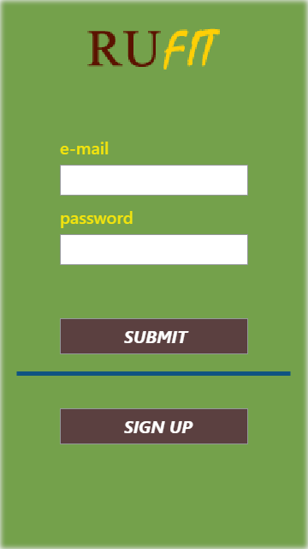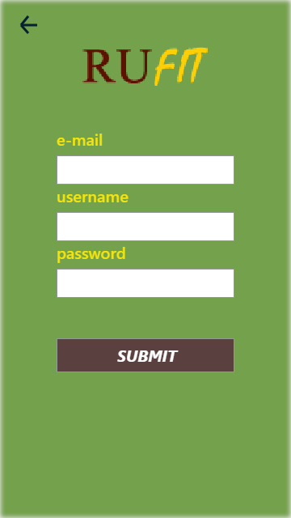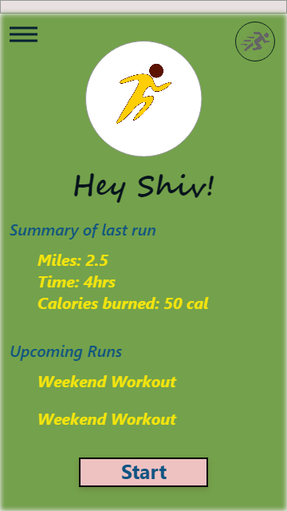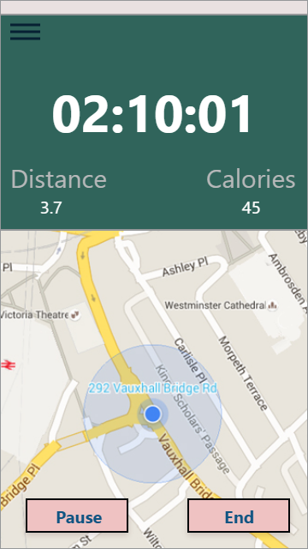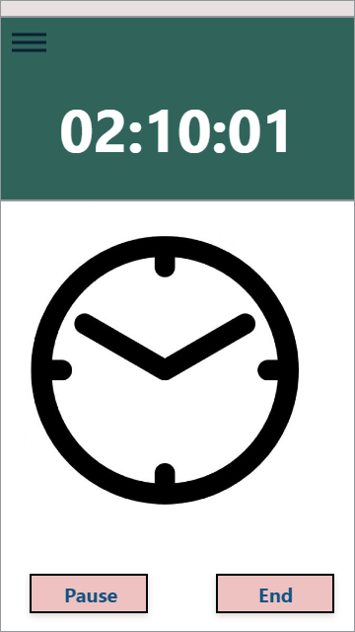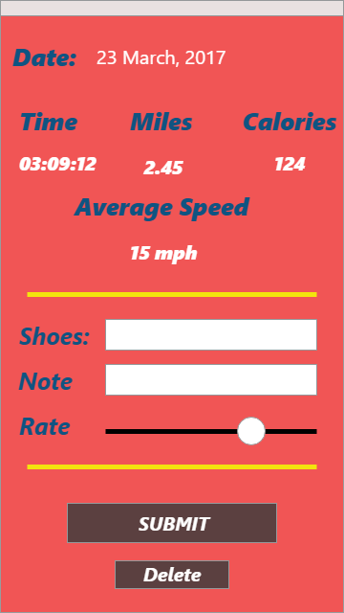

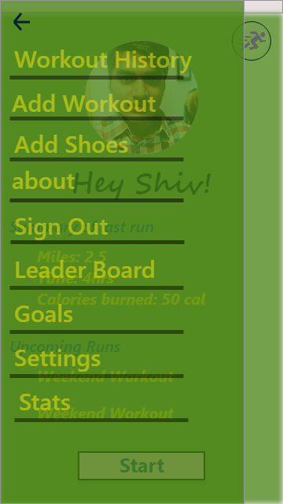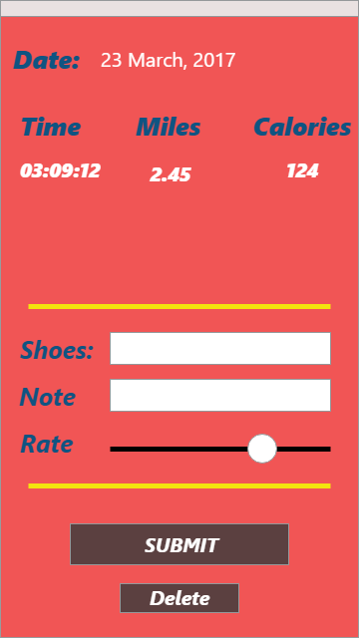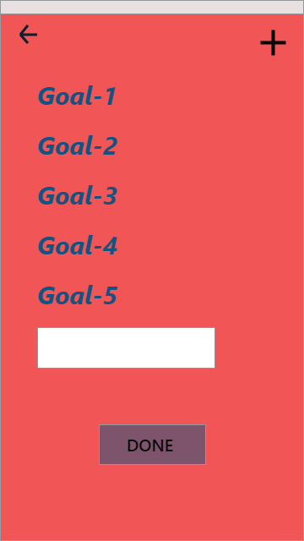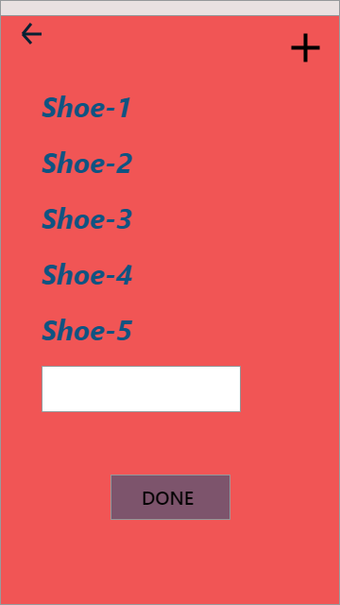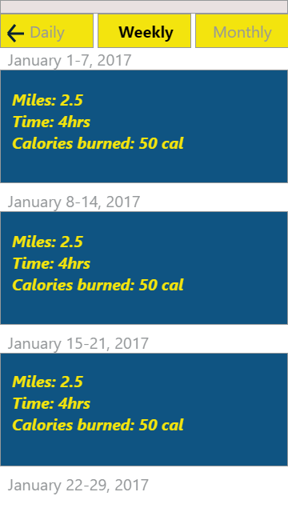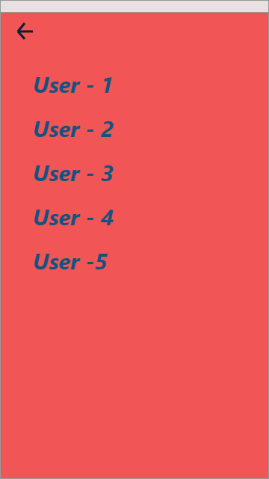

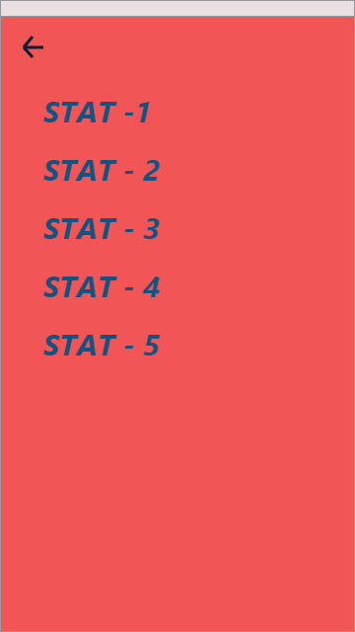

# 3 Roles and Responsibilities

|  |  |  |
| --- | --- | --- |
| ***Roles*** | ***Responsibilities*** | ***Members*** |
| Development | Does research accordingly and creates a fully functional product adhering to the Specifications Document and Design Document. | Naomi Wombough  Catherine Dougherty  Shiv Patel  Klaydon Balicanta  Erin Quigley |
| Databases | Assigns proper architecture of tables (Entity and Attribute association) and End-Point generation | Catherine Dougherty  Klaydon Balicanta |
| Firebase Research | Managing | Shiv Patel |

## 3.1 Tasks

|  |  |
| --- | --- |
| **Name** | **Tasks** |
| Klaydon Balicanta |  |
| Naomi Wombough | POST /user/runs/add/ endpoint  GET /user/runs/ endpoint  PUT /user/runs/ endpoint |
| Erin Quigley | POST /login/ endpoint  POST /signup/ endpoint |
| Catherine Dougherty |  |
| Shiv Patel |  |