*Question-1:- Write a command to get the Python version you are using.*

Answer:-

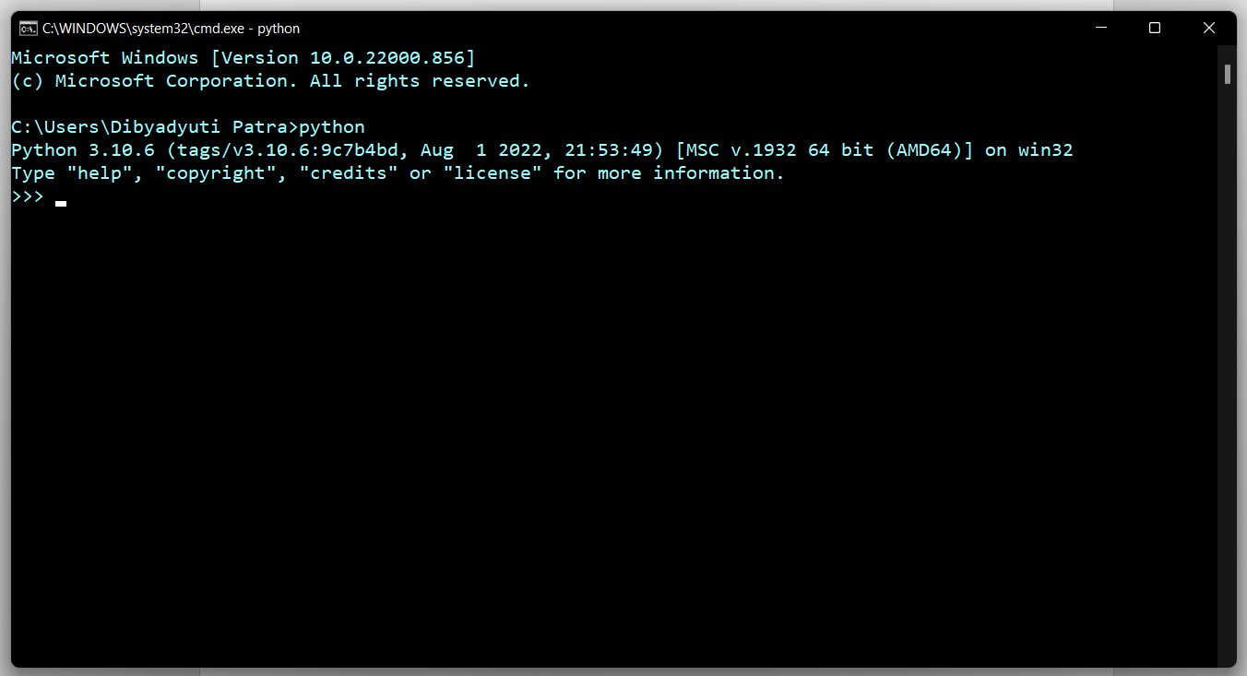The command is “python”