*Question-2: - Write a python script to print* ***Hello Python*** *on the screen directly in the command line.*

Answer: -

Step_1 – Open command prompt and type **py**.

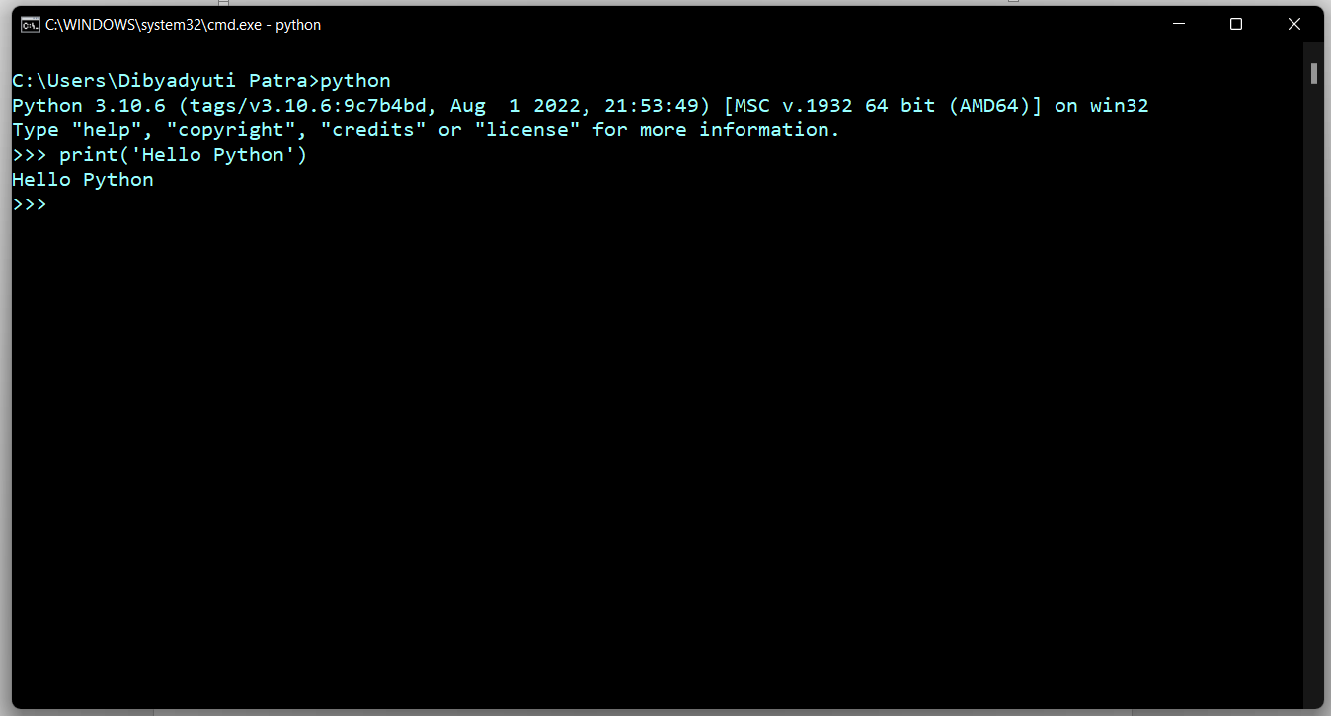Step_2 – A string prompt will open then type **print(‘Hello Python’)**.