*Question-3: - Write a python script and store it in a file and execute the file from the command line.*

Answer: -

A python file was made at the location – “D:\Python\Python iNeuron\Assignment-1” named solution-3.py. In which a python script was written – “print('Solution of question number 3 of assignment 1')”

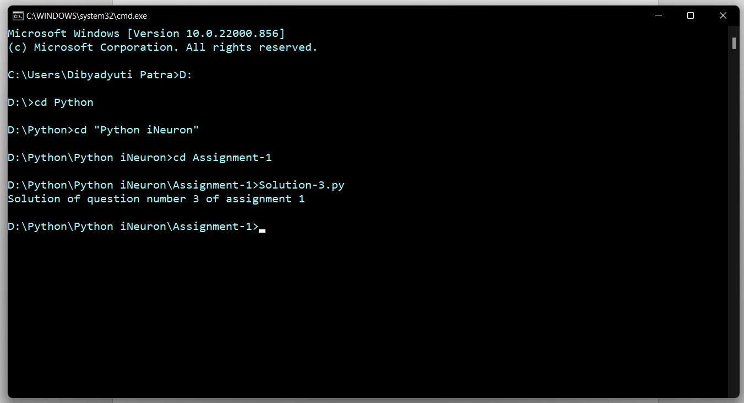The output is-