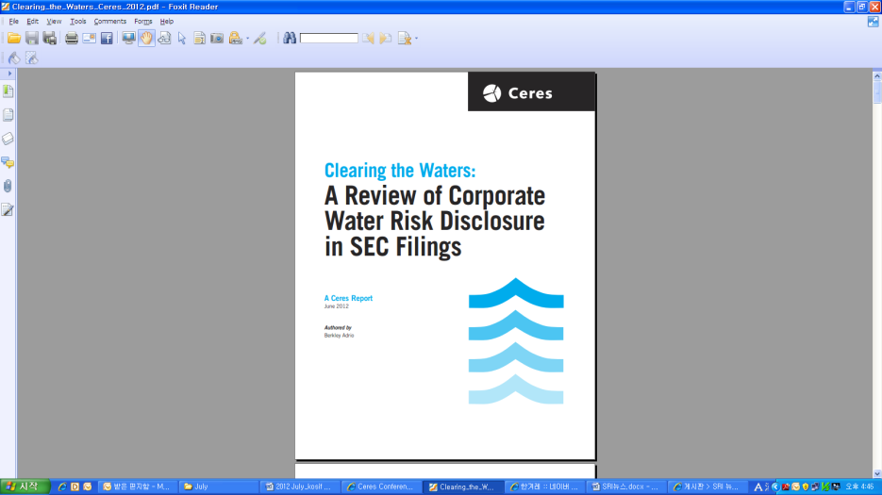**[Ceres] Clearing the Water: A Review of Corporate Water Risk Disclosure in SEC Filings**

발행일: 2012. 6 / 발행처: Ceres

The global economy depends on water resources to feed growing populations, generate

electricity, fuel industrial processes or transport goods. In short, the world runs on water.

As populations expand and industrialization and urbanization accelerate, global water

supplies are feeling the pinch and companies are more vulnerable to disruptions in their

operations, supply chains and logistics

**Key findings**

1. Disclosure of water risks has increased across the board

2. More companies are making the connection to climate change

3. Data on water use and performance goals are lacking

4. Supply chain risks are underreported

5. Information on how companies are mitigating water risks and engaging stakeholders

is limited, but growing.

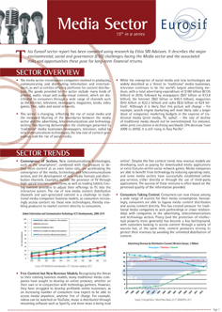**[Eurosif] Sector Report: Media sector**

발행일: 2012. 6 / 발행처: Eurosif

Eurosif sector report는 Ethix SRI Advisors의 연구를 토대로 작성되었으며, 장기적 관점에서 미디어 섹터가 직면한 주요 환경, 사회, 지배구조 관련 위험과 기회를 나타내고 있다.