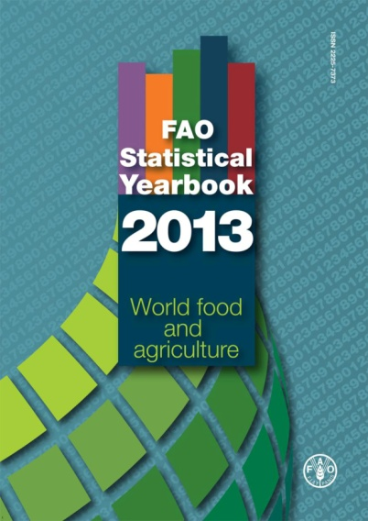

**FAO Statistical Yearbook 2013 World food and agriculture**

발행일: 2013 / 발행처: FAO

CONTENTS Foreword

Acknowledgements

How to use this book

**Part 1 The Setting**

Overview

Economy

Land and Water

Labour

Inputs

Capital and Investment

Innovation

Tables

**Part 2 Hunger dimensions**

Number undernourished and their prevalence in the population

Anthropometric indicators

Poverty

Food Availability

Economic and physical access

Clean water and sanitation

Economic and political stability

Education and health

Natural and human-made risks

Tables

**Part 3 Feeding the world**

Aggregate agriculture

Growth in crop production

Trends in the crop sector

Trends in the livestock sector

Trends in the fisheries sector

Trends in agricultural trade

Tables

**Part 4 Sustainability dimensions**

Land and Forestry

Water

Biodiversity

Agri-environmental indicators

Organic farming

Bio-based economy

Climate change

Greenhouse gas emissions

**Part 5 Metadata**

Country list

Concepts and Methods

Indicators

Acronyms

Bibliography

<보고서는 첨부된 파일을 다운로드 받으시면 됩니다.>

http://www.kosif.org/board/bbs/board.php?bo_table=interior&wr_id=438

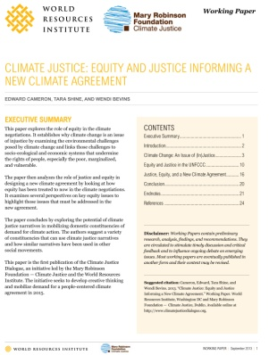

**Climate Justice: Equity and justice informing a new climate agreement**

발행일: 2013. 9 / 발행처: WRI, Mary Robison Foundation,

Executive Summary

This paper explores the role of equity in the climate negotiations. It establishes why climate change is an issue of injustice by examining the environmental challenges posed by climate change and links those challenges to socio-ecological and economic systems that undermine the rights of people, especially the poor, marginalized, and vulnerable.

The paper then analyzes the role of justice and equity in designing a new climate agreement by looking at how equity has been treated to now in the climate negotiations.

It examines several perspectives on key equity issues to highlight those issues that must be addressed in the new agreement.

The paper concludes by exploring the potential of climate justice narratives in mobilizing domestic constituencies of demand for climate action. The authors suggest a variety of constituencies that can use climate justice narratives and how similar narratives have been used in other social movements.

This paper is the first publication of the Climate Justice Dialogue, an initiative led by the Mary Robinson Foundation — Climate Justice and the World Resources Institute. The initiative seeks to develop creative thinking and mobilize demand for a people-centered climate agreement in 2015.

<보고서는 첨부된 파일을 다운로드 받으시면 됩니다.>

http://www.kosif.org/board/bbs/board.php?bo_table=interior&wr_id=440

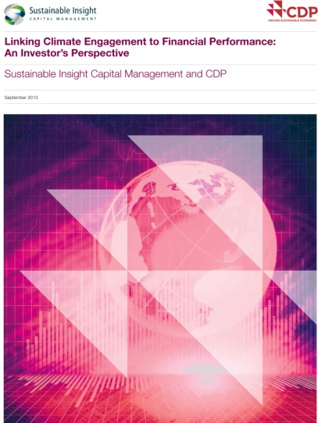

**Linking Climate Engagement to Financial Performance: An Investor’s Perspective**

발행일: 2013. 9 / 발행처: CDP,

Conclusion

Our analysis demonstrates that companies that manage against the impact climate change has on their business, as measured by the CDP disclosure score, also reflect superior financial qualities: higher return on equity, greater cash flow stability and stronger dividend growth. This realization points toward the beliefs CDP and SICM share: as the impact of climate change on global businesses increases, the differentiation between the corporate leaders and laggards will be reflected in financial terms as well.

Climate change and the impacts of resource scarcity have become material issues affecting corporations’ ability to compete and since investors seek out superior risk-adjusted returns. It is therefore our responsibility as investors to discover which companies are leading the way and which are at risk of falling behind. Through this process the market is beginning to evaluate corporate behavior through a new lens and will ultimately re-price environmental, social and governance (ESG) risk. Investors who have incorporated these principles into their investment processes and decisions will benefit.

With that in mind, we maintain that the integration of climate change and financial analysis is only just beginning. The world’s leading investment managers will consider the impact companies have on the environment and vice-versa as they make investment decisions. As SICM, as well as others, ‘mainstream’ such analyses, the financial markets will re-price risk accordingly.

<보고서는 첨부된 파일을 다운로드 받으시면 됩니다.>

http://www.kosif.org/board/bbs/board.php?bo_table=interior&wr_id=441