**ESG Strategies of European Asset Owners: From Theory to Practice**

발행처: Novethic

**Contents**

**About the survey**

Methodology

Surveyed investors

Report structure

**Key results**

**European analysis**

Investors’ views on RI

Responsible investment policies

Organization and means

Investment strategies

Implementation of RI policies

State of progress by asset class

**Country focus**

France

Netherlands

Spain

United Kingdom

**Other country results**

Austria

Belgium

Denmark

Germany

Nordic countries: Finland, Norway, Sweden

Coming soon: German-speaking Switzerland

**List of surveyed investors**

<보고서는 첨부된 파일을 다운로드 받으시면 됩니다.>

http://www.kosif.org/board/bbs/board.php?bo_table=interior&wr_id=438

**The Future of Finance**

발행처: Globalscan, Center for Responsible Business

Acknowledgements

Introduction

Executive Summary

Fundamentals: the role of finance in society

Who matters? The financial sector’s stakeholder constituencies

The biggest challenge: regulating the financial sector

What’s to come? Predictions and scenarios

What works? An inclusive innovation future

Appendix I: Thought Leader interviewees

Appendix II: About the Center for Responsible Business and GlobeScan

<보고서는 첨부된 파일을 다운로드 받으시면 됩니다.>

http://www.kosif.org/board/bbs/board.php?bo_table=interior&wr_id=440

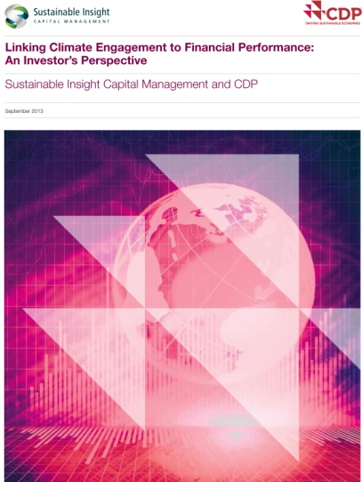

**Linking Climate Engagement to Financial Performance: An Investor’s Perspective**

발행일: 2013. 9 / 발행처: CDP,

Conclusion

Our analysis demonstrates that companies that manage against the impact climate change has on their business, as measured by the CDP disclosure score, also reflect superior financial qualities: higher return on equity, greater cash flow stability and stronger dividend growth. This realization points toward the beliefs CDP and SICM share: as the impact of climate change on global businesses increases, the differentiation between the corporate leaders and laggards will be reflected in financial terms as well.

Climate change and the impacts of resource scarcity have become material issues affecting corporations’ ability to compete and since investors seek out superior risk-adjusted returns. It is therefore our responsibility as investors to discover which companies are leading the way and which are at risk of falling behind. Through this process the market is beginning to evaluate corporate behavior through a new lens and will ultimately re-price environmental, social and governance (ESG) risk. Investors who have incorporated these principles into their investment processes and decisions will benefit.

With that in mind, we maintain that the integration of climate change and financial analysis is only just beginning. The world’s leading investment managers will consider the impact companies have on the environment and vice-versa as they make investment decisions. As SICM, as well as others, ‘mainstream’ such analyses, the financial markets will re-price risk accordingly.

<보고서는 첨부된 파일을 다운로드 받으시면 됩니다.>

http://www.kosif.org/board/bbs/board.php?bo_table=interior&wr_id=441