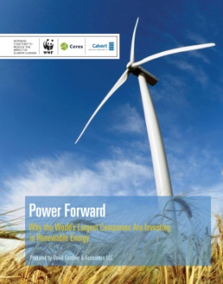**Power Forward**

**Why the World’s Largest Companies Are Investing in Renewable Energy**

발행일: 2012. 12 / 발행처: WWF/Ceres

Large corporations are increasingly turning to renewable energy to power their operations.

Companies are investing in renewable energy because it makes good business sense: renewable energy helps reduce long-term operating costs, diversify energy supply and hedge against market volatility in traditional fuel markets. It also enables companies to achieve greenhouse gas (GHG) emissions reduction goals and demonstrate leadership on broader corporate sustainability and climate commitments.

<보고서는 첨부된 파일을 다운로드 받으시면 됩니다.>

<http://www.kosif.org/board/bbs/board.php?bo_table=interior&wr_id=421>

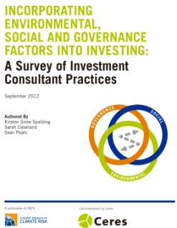**INCORPORATING ENVIRONMENTAL, SOCIAL AND GOVERNANCE FACTORS INTO INVESTING: A Survey of Investment Consultant Practices**

발행일: 2012. 10 / 발행처: INCR

Members of the Investor Network for Climate Risk (INCR) have long recognized the role of Investment Consultants as “gatekeepers” to the integration of environmental, social and governance (ESG) considerations in investment decision-making. This is particularly true for General Consultants, who supply the research and recommendations used by most institutional investors in adopting asset allocation models, risk and benchmarking metrics, investment strategies, and in selecting secondary consultants and asset managers for individual investment portfolios.

<보고서는 첨부된 파일을 다운로드 받으시면 됩니다.>

http://www.kosif.org/board/bbs/board.php?bo_table=interior&wr_id=421