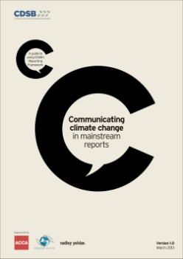

**Communication climate change in mainstream reports**

**- A guide to using CDSB’s Reporting Framework**

발행일: 2012. 3 / 발행처: CDSB

This guidance has been created to work alongside CDSB’s Reporting Framework to help enhance the quality of climate change disclosures in mainstream reporting – to make life easier for the people creating reports, and increase the relevance of disclosure for the investment community.

Climate change is already affecting businesses and society in diverse ways, and will continue to present a range of risks and opportunities into the future. These may be:

Regulatory: Current or expected requirements regarding GHG emissions limits, energy efficiency standards, carbon tax, process or product standards, and trading schemes

Physical: Changing weather patterns, sea level rise, shifts in species distribution, changes in water availability, changes in temperature, variation in agricultural yield and growing seasons

Reputational: Changing stakeholder and societal expectations and norms

Legal: Changing landscape of liability including the possibility of lawsuits against those organizations seen to be responsible for contributing to the problem

Marketplace: Disruption and innovation as low-carbon solutions make less sustainable business models obsolete

<보고서는 첨부된 파일을 다운로드 받으시면 됩니다.>

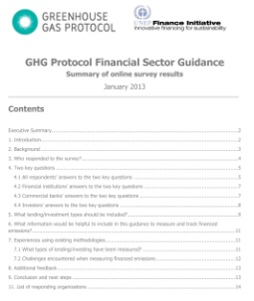

**GHG Protocol Financial Sector Guidance**

**- Summary of online survey results**

발행일: 2013. 1 / 발행처: GHG Protocol / UNEP FI

GHG Protocol and UNEP Finance Initiative have partnered to investigate whether to develop new guidance for the financial sector on accounting for greenhouse gas (GHG) emissions associated with lending and investing (“financed emissions”). The guidance would be a sector-specific supplement to the GHG Protocol Corporate Value Chain (Scope 3) Standard. An online survey was conducted to assist in establishing the need for developing guidance on accounting for financed emissions and to gain insight into what the content of the new guidance should be, if it were to be developed. Over 100 stakeholders from a broad range of organizations and regions completed the survey.

<보고서는 첨부된 파일을 다운로드 받으시면 됩니다.>

http://www.kosif.org/board/bbs/board.php?bo_table=interior&wr_id=421