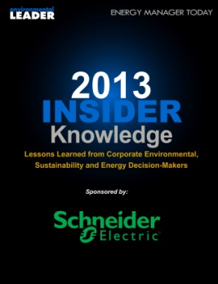

**2013 Insider Knowledge**

**- Lessons Learned from Corporate Environmental, Sustainability and Energy Decision-Makers**

발행일: 2013. 1 / 발행처: Environmental Leader

In these pages you’ll find entries covering a wide variety of lessons-learned, techniques, tactics, products, case studies, and advice from those working and innovating in companies around the world – all of which we hope will help inspire you to greater strides in the environmental and energy management space.

<보고서는 첨부된 파일을 다운로드 받으시면 됩니다.>

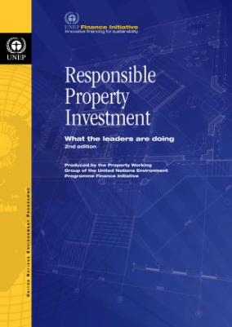

**Responsible Property Investment**

**- What the leaders are doing**

발행일: 2012. 12 / 발행처: UNEP FI

The field of Responsible Property Investment1 (RPI) has gained increasing prominence and acceptance among real estate investors in both developed and developing countries over the past few years. The inclusion of RPI principles into investors’ decision-making processes is driven by several factors. The most prominent drivers according to investors whose work is highlighted in this publication are:

• A need to better understand the impact of environmental and social issues such as climate change, resource scarcity, and mass urbanisation on macro property trends that could damage or enhance the long-term performance of property assets and businesses.

• Gaining a competitive advantage by getting ahead of more stringent regulatory environmental and social requirements. These are arising in several markets and have the potential to impact risk/adjusted returns and cost structures by requiring, for instance, that buildings are improved or retrofitted to meet a particular environmental performance.

• Responding to tenant demands for more environmentally efficient buildings that could contribute to lower tenants’ occupancy costs and environmental impacts.

• To foster better collaboration and alignment of interests between the different actors involved in the investment and use of real estate.

• It is the fiduciary responsibility of property investors to understand the implications of environmental and social issues on the performance of their investments and to seek appropriate risk-adjusted investment returns as well as economic ways to improve the sustainability of the assets they buy and hold.

<보고서는 첨부된 파일을 다운로드 받으시면 됩니다.>

http://www.kosif.org/board/bbs/board.php?bo_table=interior&wr_id=421