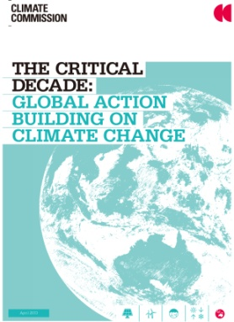

**THE CRITICAL DECADE:**

**Global Action Building on Climate Change**

발행일: 2013. 4 / 발행처: Climate Commission

In its report The Critical Decade: International Action on Climate Change, the Climate Commission outlined the global response to climate change, finding that every major economy had policies in place to tackle climate change. Since the report’s release, there has been significant progress in many countries, including China and the US.

CONTENTS

Preface / 3

Key findings / 4

IN TRODUCTION / 6

01. C HAPTER 1: The Global Energy Giants ARE MOVING / 10

1.1 Recent developments in the People’s Republic of China / 13

1.2 Recent developments in the United States of America / 17

02. CHAPTER 2: Types of international action / 21

2.1 Carbon pricing schemes / 21

2.2 Renewable energy / 24

2.3 Energy efficiency / 28

03. C HAPTER 3: A Critical Decade for Australia / 32

References / 40

<보고서는 첨부된 파일을 다운로드 받으시면 됩니다.>

http://www.kosif.org/board/bbs/board.php?bo_table=interior&wr_id=430

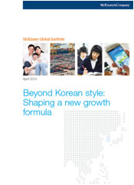

**Beyond Korean style:**

**Shaping a new growth formula**

발행일: 2013. 4 / 발행처: Mckinsey Global Institute

It is increasingly apparent that the export-oriented growth formula that helped the large Korean conglomerates drive economic development and raise incomes is running out of steam: GDP continues to grow, but the progress of the national economy has begun to decouple from the lives of many South Koreans, who have seen their fortunes wane. The current trajectory leads to growing inequality, falling consumption growth, and –eventually- a population that is too small to sustain GDP growth.

Contents

Executive summary

1. Korea’s success story
2. A growth model running out of steam
3. The new growth model
4. Implications for stake holders

<보고서는 첨부된 파일을 다운로드 받으시면 됩니다.>

http://www.kosif.org/board/bbs/board.php?bo_table=interior&wr_id=431