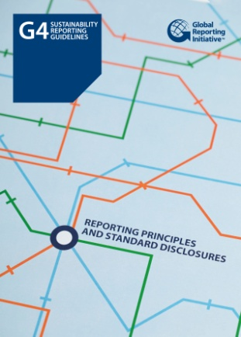

**GRI G4**

**Sustainability Reporting Guidelines**

발행일: 2013. 5 / 발행처: GRI

The GRI Sustainability Reporting Guidelines (the Guidelines) offer Reporting Principles, Standard Disclosures and an implementation Manual for the preparation of sustainability reports by organizations, regardless of their size, sector or location. The Guidelines also offer an international reference for all those interested in the disclosure of governance approach and of the environmental, social and economic performance and impacts of organizations. The Guidelines are useful in the preparation of any type of document which requires such disclosure.

The Guidelines are developed through a global multi-stakeholder process involving representatives from business, labor, civil society, and financial markets, as well as auditors and experts in various fields; and in close dialogue with regulators and governmental agencies in several countries. The Guidelines are developed in alignment with internationally recognized reporting related documents, which are referenced throughout the Guidelines.

<보고서는 첨부된 파일을 다운로드 받으시면 됩니다.>

<http://www.kosif.org/board/bbs/board.php?bo_table=interior&wr_id=433>

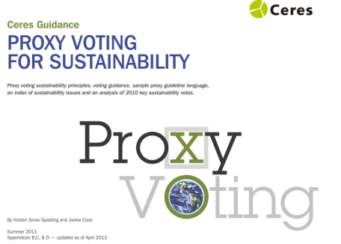

**Proxy Voting for Sustainability**

발행일: 2013. 5 / 발행처: CERES

This report serves as a resource guide to help global investors respond to environmental, social and governance (ESG) issues that are increasingly the subject of shareholder resolutions filed with U.S. publicly held corporations. This first-of-its-kind report lays out four concise sets of principles on governance, social issues, general sustainability and environmental performance to guide investors’ voting on specific resolutions addressing these topics.

<보고서는 첨부된 파일을 다운로드 받으시면 됩니다.>

http://www.kosif.org/board/bbs/board.php?bo_table=interior&wr_id=432