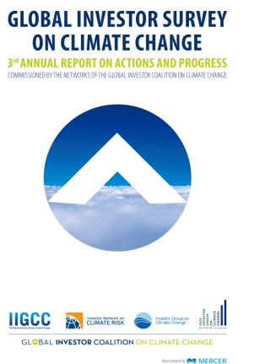

**Global Investor Survey on Climate Change**

발행일: 2013. 8 / 발행처: Global Investor Coalition on Climate Change

This is the third annual report on the results of the Global Investor Survey on Climate Change. This year’s report shows that during 2012, members of the GIC networks have retained and, in many cases, advanced their practices to address climate change in their investment activities. This is despite the ongoing economic challenges and continuing policy uncertainty and reflects increasing awareness among investors that climate risks continue to worsen.

There is a clear trend in the results showing that climate risk analysis is performed within asset classes and for specific investments rather than at the portfolio level. Climate risk analysis in equity portfolios for example is performed by almost 100% of respondents and real estate and infrastructure portfolios are receiving increasing levels of attention with respect to physical climate and policy or regulatory impacts. Around half of asset owners undertook a climate risk assessment at the portfolio level, and around half of these made changes to their investment activities as a result.

This year’s report highlights allocations to ‘low carbon investments’ and the way investors think about risk analysis, particularly in relation to ‘emissions intensive investments’. A number of respondents are either divesting or electing not to invest, based on climate change concerns, although the extent to which these practices apply across portfolios will require further examination in future years. Seeking better information on low carbon and emissions intensive investments within portfolios appears to be one of the major areas of opportunity arising from this year’s survey.

Engagement by Asset Owners and Asset Managers with policy makers and companies remain core tools for addressing climate change risks with high levels of activity in these areas. This reflects the fact that institutional investors in large diverse markets continue to face challenges to diversifying away from emissions exposures when policy signals do not sufficiently support changes.

<보고서는 첨부된 파일을 다운로드 받으시면 됩니다.>

http://www.kosif.org/board/bbs/board.php?bo_table=interior&wr_id=438

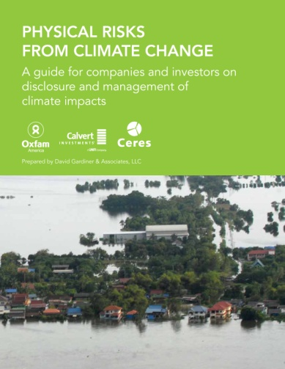

**Physical Risks from Climate Change**

**A guide for companies and investors on disclosure and management of climate impacts**

발행일: 2012. 5 / 발행처: Ceres, Oxfam, Calvert Investments,

.

Climate change has already started to cause a wide range of physical effects with serious implications for investors and businesses. While weather variability and extremes have always existed, the science shows that extreme weather events are becoming more frequent and intense, that incremental climatic changes are already underway, and that the impacts of climate change are expected to grow more severe over the coming years and decades.

The year 2011 set records for economic losses and insured losses caused by natural catastrophes, with extreme weather events accounting for 90 percent of the disasters and eight of the 10 most costly, resulting in overall losses of more than $148 billion and insured losses of more than $55 billion.1 Climate change is predicted to increase these trends. Climate impacts, such as increasing temperatures, rising sea levels, changing weather patterns, and more frequent or intense droughts, floods, and storms, can pose serious challenges for company facilities, supply chains, employees, current and potential customers, and the communities on which companies depend.

As described in this guide, companies are already experiencing business impacts from weather-related phenomena that climate change is expected to make more common and/or intense, including:

• More than 160 companies in Thailand’s textile industry harmed by 2011 floods, stopping about a quarter of the country’s garment production.

• Agribusiness and food company Bunge reporting a $56 million quarterly loss in its sugar and bioenergy segments, driven primarily by droughts in 2010 in its main growing areas.

• Electric power company Constellation Energy experiencing reduced quarterly earnings of about $0.16 per share due to the record-setting 2011 heat wave in Texas that forced it to buy incremental power at peak prices.

• Oil and gas companies’ Gulf of Mexico assets (e.g., drilling rigs, production platforms, and pipelines) suffering extensive damage from Hurricane Katrina and Hurricane Rita.

• Insurance company Munich Re receiving claims worth more than $350 million from the 2010-2011 Australian floods, contributing to a 38 percent quarterly profit decline.

<보고서는 첨부된 파일을 다운로드 받으시면 됩니다.>

http://www.kosif.org/board/bbs/board.php?bo_table=interior&wr_id=437

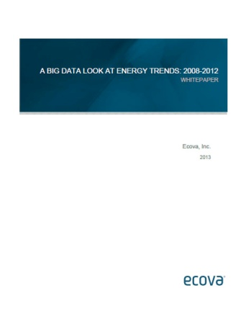

**A big data look at energy trends: 2008-2012**

발행일: 2013. 7 / 발행처: Ecova

Energy – without it, our economy would come to a standstill. Energy sources power our cars, our homes, our offices, educational facilities and healthcare buildings. The domino effect when energy is lost due to a storm or grid congestion is hard hitting: we are without key forms of technology and transportation, along with the loss of everyday necessities, conveniences and forms of communication. Energy is the lifeblood of the commercial sector in the U.S., and helps to keep the economy powered. Overall, the U.S. Department of Energy estimates that commercial facilities account for 36% of all U.S. electricity consumption and cost more than $190 billion in energy every year. Commercial facilities are also responsible for 18% of U.S. carbon dioxide (a primary greenhouse gas) emissions, and they consume more than 18%, or 18 quads, of U.S. primary energy—more than all of Canada's energy consumption.1 Compounding this consumption scenario is a startling fact: On average, 30% of the energy used in commercial buildings is wasted, according to the U.S. Environmental Protection Agency.1 Improving efficiency means tens of billions of dollars in potential energy savings, improved asset performance for owners and tenants, and increased profits.

TABLE OF CONTENTS

EXECUTIVE SUMMARY

ENERGY INTENSITY IS DOWN AGAIN: COMPANIES CONTINUE

TO USE LESS PER SQUARE FOOT

ARE IMPROVEMENTS IN CONSUMPTION BEING MIRRORED

ON THE PEAK DEMAND SIDE?

WHAT IS HAPPENING WITH THE PRICE OF ENERGY?

WHAT IS HAPPENING WITH THE PRICE OF WATER/SEWER?

ENERGY MANAGEMENT IS CHANGING, WITH SIGNIFICANTLY

GREATER POTENTIAL FOR ROI

BIG DATA: ECOVA’S ENERGY DATA WAREHOUSE

UNPRECEDENTED SCOPE AND DEPTH

ELECTRICITY CONSUMPTION TRENDS, 2008–2012

PUTTING BIG DATA TO USE: HOW ENERGY MANAGERS CAN

BENEFIT FROM ANALYTIC INSIGHTS

http://www.kosif.org/board/bbs/board.php?bo_table=interior&wr_id=436