**Report**

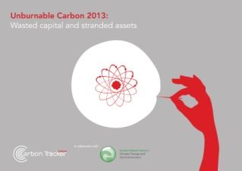

**Unburnable Carbon 2013:**

Wasted capital and stranded assets

발행처: Carbon Tracker

**Executive Summary**

* Using all fossil fuels will breach the global carbon dioxide budget
* Stress-testing the carbon budgets
* Carbon capture and storage (CCS) doesn’t change the conclusions
* The budget is constrained beyond 2050
* Listed companies face a carbon budget deficit
* The London and New York stock markets are getting more carbon-intensive
* Capital spent on finding and developing more reserves is largely wasted
* New business models are required
* Risk needs redefining
* Valuation and ratings aren’t routinely pricing stranded assets
* Financial models that only rely on past performance are an inadequate guide for investors
* Do the maths better
* Regulators and investors need to review their approach to systemic risks

**Contents**

Executive Summary

Foreword

Introduction

1. Global CO2 budgets

2. Global listed coal, oil and gas reserves and resources

3. Evolving the regulation of markets for climate risk

4. Implications for equity valuation and credit ratings

5. Implications for investors

6. The road ahead: conclusions and recommendations

References

<보고서는 첨부된 파일을 다운로드 받으시면 됩니다.>

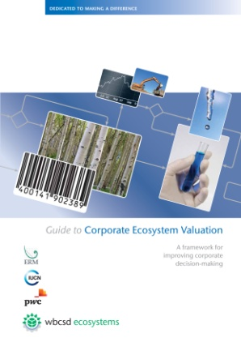

**Guide to Corporate Ecosystem Valuation**

A framework for improving corporate decision-making

발행처: ERM, IUCN, PwC, WBCSD

**Executive Summary**

**What is Corporate Ecosystem Valuation?**

Corporate Ecosystem Valuation (CEV) can be defined as a process to make better-informed business decisions by explicitly valuing both ecosystem degradation and the provided by ecosystem services. By including ecosystem values, the company’s aim is to improve corporate performance in relation to social and environmental goals and the financial bottom-line. Valuation can make decision making around ecosystems more compelling and practical, thereby enhancing sustainable development strategies and outcomes.

Ecosystem services are the benefits people gain from the environment and biodiversity (i.e. the benefits that flow from natural capital). They include, among many others, water, crops, timber, flood protection, waste assimilation, carbon sequestration, recreation and spiritual benefits. All businesses depend and impact upon ecosystem services in some way.

**Contents**

Foreword

Message from Road Testers

Executive Summary

Acronyms

Key definitions

Introduction

Overview of CEV “Road Tests”

Part 1

Screening “Do you need to undertake a CEV?”

Part 2

Methodology “How to conduct a CEV?”

Overview of the CEV stages

Stage 1 – Scoping

Stage 2 – Planning

Stage 3 – Valuation

Stage 4 – Application

Stage 5 – Embedding

Next Steps

Resources

Acknowledgements

References

<보고서는 첨부된 파일을 다운로드 받으시면 됩니다.>