**Report**

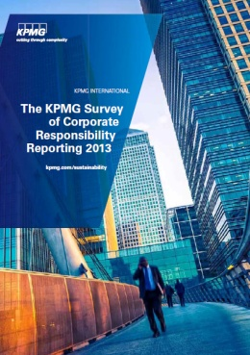

**The KPMG Survey of Corporate Responsibility Reporting 2013**

발행처: KPMG

**Contents**

* about this survey
* Methodology
* Corporate responsibility reporting: is it really worth it?
* Key findings

Part 1: **Global trends in CR reporting: a view across 41 countries**

* Cr reporting rates: asia Pacific sees strongest growth
* regulation drives growth in Cr reporting
* a narrowing gap between leading and lagging sectors
* More companies report on Cr in the annual report but ‘integrated reports’ are in a minority
* GrI remains the leading reporting framework
* assurance reaches a tipping point among the world’s largest companies
* Data quality stabilizes among the world’s largest companies

Part 2: **The quality of reporting among the world’s largest companies**

* Introduction
* lessons from the leaders

1: Strategy, risk and opportunity

2: Materiality

3: targets and indicators

4: Suppliers and the value chain

5: Stakeholder engagement

6: Governance of Cr

7: transparency and balance

* about KPMG’s Climate Change

<보고서는 첨부된 파일을 다운로드 받으시면 됩니다.>

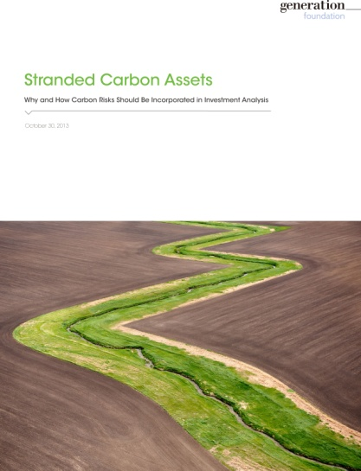

**Stranded Carbon Assets**

**Why and How Carbon Risks Should Be Incorporated in Investment Analysis**

발행처: Generation foundation

**Executive Summary**

This paper highlights the risks associated with investing in carbon-intensive assets, and explains why we feel strongly that the integration of carbon-risk assessment in the investment process is of greater relevance today than ever before. As the case for curbing carbon emissions continues to gain support on economic and scientific grounds, the commercial viability of carbon-intensive assets – particularly fossil fuels – will be increasingly threatened, creating stranded carbon assets. For the purposes of this paper, we define a stranded asset as an asset which loses significant economic value well ahead of its anticipated useful life, as a result of changes in legislation, regulation, market forces, disruptive innovation, societal norms, or environmental shocks.

**Contents**

1. Executive Summary

2. Drivers of Change: Risks to Carbon-Intensive Assets

3. False Comfort of the Status Quo

4. Investor Actions

5. Conclusion

Appendix

A. Defining Stranded Assets

B. The Carbon Budget

C. Flawed Market Assumptions: CCS & Natural Gas

<보고서는 첨부된 파일을 다운로드 받으시면 됩니다.>