**Report**

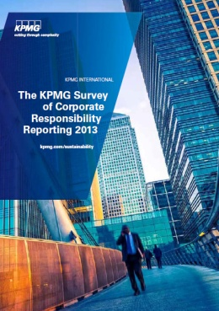

**The KPMG Survey of Corporate Responsibility Reporting 2013**

발행처: KPMG

What is inclusive business?

Inclusive business, a term coined by the WBCSD, refers to business solutions that expand access to goods, services, and livelihoods for low-income communities in commercially viable ways. Inclusive business can create opportunities for employment and entrepreneurship for the base of the pyramid, either directly or through companies’ value chains as suppliers, distributors, and retailers. Alternatively, inclusive business can provide affordable products and services such as food, water, sanitation, telecommunications, energy, housing, and health care to low-income communities as consumers. Inclusive business is about creating sustainable livelihoods. It is not about fighting for a larger share of a small wallet, but about increasing the size of the wallet. In so doing, inclusive business contributes to social priorities such as the Millennium Development Goals. It also creates value for the company – including market entry, market share, security of supply, product and service innovation, top line and bottom line growth, and competitive advantage.

<보고서는 첨부된 파일을 다운로드 받으시면 됩니다.>