Data Science for Supply Chain

The following PDF is an accumulated knowledge corpus of all that I have learned working in the Supply Chain specifically in retail. I will address various resources to give you the ability to further your knowledge without having to do the work yourself. Much of what is important in Supply Chain will be forecasts, and understanding risk involved in everything in the supply chain.

### Moving Average

The average demand during the last n periods.

$$f_{n}=\frac{1}{n}\sum_{i=1}^{n}{d_{t−i}}$$

Where:

* $n$ is the number of periods we take the average of
* $d_{t}$ the demand we observe during period $t$
* $f_{t}$ is the forecast we made for period $t$

The first forecast will be done for $t=n+1$

In scientific literature, you will find often see the output you want to predict noted $y$

A prediction would be noted as $\hat{y}$

When we want to point to a specific occurrence of the forcast at time $t$, we will not it $f_{t}$ or $d_{t}$

Demand observation: we will call the demand of each period.

**Noise**: an unexplained variation in the data. It is often due to the randomness of the different processes at hand.

## References

* [Moving Average:](http://uc-r.github.io/ts_moving_averages)

dmd <- tibble::tribble(  
 ~Date, ~Demand,  
 "2010-1-1", 37,  
 "2011-1-1", 60,  
 "2012-1-1", 85,  
 "2013-1-1", 112,  
 "2014-1-1", 132,  
 "2015-1-1", 145,  
 "2016-1-1", 179,  
 "2017-1-1", 198,  
 "2018-1-1", 212,  
 "2019-1-1", 232,  
 "2020-1-1", NA,  
 "2021-1-1", NA,  
 "2022-1-1", NA  
 )  
  
  
  
dmd$Date <- as.Date(dmd$Date)  
  
demand <- dmd %>% mutate(srate_ma_1 = rollmean(Demand, k = 4, fill = NA, align = "right"),  
 srate_ma_2 = rollmean(Demand, k = 5, fill = NA, align = "right"),   
 srate_ma_3 = rollmean(Demand, k = 6, fill = NA, align = "right"))   
  
demand

## # A tibble: 13 x 5  
## Date Demand srate_ma_1 srate_ma_2 srate_ma_3  
## <date> <dbl> <dbl> <dbl> <dbl>  
## 1 2010-01-01 37 NA NA NA   
## 2 2011-01-01 60 NA NA NA   
## 3 2012-01-01 85 NA NA NA   
## 4 2013-01-01 112 73.5 NA NA   
## 5 2014-01-01 132 97.2 85.2 NA   
## 6 2015-01-01 145 118. 107. 95.2  
## 7 2016-01-01 179 142 131. 119.   
## 8 2017-01-01 198 164. 153. 142.   
## 9 2018-01-01 212 184. 173. 163   
## 10 2019-01-01 232 205. 193. 183   
## 11 2020-01-01 NA NA NA NA   
## 12 2021-01-01 NA NA NA NA   
## 13 2022-01-01 NA NA NA NA

demand %>% gather(metric, value, Demand:srate_ma_3) %>%   
 ggplot(aes(Date, value, color = metric)) +   
 geom_line()

## Warning: Removed 24 row(s) containing missing values (geom_path).

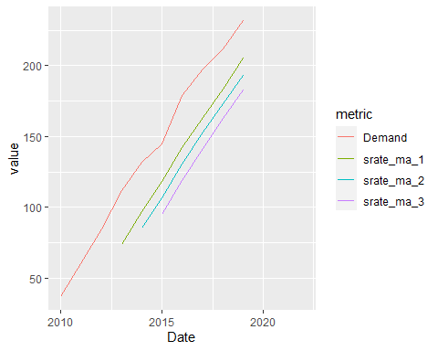

This is by far the simplest way to generate a trending forecast based on the information. This really hends up giving common trend but does not take seasonality into consideration and will thus understate/overstate when there are significant changes over a period of time.

One example of this is seasonal sales. Generally after Black Friday (Holiday in the United States similar to singles day in Asia), sales will dramatically increase due to the Christmas season.