**Wireframe**

Login

Search a Medicine….

Medicine App

**Mock Up**

**Medicine App**

Sign up

Log in

Forgot Password?

Connect Google or Facebook?

1. Now the user can use the medicine app and search for the medicine they want to know and its purpose.
2. Contains user name password fields. Call to action button to log in. also forgot password link.

Password

User Name

Login

Search a Medicine….

Medicine App

Sign up

Log in

Forgot Password?

Connect Google or Facebook?

**Medicine App**

1. Now the user can use the medicine app and search for the medicine they want to know and its purpose.
2. Contains user name password fields. Call to action button to log in. also forgot password link. ( added the sign up button )

Password

User Name

**Prototype**

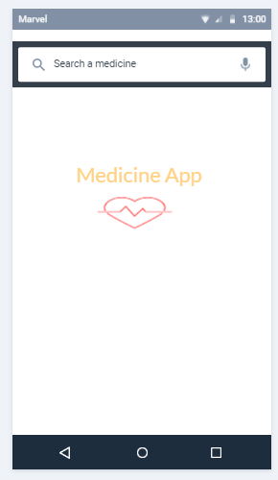Medicine App

Medicine applications - user will see all types of medicines and its purpose. The user will also know whether the type of medicine is over-the-counter or not and if it’s over-the-counter the app will suggest to go to nearest medical place to get a prescription.