**Wireframe**

Login

Search a Medicine….

Medicine App

**Mock Up**

1. Now the user can use the medicine app and search for the medicine they want to know and its purpose.
2. Contains user name password fields. Call to action button to log in. also forgot password link.

**Medicine App**

Connect Google or Facebook?

Forgot Password?

Log in

Password

User Name

Login

Search a Medicine….

Medicine App

**Medicine App**

1. Now the user can use the medicine app and search for the medicine they want to know and its purpose.
2. Contains user name password fields. Call to action button to log in. also forgot password link.

Connect Google or Facebook?

Forgot Password?

Log in

Password

User Name

**Prototype**

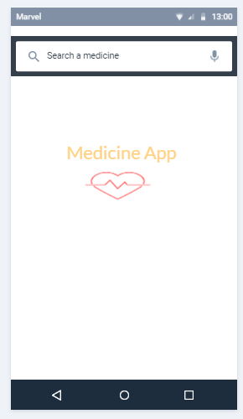Medicine App

Medicine applications - user will see all types of medicines and and its purpose.