Fest-o

By:-
Shivam Bhatia
Lakshay Summi
Shyamu Mishra

ACKNOWLEDGEMENTTRT

Exchange of ideas generates the new object to work in a better way. Whenever a person is helped and co-operated by others, his heart is bound to pay gratitude and obligation to them. To develop a project is not a one-man show. It is essentially a collective work, where every step is taken with all precautions and care. Therefore, our first duty is to thank all those who took pain in completing this project.
Firstly, we thank Ms. Ushveen Kaur, who gave us inspiration and guidance to work our way towards this field and gave us her precious time and attention whenever needed. Thanks may be a matter of mere formality but with us it is an expression of heartfelt gratitude towards our project supervisor. We are highly indebted for her advice, perceptive guidance and constant encouragement at every point of time during this study. The timely and persistent advices and assistances offered are greatly acknowledged.

CERTIFICATE

This is to certify that Shivam Bhatia, Lakshay Summi and Shyamu Mishra, students of B.Sc. Computer Science Semester IV have submitted the project entitled “FEST-O” for the partial fulfillment of the requirements of Software Engineering project.

It embodies the work done by them during semester IV of their course under the due supervision of Mrs. Ushveen Kaur.

Date Mrs. Ushveen Kaur

INDEX
S NO. | Topic | Page No.
 | Acknowledgement | 2
 | Certificate | 3
1 | Introduction
1.1 | Overview | 6
1.2 | Objective | 7
1.3 | Statement of Scope | 8
1.4 | Advantage of Software | 9
2 | Project Management
2.1 | Process Model | 10
2.3 | Risk Management and Analysis | 12
2.4 | RMMM Plan | 13
2.5 | Timeline Chart | 14
3 | Requirements Gathering and Analysis
4 | Design
5 | Software Testing

+
INTRODUCTION
GUIDED BY:-
Ms. USHVEEN KAUR
OVERVIEW

In college fests, many teams struggle to find events to compete in. But it takes a lot of hard work to find a good event of one’s choice. PRs of team contact many organizers to complete the registration process.

Many a times organizers too struggle to post and promote their events. So that it reaches out to maximum people and people participate in it. Also finding a sponsor for your event is generally a headache for event organizers.

OBJECTIVE

The main objective of our app is to provide a dedicated space for events and fests including major competitions. The organizers can post their events on this platform in few seconds. They don’t need to promote their event as this app is specially designed for only events and fests. The struggle of finding sponsors for their event is also resolved by our app as in this app, a specific platform is totally dedicated for interested sponsors.

Interested participants can take part in their event by just registering themselves into the event through this app only. The registration fees can be paid through this online portal. The guests can mark themselves as interested so that the organizers can organize the event accordingly.

STATEMENT OF SCOPE

Our app maintains a record of all the upcoming events and fests. So, that with minimum human efforts one can register them for the best events including some awesome filters. One can easily see if their event is clashing with others or not. With minimum human efforts one can find the best sponsor for their event or fest. Our app provides detailed reports to organizers about their event so that they can manage it accordingly.
ADVANTAGES OF SOFTWARE

This software not only saves a lot of time and overhead in user management but it also makes it easy to access data bases and modifies it according to need.

Therefore, Fest-O App helps in a variety of ways:

- Upload an event within seconds.
One can upload their event with only few clicks in seconds and can show their event details to a huge number of participants in just one click.

- No registration forms
No more registration forms to be made for registering participants for your event. Our app can do it for you in just few clicks. You can customize your registration form easily as per your requirements.

- Inbuilt Chat bot
No need to share your number with any organizer or any participant as our in-built chat bot solve this problem. You can message any user any time for any query without actually knowing their number or revealing yours.

- Free promotion for organizers and sponsors.
One can easily promote their event on this app and increase their reach to almost 3X. Organizers can find sponsors here as many potential sponsors can register them on this portal for free.

- Payment gateway
We use Paytm as our payment gateway to secure any kind of transactions. Payment of registration fees can easily be made using inbuilt pay feature.

- Detailed reports for organizers
We provide analytical data to organizers for their uploaded events using graphs and pie charts for the insights. The organizer can know how many people are interested in coming to their events. So, that they can make appropriate arrangements for the day.

PROCESS MODEL

DEFINITION:
The software model used to develop the project:
“Fest-O” is “LINEAR SEQUENTIAL MODEL” or “WATERFALL MODEL”.
The linear sequential model suggests a systematic, sequential approach to the software development that begins with the customer specification of requirements of the problem are reasonably well understood i.e. work flows linearly from communication through deployment.
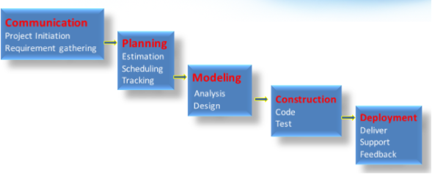
It is very simple to understand and use. In a waterfall model, each phase must be completed before the next phase can begin and there is no overlapping in the phases.

The sequential phases in Waterfall model are −
- Requirement Gathering and analysis − All possible requirements of the system to be developed are captured in this phase and documented in a requirement specification document.
- System Design − The requirement specifications from first phase are studied in this phase and the system design is prepared. This system design helps in specifying hardware and system requirements and helps in defining the overall system architecture.
- Implementation − With inputs from the system design, the system is first developed in small programs called units, which are integrated in the next phase. Each unit is developed and tested for its functionality, which is referred to as Unit Testing.
- Integration and Testing − All the units developed in the implementation phase are integrated into a system after testing of each unit. Post integration the entire system is tested for any faults and failures.
- Deployment of system − Once the functional and non-functional testing is done; the product is deployed in the customer environment or released into the market.
- Maintenance − There are some issues which come up in the client environment. To fix those issues, patches are released. Also to enhance the product some better versions are released. Maintenance is done to deliver these changes in the customer environment.
All these phases are cascaded to each other in which progress is seen as flowing steadily downwards (like a waterfall) through the phases. The next phase is started only after the defined set of goals are achieved for previous phase and it is signed off, so the name "Waterfall Model". In this model, phases do not overlap.

Why Waterfall Model?

- Requirements are very well documented, clear and fixed.
- Product definition is stable.
- Technology is understood and is not dynamic.
- There are no ambiguous requirements.
- Ample resources with required expertise are available to support the product.
- The project is short.
- Simple and easy to understand and use
- Easy to manage due to the rigidity of the model. Each phase has specific deliverables and a review process.
- Phases are processed and completed one at a time.
- Works well for smaller projects where requirements are very well understood.
- Clearly defined stages.
- Well understood milestones.
- Easy to arrange tasks.
- Process and results are well documented.

RISK ANALYSIS AND MANAGEMENT

PROJECT RISKS
- They threaten the project plan.
- If they become real, it is likely that the project schedule will slip and that costs will increase.
- Examples- potential budgetary, schedule, personnel (staffing and organization), resource, stakeholders, and requirements problems.
TECHNICAL RISKS
- They threaten the quality and timeliness of the software.
- If they become real, implementation may become difficult or impossible.
- Examples- potential design, implementation, interface, verification and maintenance problems
BUSINESS RISKS
- They threaten the viability of the software.
- If they become real, they jeopardize the project or product.
- Sub categories of business risk:-
- Market risk- building an excellent product or system that no one really wants.
- Strategic risk-building a product that no longer fits into the overall business strategy for the company.
- Sales risk- building a product that the sales force doesn’t understand how to sell.
- Management risk- losing the support of the senior management due to a change in focus or a change in people.
- Budget risk- losing budgetary or personal commitment.

RMMM PLAN

S.NO. | RISK | PROBABLITY | IMPACT | RMMM
1. | The team may lose the project anytime during the project and thus will be unable to deliver the application to the customer. Such an unlikely event may be caused by a hard disk being wiped out by a virus , hard disk failure , etc. | 10% | Catastrophic | MITIGATION PLAN: Create backups of project on regular intervals and make sure documentation is up to date.  CONTINGENCY PLAN: talk to customer for project extension and if he agrees then start the coding part again on the basis of documentation created earlier.
2. | Customer requirements might change .  Since our software and system is made in a linear fashion, changing of requirements can be a big problem. | 20% | Critical | MITIGATION PLAN: create SRS properly during communication phase.  CONTINGENCY PLAN: try to convince him to accept ongoing project else ask for project extension.

TIMELINE CHART

When creating a software project schedule, the planner begins with the set of tasks. If automated tools are used, the work breakdown is input as a task network or task outline. Effort, duration and start date are then input for each task outline. In addition, tasks may be assigned to specific individuals.

As a consequence of this input a Timeline Chart also called a Gantt Chart is generated.
S.NO. | PROCESS/PHASE | START DATE | END DATE
1. | Requirements  gathering | 18.1.2020 | 24.1.2020
2. | Requirement analysis | 31.1.2020 | 4.2.2020
3. | Risk management plan | 11.2.2020 | 15.2.2020
4. | Data dictionary preparation | 25.2.2020 | 29.2.2020
5. | FPA calculation | 4.3.2020 | 10.3.2020
6. | DFD preparation | 14.2.2020 | 18.2.2020
7. | Database design | 20.3.2020 | 22.3.2020
8. | Screen design | 10.4.2020 | 13.4.2020
9. | Pseudo code | 28.1.2020 | 29.1.2020
10. | **Project  management | 16.1.2020 | 18.4.2020
**project management is an umbrella activity that is done throughout the project.

REQUIREMENT GATHERING AND ANALYSIS

SYSTEM REQUIREMENTS SPECIFICATION (SRS)

Requirements Process is the sequence of activities that need to be performed in the requirements phase and it culminates in producing a high-quality document containing the software requirements specification (SRS). The requirement process consists of three basic tasks:

- Problem or Requirements Analysis

- Requirements Specifications

- Requirements Validation
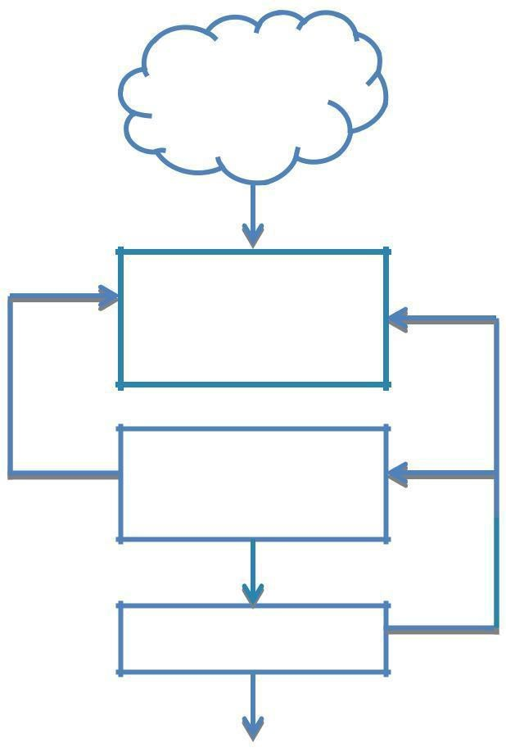
CLIENT/USER

NEEDS

PROBLEM

ANALYSIS

PRODUCT

DESCRIPTION

VALIDATION

VALIDATED SRS

Problem Analysis starts with a high-level problem statement. During analysis the problem domain and the environment are modeled in an effort to understand the system behavior, constraints on the system, its inputs and outputs etc. The basic purpose of this activity is to obtain a thorough understanding of what the software needs to provide. The understanding obtained by problem analysis forms the basis for requirements specification.

Requirements Specification focuses on clearly specifying the requirements in a document. Issues such as representation, specification languages and tools are addressed during this activity. As analysis produces large amounts of information and knowledge with possible redundancies, properly organizing and describing the requirements is an important goal of this activity.

Requirements Validation focuses on ensuring that what has been specified in the SRS are indeed all the requirements of the software and making sure that the SRS is of good quality. The requirements process terminates with the production of the validated SRS.

REQUIREMENT GATHERING

We communicated with our peers and a few members/PRs of other teams and also potential participants. As a developer we gather few points of information to start the production. They are as follow :-
- Login with google for level 3 security
- Directly message the organizers from private chatbot
- Create a new event
- Delete the already existing event
- Update the event
- Show the events to participants
- Registration for the event
- Pay registration fees using app
- Filters –
- By date
- By location
- Nearest fest
- Event name
- Organizers name
- Event category
- Stage limit
- Reports for organizers including-
- Number of views on their event
- Number of teams/participants registered
- Their details using google sheets
- Non- participants interested in event

REQUIREMENTS ANALYSIS

Requirements process is a sequence of activities that need to be performed in the requirement phase and it culminates with the work product as a highly detailed and quality document in natural language called Software Requirement Specification or SRS.
Here are the requirements of our system. Our system would have 3 portals: Organizer Portal, Participant Portal and View Portal. Their features are as follows:
- Organizer Portal:
- Name of fest
- Name of organizers
- Date and time of fest
- Prize money
- Rules and regulations
- Maximum and minimum stage limit
- Category of event
- Poster of event
- Judges (no mandatory)
- Location
- Registration fee
- Audio/video required

- Registration Portal:
- College name
- Name of members of team
- Team name
- Audio/video
- Registration fees

- View Portal
- View all events and fest without signup/login
- Mark interested for the event
- Directed to registration and organizers portal

DATA FLOW DIAGRAM (DFD)

A Data Flow Diagram (DFD) is a graphical representation of the "flow" of data
through an information system, modelling its process aspects. A DFD is often
used as a preliminary step to create an overview of the system, which can later
be elaborated.

LEVEL – 0 DFD

(CONTEXT DIAGRAM)

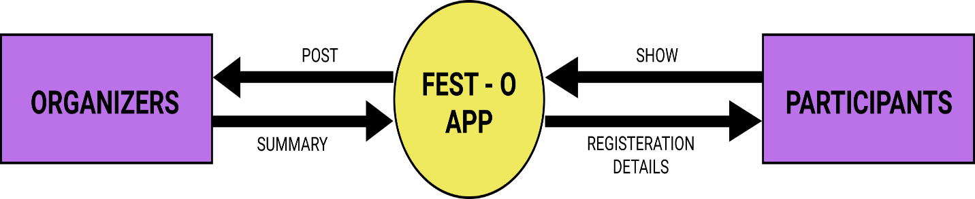

LEVEL – 1 DFD

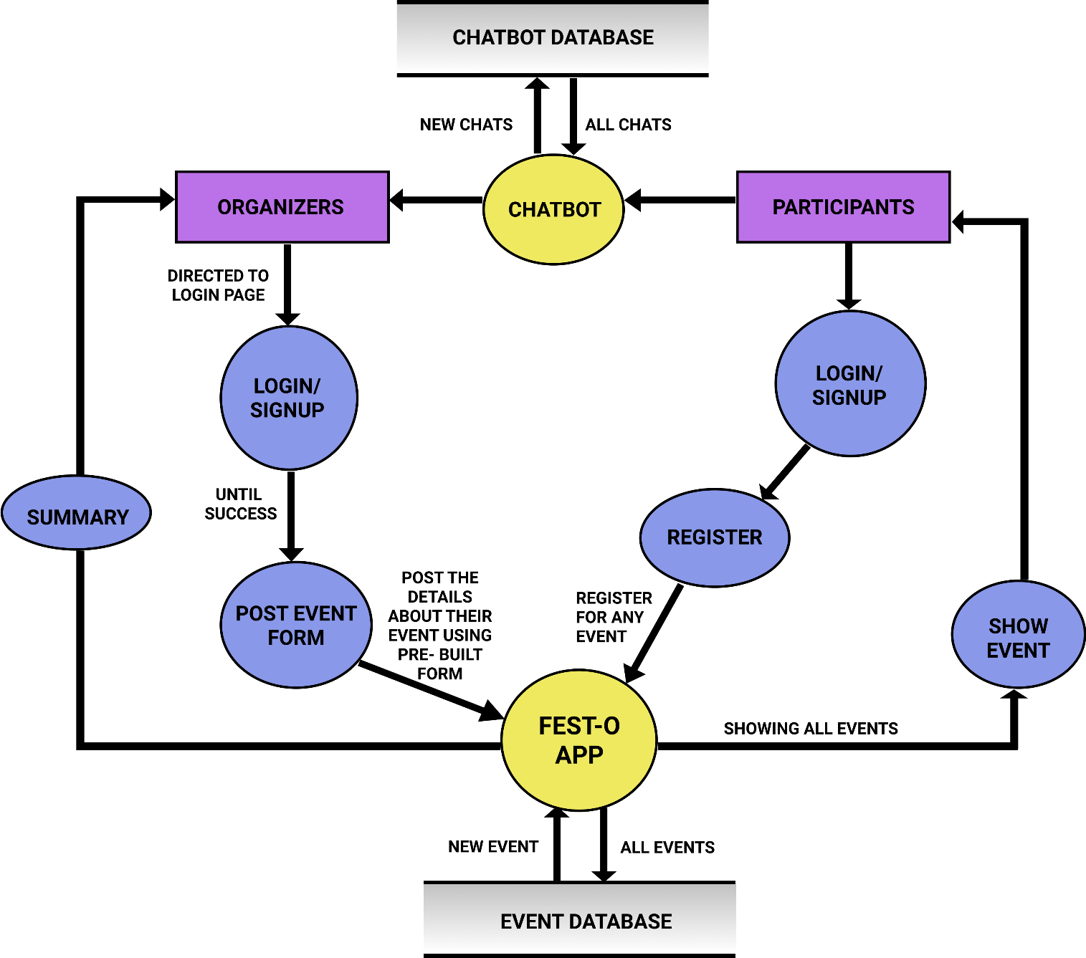

LEVEL – 2 DFD

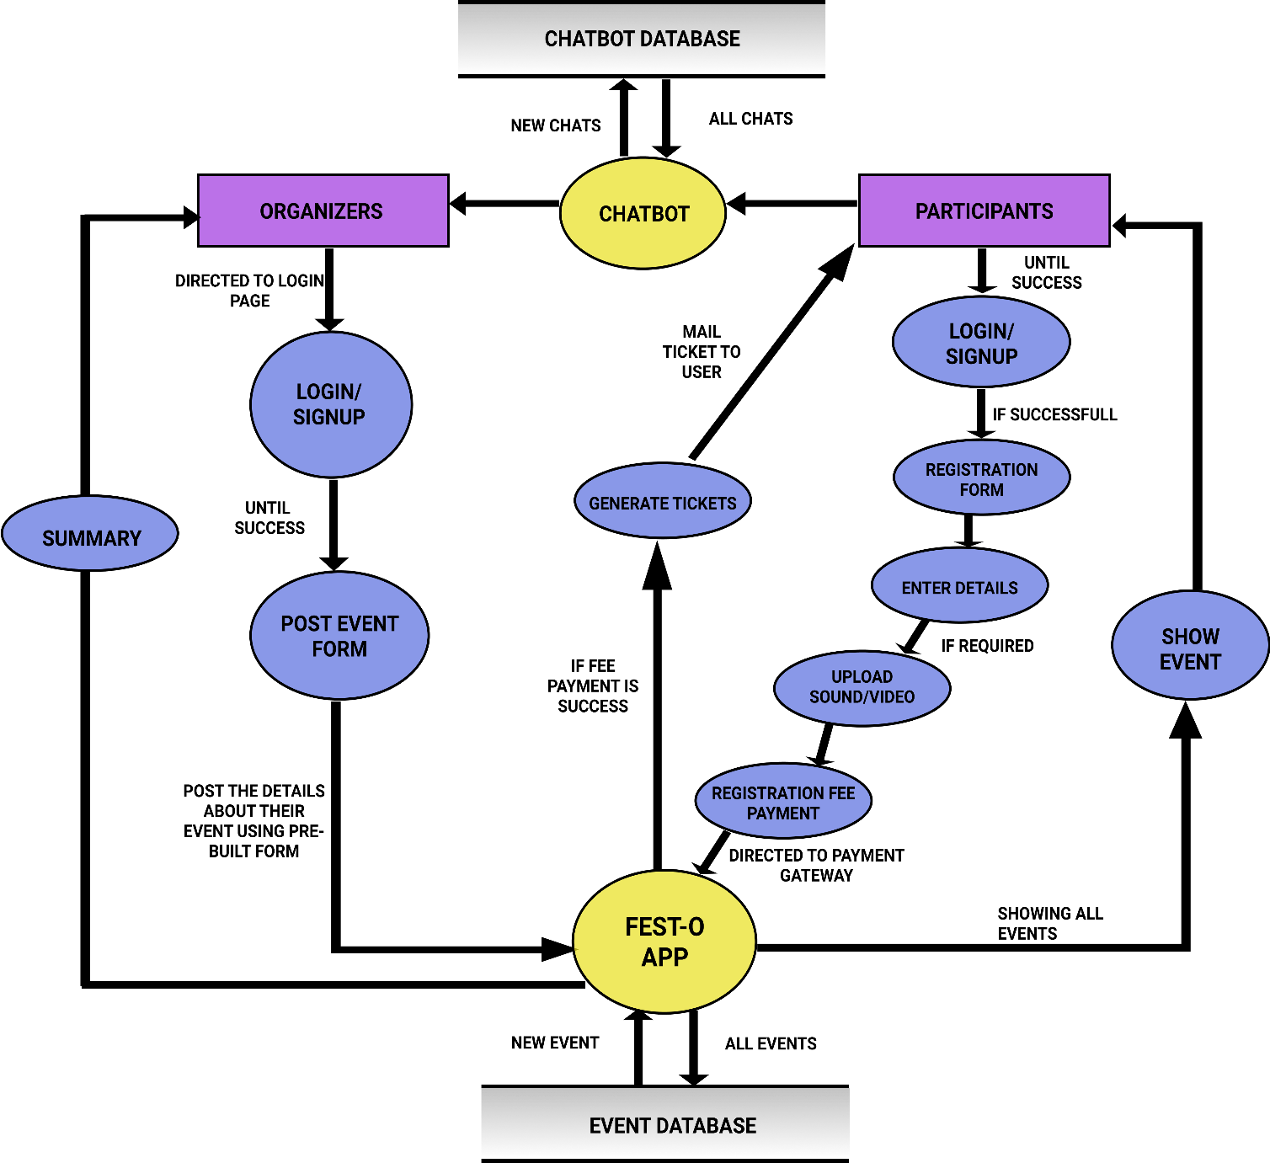

FUNCTIONAL POINT ANALYSIS

FPA is a standard metric for the relative size and complexity of a software system, originally developed by Alan Albrecht of IBM in the late 1970s.

Function points (FPs) can be used to estimate the relative size and complexity of software in the early stages of development - analysis and design.

The size is determined by identifying the components of the system as seen by the end-user: the inputs, outputs, inquiries, interfaces to other systems, and logical internal files.

The components are classified as simple, average, or complex. All of these values are then scored and the total is expressed in Unadjusted FPs (UFPs). Complexity factors described by 14 general systems characteristics, such as reusability, performance, and complexity of processing can be used to weight the UFP. Factors are also weighed on a scale of 0 - not present, 1 - minor influence, to 5 - strong influence. The result of these computations is a number that correlates to system size.

Although the FP metric doesn't correspond to any actual physical attribute of a software system (such as lines of code or the number of subroutines)

It is useful as a relative measure for comparing projects, measuring productivity, and estimating the amount development effort and time needed for a project.

Complexity Adjustment Values Table
S.No. | Questions |  | VAFs
 |  | Does the system require reliable backup and recovery?
1 |  | Does the system require reliable backup and recovery? | 3
 |  | Are specialized data communications required top
2 |  | transfer information to or from the application? | 3
3 |  | Are there distributed processing functions? | 4
4 |  | Is performance critical? | 4
 |  | Will the system run in an existing, heavily utilized operational environment?
5 |  |  | 4
6 |  | Does the system require online data entry? | 4
 |  | Does the online data enquiry require the input
7 |  | transaction to be built over multiple screens or operations? | 4
8 |  | Are the ILFs updated online? | 2
9 |  | Are the inputs, outputs, files or inquiries complex? | 3
10 |  | Is the internal processing complex? | 3
11 |  | Is the code designed to be reusable? | 3
 |  | Are conversion and installation included in the
12 |  | design? | 2
 |  | Is the system designed for multiple installations in different organizations?
13 |  |  | 3
 |  | Is the application designed to facilitate change and
14 |  | ease of use by the user? | 3
 |  | Total Degree of Influence (TDI) | 45

INPUT

Input Name |  | Fields | Tables | Complexity
Login | 2 |  | 1 | Low
Details | 9 |  | 2 | Low
Add Participant | 7 |  | 1 | Low
Event Registration | 4 |  | 1 | Low
Create Event | 5 |  | 1 | Low
Feedback | 1 |  | 1 | Low

Output

Output Name | Fields | Tables | Complexity
Registered users | 7 | 1 | Low
View Location | 4 | 1 | Low
Ticket | 4 | 1 | Low
Event Search | 5 | 2 | Low
Feedback | 2 | 1 | Low

Queries

Output Name | Fields | Tables | Complexity
View Profile | 1 | 1 | Low
Add User | 1 | 2 | Low
View Event Profile | 1 | 2 | Low
Remove User | 1 | 1 | Low
Generate Ticket | 1 | 1 | Low

Tables

Name | Fields | Complexity
Admin | 2 | Low
Login | 2 | Low
Participant | 10 | Low
Organiser | 7 | Low
College | 5 | Low
Event | 5 | Low
Tickets | 4 | Low

Unadjusted Function Points

(UAFP) Calculation

Type | Complexity of components
 | Low | Avg | High | Total
External Inputs | 6*3 | 0*4 | 0*6 | 18
External outpus | 5*4 | 0*5 | 0*7 | 20
External Inqueries | 5*3 | 0*4 | 0*6 | 15
Internal Tables | 7*7 | 0*10 | 0*15 | 49
External logical files | 0*5 | 0*7 | 0*10 | 0
Total UAFP | 20 | 0 | 0 | 102

FPA CALCULATION

FP = [0.65+(0.01 x TDI)] * UAFP
= [0.65+(0.01 x 45)]*102
= 102 * (0.65 + 0.45)
= 102 * 1.10
FP = 112.2

EFFORT ESTIMATION

In Flutter it takes 13 hrs to complete 1 FP by 1 person.
Let’s say a person works for 6-7 hrs per day and 24 days a month. Then in 1 month one person will be able to complete 12 FP.
Then in almost 8.6 ~ 9 months one person will be able to complete 112.2 FP.
Therefore, Efforts = 9 PM

However, if 4 people work on project then the effort is divided into 4 people and it comes to 2.25 PM.
So, for 4 people efforts = 2.25 PM

Data Dictionary

The data dictionary provides an organized approach for representing the characteristics of each data object and control item. It has been proposed for describing the contents of the objects defined during structured analysis.
A Data Dictionary is very important in the software development process because of the following reasons:
- A Data Dictionary lists standard terminology for use by an engineer working on a project.
- The Dictionary provides the analyst with means to determine the definition of the different data structures in terms of their component elements.

Field Name | Data Type | Maximum Length | Description
Participant_id | Int | 8 | Partcipant Id
Name | Varchar | 30 | Participant Name
Email | Varchar | 30 | Email id of user
Password | Varchar | 10 | Password
Age | Int | 2 | Age of the Participant
Gender | Varchar | 10 | Gender of Paticipant
DOB | Date | - | Date Of Birth
Address | Varchar | 50 | Address of Paticipant
Ph_no | Int | 12 | Mobile number of Participant
Feedback | Varchar | 100 | Feedback given by participant
Organiser_id | Int | 8 | Organiser Id
Organiser_name | Varchar | 30 | Organiser Name
College_id | Int | 8 | College ID
College_name | Varchar | 30 | College Name
College_Address | Varchar | 50 | College Address
College_contact_no | Int | 12 | College Contact Number
Pincode | Int | 6 | Area Pincode
Ticket_id | Int | 8 | Ticket ID
Receiver_name | Varchar | 30 | Receiver’s name
Receiver_contact | Int | 12 | Receiver’s contact number
Admin Name | Varchar | 30 | Name of Admin
Password | Varchar | 10 | Admin’s Password
Event_id | Int | 8 | Event ID
Event_name | Varchar | 30 | Event Name
Event_location | Varchar | 30 | Location of Event
Feedback | Varchar | 1000 | Feedback Message

The format of Data Dictionary includes the following information:
- Name- the primary name if the data or control item, the data store or external entity.
- Alias-other names used for first entity.
- Description-a notion for representing content. Type-type of the data.

DESIGN

INTRODUCTION

The design activity begins when the requirements document for the software to be developed is available and the architecture has been designed. During design we further refine the architecture.

Software design is a process of problem solving and planning for a software solution. After the purpose and specifications of software are determined, software developers will design or employ designers to develop a plan for a solution. It includes low-level component and algorithm implementation issues as well as the architectural view. The design of a system is a blueprint or a plan for a solution for the system. Here we consider a system to be a set of modules with clearly defined behavior, which interact with each other in a defined manner to produce some behavior or services for its environment.

A design should clearly be verifiable, complete (implements all the specifications), and traceable (all design elements can be traced to some requirements). However, the two most important properties that concern designers are efficiency and simplicity. Efficiency of any system is concerned with proper use of scarce resources by the system. Simplicity is perhaps the most important quality criteria for software systems.

Maintenance of the software is quite expensive. The simpler the software, the more easily it can be maintained.
The design activity mainly focuses on the following major areas of concern:

COMPONENT LEVEL DESIGN: It establishes the algorithmic detail required manipulating the data structures, effect communication between software components via their interfaces, and implement the processing algorithms allocated to each component i.e. it transforms structural elements of software architecture into a procedural description of software components.
INTERFACE DESIGN: It deals with the process of developing a method for two or more modules in a system to connect and communicate. It describes how the software communicates with itself, with systems that interoperate with it, and with the users who use it.
ARCHITECTURAL DESIGN: It defines the relationship among the major structural elements. Here the main objective is to develop a modular structure and represent the control relationship between the modules
DATA DESIGN: It is the first and most important Design activity. It transforms the information domain model created during analysis into the data structures that will be required to implement the software. Hence, Data Design focuses on the definition of data structures.

DATA DESIGN

ADMIN
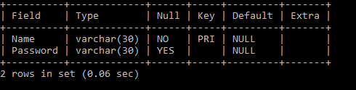

USER

COLLEGE 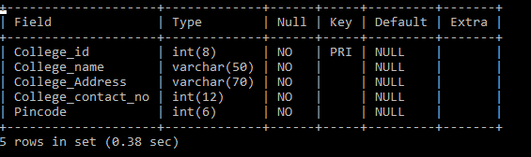

EVENT
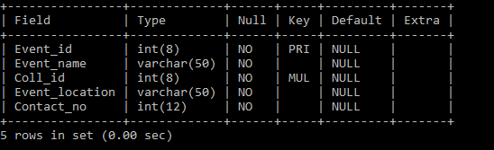

PARTICIPANT 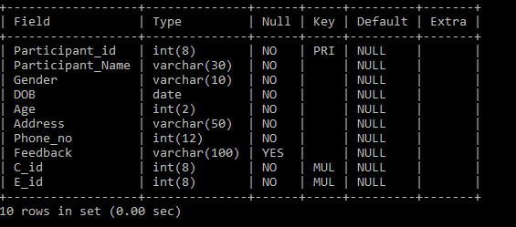

ORGANISER
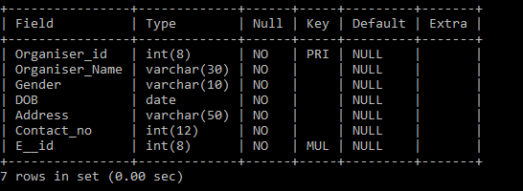

TICKETS
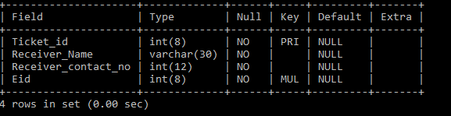

INTERFACE DESIGN


