About Me
Crystal Sparks
Table of Contents
Who I am and where I came from 1
Research Interests 2
Influential papers 3
The mathematics behind my research 3
What I hope to get out of this class 3
Evaluating some R code 4
Citations 4

Who I am and where I came from
I was born and raised in Anniston, Alabama. I had always wanted to leave and when friends invited me to move to Colorado in 2010, I gladly accepted the opportunity. Here I decided to explore academia again but only had the confidence to get my toes wet. Community College lead me to an interest in biology which spiraled out of control into a B.S. in Biochemistry and Molecular Biology from Colorado State University, and then to PhD in Agricultural Biology, which a discipline in molecular weed science. I was more keen to wet lab until I was introduced to bioinformatics by inheriting an underutilized RNAseq data set. This inspired me to look for more data science and computational courses, such as this one, where I appreciate the biological context ##Put in a hypertext link to your undergraduate institution.
My favorite leisure activities, like this:
- Singing
- Hiking
- Volleyball
- Video Games
This image of me was taken at the Meow Wolf Convergence Station in Denver, CO. It was an artistic and fun adventure.
knitr::include_graphics("images/meowwolf.jpeg", auto_pdf = TRUE)

Research Interests
My primary research interests involve exploring the molecular and biochemical mechanisms of herbicide resistance in weeds and in mutagenic crop lines.

Influential papers
In my field we often classify mechanisms of resistance as target site or non-target site. One early and important paper came from my advisors PhD work. ‘Gaines et al. (2010)’ found a now commonly known target site mechanisms that involves multiple copies of the gene normally inhibited by the herbicide, in this case 50-200 fold increase, allowing the weed to easily overcome normal field applications of herbicide. Though it is unique in Amaranthus palmeri for more complex reasons, target site gene duplication itself has since been found in several species.
On the other hand, resistance is not always caused by any change in the target site but rather a non-target mechanism. This may be a change in absorption and translocation of the herbicide, or detoxification through metabolic processes of enzyme families, as described by ‘Yuan, Tranel, and Stewart (2007).’

The mathematics behind my research
These equations are commonly used in my field. The first on is the well known and historically renowned dilution equation. The other is the Hill equation which we commonly used with dose response curves to calculate the dose of herbicide that controls 50% of a population.
$$C_{1}\left(V_{1}\right)=C_{2}\left(V_{2}\right)$$
$$\frac{E}{E_{\text{max}}}={\frac{1}{1+\left(\frac{EC_{50}}{\left[A\right]}\right)}}^{n}$$
## My computing experience
My computing experience involves many hours but not much expertise. I have taken the data science courses that are only 1/3 semester. One on basic linux and one on RNA-seq. I also took the python class, but I did not enjoy it. I inherited an RNA-seq project that I have spent a lot of time playing with. I also took the STAT511 which introduced me to some R-specific computation. I have ran a variant calling pipeline, and a few other random processes.

What I hope to get out of this class
Give me a bullet list of three things:
- Best practices for file management
- How to use github for reproducibility
- Learning proper and cool ways to run common commands and bioinformatics processes

Evaluating some R code
Nothing fancy for today but here is a simple set of data and a base r histogram.
x <- rnorm(1500, mean=5, sd=1)
hist(x)
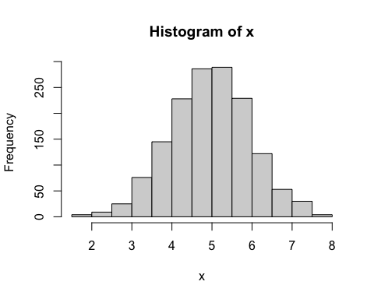

Citations
Gaines, Todd A, Wenli Zhang, Dafu Wang, Bekir Bukun, Stephen T Chisholm, Dale L Shaner, Scott J Nissen, et al. 2010. “Gene Amplification Confers Glyphosate Resistance in Amaranthus Palmeri.” Proceedings of the National Academy of Sciences - PNAS 107 (3): 1029–34.
Yuan, Joshua S, Patrick J Tranel, and C. Neal Stewart. 2007. “Non-Target-Site Herbicide Resistance: A Family Business.” Trends in Plant Science 12 (1): 6–13.

