**Documentation**

Dream team CD Store is an online store for sales of CDs, the aim is to ensure that users have an accessible and convenient means of buying their CDs of their favourite artist.

Functional Requirement

A customer can browse the CDs based on Categories. Details of each CD is also made available

A Shopping Cart facility that enables customers to add CDs to their cart, update the quantity of each CD, remove items from their cart, view summary of items selected, their quantities and their total price and proceed to make payment online through a secure checkout process where the customer provides address information for shipment

New Customers are prompted create an account in which they enter their billing and shipping information during checkout but old customers can simply log in with their user name and password to continue

Taking statistics of visitors and their activity

Non Functional Requirement

All 5th Requests should be refused

The website should run under https (SSL)

USE-CASE

The customer visits the home page and selects any of the CD categories

Customer can browse the CDs within the selected category in the new products page

At products page the customer can add selected CDs to their shopping cart.

At the products page the customer can select different categories and add different CDs to the shopping cart

The Customer can select “view cart” to see details of selected CDs and can also update the quantities of the different CDs in the cart page

The Customer can proceed to checkout where he/she is directed to the Account order page

At the Account order page the customer is prompted to login or create new account, during the account creation the customer supplies his/her billing and shipping information

After logging in the customer is directed to the checkout page where he/she verifies the billing and shipping information, enters their credit card number and finally proceed submit to checkout.

If order is approved, customer is directed to a confirmation page which contains “Order completed successfully” and summary of Invoice for Print out. If the order is denied, it displays “Credit Card Authorization Failed”.

General Use Case Diagram

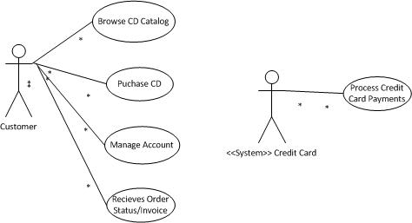

High Level Process Flow Diagram

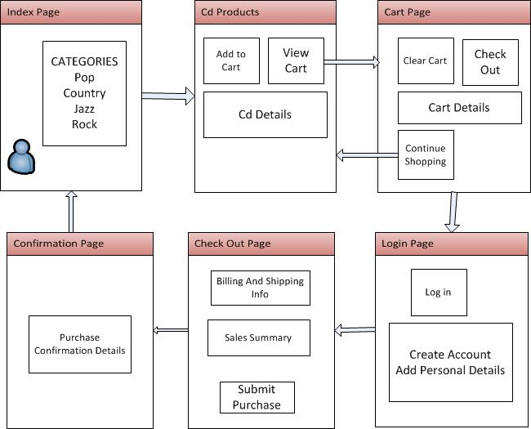

Detail Use Case Diagram

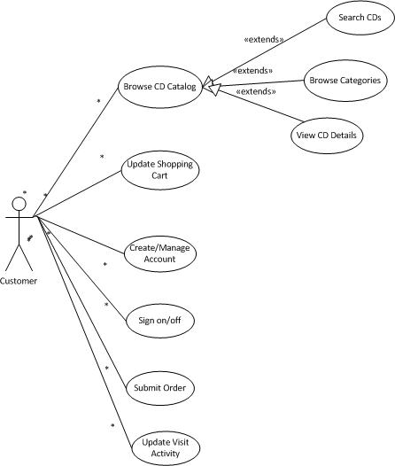

Architecture: MVC

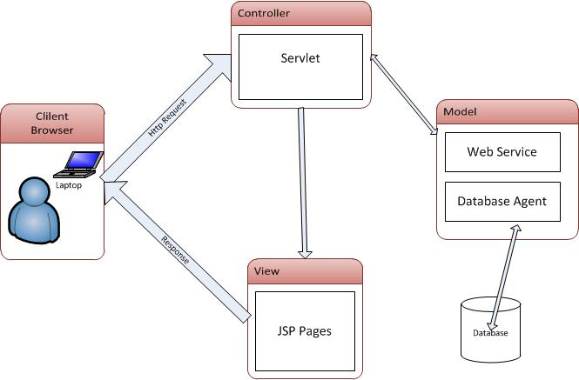

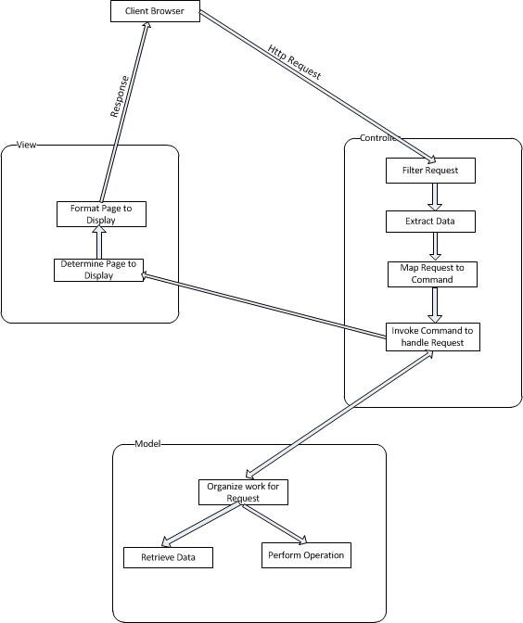

Package Diagram

Deployment Diagram

Interaction Diagram