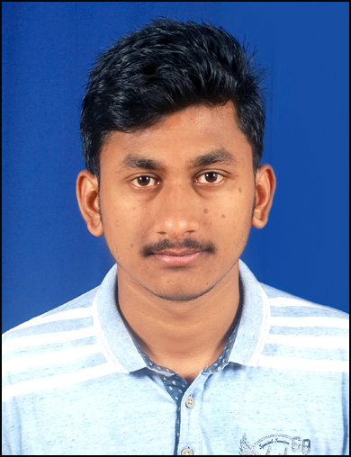**CHINAM DIPAK PATRA**

**Communication Address:**

Palash Palli, Aerodrome Area,Bhubaneswar-751020

**Email Id:**chinamdipakp@gmail.com

**Mob-No:**8093859409, 6370052454

**Career Objective:**

To become a master in Web-Development with working under a professional group to enhance my knowledge and optimum utilize my skill to ensure effective value addition to the organization.To excel my career by working sincerely and didactically. To work for the benefits of the organization as well as for my core competencies.

|  |  |  |  |  |
| --- | --- | --- | --- | --- |
| **Qualification** | **Year of**  **passing** | **School/College** | **Board/University** | **Grade** |
| Xth | 2013 | Govt. High School, Unit-I  Bhubaneswar | Board of  Secondary  Education,Odisha | First Division |
| XIIth  (science) | 2015 | Maharishi College of Natural Law,  Bhubaneswar | CHSE,Odisha | First Division |
| Graduation  (science) | 2018 | D. R. Nayapalli College, Bhubaneswar | Utkal University | Second Division |

**Educational Qualification****:**

**Professional Qualification:**

* Web-Development from Water flame Institute cleared

**Job Responsibilities:**

* Working with HTML, CSS, Bootstrap .
* JavaScript , Responsive.
* PHP, MySQL, WordPress, Ajax etc.

**Computer & Other Qualification:**

* PGDCA from NICET Bhubaneswar

**Personal Details:**

* **Fathers Name**- Chinam Badri Patra
* **Date of Birth**- 16th December1997
* **Gender**- Male
* **Marital Status**- Unmarried
* **Languages Know**- Odia,Hindi, English
* **Permanent Address**- Plot.no.610,Lane.No-11,Palash Palli,Aerodrome Area,

Pin-751020

**Declaration:**

I do here by confirm that the information mentioned here in my resume is correct and complete to the best of my knowledge and belief.

Place:

Date: Chinam Dipak Patra