**Assignment: Flipkart Login Page**

**Name:- Jogdand Abhishek Chandrasen**

**Email id:-** [**cdt.abhijogdand447@gmail.com**](mailto:cdt.abhijogdand447@gmail.com)

**Mobno:- 9325496292**

**o/p:-**

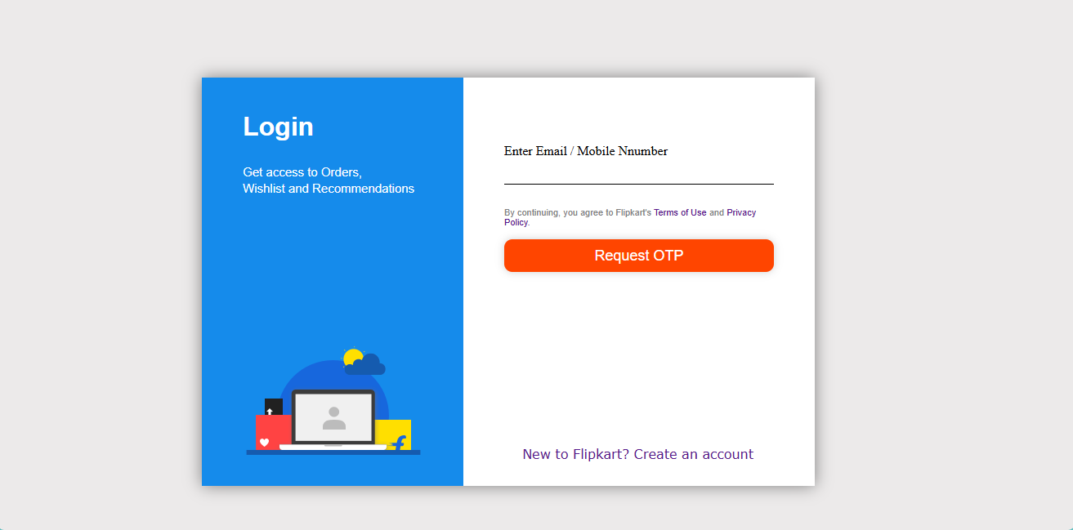

**Code:-**

<!DOCTYPE html>

<html lang="en">

<head>

<meta charset="UTF-8">

<meta name="viewport" content="width=device-width, initial-scale=1.0">

<title>Flipkart Login</title>

<style>

* {

padding: 0px;

margin: 0px;

box-sizing: border-box;

}

body {

background-color: rgb(236, 234, 234);

}

.parent {

height: 500px;

width: 750px;

margin: 100px 250px;

text-align: center;

border: 0px solid transparent;

box-shadow: 0px 0px 20px gray;

position: absolute;

text-align: justify;

}

.container {

height: 500px;

position: relative;

display:inline-block;

}

#child1 {

width: 320px;

position: absolute;

top: 0px;

left: 0px;

display: inline-block;

background-color: rgb(21 139 235);

padding: 50px;

}

#child2 {

top: 0px;

right: 0px;

position: absolute;

width: 430px;

padding: 50px;

}

.img {

/* top: 170px; */

bottom: 30px;

align-content: center;

position: absolute;

padding: 0px;

/* background-image: url(" https://static-assets-web.flixcart.com/fk-p-linchpin-web/fk-cp-zion/img/login_img_c4a81e.png"); */

}

#child2 {

background-color: white;

}

.text {

color: white;

line-height: 20px;

text-align: justify;

text-align: left;

font-family: Arial, Helvetica, sans-serif;

}

h4 {

font-size: 15px;

color: gray;

/* text-shadow: 0px 0px 0px; */

font-weight: lighter;

}

.innputuser {

position: relative;

margin-bottom: 30px;

}

#inputuser1 {

padding: 30px auto;

width: 100%;

color: black;

font-size: inherit;

background-color: white;

border: none;

top: 50px;

line-height: 30px;

outline: none;

position: relative;

border-bottom: 1px solid;

}

.lable1{

font-weight: 400px;

position: relative;

left: 0px;

top: 0px;

pointer-events: none;

}

.terms {

position: relative;

top: 60px;

color: gray;

font-family: Arial, Helvetica, sans-serif;

/* text-decoration-line: none; */

font-size: 11px;

text-align: justify;

text-align: left;

text-decoration: none;

}

#otpbtn {

width: 100%;

position: relative;

top: 60px;

margin-top: 15px;

padding: 10px 20px;

border-radius: 10px;

font-weight: 500px;

line-height: 20px;

border: none;

color: white;

font-size: 18px;

cursor: pointer;

box-shadow: 0px 0px 10px rgba(27, 27, 27,0.2);

background-color: orangered;

}

.newac {

position: absolute;

bottom: 15px;

text-align: center;

padding: 15px;

right: 60px;

font-family: Verdana, Geneva, Tahoma, sans-serif;

/* text-decoration: none;

text-decoration-line: none; */

}

a{

text-decoration: none;

}

</style>

</head>

<body>

<div class="parent">

<div class="container" id="child1">

<h1 class="text"> Login </h1>

<br>

<br>

<h4 class="text">Get access to Orders,<br>Wishlist and Recommendations</h4>

<div class="img">

<img src=" https://static-assets-web.flixcart.com/fk-p-linchpin-web/fk-cp-zion/img/login_img_c4a81e.png"

alt="">

</div>

</div>

<div class="container" id="child2">

<form action="">

<div class="inputuser">

<input type="text" placeholder="" id="inputuser1" required>

<label class="lable1" for="">Enter Email / Mobile Nnumber</label>

</div>

<div class="terms">

By continuing, you agree to Flipkart's <a href="#">Terms of Use</a> and <a href="#">Privacy

Policy.</a>

</div>

<input type="button" value="Request OTP" id="otpbtn">

<div class="newac">

<a href="#">New to Flipkart? Create an account</a>

</div>

</div>

</form>

</div>

</body>

</html>