**Web Programming Fundamentals:   
Problem Solving Activity – Problem 1 of 3**

Christina Thorpe  
February 5, 2014

**PROBLEM #1: A Cat, a Parrot and a Bag of Seed**

In this scenario, a man is trying to deliver himself, along with a cat, a parrot and a bag of seed across the river in a boat. The problem is that only himself and one other item can fit in the boat. The man is fearful that if he leaves the animals behind while taking the seed across, the cat would eat the parrot; alternatively, if he leaves the parrot and the seed behind, the seed would be eaten. How can the man get himself and all three items to the other side without leaving the wrong items together?

INSIGHT: The gentleman seems quite unprepared for this seemingly short journey. Additionally, he must have an extremely tiny boat due to not being able to fit these rather small items into his vessel.

OVERALL GOAL: The overall goal of this dilemma is for the gentleman to successfully transport himself, along with all three items, to the other side of the river, in the most efficient manner possible.

CONSTRAINTS: The constraints of this dilemma are that perishable items all need to cross this river in a very small boat.

SUB-GOAL #1: The first goal is to transport the parrot unscathed.

SUB-GOAL #2: The second goal is to transport the seed uneaten.

SUB-GOAL #3: The third goal is to find the most efficient way to transport the items.

POSSIBLE SOLUTION #1: Walk items across a bridge instead of boating them.

POSSIBLE SOLUTION #2: Place animals in stacked animal crates on the boat.

POSSIBLE SOLUTION #3: Place *only* the cat INSIDE of the boat; the seed and bird would be transport creatively and separately OUTSIDE of the boat structure.

RESULT #1: The first solution could possibly meet the overall goals. It may not work in all cases, as there may not be a bridge or perhaps it’s too far away to feasibly cross.

RESULT #2: The second solution could possibly meet the overall goals. The man would place the parrot in its cage; the cat in its kennel and stack the carriers in the boat; and either the seed would be stacked on top of the carriers *OR* placed inside the kennel with the cat, who is not interested in the seed. This may not work in all cases; for example, animal carriers may not be accessible or possibly the stacked carriers may prove to be too cumbersome.

RESULT #3: The final solution could result in meeting the overall goals and should work in ALL possible cases due the absence of any extra aids, such as a bridge or animal crates.

BEST SOLUTION: Since only one item can fit in the boat with the man, the cat could ride in the boat, next to the man; the seed could be tied to hang outside of the boat; and the parrot would simply perch on the man’s shoulder, for one efficient ride across the river.

TESTING: See illustrated diagram below of the best solution.

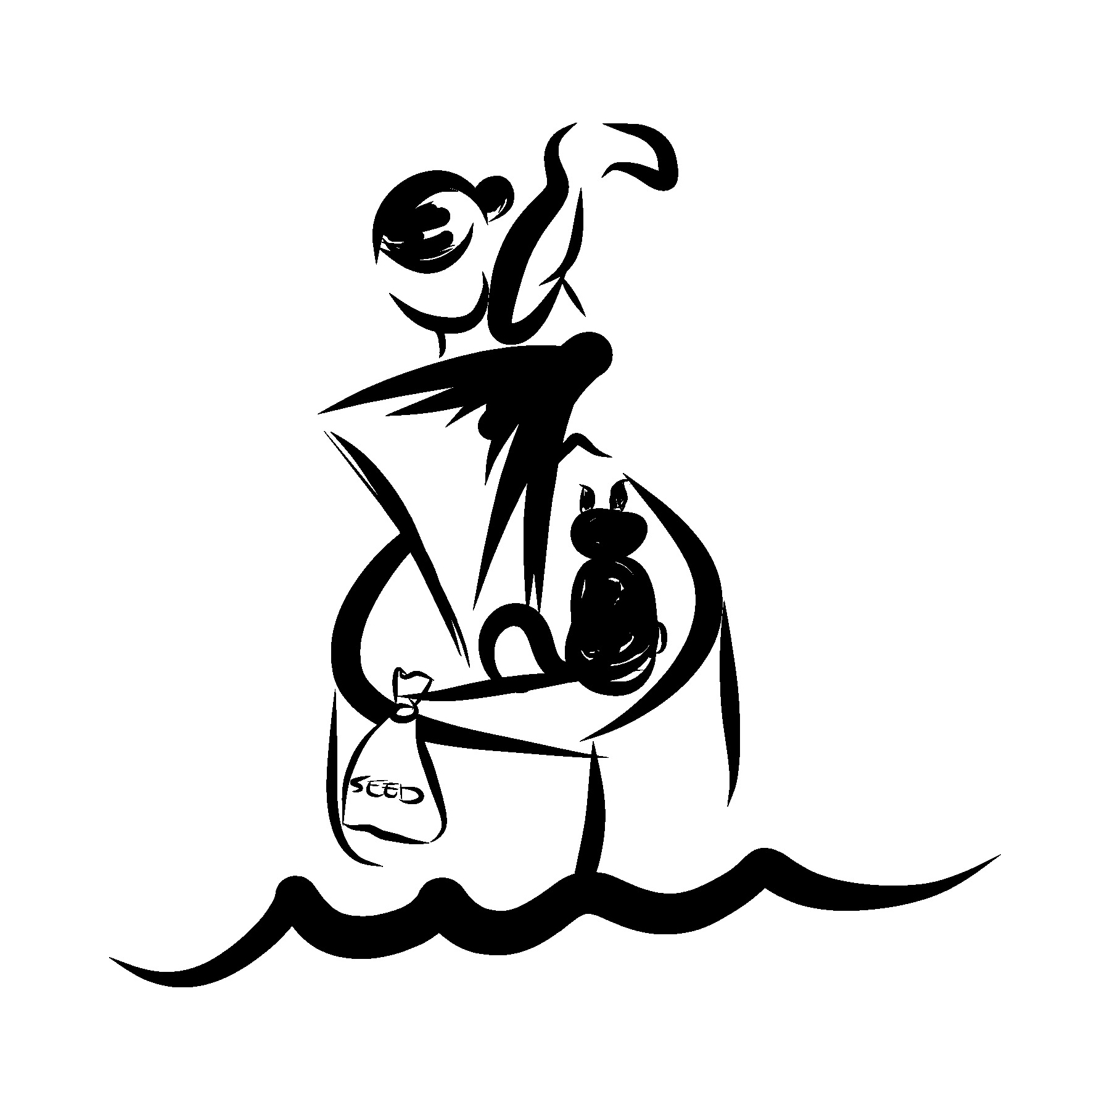

**Web Programming Fundamentals:   
Problem Solving Activity – Problem 2 of 3**

Christina Thorpe  
February 5, 2014

**PROBLEM #2: Socks in the Dark**

There are 10 pairs of socks in a drawer: 5 pairs are black, 3 pairs are brown and 2 pairs are white. Without the lights on, a minimum of one matching pair per color must be chosen. What is the minimum amount of socks needed to guarantee the said selection?

INSIGHT: Are the socks in the drawer loose or are they bound as pairs? There will be alternate solutions, depending on this variable.

OVERALL GOAL: The overall goal is to retrieve the minimal number of socks while retrieving at least one pair each of the 3 colors, all while in the dark.

CONSTRAINTS: The constraints are selection process being in darkness, minimal number of socks and not having the ability to check selection after the fact.

SUB-GOAL #1: Remove at least one matching pair.

SUB-GOAL #2: Remove matching pairs of each color.

POSSIBLE SOLUTION #1: If socks are loose in the drawer, select 4 socks (2 pairs) to obtain at least one matching pair.

POSSIBLE SOLUTION #2: If socks are bound in the drawer, select 5 pair to obtain matching pairs of ALL 3 colors.

RESULT #1: The first solution guarantees the desired end result of goal #1. With there only being 3 different colors, and with 4 socks being selected in the dark, there should be at least one duplicate colored sock, rendering the desired result of at least one matching pair.

RESULT #2: The second solution should render the desired result of goal #2 by selecting half of the socks (5 pair) to obtain one matching pair each of all 3 colors.

BEST SOLUTION: The second goal should try to be attained when facing this challenge, knowing that, at the very least, the first goal is guaranteed to be met, but chances of meeting goal #2 will certainly be left to probability.

TESTING: (drawings/diagrams)

**Web Programming Fundamentals:   
Problem Solving Activity – Problem 3 of 3**

Christina Thorpe  
February 5, 2014

**PROBLEM #3: Predicting Fingers**

A little girl counts on her fingers of her left hand to 10, with 1 beginning on her thumb, 2 is her pointer finger, 3 is her middle finger, 4 is her ring finger, 5 is her pinky. Then continues to 6 reversing back to her ring finger, 7 is her middle finger, 8 is her pointer finger, 9 is her thumb, then reversing again with 10 at her pointer finger. What finger will she stop at when counting to 100 and 1,000?

INSIGHT: This method of counting should form a pattern, which should be detectable when counting to the first 100. Hence, the finger stopped on will be established and replicated to give the solution for counting to 1,000.

OVERALL GOAL: The overall goal is to establish which finger the little girl stops counting at for the numbers 10, 100 and 1,000.

CONSTRAINTS: The constraints on this problem are that the odd counting method must be upheld and only the numbers 10, 100 and 1,000 must be predicted which fingers it is assigned using this counting method.

SUB-GOAL #1: Predict the correct finger for number 100.

SUB-GOAL #2: Predict the correct finger for number 1,000.

POSSIBLE SOLUTION #1: Count on fingers all the way up to 1,000 to find out which finger counting stops at.

POSSIBLE SOLUTION #2: Draw a diagram to establish a pattern to figure out which finger is stopped on when counting to 1,000.

RESULT #1: The first solution meets the goal and does work for all three cases of 10, 100 and 1,000 by counting manually on fingers, but proves to be difficult to maintain accuracy and quite time consuming to reach the problem’s solution.

RESULT #2: The second solution also meets the goal, but in a much more economical, accurate fashion.

BEST SOLUTION: The best solution for this problem of predicting fingers is the second solution, in which a diagram was illustrated to first determine the pattern of fingers from 1-100. This established an additional pattern that predicted the end finger for every 100, which established that the final finger at 1,000 is the pointer finger.

TESTING: See illustrated diagram below of the best solution.

