Seng350 Project

Use Case Report

Author: Author

Revision: 0.2

|  |  |
| --- | --- |
| Group 4 |  |
| Xingyun Chen (v00855160), Zhangze Chen (v00019174), Jue Fu(v00863998), Xiaobin Yang (v00869226) | Date: September 30, 2018 |

**Revision History**

|  |  |  |  |
| --- | --- | --- | --- |
| **Revision** | **Date** | **Reason For Changes** | **Author** |
| 0.1 | <date 1> | <draft> | <Author name> |
| 0.2 | <date 2> | <release> | <Author name> |
|  |  |  |  |

**Table of Content**

YMicrosoft Word users please click here and press F9 to create Table of Contents.

OpenOffice.org users please remove this text and select Insert Table of Content from menu.

**Table of Figure**

YMicrosoft Word users please click here and press F9 to create Table of Contents.

OpenOffice.org users please remove this text and select Insert Table of Content from menu.

# 

# Introduction

## Purpose

This document provides an overview of use case view.

## Scope

Our team is developing a web-based simulation and operation game - “rural life”, where players have their own farms to operate. The main purpose of this application for players is to entertain in their spare time and interact with their friends through the social system in the game.

In our application, players start their game with some initial money. By planting seeds and collecting products, players can sell their products to gain more money to but new seeds in the market. The leader board will rank players by their total accumulative assets..

## Overview

This documents introduces nine use cases and corresponding activity diagrams for each use case, including “sign up”,“log in”, “log off” ,”purchase seeds”, “sell products”,”plant”,”harvest”,”view leader board”,and “edit leader board”.

* UseCase Sign up: This use case manages the process of registering a new game account.
* UseCase Log in: This use case manages the process of log in.
* UseCase Log out: This use case manages the process of log out.
* UseCase Purchase seeds: This use case will demonstrate how players purchase various types of seeds in the market.
* UseCase Sell products: This use case will demonstrate how players gain funds by selling their products in the market.
* UseCase Plant: This use case will demonstrate how players plant seeds on the selected field.
* UseCase Harvest: This use case will demonstrate how players harvest their products when the crops are ready.
* UseCase View leader board: This use case will illustrate how players view their ranking results on the leader board.
* UseCase Edit leader board: this is use case will illustrate how administrators renew the ranking results every rank interval.

# Model

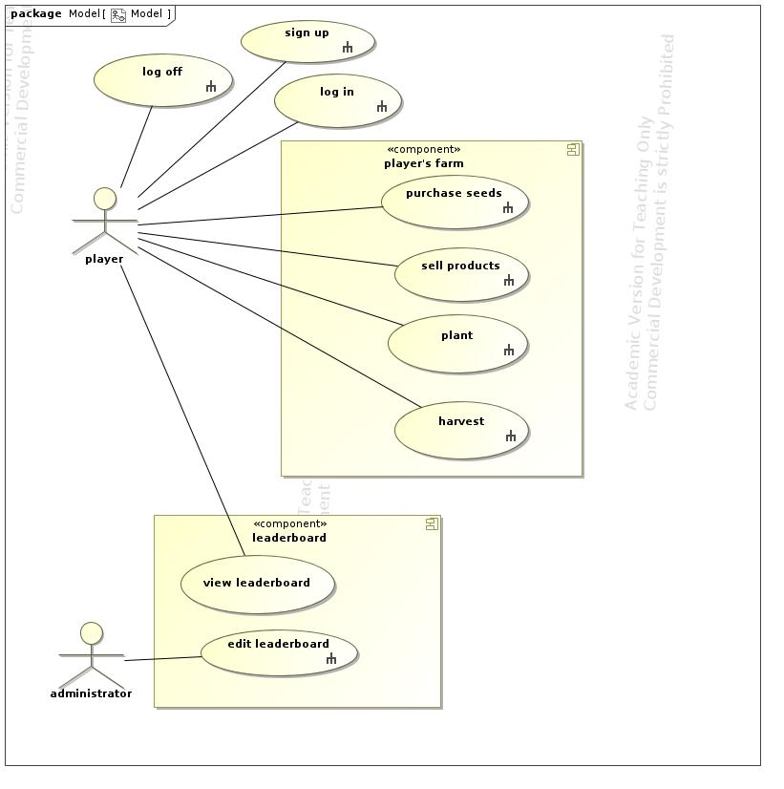

1. Model

## Actor administrator

* administrator performs edit leaderboard

## Actor player

* player performs harvest
* player performs log in
* player performs log off
* player performs plant
* player performs purchase seeds
* player performs sell products
* player performs sign up
* player performs view leaderboard

## UseCase edit leaderboard

* edit leaderboard is performed by administrator

### Scenarios

#### Basic Flow

1. clear ranks

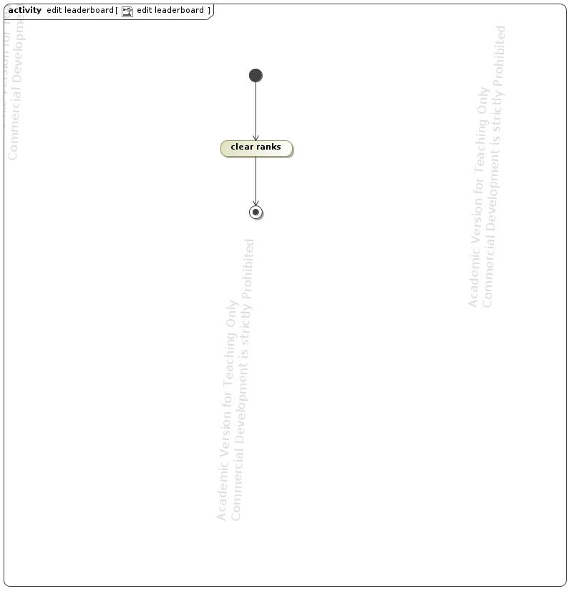

1. edit leaderboard

## UseCase harvest

This use case manages the process of harvesting grown-up seeds. Players can harvest their products when ready.

Preconditions: products are ready for cropping;

Postconditions: products added to the storage; the field becomes empty and available for next round of planting;

* harvest is performed by player

### Scenarios

#### Basic Flow

1. click harvest all

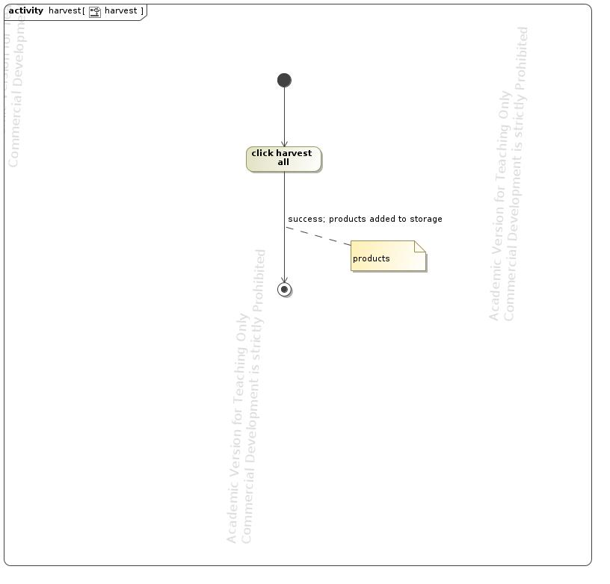

1. harvest

## UseCase log in

This use case manages the process of login.

Preconditions: players have an valid username; players enter the correct password;

Postconditions: players log in to the game;

* log in is performed by player

### Scenarios

#### Basic Flow

1. enter username

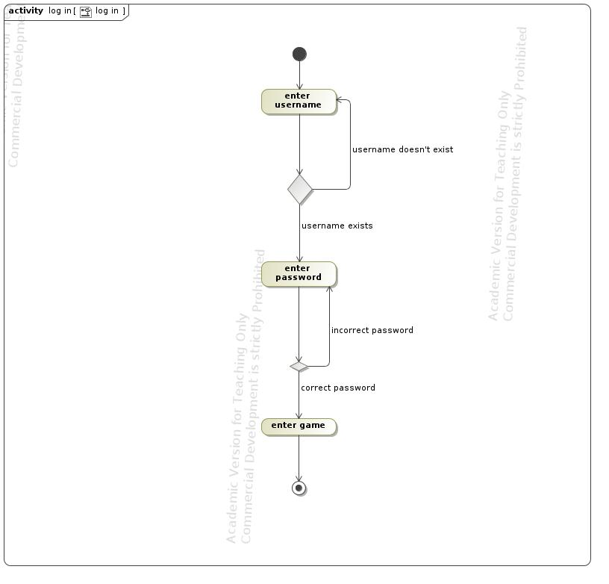

1. log in

## UseCase log off

this use case manages the process of log off.

* log off is performed by player

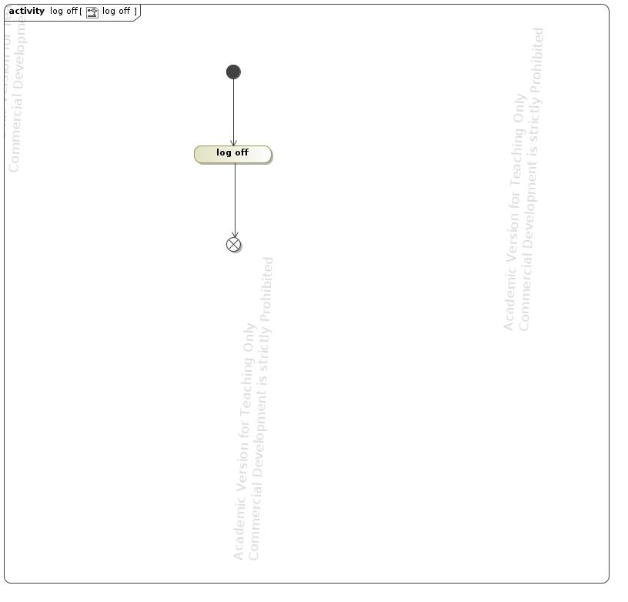

1. log off

## UseCase plant

This use case manages the plating process. Players can plant seeds on the selected field.

Preconditions: the selected field is empty; the seed to plant is in the storage;

Postcondition: seeds panted; players will receive products after the seeds grow up.

* plant is performed by player

### Scenarios

#### Basic Flow

1. select field to plant

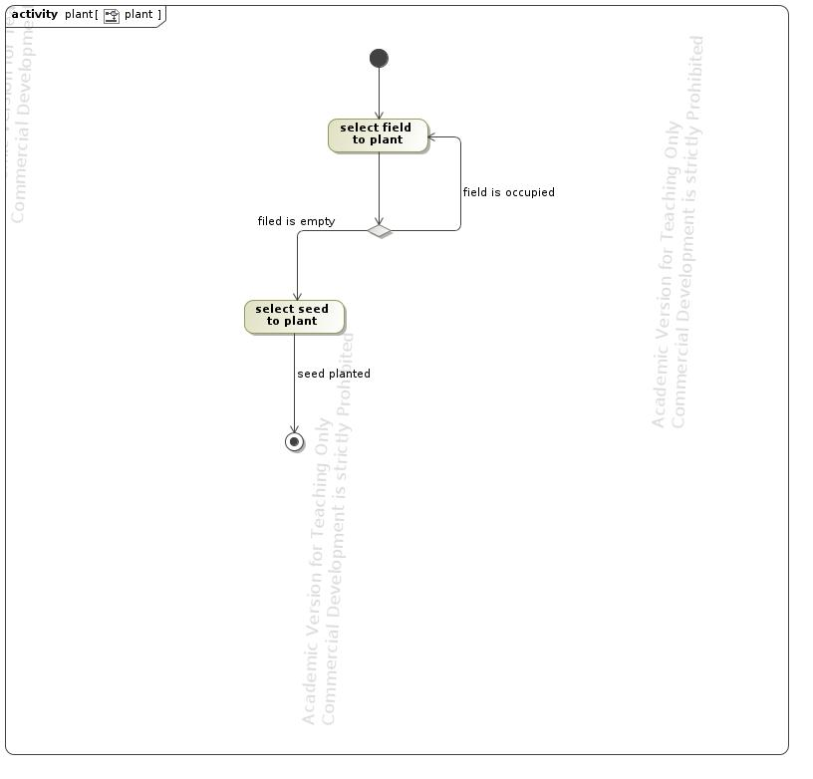

1. plant

## UseCase purchase seeds

This use case manages the purchasing process. Players can purchase seeds only at the market managed by the system.

Preconditions: players have enough money; players reach required game level;

Postconditions: acquire new seeds; decrement money;

* purchase seeds is performed by player

### Scenarios

#### Basic Flow

1. select seed type and amount

2. confirm purchase

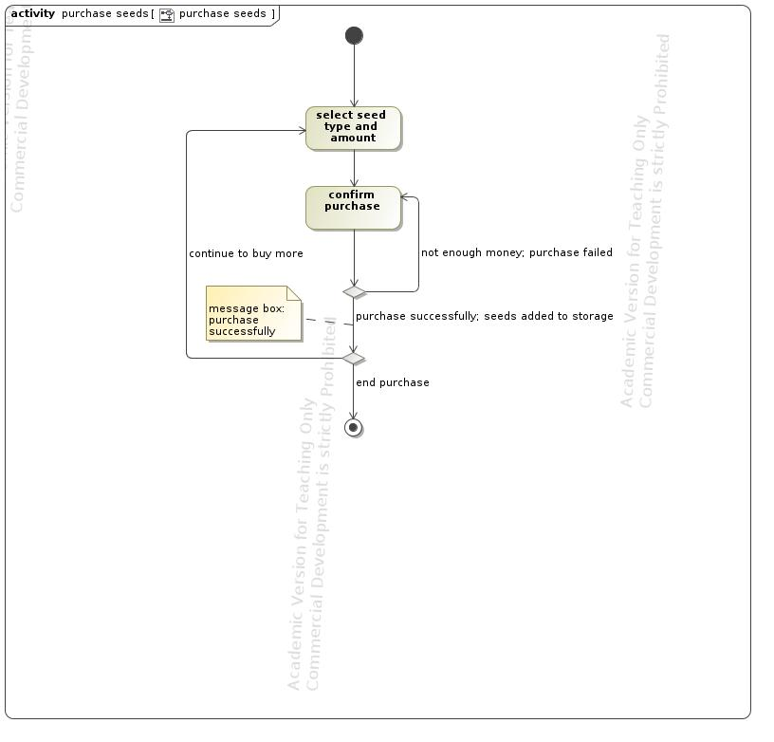

1. purchase seeds

## UseCase sell products

This use case manages the process of selling harvested products. Players can sell their products to the market.

Preconditions: players have enough amount of products to sell;

Postconditions: money is increased; the amount of products is decreased;

* sell products is performed by player

### Scenarios

#### Basic Flow

1. sell all

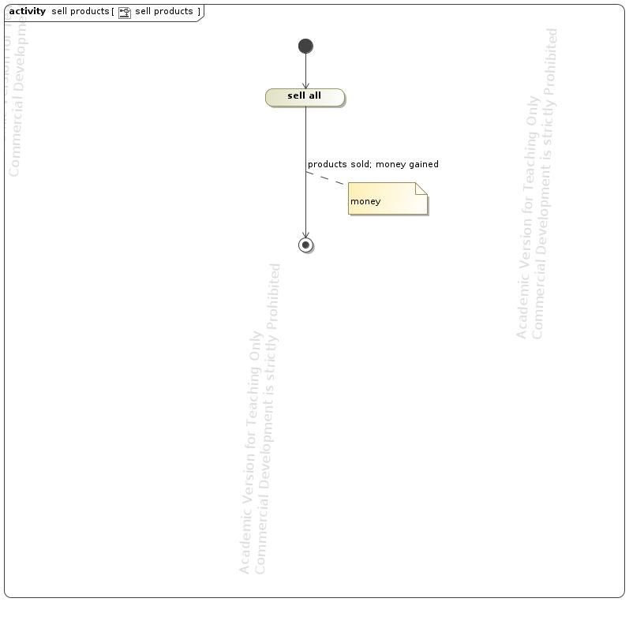

1. sell products

## UseCase sign up

This use case manages the process of registering a new game account.

Preconditions: none;

Postconditions: a new account created;

* sign up is performed by player

### Scenarios

#### Basic Flow

1. enter username

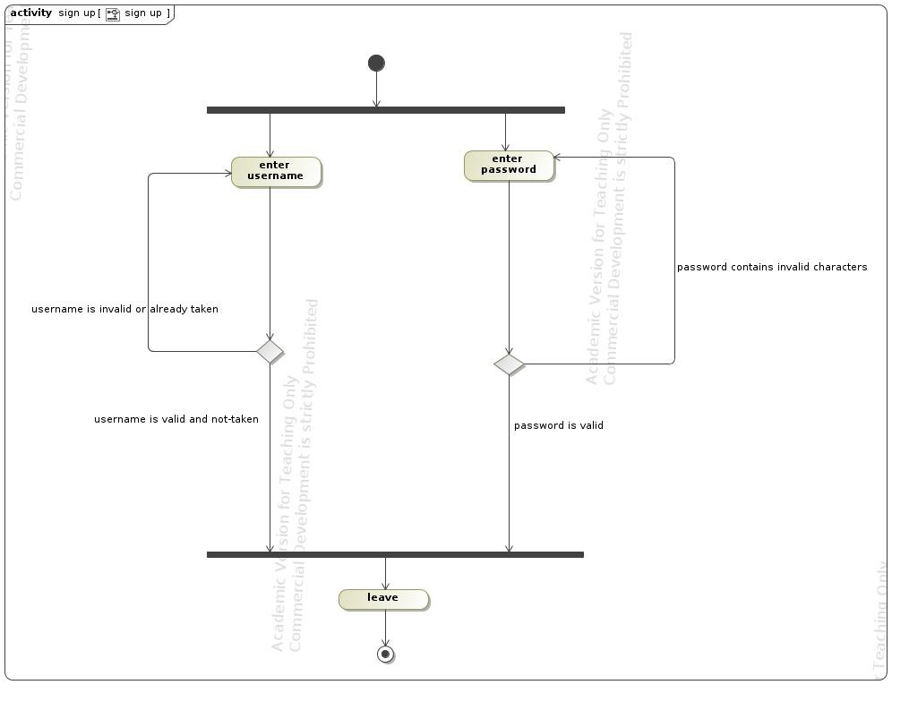

1. sign up

## UseCase view leaderboard

* view leaderboard is performed by player
* **NOTE: players can only view the leader board on a specific website, so there is no activity diagram for this use case**