User Manual

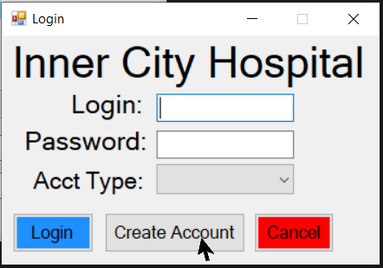

New Employees need to create an account.

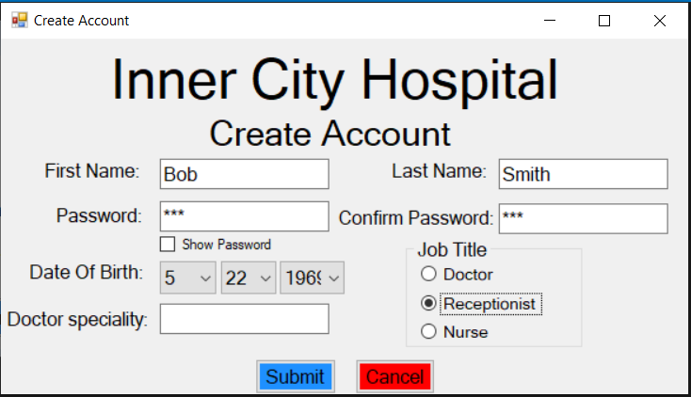

Create your account and click submit when all the information that is needed is filled out. If all the information is filled out correctly a message box will pop up and give you your username with the first initial of your first and last name along with 4 random numbers. This is your username to login into the system.

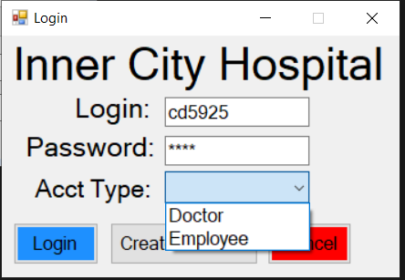

To login into the system enter in your username, password, and select your account type. If you are a nurse or receptionist your account type is Employee. If you’re a doctor your account type is Doctor. Click Login once all the information is entered and you’ll login if it is correct.

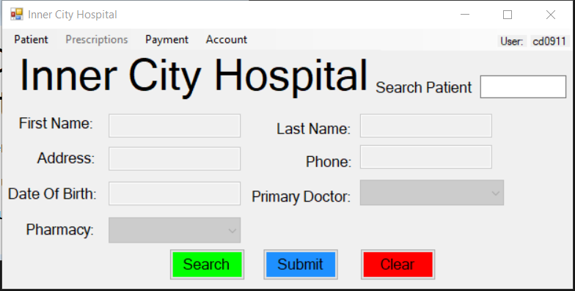

This is the Home Screen where the user can Search for a Patient, Edit Patient Record, Add a Patient, Add a Patient Record, Simulate a Payment (which only employees can do), and Order Prescriptions (which doctors can only do).

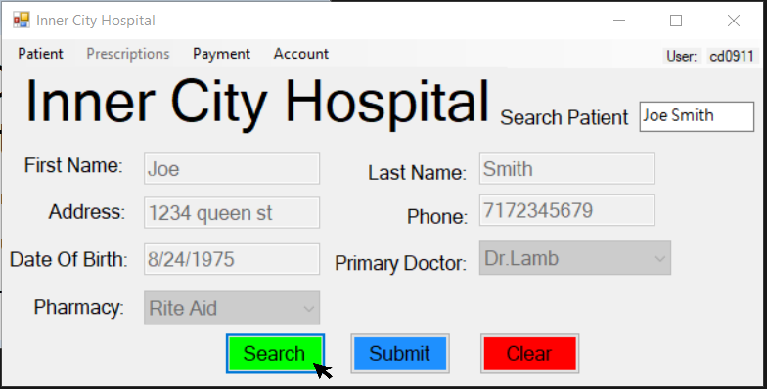

To search for a patient type in their first and last name in the search textbox, located in the top right. Then click Search to view their information.

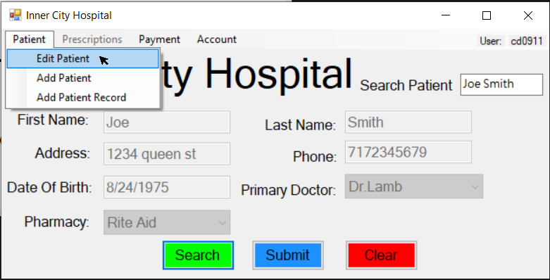

To edit a patient’s record, the user will first have to search for the patient. Then they will click on Patient and then click on Edit Patient.

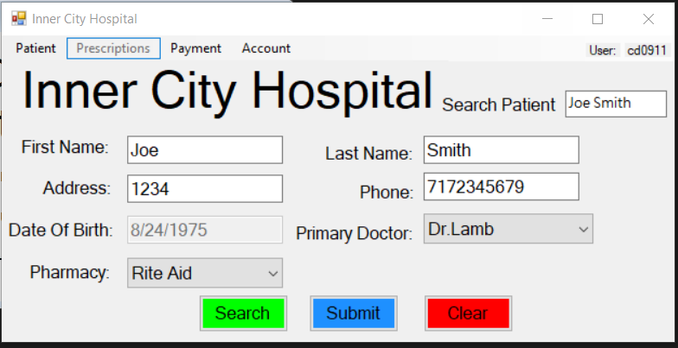

When done editing the patient’s record click on Submit to update the database.

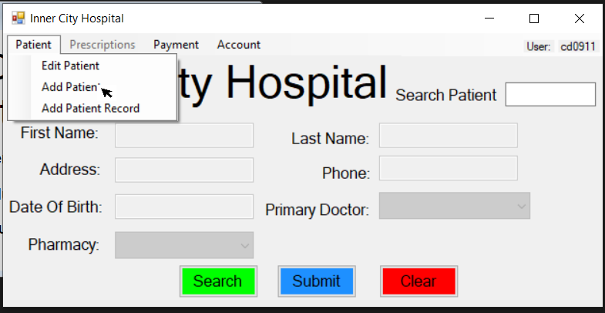

To add a patient, click on Patient, then click on Add Patient.

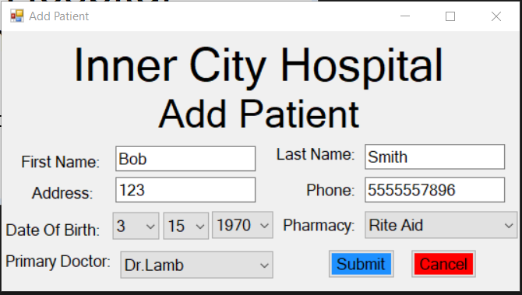

For adding a patient, fill in all the information, then click on Submit to add the patient.

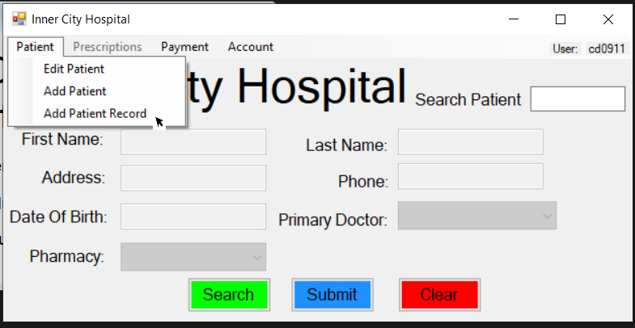

To add a patient record, click on Patient, then click on Add Patient Record

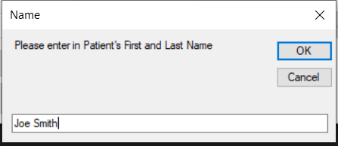

Once Add Patient Record is clicked an input box will pop up. Enter in the patients name and click OK.

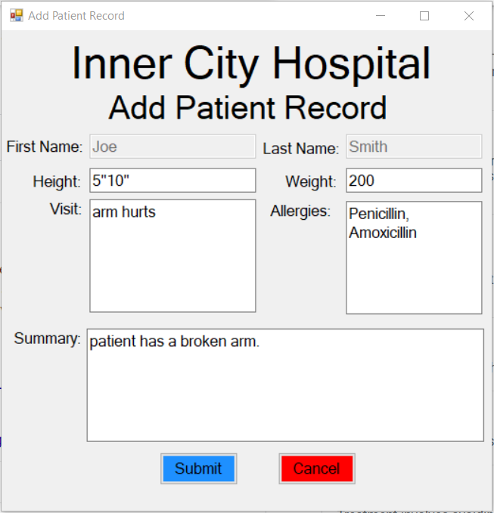

Enter in the patient records information. If they do not have any allergies, the user can leave it blank. When listing in the allergies try to add a comma between each allergy. At the end of the visit, fill in the summary and click Submit.

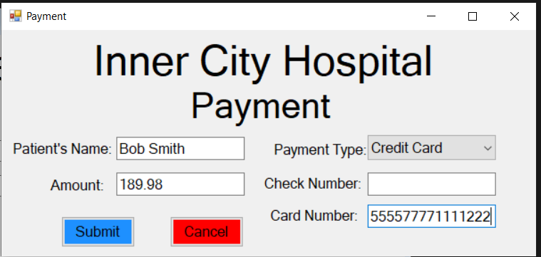

To simulate a payment, click on Payment on the Home Screen (Only Employees can access the payment screen). This form will popup. Fill in the information. The patient has a choice of paying with a check or a credit card. Click Submit when all the information is filled out.

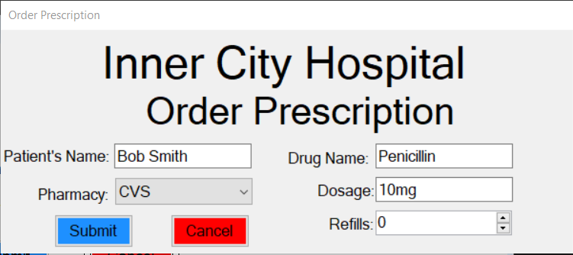

To order a prescription, on the Home Screen click on Prescriptions (Only doctors can order prescriptions). Fill in all the information, select the pharmacy where the patient is picking up the prescriptions. Click Submit when all the information is filled out.

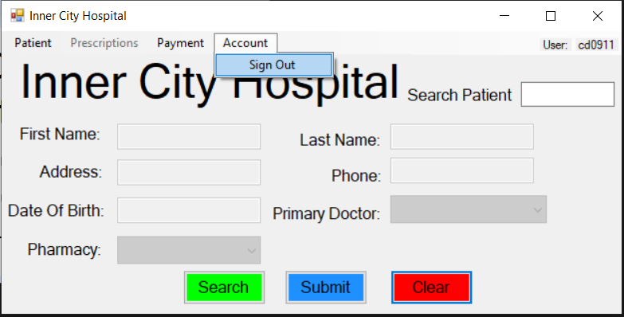

To sign out of the account, click Account and then click Sign Out. The user will be brought back to the Login Screen.