

Portfolio



April 30, 2020

COle’s Soccer corner

Cole Dumbauld

Table of Contents

**CEO’s Home Page** 2

**Company’s Homepage** 4

**Schedule** 6

**Inventory** 8

**Register (JavaScript)** 10

**Order Form** 16

**Pizza Shop** 24

**Register (C#)** 28

**Employee Table** 34

**Inventory (C#)** 35

**Blog** 37

**Add Inventory** 39

**Kitty App** 42

**Tip Calculator** 43

**Browser** 44

**Stopwatch** 45

**Painting** 46

# **CEO’s Home Page**

**Date:** 01/28/2020

**Number of Hours:** 1 hour

**Output:**

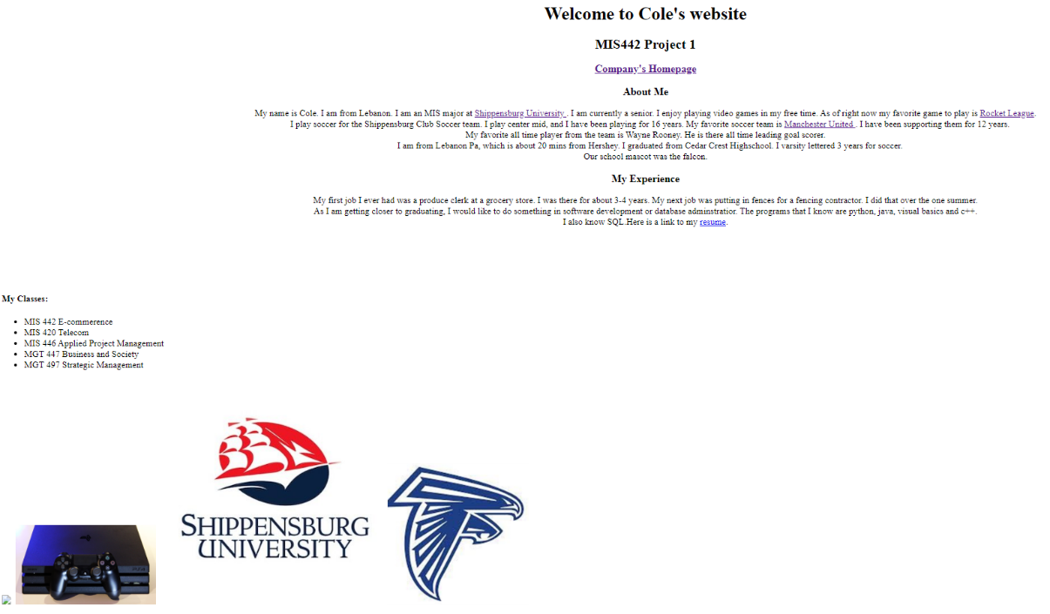

**Source Code:**

<HTML>

<head>

<title> **My Website** </title>

</head>

<body>

<center><h1> **Welcome to Cole's website** </h1></center>

<center><h2> **MIS442 Project 1**</h2>

<h3><a href = **"company.html"**> **Company's Homepage**</a><h3>

<h3> **About Me** </h3>

**My name is Cole. I am from Lebanon. I am an MIS major at** <a href =**"**http://www.ship.edu**"**>**Shippensburg University** </a>**. I am currently a senior.**

**I enjoy playing video games in my free time. As of right now my favorite game to play is** <a href = **"**https://www.rocketleague.com/**"**>**Rocket League**</a>**.**<br>

*&nbsp;&nbsp;&nbsp;* **I play soccer for the Shippensburg Club Soccer team. I play center mid, and I have been playing for 16 years. My favorite soccer team is**

<a href =**"**https://www.manutd.com/**"**>**Manchester United** </a>**. I have been supporting them for 12 years.** <br>**My favorite all time player from the team is Wayne Rooney. He is there all time leading goal scorer.**<br>

*&nbsp;&nbsp;&nbsp;* **I am from Lebanon Pa, which is about 20 mins from Hershey. I graduated from Cedar Crest Highschool. I varsity lettered 3 years for soccer.**<Br>

**Our school mascot was the falcon.** </center>

<center><h3> **My Experience** </h3>

**My first job I ever had was a produce clerk at a grocery store. I was there for about 3-4 years. My next job was putting in fences for a fencing contractor. I did that over the one summer.**<br>

**As I am getting closer to graduating, I would like to do something in software development or database adminstratior. The programs that I know are python, java, visual basics and c++.**<br>

**I also know SQL.Here is a link to my** <a href = **"resume2.pdf"**>**resume**</a>**.**</center>

<br><br><br><br><br>

<h4> **My Classes:** </h4>

<ul>

<li> **MIS 442 E-commerence** </li>

<li> **MIS 420 Telecom**</li>

<li> **MIS 446 Applied Project Management**</li>

<li> **MGT 447 Business and Society**</li>

<li> **MGT 497 Strategic Management**</li>

</ul>

<img src=**"manchester united2.png"**><img>

<img src=**"ps4.jpg"**;height = **"250"** ; width = **"250"**><img>

<img src =**"**https://d28htnjz2elwuj.cloudfront.net/wp-content/uploads/2019/05/07160014/Shippensburg-University-of-Pennslyvania-400x400.jpg**"**><img>

<img src =**"**https://static.hudl.com/users/prod/2535416_b6fadb0daa8f4e699f93cc4e66676f38.jpg**"**; height =**"250"**; width=**"250"**;><img>

</body>

</HTML>

**Purpose:** The purpose of the CEO’s Home page is to tell the user a bit about the CEO.

**What I learned:** While creating this web page I learned a lot of new HTML tags. I learned how to do a bulleted list, and a numbered list as well. I learned that the img src could be a website of a picture instead of a file of the picture. I also learned how to link webpages in HTML.

# **Company’s Homepage**

**Date:** 02/04/2020

**Number of Hours:** 1 hour 30 minutes

**Output:**

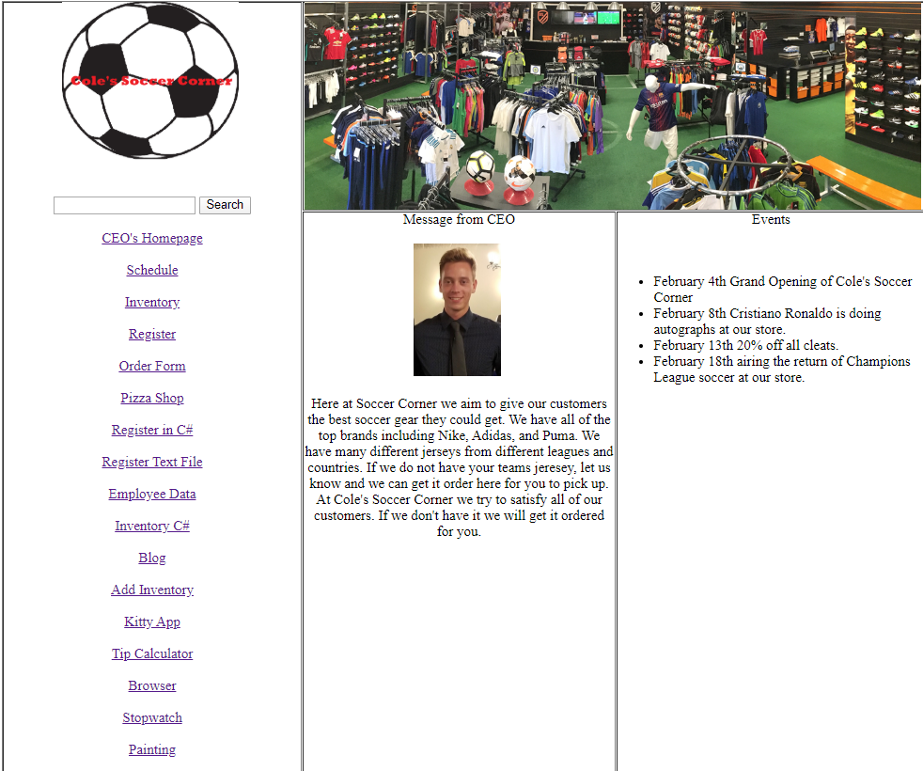

**Source Code:**

<html>

<head>

<!-- Global site tag (gtag.js) - Google Analytics -->

<script async src=**"**https://www.googletagmanager.com/gtag/js?id=UA-163511325-1**"**></script>

<script>

window.dataLayer **=** window.dataLayer **||** **[];**

***function*** gtag**(){**dataLayer.push**(**arguments**);}**

gtag**(**'js'**,** ***new*** Date**());**

gtag**(**'config'**,** 'UA-163511325-1'**);**

</script>

</head>

<body>

<form name = **"form1"** method = **"post"** action = **"newinventory.aspx"**>

<center><table border=1; height = 950; width = 1050></center>

<tr>

<td rowspan = 2; width =34%; valign=**"top"**>

<center><img src = **"soccercorner.png"**;height = **"200"**; width = **"200"**><img></center><br><br>

<center>

<input type = **"textbox"** name = **"txtSearch"** size = 20>

<input type = **"submit"** name = **"btnSearch"** value = **"Search"**><br><br>

<a href = **"first.html"**> **CEO's Homepage** </a><br><br>

<a href = **"table.html"**> **Schedule** </a><br><br>

<a href = **"Inventory1.html"**> **Inventory** </a><br><br>

<a href = **"register1.html"**> **Register** </a><br><br>

<a href = **"orderForm.html"**> **Order Form**</a><br><br>

<a href = **"shopPizza.html"**> **Pizza Shop**</a><br><br>

<a href = **"registerC.html"**> **Register in C#**</a><br><br>

<a href = **"registerFile.txt"**> **Register Text File** </a><br><br>

<a href = **"employee.aspx"**> **Employee Data**</a><br><br>

<a href = **"newinventory.aspx"**> **Inventory C#**</a><br><br>

<a href = **"blog.html"**> **Blog**</a><br><br>

<a href = **"addInventory.html"**> **Add Inventory**</a><br><br>

<a href = **"kittyapp.pdf"**> **Kitty App**</a><br><br>

<a href = **"tipCalculator.pdf"**> **Tip Calculator**</a><br><br>

<a href = **"browser.pdf"**> **Browser**</a><br><br>

<a href = **"stopwatch.pdf"**> **Stopwatch**</a><br><br>

<a href = **"painting.pdf"**> **Painting**</a><br><br>

</center>

</td>

<td colspan = 2; height = 20%>

<img src = **"soccerstore.jpg"**; height = 70%><img>

</td>

</tr>

<tr>

<td width =34%; valign =**"top"**>

<center>**Message from CEO**<br><br>

<img src = **"me.jpg"**; height =**"150"**;width=**"150"**><img><br><br>

**Here at Soccer Corner we aim to give our customers the best soccer gear they could get. We have all of the top brands including Nike, Adidas,**

**and Puma. We have many different jerseys from different leagues and countries. If we do not have your teams jeresey, let us know and we can get it order here**

**for you to pick up. At Cole's Soccer Corner we try to satisfy all of our customers. If we don't have it we will get it ordered for you.**</center>

</td>

<td width = 34%; valign=**"top"**>

<center> **Events** </center><br><br>

<ul>

<li> **February 4th Grand Opening of Cole's Soccer Corner**</li>

<li> **February 8th Cristiano Ronaldo is doing autographs at our store.**</li>

<li> **February 13th 20% off all cleats.**</li>

<li> **February 18th airing the return of Champions League soccer at our store.**</li>

</ul>

</td>

</tr>

</table>

</form>

</body>

</html>

**Purpose:** The purpose of the home page is to have links to all of the other pages on our sites. You can also search for a product you would like to buy. If you go to the search box and type the product you want, then click on search it will show you all the information we have on that product.

**What I learned:** I learned how to put google analytics on my homepage, so I can track how many users view my site. I learned how to use rowspan and colspan to make the web page more appealing.

# **Schedule**

**Date:** 02/04/2020

**Number of Hours:** 30 minutes

**Output:**

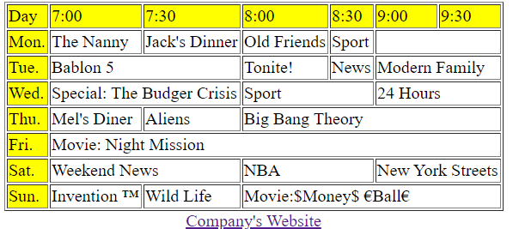

**Source Code:**

<html>

<body>

<center><table border = 1></center>

<tr bgcolor = yellow>

<td> **Day** </td>

<td> **7:00** </td>

<td> **7:30** </td>

<td> **8:00** </td>

<td> **8:30** </td>

<td> **9:00** </td>

<td> **9:30** </td>

</tr>

<tr>

<td bgcolor = yellow> **Mon.** </td>

<td> **The Nanny** </td>

<td> **Jack's Dinner**</td>

<td> **Old Friends**</td>

<td> **Sport**</td>

<td colspan = 2 ></td>

</tr>

<tr>

<td bgcolor = yellow> **Tue.**</td>

<td colspan = 2> **Bablon 5** </td>

<td> **Tonite!** </td>

<td> **News** </td>

<td colspan = 2> **Modern Family**</td>

</tr>

<tr>

<td bgcolor = yellow> **Wed.** </td>

<td colspan = 2> **Special: The Budger Crisis**</td>

<td colspan = 2> **Sport**</td>

<td colspan = 2> **24 Hours**</td>

</tr>

<tr>

<td bgcolor = yellow> **Thu.**</td>

<td> **Mel's Diner** </td>

<td> **Aliens**</td>

<td colspan = 4> **Big Bang Theory**</td>

</tr>

<tr>

<td bgcolor = yellow> **Fri.**</td>

<td colspan = 6> **Movie: Night Mission**</td>

</tr>

<tr>

<td bgcolor = yellow> **Sat.**</td>

<td colspan = 2> **Weekend News** </td>

<td colspan = 2> **NBA** </td>

<td colspan = 2> **New York Streets**</td>

</tr>

<tr>

<td bgcolor = yellow> **Sun.**</td>

<td> **Invention** *&trade;*</td>

<td> **Wild Life** </td>

<td colspan = 4> **Movie:$Money$** *&euro;***Ball***&euro;*</td>

</tr>

</table>

<center><a href =**"company.html"**> **Company's Website** </a></center>

</body>

</html>

**Purpose:** The purpose of the schedule is to display the TV schedule, and how long each program will be on for.

**What I learned:** I learned how to create tables in HTML. I learned that when webpages are created, they create tables to help format the webpage, and they just hide the borders. I never realized that is how it was done. I learned how to print the trademark sign and the euro sign in HTML.

# **Inventory**

**Date:** 02/11/2020

**Number of Hours:** 1 hour 15 minutes

**Output:**

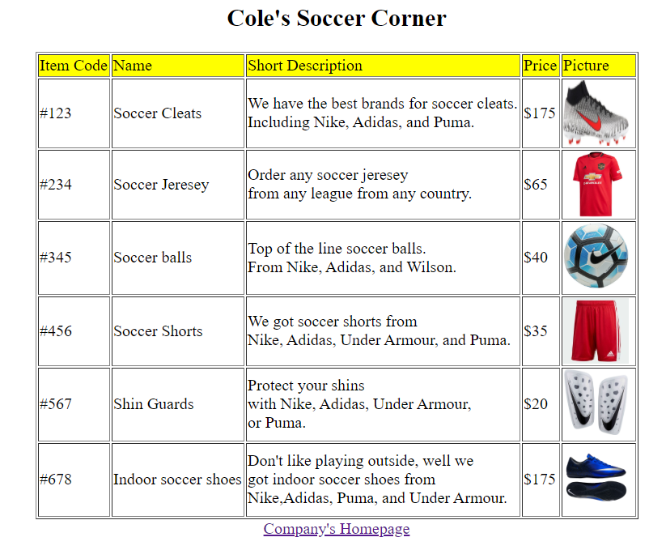

**Source Code:**

<html>

<body>

<center><h2> **Cole's Soccer Corner**<h2></center>

<center><table border =1>

<tr bgcolor = **"yellow"**>

<td> **Item Code** </td>

<td> **Name** </td>

<td> **Short Description**</td>

<td> **Price** </td>

<td> **Picture** </td>

</tr>

<tr>

<td> **#123** </td>

<td> **Soccer Cleats** </td>

<td> **We have the best brands for soccer cleats.** <br>**Including Nike, Adidas, and Puma.** </td>

<td> **$175** </td>

<td><img src = **"cleats.jpg"**; height = **"65"**; width = **"65"**;><img></td>

</tr>

<tr>

<td> **#234** </td>

<td> **Soccer Jeresey**</td>

<td> **Order any soccer jeresey** <br>**from any league from any country.**</td>

<td> **$65** </td>

<td><img src =**"manu.jpg"**; height = **"65"**; width =**"65"**><img></td>

</tr>

<tr>

<td> **#345** </td>

<td> **Soccer balls**</td>

<td> **Top of the line soccer balls.** <br>**From Nike, Adidas, and Wilson.**</td>

<td> **$40** </td>

<td><img src =**"soccer ball.jpg"**; height = **"65"**; width = **"65"**><img></td>

</tr>

<tr>

<td> **#456** </td>

<td> **Soccer Shorts**</td>

<td> **We got soccer shorts from** <br>**Nike, Adidas, Under Armour, and Puma.** </td>

<td> **$35** </td>

<td><img src =**"Shorts.jpg"**; height=**"65"**; width= **"65"**><img></td>

</tr>

<tr>

<td> **#567** </td>

<td> **Shin Guards**</td>

<td> **Protect your shins** <br>**with Nike, Adidas, Under Armour,** <br>**or Puma.**</td>

<td> **$20** </td>

<td><img src =**"guards.jpg"**; height =**"65"**; width =**"65"**><img></td>

</tr>

<tr>

<td> **#678** </td>

<td> **Indoor soccer shoes**</td>

<td> **Don't like playing outside, well we** <br>**got indoor soccer shoes from**<br> **Nike,Adidas, Puma, and Under Armour.**</td>

<td> **$175** </td>

<td><img src =**"indoor.jpg"**; height =**"65"**;width =**"65"**><img></td>

</tr>

</table></center>

<center>

<a href = **"company.html"**>**Company's Homepage**</a>

</center>

**Purpose:** The purpose of the inventory was to hard code all of our items to display in a table, so users can see the items that we sell.

**What I learned:** I do not think I learned anything in while creating the inventory page, because I did all the same stuff in the previous projects.

# **Register (JavaScript)**

**Date:** 02/18/2020

**Number of Hours:** 3 hours

**Input:**

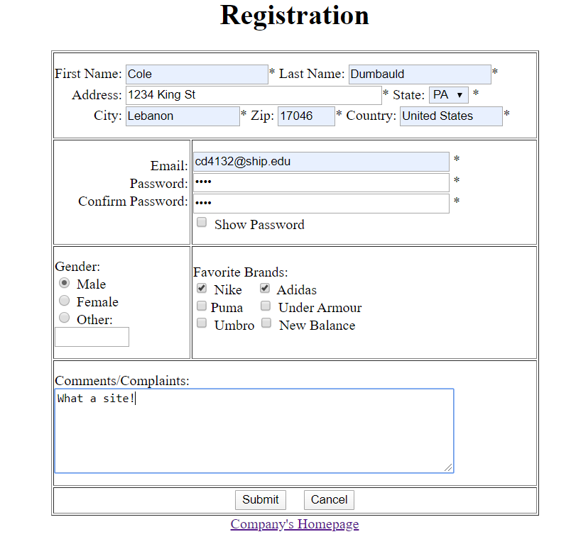

**Output:**

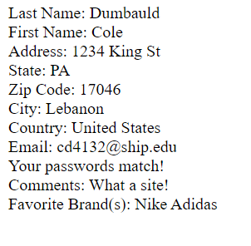

**Source Code:**

<html>

<body>

<script language = **"javascript"**>

***function*** checkField**()**

**{**

errorFlag **=** ***false*;**

errorMsg **=** ""**;**

confirmMsg **=** ""**;**

brandMsg **=** "Favorite Brand(s): "**;**

//textbox

***if*(**document.form1.txtLname.value **==**""**)**

**{**

errorFlag **=** ***true*;**

errorMsg **=** "Please enter in your Last Name! <br>"**;**

**}**

***else***

**{**

confirmMsg **=** "Last Name: " **+** document.form1.txtLname.value **+** "<br>"**;**

**}**

***if*(**document.form1.txtFname.value **==** ""**)**

**{**

errorFlag **=** ***true*;**

errorMsg **=** errorMsg **+** "Please enter in your First Name! <br>"**;**

**}**

***else***

**{**

confirmMsg **=** confirmMsg **+** "First Name: " **+** document.form1.txtFname.value **+** "<br>"**;**

**}**

***if*(**document.form1.txtAddress.value **==** ""**)**

**{**

errorFlag **=** ***true*;**

errorMsg **=** errorMsg **+** "Please enter in your Address! <br>"**;**

**}**

***else***

**{**

confirmMsg **=** confirmMsg **+** "Address: " **+** document.form1.txtAddress.value **+** "<br>"**;**

**}**

***if*(**document.form1.state.value **==**""**)**

**{**

errorFlag **=** ***true*;**

errorMsg **=** errorMsg **+** "Please put in your State! <br>"**;**

**}**

***else***

**{**

confirmMsg **=** confirmMsg **+** "State: " **+** document.form1.state.value **+** "<br>"**;**

**}**

***if*(**document.form1.txtZip.value **==**""**)**

**{**

errorFlag **=** ***true*;**

errorMsg **=** errorMsg **+** "Please enter in your Zip Code! <br>"**;**

**}**

***else***

**{**

confirmMsg **=** confirmMsg **+** "Zip Code: " **+** document.form1.txtZip.value **+** "<br>"**;**

**}**

***if*(**document.form1.txtCity.value **==** ""**)**

**{**

errorFlag **=** ***true*;**

errorMsg **=** errorMsg **+** "Please enter in your City! <br>"**;**

**}**

***else***

**{**

confirmMsg **=** confirmMsg **+** "City: " **+** document.form1.txtCity.value **+** "<br>"**;**

**}**

***if*(**document.form1.txtCountry.value **==** ""**)**

**{**

errorFlag **=** ***true*;**

errorMsg **=** errorMsg **+** "Please enter in your Country! <br>"**;**

**}**

***else***

**{**

confirmMsg **=** confirmMsg **+** " Country: " **+** document.form1.txtCountry.value **+** "<br>"**;**

**}**

***if*(**document.form1.txtEmail.value **==**""**)**

**{**

errorFlag **=** ***true*;**

errorMsg **=** errorMsg **+** "Please enter in your Email! <br>"**;**

**}**

***else***

**{**

confirmMsg **=** confirmMsg **+** "Email: " **+** document.form1.txtEmail.value **+** "<br>"**;**

**}**

***if*(**document.form1.txtPassword.value **==**""**)**

**{**

errorFlag **=** ***true*;**

errorMsg **=** errorMsg **+** "Please enter in a Password! <br>"**;**

**}**

***if*(**document.form1.txtCpassword.value **!=** document.form1.txtPassword.value**)**

**{**

errorFlag **=** ***true*;**

errorMsg **=** errorMsg **+** "Your Password does not match your Confirm password!<br>"**;**

**}**

***else***

**{**

confirmMsg **=** confirmMsg **+** "Your passwords match! <br>"**;**

**}**

***if*(**document.form1.txtCpassword.value **==** ""**)**

**{**

errorFlag **=** ***true*;**

errorMsg **=** errorMsg **+** "Please enter in the confirm password!<br>"**;**

**}**

//radio buttons

***if*(**document.form1.rdGender**[**0**].**checked **==** ***false*** **&&** document.form1.rdGender**[**1**].**checked **==** ***false*** **&&** document.form1.rdGender**[**2**].**checked **==** ***false*)**

**{**

errorFlag **=** ***true*;**

errorMsg **=** errorMsg **+** "Please select a gender.<br>"**;**

**}**

***if*(**document.form1.rdGender**[**2**].**checked **==** ***true*** **&&** document.form1.txtOther.value **==**""**)**

**{**

errorFlag **=** ***true*;**

errorMsg **=** errorMsg **+** "Please enter in your gender. <br>"**;**

**}**

//checkbox

***if*(**document.form1.chkNike.checked **==** ***true*)**

**{**

brandMsg **=** brandMsg **+** "Nike "**;**

**}**

***if*(**document.form1.chkAdidas.checked **==** ***true*)**

**{**

brandMsg **=** brandMsg **+** "Adidas "**;**

**}**

***if*(**document.form1.chkArmour.checked **==** ***true*)**

**{**

brandMsg **=** brandMsg **+** "Under Armour "**;**

**}**

***if*(**document.form1.chkBalance.checked **==** ***true*)**

**{**

brandMsg **=** brandMsg **+** "New Balance "**;**

**}**

***if*(**document.form1.chkUmbro.checked **==** ***true*)**

**{**

brandMsg **=** brandMsg **+** "Umbro "**;**

**}**

***if*(**document.form1.chkPuma.checked **==** ***true*)**

**{**

brandMsg **=** brandMsg **+** "Puma"**;**

**}**

//textArea

***if*(**document.form1.comments.value **!=** ""**)**

**{**

confirmMsg **=** confirmMsg **+** "Comments: " **+** document.form1.comments.value **+** "<br>"**;**

**}**

//Messages

***if*(**errorFlag **==** ***true*)**

**{**

document.write**(**errorMsg**);**

**}**

***else***

**{**

document.write**(**confirmMsg**);**

document.write**(**brandMsg**);**

**}**

**}**

***function*** showPassword**()**

**{**

***if*(**document.form1.txtPassword.type **==** "password" **&&** document.form1.txtCpassword.type **==** "password"**)**

**{**

document.form1.txtPassword.type **=** "text"**;**

document.form1.txtCpassword.type **=** "text"**;**

**}**

***else***

**{**

document.form1.txtPassword.type **=** "password"**;**

document.form1.txtCpassword.type **=** "password"**;**

**}**

**}**

</script>

<form name = **"form1"** method =**"post"**>

<center><h1> **Registration** </h1></center>

<center><table border =1; width = 550; height = 525>

<tr>

<td colspan = 2> **First Name:** <input type=**"Text"** Name = **"txtFname"** size = 20>**\***

**Last Name:** <input type = **"text"** name = **"txtLname"** size =20>**\***<br><br style=**"line-height:2px;"**/>

*&nbsp;&nbsp;&nbsp;&nbsp;* **Address:** <input type = **"text"** name = **"txtAddress"** size = 40>**\***

**State:**

<select name=**"state"**>

<option></option>

<option value=**"AL"**>**AL**</option>

<option value=**"AK"**>**AK**</option>

<option value=**"AZ"**>**AZ**</option>

<option value=**"AR"**>**AR**</option>

<option value=**"CA"**>**CA**</option>

<option value=**"CO"**>**CO**</option>

<option value=**"CT"**>**CT**</option>

<option value=**"DE"**>**DE**</option>

<option value=**"DC"**>**DC**</option>

<option value=**"FL"**>**FL**</option>

<option value=**"GA"**>**GA**</option>

<option value=**"HI"**>**HI**</option>

<option value=**"ID"**>**ID**</option>

<option value=**"IL"**>**IL**</option>

<option value=**"IN"**>**IN**</option>

<option value=**"IA"**>**IA**</option>

<option value=**"KS"**>**KS**</option>

<option value=**"KY"**>**KY**</option>

<option value=**"LA"**>**LA**</option>

<option value=**"ME"**>**ME**</option>

<option value=**"MD"**>**MD**</option>

<option value=**"MA"**>**MA**</option>

<option value=**"MI"**>**MI**</option>

<option value=**"MN"**>**MN**</option>

<option value=**"MS"**>**MS**</option>

<option value=**"MO"**>**MO**</option>

<option value=**"MT"**>**MT**</option>

<option value=**"NE"**>**NE**</option>

<option value=**"NV"**>**NV**</option>

<option value=**"NH"**>**NH**</option>

<option value=**"NJ"**>**NJ**</option>

<option value=**"NM"**>**NM**</option>

<option value=**"NY"**>**NY**</option>

<option value=**"NC"**>**NC**</option>

<option value=**"ND"**>**ND**</option>

<option value=**"OH"**>**OH**</option>

<option value=**"OK"**>**OK**</option>

<option value=**"OR"**>**OR**</option>

<option value=**"PA"**>**PA**</option>

<option value=**"RI"**>**RI**</option>

<option value=**"SC"**>**SC**</option>

<option value=**"SD"**>**SD**</option>

<option value=**"TN"**>**TN**</option>

<option value=**"TX"**>**TX**</option>

<option value=**"UT"**>**UT**</option>

<option value=**"VT"**>**VT**</option>

<option value=**"VA"**>**VA**</option>

<option value=**"WA"**>**WA**</option>

<option value=**"WV"**>**WV**</option>

<option value=**"WI"**>**WI**</option>

<option value=**"WY"**>**WY**</option>

</select> **\***<br><br style=**"line-height:2px;"**/>

*&nbsp;&nbsp;&nbsp;&nbsp;&nbsp;&nbsp;&nbsp;&nbsp;&nbsp;&nbsp;&nbsp;***City:** <input type = **"text"** name = **"txtCity"** size = 15>**\***

**Zip:** <input type = **"text"** name = **"txtZip"** size = 5 maxlength = 5>**\***

**Country:** <input type = **"text"** name = **"txtCountry"** size = 13.5>**\***<br>

</td>

</tr>

<tr>

<td width = 25%; align = **"right"**; valign = **"top"**>

<br>

**Email:** <br><br style=**"line-height:2px;"**/>

**Password:** <br><br style=**"line-height:2px;"**/>

**Confirm Password:** <br><br style=**"line-height:2px;"**/>

</td>

<td>

<input type = **"text"** name = **"txtEmail"** size = 40> **\***<br><br style=**"line-height:2px;"**/>

<input type = **"password"** name = **"txtPassword"** size = 40> **\***<br><br style=**"line-height:2px;"**/>

<input type = **"password"** name = **"txtCpassword"** size = 40> **\***<br><br style=**"line-height:2px;"**/>

<input type = **"checkbox"** name = **"chkPassord"** onclick = **"showPassword()"**> **Show Password**

</td>

</tr>

<tr>

<td>**Gender:**<br>

<input type =**"radio"** name = **"rdGender"** value =**"male"**> **Male**<br>

<input type = **"radio"** name = **"rdGender"** value = **"female"**> **Female** <br>

<input type = **"radio"** name = **"rdGender"** value = **"other"**> **Other:**

<input type =**"text"** name =**"txtOther"** size = 8>

</td>

<td valign = **"top"**>

<br>

**Favorite Brands:**<br>

<input type =**"checkbox"** name =**"chkNike"** value = **"Nike"**> **Nike** *&nbsp;&nbsp;*

<input type = **"checkbox"** name =**"chkAdidas"** value = **"Adidas"**> **Adidas**<br>

<input type = **"checkbox"** name = **"chkPuma"** value = **"Puma"**>**Puma** *&nbsp;&nbsp;*

<input type = **"checkbox"** name =**"chkArmour"** value = **"Armour"**> **Under Armour** <br>

<input type = **"checkbox"** name = **"chkUmbro"** value = **"Umbro"**> **Umbro**

<input type = **"checkbox"** name =**"chkBalance"** value = **"Balance"**> **New Balance**

</td>

</tr>

<tr>

<td colspan =2>

**Comments/Complaints:**<br>

<textarea name = **"comments"** cols = 60 rows = 6 value = **""**></textarea>

</td>

</tr>

<tr>

<td colspan = 2 height = 6%>

<center>

<input type = **"submit"** name = **"btnSubmit"** size = 10 onclick = **"checkField()"**>*&nbsp;&nbsp;&nbsp;*

<input type = **"reset"** name = **"btnCancel"** size = 10 value = **"Cancel"**>

</center>

</td>

</tr>

</table></center>

<center>

<a href = **"company.html"**> **Company's Homepage** </a>

</center>

</form>

</body>

</html>

**Purpose:** The purpose of the register is to gather all the information of the user so they can order items from our site. We error checked everything, so everything with a * next to it needs to be filled out. If it is left blank an error message will pop up telling the user what information needs to be filled out. If everything is filled out, once the submit button is clicked, the user will see all the information they filled out in the next page.

**What I learned:** While creating this page I learned how to code in JavaScript. I learned that client-side programming is when the program runs on the user’s computer. I learned how to error check to make sure all the text boxes are filled out. I learned about the form tag and how to use the button click event. I learned about the password input type and how to make it change the input type to text when a check box is clicked.

# **Order Form**

**Date:** 02/25/2020

**Number of Hours:** 3 hours

**Input:**

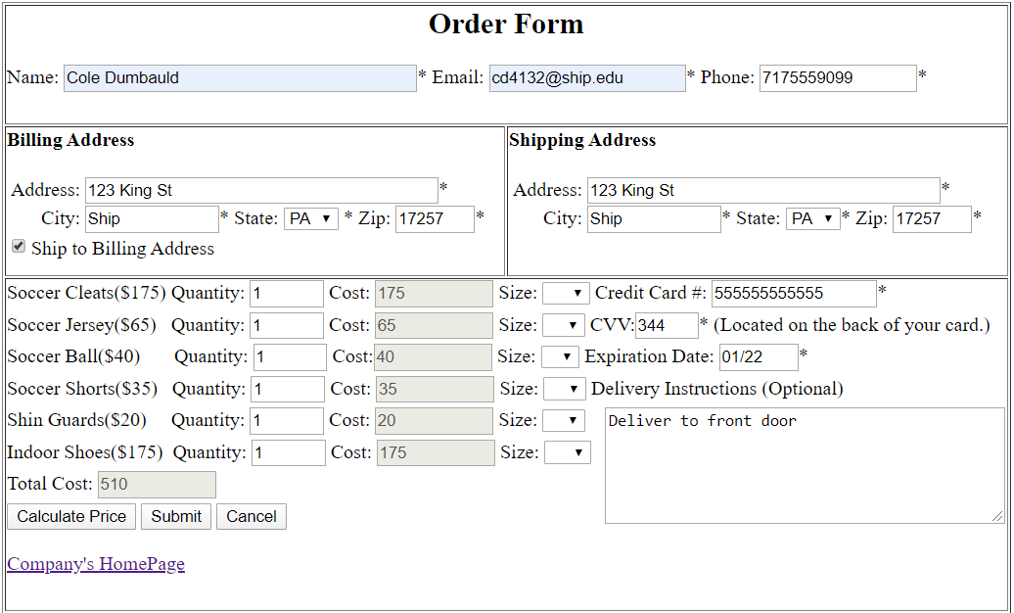

**Output:**

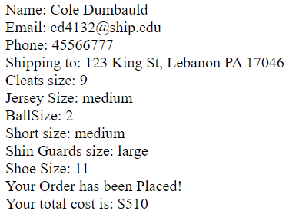

**Source Code:**

<html>

<body>

<script language =**"javascript"**>

***function*** calculate**()**

**{**

***var*** cleat **=** 175**;**

***var*** jersey **=** 65**;**

***var*** ball **=** 40**;**

***var*** shorts **=** 35**;**

***var*** guards **=** 20**;**

***var*** shoes **=** 175**;**

***var*** totalCost **=** 0**;**

***if*(**document.form1.qtyCleats.value **<** 0 **||** document.form1.qtyJersey.value **<** 0 **||** document.form1.qtyBall.value **<** 0 **||** document.form1.qtyShorts.value **<** 0 **||** document.form1.qtyGuards.value **<** 0 **||** document.form1.qtyShoes.value **<** 0**)**

**{**

alert**(**"Cannot have a negative amount of Quantity!"**);**

**}**

***else***

**{**

document.form1.costCleats.value **=** document.form1.qtyCleats.value **\*** cleat**;**

document.form1.costJersey.value **=** document.form1.qtyJersey.value **\*** jersey**;**

document.form1.costBall.value **=** document.form1.qtyBall.value **\*** ball**;**

document.form1.costShorts.value **=** document.form1.qtyShorts.value **\*** shorts**;**

document.form1.costGuards.value **=** document.form1.qtyGuards.value **\*** guards**;**

document.form1.costShoes.value **=** document.form1.qtyShoes.value **\*** shoes**;**

totalCost **=** parseInt**(**document.form1.costCleats.value**)** **+** parseInt**(**document.form1.costJersey.value**)** **+** parseInt**(**document.form1.costBall.value**)** **+** parseInt**(**document.form1.costShorts.value**)** **+** parseInt**(**document.form1.costGuards.value**)** **+** parseInt**(**document.form1.costShoes.value**);**

document.form1.txtTotal.value **=** totalCost**;**

***return*** totalCost**;**

**}**

**}**

***function*** checkFields**()**

**{**

errorFlag **=** ***false*;**

errorMsg **=** ""**;**

confirmMsg **=** ""**;**

//name

***if*(**document.form1.txtName.value **==**""**)**

**{**

erroFlag **=** ***true*;**

errorMsg **=** errorMsg **+** "Please Enter your Name! \n"**;**

**}**

***else***

**{**

confirmMsg **=** confirmMsg **+** "Name: " **+** document.form1.txtName.value **+** "<br>"**;**

**}**

//email

***if*(**document.form1.txtEmail.value **==** ""**)**

**{**

errorFlag **=** ***true*;**

errorMsg **=** errorMsg **+** "Please enter your Email! \n"**;**

**}**

***else***

**{**

confirmMsg **=** confirmMsg **+** "Email: " **+** document.form1.txtEmail.value **+** "<br>"**;**

**}**

//phone

***if*(**document.form1.txtPhone.value **==** ""**)**

**{**

errorFlag **=** ***true*;**

errorMsg **=** errorMsg **+** "Please Enter your phone number! \n"**;**

**}**

***else***

**{**

confirmMsg **=** confirmMsg **+** "Phone: " **+** document.form1.txtPhone.value **+**"<br>"**;**

**}**

//address

***if*(**document.form1.txtAddressB.value **==** ""**)**

**{**

errorFlag **=** ***true*;**

errorMsg **=** errorMsg **+** "Please fill in your address! \n"**;**

**}**

//city

***if*(**document.form1.txtCityB.value **==**""**)**

**{**

errorFlag **=** ***true*;**

errorMsg **=** errorMsg **+** "Please enter your city! \n"**;**

**}**

//state

***if*(**document.form1.txtStateB.value **==**""**)**

**{**

errorFlag **=** ***true*;**

errorMsg **=** errorMsg **+** "Please select a state! \n"**;**

**}**

//zip

***if*(**document.form1.txtZipB.value **==**""**)**

**{**

errorFlag **=** ***true*;**

errorMsg **=** errorMsg **+** "Please enter your Zip! \n"**;**

**}**

//ship address

***if*(**document.form1.txtAddressS.value **==**""**)**

**{**

errorFlag **=** ***true*;**

errorMsg **=** errorMsg **+** "Please enter your shiping Address! \n"**;**

**}**

//ship city

***if*(**document.form1.txtCityS.value **==** ""**)**

**{**

errorFlage **=** ***true*;**

errorMsg **=** errorMsg **+** "Please enter in your state! \n"**;**

**}**

//ship state

***if*(**document.form1.txtStateS.value **==**""**)**

**{**

errorFlag **=** ***true*;**

errorMsg **=** errorMsg **+** "Please select a state! \n"**;**

**}**

//ship zip

***if*(**document.form1.txtZipS.value **==**""**)**

**{**

errorFlag **=** ***true*;**

errorMsg **=** errorMsg **+** "Please enter your Zip \n"

**}**

***else***

**{**

confirmMsg **=** confirmMsg **+** "Shipping to: " **+** document.form1.txtAddressS.value **+** ", " **+** document.form1.txtCityS.value **+** " " **+**document.form1.txtStateS.value **+** " " **+**document.form1.txtZipS.value **+** "<br>"**;**

**}**

//Credit card

***if*(**document.form1.txtCard.value **==** ""**)**

**{**

errorFlag **=** ***true*;**

errorMsg **=** errorMsg **+** "Please enter in your credit card! \n"**;**

**}**

//CVV

***if*(**document.form1.txtCvv.value **==**""**)**

**{**

errorFlag **=** ***true*;**

errorMsg **=** errorMsg **+** "Please enter the CVV of your credit card! \n"**;**

**}**

//expiration date

***if*(**document.form1.txtDate.value **==**""**)**

**{**

errorFlag **=** ***true*;**

errorMsg **=** errorMsg **+** "Please enter the expiration date of your credit card! \n"**;**

**}**

//no size cleats

***if*(**document.form1.qtyCleats.value **>** 0 **&&** document.form1.cleatSize.value **==** ""**)**

**{**

errorFlag **=** ***true*;**

errorMsg **=** errorMsg **+** "Please select a size for your cleats! \n"**;**

**}**

***else*** ***if*(**document.form1.qtyCleats.value **>** 0 **&&** document.form1.cleatSize.value **!=** ""**)**

**{**

confirmMsg **=** confirmMsg **+** "Cleats size: " **+** document.form1.cleatSize.value **+** "<br>"**;**

**}**

//no size jersey

***if*(**document.form1.qtyJersey.value **>** 0 **&&** document.form1.jerseySize.value **==** ""**)**

**{**

errorFlag **=** ***true*;**

errorMsg **=** errorMsg **+** "Please select a size for your jersey! \n"**;**

**}**

***else*** ***if*(**document.form1.qtyJersey.value **>** 0 **&&** document.form1.jerseySize.value **!=**""**)**

**{**

confirmMsg **=** confirmMsg **+** "Jersey Size: " **+** document.form1.jerseySize.value **+** "<br>"**;**

**}**

// no ball size

***if*(**document.form1.qtyBall.value **>** 0 **&&** document.form1.ballSize.value **==** ""**)**

**{**

errorFlag **=** ***true*;**

errorMsg **=** errorMsg **+** "Please select a size for your ball! \n"**;**

**}**

***else*** ***if*(**document.form1.qtyBall.value **>** 0 **&&** document.form1.ballSize.value **!=**""**)**

**{**

confirmMsg **=** confirmMsg **+** "BallSize: " **+** document.form1.ballSize.value **+** "<br>"**;**

**}**

//no shorts size.

***if*(**document.form1.qtyShorts.value **>** 0 **&&** document.form1.shortSize.value **==**""**)**

**{**

errorFlag **=** ***true*;**

errorMsg **=** errorMsg **+** "Please select a size for your shorts! \n"**;**

**}**

***else*** ***if*(**document.form1.qtyShorts.value **>** 0 **&&** document.form1.shortSize.value **!=**""**)**

**{**

confirmMsg **=** confirmMsg **+** "Short size: " **+** document.form1.shortSize.value **+** "<br>"**;**

**}**

//no guards size

***if*(**document.form1.qtyGuards.value **>** 0 **&&** document.form1.shinSize.value **==**""**)**

**{**

errorFlag **=** ***true*;**

errorMsg **=** errorMsg **+** "Please select your shin size! \n"**;**

**}**

***else*** ***if*(**document.form1.qtyGuards.value **>** 0 **&&** document.form1.shinSize.value **!=**""**)**

**{**

confirmMsg **=** confirmMsg **+** "Shin Guards size: " **+** document.form1.shinSize.value **+**"<br>"**;**

**}**

//no shoe size

***if*(**document.form1.qtyShoes.value **>** 0 **&&** document.form1.shoeSize.value **==**""**)**

**{**

errorFlag **=** ***true*;**

errorMsg **=** errorMsg **+** "Please select a shoe size! \n"**;**

**}**

***else*** ***if*(**document.form1.qtyShoes.value **>** 0 **&&** document.form1.shoeSize.value **!=**""**)**

**{**

confirmMsg **=** confirmMsg **+** "Shoe Size: " **+** document.form1.shoeSize.value **+** "<br>"**;**

**}**

//error message

***if*(**errorFlag **==** ***true*)**

**{**

alert**(**errorMsg**);**

**}**

***else***

**{**

***var*** total **=** 0**;**

total **=** calculate**();**

***if*(**total **==** 0**)**

**{**

alert**(**"You didn't order any products"**)**

**}**

***else***

**{**

confirmMsg **=** confirmMsg **+** "Your Order has been Placed!<br> Your total cost is: $" **+** total**;**

document.write**(**confirmMsg**);**

**}**

**}**

**}**

***function*** billToShip**()**

**{**

***if*(**document.form1.chkShip.checked **==** ***true*)**

**{**

document.form1.txtAddressS.value **=** document.form1.txtAddressB.value**;**

document.form1.txtCityS.value **=** document.form1.txtCityB.value**;**

document.form1.txtStateS.value **=** document.form1.txtStateB.value**;**

document.form1.txtZipS.value **=** document.form1.txtZipB.value**;**

**}**

***else***

**{**

document.form1.txtAddressS.value **=** ""**;**

document.form1.txtCityS.value **=** ""**;**

document.form1.txtStateS.value **=** ""**;**

document.form1.txtZipS.value **=** ""**;**

**}**

**}**

</script>

<form name = **"form1"** method =**"post"**>

<center><table border = 1; width = 825; height = 500></center>

<tr >

<td valign = **"top"** colspan = 2 height = 20%>

<h2><center> **Order Form** </center></h2>

**Name:** <input type = **"text"** name = **"txtName"** size = 40>**\***

**Email:** <input type = **"text"** name = **"txtEmail"** size = 20>**\***

**Phone:** <input type = **"text"** name = **"txtPhone"** size = 15>**\***

</td>

</tr>

<tr height = 25%>

<td valign = **"top"** width = 50%>

<h4> **Billing Address**</h4>

*&nbsp;***Address:** <input type = **"text"** name = **"txtAddressB"** size = 40>**\***<br><br style=**"line-height:2px;"**/>

*&nbsp;&nbsp;&nbsp;&nbsp;&nbsp;&nbsp;* **City:** <input type = **"text"** name = **"txtCityB"** size = 12>**\***

**State:**

<select name=**"txtStateB"**>

<option></option>

<option value=**"AL"**>**AL**</option>

<option value=**"AK"**>**AK**</option>

<option value=**"AZ"**>**AZ**</option>

<option value=**"AR"**>**AR**</option>

<option value=**"CA"**>**CA**</option>

<option value=**"CO"**>**CO**</option>

<option value=**"CT"**>**CT**</option>

<option value=**"DE"**>**DE**</option>

<option value=**"DC"**>**DC**</option>

<option value=**"FL"**>**FL**</option>

<option value=**"GA"**>**GA**</option>

<option value=**"HI"**>**HI**</option>

<option value=**"ID"**>**ID**</option>

<option value=**"IL"**>**IL**</option>

<option value=**"IN"**>**IN**</option>

<option value=**"IA"**>**IA**</option>

<option value=**"KS"**>**KS**</option>

<option value=**"KY"**>**KY**</option>

<option value=**"LA"**>**LA**</option>

<option value=**"ME"**>**ME**</option>

<option value=**"MD"**>**MD**</option>

<option value=**"MA"**>**MA**</option>

<option value=**"MI"**>**MI**</option>

<option value=**"MN"**>**MN**</option>

<option value=**"MS"**>**MS**</option>

<option value=**"MO"**>**MO**</option>

<option value=**"MT"**>**MT**</option>

<option value=**"NE"**>**NE**</option>

<option value=**"NV"**>**NV**</option>

<option value=**"NH"**>**NH**</option>

<option value=**"NJ"**>**NJ**</option>

<option value=**"NM"**>**NM**</option>

<option value=**"NY"**>**NY**</option>

<option value=**"NC"**>**NC**</option>

<option value=**"ND"**>**ND**</option>

<option value=**"OH"**>**OH**</option>

<option value=**"OK"**>**OK**</option>

<option value=**"OR"**>**OR**</option>

<option value=**"PA"**>**PA**</option>

<option value=**"RI"**>**RI**</option>

<option value=**"SC"**>**SC**</option>

<option value=**"SD"**>**SD**</option>

<option value=**"TN"**>**TN**</option>

<option value=**"TX"**>**TX**</option>

<option value=**"UT"**>**UT**</option>

<option value=**"VT"**>**VT**</option>

<option value=**"VA"**>**VA**</option>

<option value=**"WA"**>**WA**</option>

<option value=**"WV"**>**WV**</option>

<option value=**"WI"**>**WI**</option>

<option value=**"WY"**>**WY**</option>

</select> **\***

**Zip:** <input type = **"text"** name = **"txtZipB"** size = 5>**\***<br><br style = **"line-height:2px;"**/>

<input type = **"checkbox"** name = **"chkShip"** onclick =**"billToShip()"**>**Ship to Billing Address** <br>

</td>

</tr>

<tr >

<td valign = **"top"** colspan = 2 width =50%>

**Soccer Cleats($175) Quantity:** <input type = **"number"** min = **"0"** max =**"10"** name = **"qtyCleats"** size =**"1"** value =**"0"**>

**Cost:** <input type = **"text"** name =**"costCleats"** size = 10 disabled value = **"0"**>

**Size:** <select name = **"cleatSize"**>

<option></option>

<option value =**"8"**>**8**</option>

<option value =**"9"**>**9**</option>

<option value =**"10"**>**10**</option>

<option value =**"11"**>**11**</option>

<option value =**"12"**>**12**</option>

<option value =**"13"**>**13**</option>

</select>

**Credit Card #:** <input type =**"text"** name =**"txtCard"** size = 16>**\***<br><br style=**"line-height:4px;"**/>

**Soccer Jersey($65)** *&nbsp;&nbsp;***Quantity:** <input type =**"number"** min =**"0"** max =**"10"** name = **"qtyJersey"** size =1 value =**"0"**>

**Cost:** <input type = **"text"** name =**"costJersey"** size = 10 disabled value =**"0"**>

**Size:** <select name = **"jerseySize"**>

<option></option>

<option value = **"small"**>**S**</option>

<option value =**"medium"**>**M**</option>

<option value = **"large"**>**L**</option>

</select>

**CVV:**<input type =**"text"** name =**"txtCvv"**size =3>**\* (Located on the back of your card.)**<br><br style=**"line-height:4px;"**/>

**Soccer Ball($40)***&nbsp;&nbsp;&nbsp;&nbsp;&nbsp;&nbsp;&nbsp;***Quantity:** <input type = **"number"** min =**"0"** max =**"10"** name = **"qtyBall"** size = 1 value =**"0"**>

**Cost:**<input type = **"text"** name = **"costBall"** size = 10 disabled value =**"0"**>

**Size:** <select name =**"ballSize"**>

<option></option>

<option value =**"1"**> **1**</option>

<option value =**"2"**> **2**</option>

<option value =**"3"**> **3**</option>

<option value =**"4"**> **4**</option>

<option value =**"5"**> **5**</option>

</select>

**Expiration Date:** <input type = **"text"** name =**"txtDate"** size = **"5"**>**\***<br><br style=**"line-height:4px;"**/>

**Soccer Shorts($35)** *&nbsp;&nbsp;***Quantity:** <input type = **"number"** min = **"0"** max =**"10"** name = **"qtyShorts"** size = 1 value =**"0"**>

**Cost:** <input type = **"text"** name = **"costShorts"** size = 10 disabled value =**"0"**>

**Size:** <select name = **"shortSize"**>

<option></option>

<option value = **"small"**>**S**</option>

<option value =**"medium"**>**M**</option>

<option value = **"large"**>**L**</option>

</select>

**Delivery Instructions (Optional)**<br><br style =**"line-height:4px;"**/>

<textarea name =**"instructions"** rows = 6 cols =43 style =**"float: right;"**></textarea>

**Shin Guards($20)** *&nbsp;&nbsp;&nbsp;&nbsp;***Quantity:** <input type = **"number"** min =**"0"** max =**"10"** name =**"qtyGuards"** size = 1 value = **"0"**>

**Cost:** <input type = **"text"** name =**"costGuards"** size = 10 disabled value = **"0"**>

**Size:** <select name = **"shinSize"**>

<option></option>

<option value = **"small"**>**S**</option>

<option value =**"medium"**>**M**</option>

<option value = **"large"**>**L**</option>

</select><br><br style=**"line-height:4px;"**/>

**Indoor Shoes($175)** *&nbsp;***Quantity:** <input type = **"number"** min =**"0"** max =**"10"** name =**"qtyShoes"** size =1 value =**"0"**>

**Cost:** <input type = **"text"** name = **"costShoes"** size = 10 disabled value =**"0"**>

**Size:** <select name = **"shoeSize"**>

<option></option>

<option value =**"8"**>**8**</option>

<option value =**"9"**>**9**</option>

<option value =**"10"**>**10**</option>

<option value =**"11"**>**11**</option>

<option value =**"12"**>**12**</option>

<option value =**"13"**>**13**</option>

</select><br><br style=**"line-height:4px;"**/>

**Total Cost:** <input type = **"text"** name =**"txtTotal"** size = 10 disabled value =**"0"**><br><br style =**"line-height:4px;"**/>

<input type =**"button"** name = **"btnCalculate"** value = **"Calculate Price"** onclick = **"calculate()"**>

<input type =**"button"** name = **"btnSubmit"** value = **"Submit"** onclick=**"checkFields()"**>

<input type = **"reset"** name =**"btnReset"** value = **"Cancel"**><br><br>

<a href = **"company.html"**> **Company's HomePage**</a>

</td>

</tr>

</table>

</form>

</body>

</html>

**Purpose:** The purpose of the order form, is for the user to order products, and have them shipped based on the information they entered. They need to enter all the information that has a *. If they leave anything blank, an error page will popup telling them what information needs to be filled out. If all the information is filled out and they click submit, it will confirm their order and print out all the stuff that they have ordered. The user has the option to click on the calculate total button to see their total before they confirm their order.

**What I learned:** I learned about the input type button, and how it is different from the input type submit. The input type submit is for when you want to submit stuff to your server. The button type is for when you want something to happen when it is clicked, like how the calculate button will calculate the total price of all the items you want to order.

# **Pizza Shop**

**Date:** 03/03/2020

**Number of Hours:** 1 hour 30 minutes

**Input:**

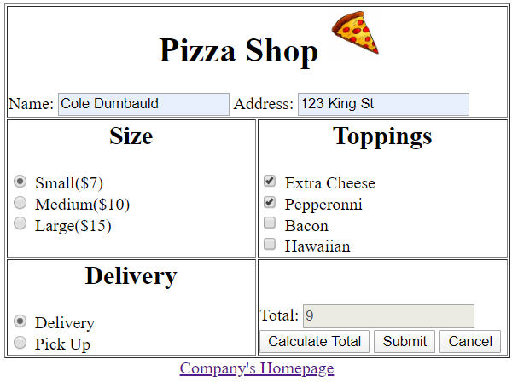

**Output:**

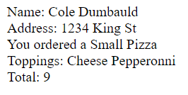

**Source Code:**

<html>

<body>

<script language = **"javascript"**>

***var*** toppingCount **=** 0**;**

***function*** calc**()**

**{**

***var*** small **=** 7**;**

***var*** medium **=** 10**;**

***var*** large **=** 15**;**

***var*** top **=** 1**;**

***var*** total **=** 0**;**

//Size price

***if*(**document.form1.radSize**[**0**].**checked **==** ***true*)**

**{**

total **=** small**;**

**}**

***else*** ***if*(**document.form1.radSize**[**1**].**checked **==** ***true*)**

**{**

total **=** medium**;**

**}**

***else*** ***if*(**document.form1.radSize**[**2**].**checked **==** ***true*)**

**{**

total **=** large**;**

**}**

***else***

**{**

alert**(**"You need to pick a size"**);**

**}**

total **=** total **+(**toppingCount **\*** top**);**

document.form1.txtTotal.value **=** total**;**

***return*** total**;**

**}**

//counting toppings

***function*** checkTop**(**topping**)**

**{**

***if*(**topping **==** ***true*)**

**{**

toppingCount **=** toppingCount **+** 1**;**

**}**

***else*** ***if*(**topping **==** ***false*)**

**{**

toppingCount **=** toppingCount **-**1**;**

**}**

**}**

***function*** checkFields**()**

**{**

errorFlag **=** ***false*;**

errorMsg **=** ""**;**

confirmMsg **=** ""**;**

toppingMsg **=** "Toppings: "**;**

//name

***if*(**document.form1.txtName.value **==** ""**)**

**{**

errorFlag **=** ***true*;**

errorMsg **=** errorMsg **+** "Please enter your name. \n"**;**

**}**

***else***

**{**

confirmMsg **=** confirmMsg **+** "Name: " **+** document.form1.txtName.value **+** "<br>"**;**

**}**

//address

***if*(**document.form1.txtAddress.value **==** "" **&&** document.form1.radDeliv**[**0**].**checked **==** ***true*)**

**{**

errorFlag **=** ***true*;**

errorMsg **=** errorMsg **+** "Please enter your address if you want delivery. \n"**;**

**}**

***else***

**{**

confirmMsg **=** confirmMsg **+** "Address: " **+** document.form1.txtAddress.value **+** "<br>"**;**

**}**

//size

***if*(**document.form1.radSize**[**0**].**checked **==** ***false*** **&&** document.form1.radSize**[**1**].**checked **==** ***false*** **&&** document.form1.radSize**[**2**].**checked **==** ***false*)**

**{**

errorFlag **=** ***true*;**

errorMsg **=** errorMsg **+** "Please Select a size of pizza. \n"**;**

**}**

***else*** ***if*(**document.form1.radSize**[**0**].**checked **==** ***true*)**

**{**

confirmMsg **=** confirmMsg **+** "You ordered a Small Pizza <br>"**;**

**}**

***else*** ***if*(**document.form1.radSize**[**1**].**checked **==** ***true*)**

**{**

confirmMsg **=** confirmMsg **+** "You ordered a Medium Pizza <br>"**;**

**}**

***else*** ***if*(**document.form1.radSize**[**2**].**checked **==** ***true*)**

**{**

confirmMsg **=** confirmMsg **+** "You ordered a Large Pizza <br>"**;**

**}**

//delivery

***if*(**document.form1.radDeliv**[**0**].**checked **==** ***false*** **&&** document.form1.radDeliv**[**1**].**checked **==** ***false*)**

**{**

errorFlag **=** ***true*;**

errorMsg **=** errorMsg **+** "Please pick delivery or pick up. \n"**;**

**}**

// toppings

***if*(**document.form1.chkCheese.checked **==** ***true*)**

**{**

toppingMsg **=** toppingMsg **+** "Cheese "**;**

**}**

***if*(**document.form1.chkBacon.checeked **==** ***true*)**

**{**

toppingMsg **=** toppingMsg **+** "Bacon"**;**

**}**

***if*(**document.form1.chkHawaiian.checked **==** ***true*)**

**{**

toppingMsg **=** toppingMsg **+** "Hawaiian"**;**

**}**

***if*(**document.form1.chkPep.checked **==** ***true*)**

**{**

toppingMsg **=** toppingMsg **+** "Pepperonni"**;**

**}**

// Message handler

***if*(**errorFlag **==** ***true*)**

**{**

alert**(**errorMsg**);**

**}**

***else***

**{**

confirmMsg **=** confirmMsg **+** toppingMsg **+** "<br> Total: " **+** calc**();**

document.write**(**confirmMsg**);**

**}**

**}**

</script>

<form name = **"form1"** method = **"post"**>

<center><table border = 1; width = 475; height = 300;></center>

<tr>

<td valign = **"top"** height = 10% colspan = 2>

<center><h1>*&nbsp;&nbsp;&nbsp;***Pizza Shop**

<img src = **"pizza.jpeg"**; height = 50; width = 50><img></h1></center>

**Name:** <input type = **"text"** name = **"txtName"**>

**Address:** <input type = **"text"** name = **"txtAddress"**>

</td>

</tr>

<tr>

<td valign = **"top"** width = 50% height = 45%>

<center><h2> **Size**</h2></center>

<input type = **"radio"** name =**"radSize"** value =**"small"**> **Small($7)** <br>

<input type = **"radio"** name =**"radSize"** value = **"medium"**> **Medium($10)** <br>

<input type = **"radio"** name = **"radSize"** value = **"large"**> **Large($15)** <br>

</td>

<td valign = **"top"**>

<center><h2> **Toppings**</h2></center>

<input type = **"checkbox"** name = **"chkCheese"** value =**"cheese"** onclick = **"checkTop(document.form1.chkCheese.checked)"**> **Extra Cheese** <br>

<input type = **"checkbox"** name = **"chkPep"** value = **"pep"** onclick = **"checkTop(document.form1.chkPep.checked)"**> **Pepperonni** <br>

<input type = **"checkbox"** name = **"chkBacon"** value =**"bacon"** onclick = **"checkTop(document.form1.chkBacon.checked)"**> **Bacon** <br>

<input type = **"checkbox"** name =**"chkHawaiian"** value = **"hawaiian"** onclick = **"checkTop(document.form1.chkHawaiian.checked)"**> **Hawaiian**<br>

</td>

</tr>

<tr>

<td>

<center><h2> **Delivery**</h2></center>

<input type = **"radio"** name = **"radDeliv"** value = **"delivery"**> **Delivery** <br>

<input type = **"radio"** name = **"radDeliv"** value = **"pickUp"**> **Pick Up**

</td>

<td valign = **"bottom"**>

**Total:** <input type = **"text"** name =**"txtTotal"** value = **"0"** disabled><br><br style=**"line-height:2px;"**/>

<input type = **"button"** name = **"btnCalculate"** onclick = **"calc()"** value = **"Calculate Total"**>

<input type = **"button"** name = **"btnSubmit"** value = **"Submit"** Onclick = **"checkFields()"**>

<input type = **"reset"** name = **"btnReset"** value = **"Cancel"**>

</td>

</tr>

</table>

<a href =**"company.html"**> **Company's Homepage** </a>

</form>

</body>

</html>

**Purpose:** The purpose of the pizza shop, is for the user to order any size pizza, and be able to add any topping they would like. Each size pizza has a cost associated with it and when they click on the calculate total button, a total will display based on the size of pizza and what toppings they picked. Once the submit button is clicked it will repeat what they have ordered.

**What I learned:** I didn’t learn anything from creating the pizza shop. Creating the pizza shop used all my previous knowledge on past assignments.

# **Register (C#)**

**Date:** 03/24/2020

**Number of Hours:** 1 hour

**Input:**

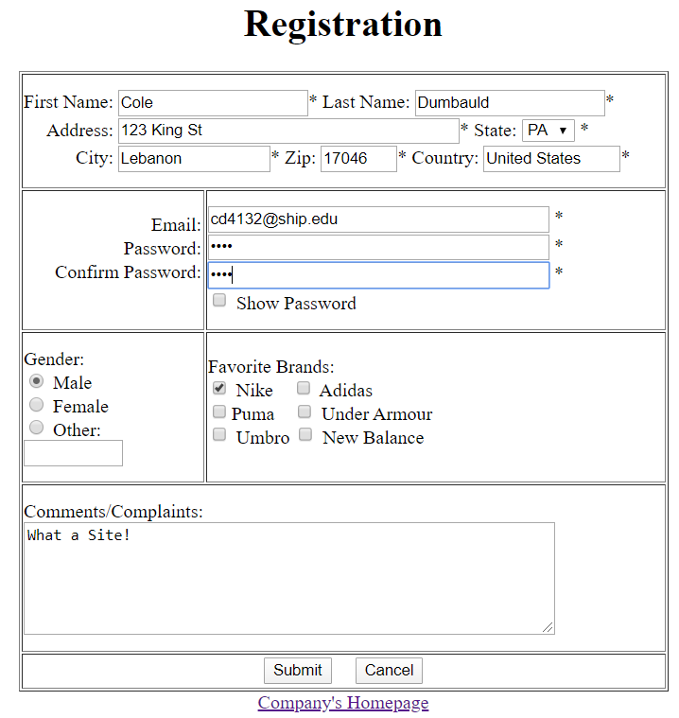

**Output:**

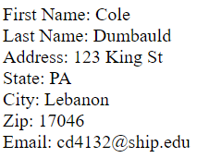

**Source Code:(register.html)**

<html>

<body>

<script language = **"javascript"**>

***function*** showPassword**()**

**{**

***if*(**document.form1.txtPassword.type **==** "password" **&&** document.form1.txtCpassword.type **==** "password"**)**

**{**

document.form1.txtPassword.type **=** "text"**;**

document.form1.txtCpassword.type **=** "text"**;**

**}**

***else***

**{**

document.form1.txtPassword.type **=** "password"**;**

document.form1.txtCpassword.type **=** "password"**;**

**}**

**}**

</script>

<form name = **"form1"** method =**"post"** action = **"registerC.aspx"**>

<center><h1> **Registration** </h1></center>

<center><table border =1; width = 550; height = 525>

<tr>

<td colspan = 2> **First Name:** <input type=**"Text"** Name = **"txtFname"** size = 20>**\***

**Last Name:** <input type = **"text"** name = **"txtLname"** size =20>**\***<br><br style=**"line-height:2px;"**/>

*&nbsp;&nbsp;&nbsp;&nbsp;* **Address:** <input type = **"text"** name = **"txtAddress"** size = 40>**\***

**State:**

<select name=**"state"**>

<option></option>

<option value=**"AL"**>**AL**</option>

<option value=**"AK"**>**AK**</option>

<option value=**"AZ"**>**AZ**</option>

<option value=**"AR"**>**AR**</option>

<option value=**"CA"**>**CA**</option>

<option value=**"CO"**>**CO**</option>

<option value=**"CT"**>**CT**</option>

<option value=**"DE"**>**DE**</option>

<option value=**"DC"**>**DC**</option>

<option value=**"FL"**>**FL**</option>

<option value=**"GA"**>**GA**</option>

<option value=**"HI"**>**HI**</option>

<option value=**"ID"**>**ID**</option>

<option value=**"IL"**>**IL**</option>

<option value=**"IN"**>**IN**</option>

<option value=**"IA"**>**IA**</option>

<option value=**"KS"**>**KS**</option>

<option value=**"KY"**>**KY**</option>

<option value=**"LA"**>**LA**</option>

<option value=**"ME"**>**ME**</option>

<option value=**"MD"**>**MD**</option>

<option value=**"MA"**>**MA**</option>

<option value=**"MI"**>**MI**</option>

<option value=**"MN"**>**MN**</option>

<option value=**"MS"**>**MS**</option>

<option value=**"MO"**>**MO**</option>

<option value=**"MT"**>**MT**</option>

<option value=**"NE"**>**NE**</option>

<option value=**"NV"**>**NV**</option>

<option value=**"NH"**>**NH**</option>

<option value=**"NJ"**>**NJ**</option>

<option value=**"NM"**>**NM**</option>

<option value=**"NY"**>**NY**</option>

<option value=**"NC"**>**NC**</option>

<option value=**"ND"**>**ND**</option>

<option value=**"OH"**>**OH**</option>

<option value=**"OK"**>**OK**</option>

<option value=**"OR"**>**OR**</option>

<option value=**"PA"**>**PA**</option>

<option value=**"RI"**>**RI**</option>

<option value=**"SC"**>**SC**</option>

<option value=**"SD"**>**SD**</option>

<option value=**"TN"**>**TN**</option>

<option value=**"TX"**>**TX**</option>

<option value=**"UT"**>**UT**</option>

<option value=**"VT"**>**VT**</option>

<option value=**"VA"**>**VA**</option>

<option value=**"WA"**>**WA**</option>

<option value=**"WV"**>**WV**</option>

<option value=**"WI"**>**WI**</option>

<option value=**"WY"**>**WY**</option>

</select> **\***<br><br style=**"line-height:2px;"**/>

*&nbsp;&nbsp;&nbsp;&nbsp;&nbsp;&nbsp;&nbsp;&nbsp;&nbsp;&nbsp;&nbsp;***City:** <input type = **"text"** name = **"txtCity"** size = 15>**\***

**Zip:** <input type = **"text"** name = **"txtZip"** size = 5 maxlength = 5>**\***

**Country:** <input type = **"text"** name = **"txtCountry"** size = 13.5>**\***<br>

</td>

</tr>

<tr>

<td width = 25%; align = **"right"**; valign = **"top"**>

<br>

**Email:** <br><br style=**"line-height:2px;"**/>

**Password:** <br><br style=**"line-height:2px;"**/>

**Confirm Password:** <br><br style=**"line-height:2px;"**/>

</td>

<td>

<input type = **"text"** name = **"txtEmail"** size = 40> **\***<br><br style=**"line-height:2px;"**/>

<input type = **"password"** name = **"txtPassword"** size = 40> **\***<br><br style=**"line-height:2px;"**/>

<input type = **"password"** name = **"txtCpassword"** size = 40> **\***<br><br style=**"line-height:2px;"**/>

<input type = **"checkbox"** name = **"chkPassord"** onclick = **"showPassword()"**> **Show Password**

</td>

</tr>

<tr>

<td>**Gender:**<br>

<input type =**"radio"** name = **"rdGender"** value =**"Male"**> **Male**<br>

<input type = **"radio"** name = **"rdGender"** value = **"Female"**> **Female** <br>

<input type = **"radio"** name = **"rdGender"** value = **"other"**> **Other:**

<input type =**"text"** name =**"txtOther"** size = 8>

</td>

<td valign = **"top"**>

<br>

**Favorite Brands:**<br>

<input type =**"checkbox"** name =**"chkNike"** value = **"Nike"**> **Nike** *&nbsp;&nbsp;*

<input type = **"checkbox"** name =**"chkAdidas"** value = **"Adidas"**> **Adidas**<br>

<input type = **"checkbox"** name = **"chkPuma"** value = **"Puma"**>**Puma** *&nbsp;&nbsp;*

<input type = **"checkbox"** name =**"chkArmour"** value = **"Armour"**> **Under Armour** <br>

<input type = **"checkbox"** name = **"chkUmbro"** value = **"Umbro"**> **Umbro**

<input type = **"checkbox"** name =**"chkBalance"** value = **"Balance"**> **New Balance**

</td>

</tr>

<tr>

<td colspan =2>

**Comments/Complaints:**<br>

<textarea name = **"comments"** cols = 60 rows = 6 value = **""**></textarea>

</td>

</tr>

<tr>

<td colspan = 2 height = 6%>

<center>

<input type = **"submit"** name = **"btnSubmit"** size = 10>*&nbsp;&nbsp;&nbsp;*

<input type = **"reset"** name = **"btnCancel"** size = 10 value = **"Cancel"**>

</center>

</td>

</tr>

</table></center>

<center>

<a href = **"company.html"**> **Company's Homepage** </a>

</center>

</form>

</body>

</html>

**Register.aspx**

<%@ Page language = "c#"%>

<html>

<body>

<%

System.IO.StreamWriter myOutFile = new

System.IO.StreamWriter(@"c:\inetpub\wwwroot\2020\cd4132\registerFile.txt",true);

string confirmMsg = "";

string errorMsg = "";

bool errorFlag = false;

if(Request.Form["txtFname"] == "")

{

errorFlag = true;

errorMsg = errorMsg + "Please Enter in your name!<br>";

}

else

{

confirmMsg = confirmMsg + "First Name: " + Request.Form["txtFname"] + "<br>";

}

if(Request.Form["txtLname"] == "")

{

errorFlag = true;

errorMsg = errorMsg + "Please Enter in your last name! <br>";

}

else

{

confirmMsg = confirmMsg + "Last Name: " + Request.Form["txtLname"] + "<br>";

}

if(Request.Form["txtAddress"] == "")

{

errorFlag = true;

errorMsg = errorMsg + "Please enter in your address! <br>";

}

else

{

confirmMsg = confirmMsg + "Address: " + Request.Form["txtAddress"] + "<br>";

}

if(Request.Form["state"] == "")

{

errorFlag = true;

errorMsg = errorMsg + "Please select your state! <br>";

}

else

{

confirmMsg = confirmMsg + "State: " + Request.Form["state"] + "<br>";

}

if(Request.Form["txtCity"] == "")

{

errorFlag = true;

errorMsg = errorMsg + "Please enter in your city! <br>";

}

else

{

confirmMsg = confirmMsg + "City: " + Request.Form["txtCity"] + "<br>";

}

if(Request.Form["txtZip"] == "")

{

errorFlag = true;

errorMsg = errorMsg + "Please enter in your zip code! <br>";

}

else

{

confirmMsg = confirmMsg + "Zip: " + Request.Form["txtZip"] + "<br>";

}

if(Request.Form["txtEmail"] == "")

{

errorFlag = true;

errorMsg = errorMsg + "Please enter in your email! <br>";

}

else

{

confirmMsg = confirmMsg + "Email: " + Request.Form["txtEmail"] + "<br>";

}

if(Request.Form["txtPassword"] == "")

{

errorFlag = true;

errorMsg = errorMsg + "Please enter a password! <br>";

}

if(Request.Form["txtCpassword"] == "")

{

errorFlag = true;

errorMsg = errorMsg + "Please enter your password again! <br>";

}

if(Request.Form["txtPassword"] != Request.Form["txtCpassword"])

{

errorFlag = true;

errorMsg = errorMsg + "Your Passwords do not match! <br>";

}

if((Request.Form["rdGender"] != "Male") && (Request.Form["rdGender"] != "Female") && (Request.Form["rdGender"] !="other"))

{

errorFlag = true;

errorMsg = errorMsg + "Please select your gender! <br>";

}

if((Request.Form["rdGender"]) == "other" && (Request.Form["txtOther"] == ""))

{

errorFlag = true;

errorMsg = errorMsg + "Please type in your gender! <br>";

}

if(errorFlag == true)

{

Response.Write(errorMsg);

}

else

{

Response.Write(confirmMsg);

myOutFile.WriteLine("Date of Registration " + DateTime.Now);

myOutFile.WriteLine("First Name: " + Request.Form["txtFname"]);

myOutFile.WriteLine("Last Name: " + Request.Form["txtLname"]);

myOutFile.WriteLine("Address: " + Request.Form["txtAddress"] + " " + Request.Form["txtCity"] + " " + Request.Form["state"] + " ," + Request.Form["txtZip"]);

myOutFile.WriteLine("Email: " + Request.Form["txtEmail"]);

myOutFile.WriteLine("Password: " + Request.Form["txtPassword"]);

if(Request.Form["rdGender"] == "other")

{

myOutFile.WriteLine("Gender: " + Request.Form["txtOther"]);

}

else

{

myOutFile.WriteLine("Gender: " + Request.Form["rdGender"]);

}

myOutFile.WriteLine("--------------------------------------------------------------------------------------------------------");

}

myOutFile.Close();

%>

</body>

</html>

**Purpose:** The purpose of this New Register page, is to have the code run on the server, instead on the clients PC. Once again, the Register error checks all the user inputs, to make sure they entered everything in. If everything that needs to be filled out, the information the user inputted will be displayed new page. Also, the information they submitted will be saved on to a text file plus the date and time the user submitted their information.

**What I learned:** I learned how to do server-side programming, while creating this webpage. I learned how to save the information that was inputted by the user to save to a text file.

# **Employee Table**

**Date:** 04/02/2020

**Number of Hours:** 2 hours

**Output:**

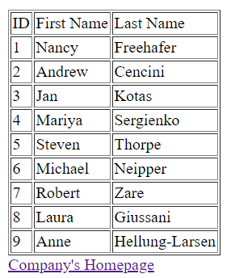

**Source Code:**

<%@ Page Language ="C#" Debug = "true"%>

<%@ Import Namespace = "System.Data.Odbc"%>

<%

Response.Write("<html><head><title>EMPLOYEE ASP in C#</title></head><body>");

//step1: Create ODBC Database connection,command, and datareader objects

OdbcConnection myconn;

OdbcCommand mycmd;

OdbcDataReader myreader;

//step2: connecting to a physical database using ODBC drivers for .mdb and .accdb files

myconn= new OdbcConnection(@"DRIVER={Microsoft Access Driver (*.mdb, *.accdb)};DBQ=c:\inetpub\wwwroot\northwind.accdb");

mycmd = new OdbcCommand("Select * from employees",myconn);

Response.Write("<b>Data from the Names table in the Employees Access Database: C# Program</b><br>");

//step3: Opening connection object and reader object(cursor in oracle)

myconn.Open();

myreader = mycmd.ExecuteReader();

//step4: using a loop to go through the records in the reader(going through the cursor in oracle)

Response.Write("<table border = 1> <tr><td> ID </td><td> First Name</td><td> Last Name</td></tr>");

while((myreader.Read()))

{

Response.Write("<tr>");

Response.Write("<td>" + myreader["ID"] + "</td>");

Response.Write("<td>" + myreader["First Name"] + "</td>");

Response.Write("<td>" + myreader["Last Name"] + "</td>");

Response.Write("</tr> <br>");

}

Response.Write("</table>");

//step5: closing the reader and connection objects

myreader.Close();

myconn.Close();

%>

<a href = "company.html"> Company's Homepage </a>

</body>

</html>

**Purpose:** This webpage is supposed to get all the employee’s names out of the employee table and display them on to a webpage.

**What I learned:** I learned how to connect to a database. I learned how to retrieve data from a database and display it on a webpage.

# **Inventory (C#)**

**Date:** 04/23/2020

**Number of Hours:** 2 hours

**Output:**

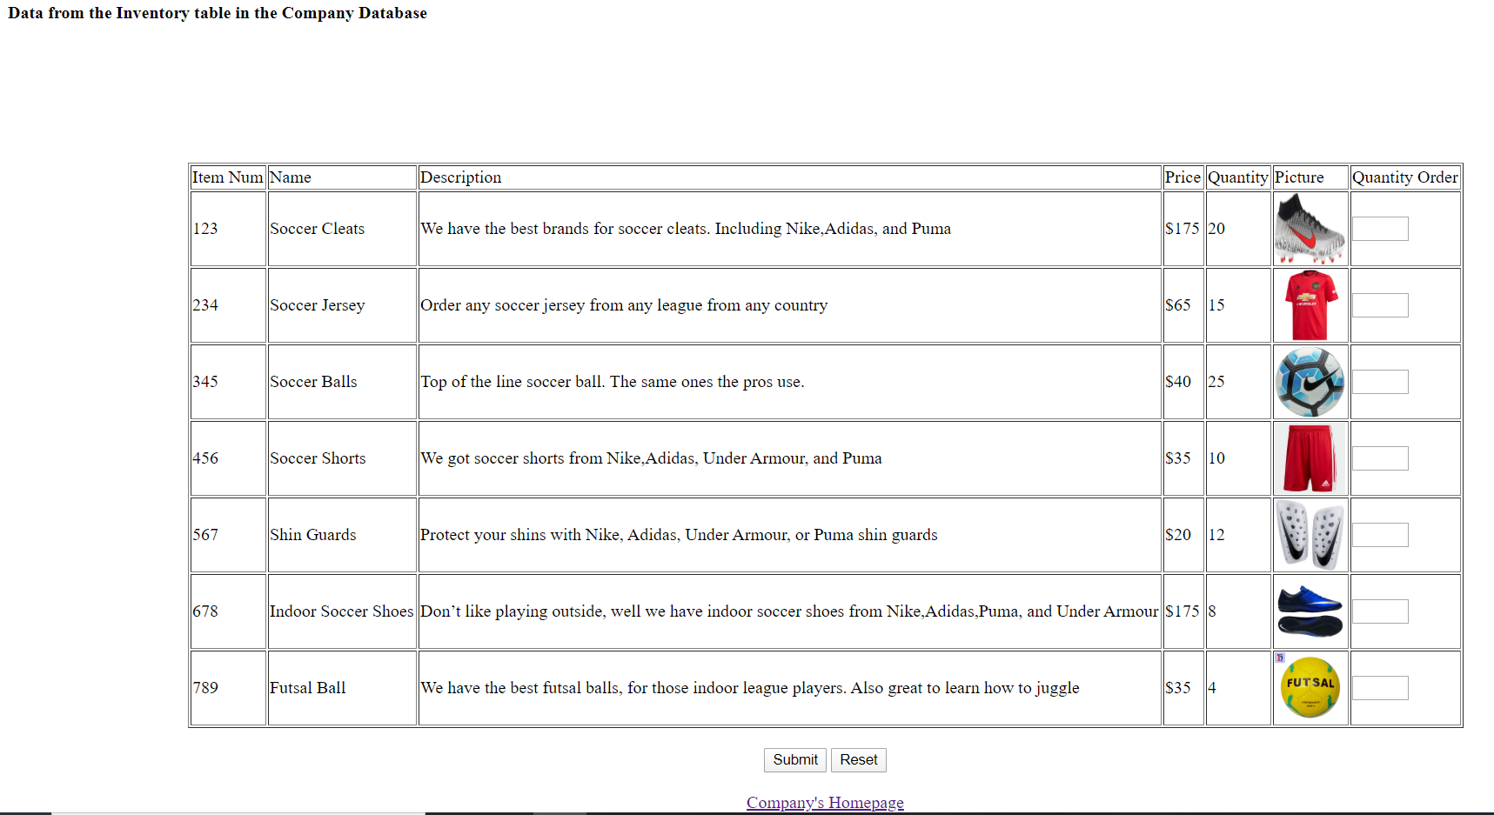

**Source Code:**

<%@ Page Language ="C#" Debug ="true"%>

<%@ Import Namespace ="System.Data.Odbc"%>

<%

Response.Write("<html><head><title>Inventory</title></head><body><form name = 'form1' method = 'post'>");

OdbcConnection myconn;

OdbcCommand mycmd;

OdbcDataReader myreader;

string search = "";

int qtyCount = 0;

if(Request.Form["txtSearch"] == "")

{

Response.Write("Please Search for an item");

}

else

{

search = Request.Form["txtSearch"];

myconn=new OdbcConnection (@"DRIVER={Microsoft Access Driver (*.mdb, *.accdb)};DBQ=c:\inetpub\wwwroot\2020\cd4132\company.accdb");

mycmd = new OdbcCommand("Select * from Inventory where itemName LIKE '%" + search + "%'", myconn);

Response.Write("<b>Data from the Inventory table in the Company Database</b><br>");

myconn.Open();

myreader = mycmd.ExecuteReader();

//Create table

Response.Write("<center><table border =1> <tr> <td> Item Num</td><td> Name </td> <td> Description</td><td> Price</td><td> Quantity</td><td>Picture</td><td>Quantity Order</td></tr>");

while((myreader.Read()))

{

Response.Write("<tr>");

Response.Write("<td>" + myreader["itemNum"] + "</td>");

Response.Write("<td>" + myreader["itemName"] + "</td>");

Response.Write("<td>" + myreader["description"] + "</td>");

Response.Write("<td>$" + myreader["price"] + "</td>");

Response.Write("<td>" + myreader["quantity"] + "</td>");

Response.Write("<td> <img src = \"" + myreader["picture"] + "\"; width = 65; height = 65;><img></td>");

Response.Write("<td> <input type = 'text' name = 'qty" + qtyCount.ToString() + "' size = 3> </td>");

Response.Write("</tr> <br>");

qtyCount = qtyCount + 1;

}

Response.Write("</table><br>");

Response.Write("<input type = 'Submit' name = 'btnSubmit' size = 20> <input type = 'reset' name = 'btnReset' size = 20> </center><br>");

myreader.Close();

myconn.Close();

}

%>

<center><a href = "company.html"> Company's Homepage </a></center>

</form>

</body>

</html>

**Purpose:**  The purpose was to retrieve data from the Company database and pull out all the information in the Inventory table and display it on a webpage.

**What I Learned:** While creating this webpage I learned how the search bar for websites like amazon work. So, I learned how to search for a certain item that is in my item table.

# **Blog**

**Date:** 04/07/2020

**Number of Hours:** 1 hour

**Input:**

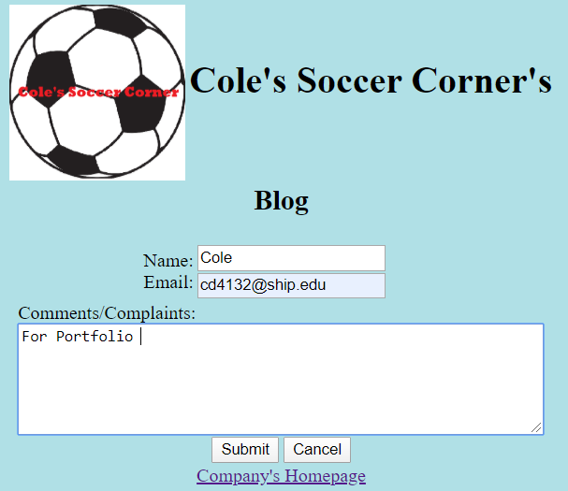

**Output:**

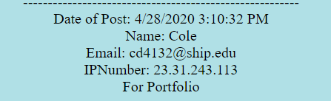

**Source Code:**

<html>

<body style = **"background-color:powderBlue"**>

<form name =**"form1"** method = **"post"** action = **"blog.aspx"**>

<center><table >

<tr>

<td>

<img src = **"soccercorner.png"**; height = **"150"**; width = **"150"**><img>

</td>

<td>

<h1> **Cole's Soccer Corner's** </h1>

</td>

</tr>

<tr>

<td colspan = 2>

<center><h2> **Blog**</h2></center>

</td>

</tr>

</table></center>

<center><table>

<tr>

<td align = **"right"** width = 150>

**Name:** <br style=**"line-height:2px;"**/>

**Email:** <br style=**"line-height:2px;"**/>

</td>

<td>

<input type = **"text"** name = **"txtName"** size = 20><br><br style =**"line-height:2px;"**/>

<input type = **"text"** name = **"txtEmail"** size = 20>

</td>

</tr>

<tr>

<td colspan = 2>

**Comments/Complaints:**<br>

<textarea name = **"comments"** rows = 6 cols = 60 value = **""**></textarea><br><br style =**"line-height:2px;"**/>

<center><input type = **"submit"** name = **"btnSubmit"** size = 10>

<input type = **"reset"** name = **"btnCancel"** value = **"Cancel"** size = 10><br><br style =**"line-height:2px;"**/>

<a href = **"company.html"**> **Company's Homepage**</a></center><br>

</td>

</tr>

</table></center>

</form>

</body>

</html>

<%@ Page language = "c#"%>

<html>

<body>

<%

System.IO.StreamWriter outfile = new System.IO.StreamWriter(@"c:\inetpub\wwwroot\2020\cd4132\blog.html",true);

bool errorFlag = false;

string errorMsg = "";

if(Request.Form["txtName"] == "")

{

errorFlag = true;

errorMsg = errorMsg + "Please enter in your name! <br>";

}

if(Request.Form["txtEmail"] == "")

{

errorFlag = true;

errorMsg = errorMsg + "Please enter in your email! <br>";

}

if(Request.Form["comments"] == "")

{

errorFlag = true;

errorMsg = errorMsg + "Please leave a comment or complaint";

}

if(errorFlag == true)

{

Response.Write(errorMsg);

outfile.Close();

}

else

{

outfile.WriteLine("<center>");

outfile.WriteLine("--------------------------------------------------------<br>");

outfile.WriteLine("Date of Post: " + DateTime.Now+"<br>");

outfile.WriteLine("Name: " + Request.Form["txtName"]+"<br>");

outfile.WriteLine("Email: " + Request.Form["txtEmail"]+"<br>");

outfile.WriteLine("IPNumber: " + (HttpContext.Current.Request.ServerVariables["Remote_ADDR"]+"<br>"));

outfile.WriteLine(Request.Form["comments"]+"<br>");

outfile.WriteLine("</center>");

outfile.Close();

Response.Redirect("blog.html");

}

%>

</body>

</html>

**Purpose:** Enter in your name, email address and what your complaint or comments are. The site will then refresh and display your name, email, date and time of post, your IP address, and your comments.

**What I learned:**  I learned out to output the user input onto the same page they are viewing with the help of Response.Redirect. I also learned out to print the users IP address.

# **Add Inventory**

**Date:** 4/30/2020

**Number of Hours:** 1 hour

**Input:**

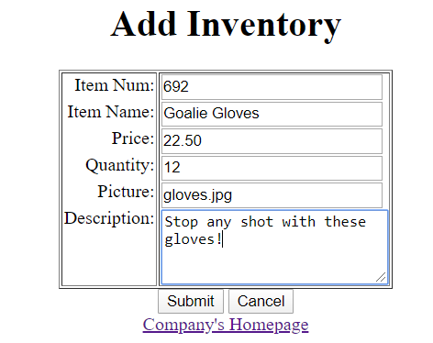

**Output:**



**Source Code(addInventory.html):**

<html>

<body>

<form name = **"form1"** method = **"post"** action = **"addInventory.aspx"**>

<center><h1> **Add Inventory**</h1>

<table border = 1 valign = **"top"**>

<tr>

<td align = **"right"** valign = **"top"**> **Item Num:** <br><br style=**"line-height:5px;"**/>

**Item Name:** <br><br style=**"line-height:5px;"**/>

**Price:** <br><br style=**"line-height:5px;"**/>

**Quantity:** <br><br style=**"line-height:5px;"**/>

**Picture:** <br><br style=**"line-height:5px;"**/>

**Description:** </td>

<td><input type = **"textbox"** name = **"txtNum"** size = **"25"**><br><br style=**"line-height:2px;"**/>

<input type = **"textbox"** name = **"txtName"**size = **"25"**><br><br style=**"line-height:2px;"**/>

<input type = **"textbox"** name = **"txtPrice"** size = **"25"**><br><br style=**"line-height:2px;"**/>

<input type = **"textbox"** name =**"txtQty"** size = **"25"**><br><br style=**"line-height:2px;"**/>

<input type = **"textbox"** name = **"txtPic"** size = **"25"**><br><br style=**"line-height:2px;"**/>

<textarea name = **"description"** rows = **"4"** cols = **"25"**></textarea></td></tr>

</table>

<input type = **"submit"** name = **"btnSubmit"**>

<input type = **"reset"** name = **"btnReset"** Value = **"Cancel"**><br>

<a href =**"company.html"**> **Company's Homepage**</a></center>

</form>

</body>

</html>

**addInventory.aspx:**

**<%**@ Page Language **=** "C#" Debug **=**"true"**%>**

**<%**@ Import Namespace **=** "System.Data.Odbc"**%>**

**<%**

Response**.**Write**(**"<html> <body>"**);**

string errorMsg **=** ""**;**

bool errorFlag **=** **false;**

OdbcConnection myconn**;**

OdbcCommand mycmd**;**

OdbcDataReader myreader**;**

**if(**Request**.**Form**[**"txtNum"**]** **==**""**)**

**{**

errorFlag **=** **true;**

errorMsg **=** errorMsg **+** "Please fill in the item number! <br>"**;**

**}**

**if(**Request**.**Form**[**"txtName"**]** **==** ""**)**

**{**

errorFlag **=** **true;**

errorMsg **=** errorMsg **+** "Please fill in the item name! <br>"**;**

**}**

**if(**Request**.**Form**[**"txtPrice"**]** **==** ""**)**

**{**

errorFlag **=** **true;**

errorMsg **=** errorMsg **+** "Please fill in the item price! <br>"**;**

**}**

**if(**Request**.**Form**[**"txtQty"**]** **==** ""**)**

**{**

errorFlag **=** **true;**

errorMsg **=** errorMsg **+** "Please fill in the item quantity! <br>"**;**

**}**

**if(**Request**.**Form**[**"txtPic"**]** **==** ""**)**

**{**

errorFlag **=** **true;**

errorMsg **=** errorMsg **+** "Please fill the file name of the picture! <br>"**;**

**}**

**if(**Request**.**Form**[**"description"**]** **==** ""**)**

**{**

errorFlag **=** **true;**

errorMsg **=** errorMsg **+** "Please fill in the description of the item! <br>"**;**

**}**

**if(**errorFlag **==** **true)**

**{**

Response**.**Write**(**errorMsg**);**

**}**

**else**

**{**

myconn**=new** OdbcConnection **(**@"DRIVER={Microsoft Access Driver (*.mdb, *.accdb)};DBQ=c:\inetpub\wwwroot\2020\cd4132\company.accdb"**);**

mycmd **=** **new** OdbcCommand**(**"Insert into Inventory values('" **+** Request**.**Form**[**"txtNum"**]** **+** "' , '" **+** Request**.**Form**[**"txtName"**]** **+** "' , '" **+** Request**.**Form**[**"description"**]** **+** "' , '" **+** Request**.**Form**[**"txtPrice"**]** **+** "' , '" **+** Request**.**Form**[**"txtQty"**]** **+** "' , '" **+** Request**.**Form**[**"txtPic"**]** **+** "')"**,**myconn**);**

myconn**.**Open**();**

myreader **=** mycmd**.**ExecuteReader**();**

myreader**.**Close**();**

myconn**.**Close**();**

Response**.**Write**(**"Item Added!"**);**

**}**

**%>**

**</**body**>**

**</**html**>**

**Purpose:** The purpose of the webpage is to be able to add items to the Inventory table in the company database. You’re supposed to fill out all the information on the webpage and click submit. It then will insert those values into the inventory table. Then when you click on the Inventory page it should display all the information you added.

**What I learned:** I learned how to use the insert command to add items to a table in a database. I learned how to properly concatenate a string with user input, in proper SQL syntax.

# **Kitty App**

**Date:** 01/30/2020

**Number of Hours:** 30 minutes

**Output: Source Code:**

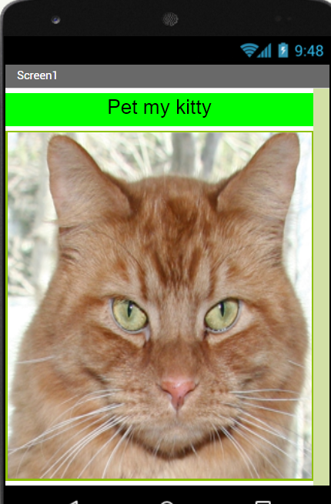 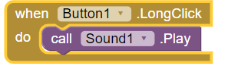

**Purpose:** When the picture of the cat is pressed, the kitty will meow.

**What I learned:** I learned how to create an app in app inventor. I learned how to upload a picture and audio to app inventor. I learned how to make the app do something when the event click happens.

# **Tip Calculator**

**Date:** 02/06/2020

**Number of Hours:** 1 hour

**Output: Source Code:**

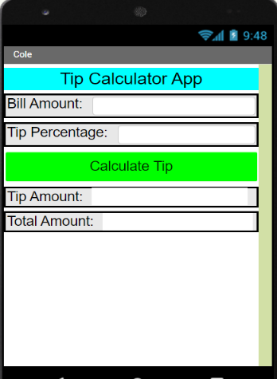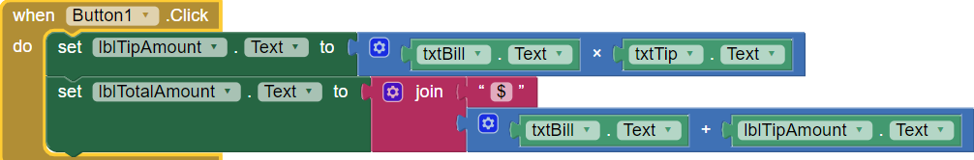

**Purpose:** The purpose of this app is to find out what your total bill should be when you add the tip. You have to enter in your bill amount and the tip percentage. Then click on Calculate Tip and your tip amount and total amount will show.

**What I learned:** I learned how to use math operations, and how to join strings together in app inventor.

# **Browser**

**Date:** 02/25/2020

**Number of Hours:** 1 hour

**Output: Source Code:**

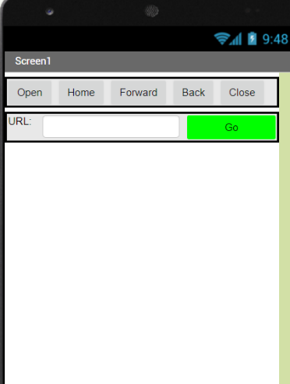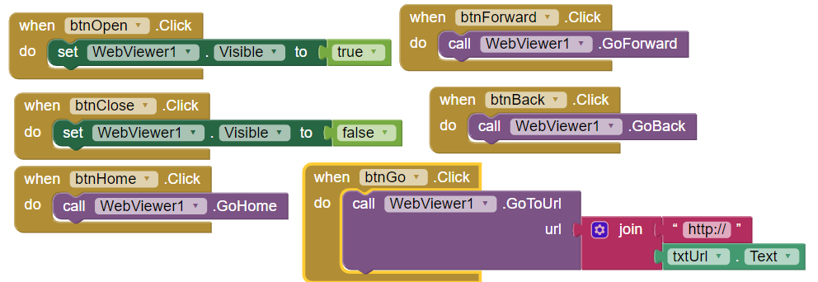

**Purpose:** The purpose of this app is to take you to the URL you search in the search box. When you click go it will take you to that URL. Clicking Home will take you to the home page, which is ship.edu. Forward will take you forward to the next web page. Clicking Back will take you back a web page.

**What I learned:** I learned how the WebViewer worked in the app inventor. I learned the WebViewer has built in methods to make it easier to use, like the .GoHome method.

# **Stopwatch**

**Date:** 04/14/2020

**Number of Hours:** 2 hours

**Output: Source Code:**

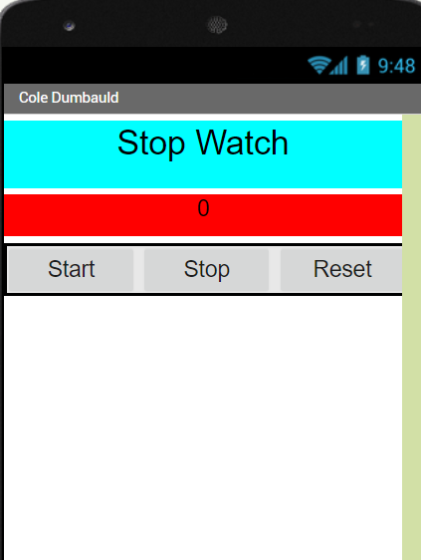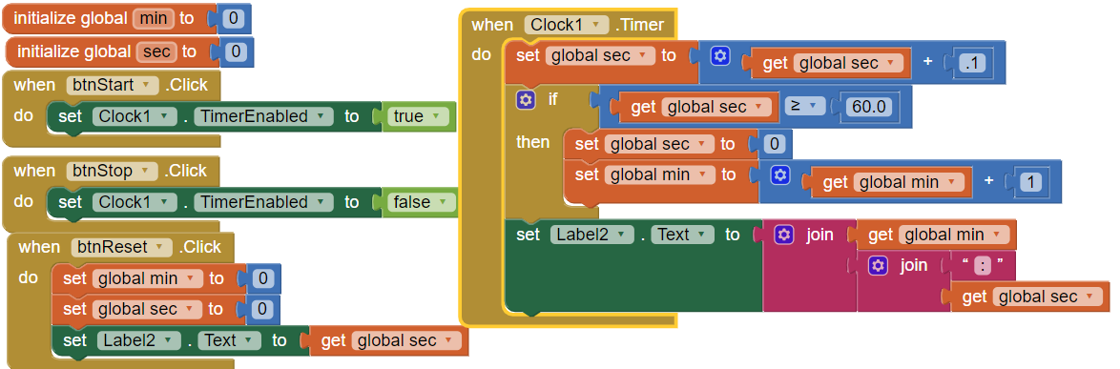

**Purpose:** The purpose of the stopwatch app is to keep track of minutes and seconds that have passed when clicking start. When clicking stop the stopwatch will stop. When clicking reset the minutes and seconds will be set to 0. When the stopwatch goes past 60 seconds, it will add a minute to label and keep track of how many minutes went by.

**What I learned:** I learned how the timer works in app inventor. I learned how to keep track of the minutes when 60 seconds have passed.

# **Painting**

**Date:** 04/21/2020

**Number of Hours:** 30 minutes

**Output: Source Code:**

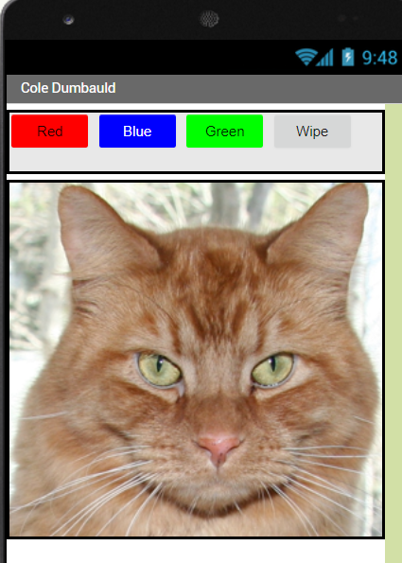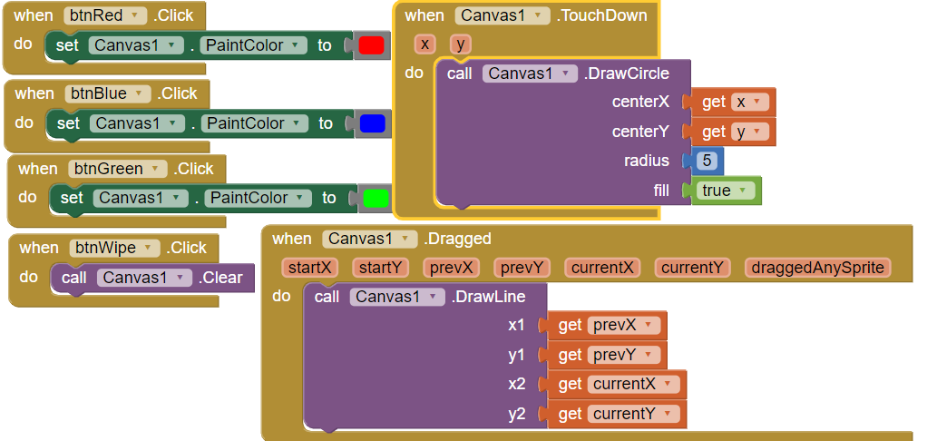

**Purpose:** When clicking on the colored buttons, it will change the color of the paint based on which button was clicked. Clicking on the Wipe button will clear the canvas. When you just press down on the canvas or kitty it will draw a circle. If you drag your finger across the canvas it will draw a line from where you started dragging till when you stopped.

**What I learned:** I learned how to draw a circle on the canvas, and how to draw a line on the canvas.