Project: Weather Trends

In this project, we are asked to analyze weather trends in our country with respect to global data. In order to achieve this, I have follow below steps;

* Reaching database by using SQL commands, SELECT FROM
  + For accessing city data below code;

SELECT city,year,avg_temp

FROM city_data

WHERE city='Adana'

ORDER BY year

Below command will give all “global_data” table.

SELECT *

FROM global_data

* Data is collected in .xls sheet and analyzed by using Excel commands.
* For analyzing, I have used moving averages as suggested. I have performed moving average operation as taking average of first three element and then taking average of second element to fourth element and so on. Then I have created a line chart from moving averages of global data and my country data.
* 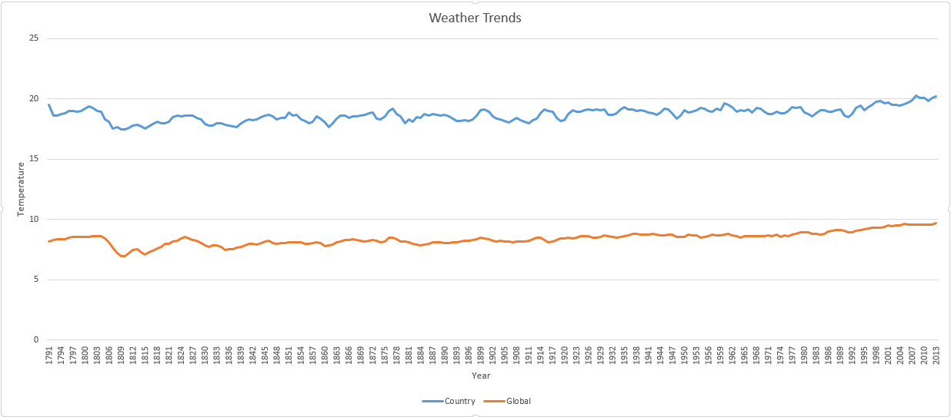Resulting Line Chart

Figure 1: Line Chart of Weather Trend

Observations:

1. Weather Trend in my country, Adana/Istanbul, does not oscillate too much. It is always between 15 and 20 degree.
2. The difference between global and country data seems same during years. Their difference is almost 10 degree.
3. Weather trend between the years 1803 and 1810 is decreasing and then sudden increasing to year 1812 and again it has decreasing characteristics. Between these years, global and country trend is same.
4. Global weather data oscillation is much better than the country oscillation.