RESEARCH PROJECT REPORT

AUTONOMOUS MOBILE BUOY FOR MONITORING THE HEALTH OF LAKE WAIKARE

Cromwell Pilacan

Co-worker: Connor Dunn

Supervisor: Dr Akshat Bisht

Co-supervisor: Dr Kevin I-Kai Wang

Department of Electrical, Computer and Software Engineering
The University of Auckland

October 2025

ABSTRACT

Abstract goes here.

DECLARATION
Student

I hereby declare that:

- This report is the result of the final year project work carried out by my project partner (see cover page) and I under the guidance of our supervisor (see cover page) in the 2025 academic year at the Department of Electrical, Computer and Software Engineering, Faculty of Engineering, University of Auckland.
- This report is not the outcome of work done previously.
- This report is not the outcome of work done in collaboration, except that with a potential project sponsor (if any) as stated in the text.
- This report is not the same as any report, thesis, conference article or journal paper, or any other publication or unpublished work in any format.

In the case of a continuing project, please state clearly what has been developed during the project and what was available from previous year(s):

Signature:

Date:

RESEARCH PROJECT REPORT 1
ABSTRACT 2
DECLARATION 3
Acknowledgements 5
Glossary of Terms 6
Abbreviations 6
1. Introduction 1
2. Project Scope and Objectives 1
2.1. Project Scope 1
2.2. Objectives and Deliverables 1
2.3. Constraints and Assumptions 1
3. Literature Review 1
3.1. Commercial Solutions 1
3.2. Existing Project Solutions 1
3.3. Identified Research Gaps 1
4. System Design 1
4.1. System Architecture 2
4.2. Physical Design 2
4.2.1. Hull(INCLUDE PHOTO) 2
4.2.2. Propulsion System(INCLUDE PHOTO) 2
4.2.3. Waterproof Box and Mounting 3
4.3. Autonomy Hardware and Software (CONFIRM RATIONALE WITH CONNOR) 3
4.4. Power Supply and Distribution System 4
4.4.1. Batteries 4
4.4.2. Solar Panels(PHOTOS OF SETUP?) 5
4.4.3. Power Distribution 6
4.5. PCB Design 7
4.5.1. Size Requirements 7
4.5.2. Power Converter & Distribution 7
4.5.3. Current Sensing 8
4.5.4. Battery Balancing & Voltage Sensor 8
4.5.5. Power Switching 8
4.5.6. Sonar Integration 8
4.5.7. Communications 8
4.5.8. Jumpers for Current Sensors 8
4.5.9. ESP Motor Control 8
4.5.10. Final PCB Design 9
4.6. Final Design Implementation(INCLUDE PHOTOS AND DIAGRAMS) 9
5. Methodology 9
5.1. Lab Testing 9
5.2. Field Testing 9
5.2.1. Set up 9
5.2.2. Autonomy 9
6. Power Results 9
6.1. Lab Results 9
6.2. Field Results 9
7. Discussion 10
7.1. Current Draw 10
7.2. Calculating Solar Power 10
7.3. Net Energy Expenditure 10
7.4. Deployment Implications 10
7.5. Challenges 10
9. Future Works 10
10. Conclusion 10
References 11
Appendix A – System Design Diagram and Photos 12
A1. Power Distribution Diagram 12
A2. PCB Schematic from Altium 12
A3. Full System Wiring Diagram 12
A4. Physical Layout Diagram 12
A5. Testing Set Up 12
A6. Final Set Up 12
Appendix B – Final Implementation Bill of Materials 13
Appendix C – Testing Results 16
C1. Lab Testing Results 16
C2. Field Testing Results 16

Acknowledgements
Thank important people here. Be sure to thank your mum.

Lake owners.

Drone boat designer.

Glossary of Terms
ArduPilot
ArduRover

Abbreviations
USV Unmanned Surface Vehicle
ASV Autonomous Surface Vehicle
ESC Electric Speed Controller
SLA Sealed Lead Battery
LiPo Lithium Polymer
LiFePO₄ Lithium Iron Phosphate
PCB Plastic Circuit Board

Introduction
Idk what goes here.

Project Scope and Objectives
mhmmm project.

Project Scope
I focus on this.

Objectives and Deliverables
Define something idk anymore.

Constraints and Assumptions
Lake Pupuke = Lake Waikare.

Literature Review
Stuff.

Commercial Solutions
Existing stuff.

Existing Project Solutions
Project stuff.

Identified Research Gaps
Non existing stuff.

System Design
After reviewing existing commercial solutions and technologies, this project aims to design and develop an autonomous buoy capable of self-navigation using onboard-generated waypoints, while being energy self-sufficient. This would require a design that can achieve basic autonomy while leaving room for improvement, both in its autonomous capabilities and power-saving qualities.
The buoy design is required to provide a low-cost, reliable platform to support research and development into autonomous navigation and extended operational uptime in lake environments. The design prioritises reliability, affordability, and replicability by using proven, commercially available, and cost-effective components. The early stages of development involved reviewing existing ASV projects to provide insights into building an autonomous mobile buoy.
This section outlines the design process and component selection for each subsystem, including the physical structure, the autonomy hardware and software, and the power supply and distribution system.

System Architecture
The diagram in Figure 4.1, shows the design we plan to use as the foundation for our research.
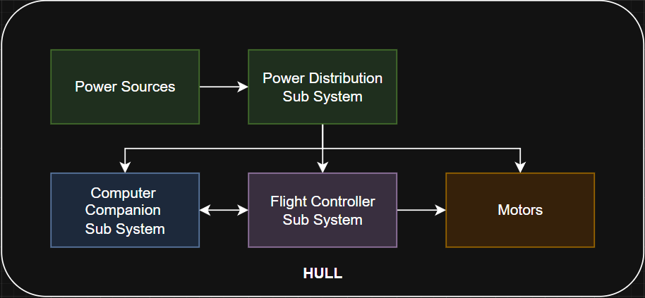
Figure 4.1 System Diagram.
This design provides a solid foundation for the development of autonomy, utilising pre-existing software, such as ArduPilot, as the basis of the design.

Physical Design
The physical design of the buoy provides the structural foundation for all onboard systems, supporting electronics, propulsion systems and sensors whilst maintaining stability in lake environments. Key considerations include stability, maintenance, and structural complexity.

Hull(INCLUDE PHOTO)
Several hull configurations were evaluated to determine a suitable base for our buoy design. Options such as monohull, catamaran, trimaran, horseshoe buoy, life buoy and spar buoys were considered. Canoe-like builds, such as a monohull, catamaran or trimaran designs, were dismissed due to their structural complexity, which was undesirable given the one-year time frame and the lack of mechanical design background within the team. Circular and spar buoy designs were excluded due to their rotational symmetry, which causes unwanted spinning and is anticipated to result in harder directional control. Horseshoe buoys, while more stable, were eliminated due to their limited flat surface area for secure mounting of electronics and propulsion systems. Ultimately, a simple boogie board design was selected for its simplicity, stability, ease of integration, and low cost and high availability.

Propulsion System(INCLUDE PHOTO)
Multiple propulsion configurations were considered to achieve efficient and reliable mobility for the buoy. The options included single or dual azimuth motors, a motor and rudder combination, and twin fixed motors. Azimuth systems were dismissed due to the added control requirements associated with motor rotation. The motor and rudder configuration was excluded as the rudder introduced additional drag and moving parts, reducing overall efficiency. Ultimately, a twin fixed motor setup with skid steering was selected for its simplicity and low drag, making it the most suitable choice for our flat hull platform.
The T200 thrusters from BlueRobotics [1], as shown below in Figure 4.2, were selected for their proven reliability and widespread use in the USV project realm. Although they are not the cheapest commercially available option, their robust and proven design reduces the likelihood of future mechanical or electrical failures. The necessary supporting hardware, including ESCs [2] and mounting brackets [3], was also sourced from BlueRobotics to ensure full compatibility and simplify integration.
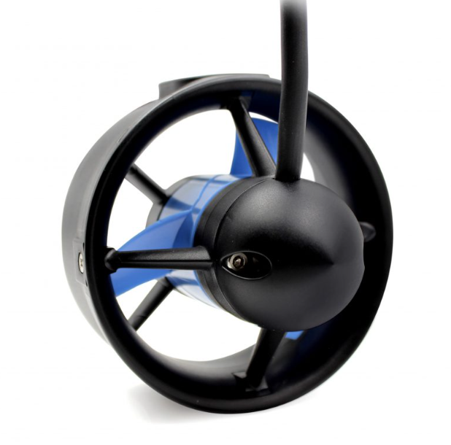
Figure 4.2, T200 Motors from BlueRobotics [1].

Waterproof Box and Mounting
A square waterproof box, for the electronics, was provided by our supervisor and acts as the enclosure for all our hardware. The box is approximately 19cm x 19cm x 11cm in size and has a plate inside for component separation that is approximately 18cm by 18cm in size. This plate is intended to be used to separate excess wires to allow for a clean and accessible top level.
The enclosure was mounted using 3D printed brackets based on open-source designs from similar projects [4]. These brackets secured the box firmly in place, while a fishing line tether at the hinges maintained downward tension to prevent movement during operation.

Autonomy Hardware and Software (CONFIRM RATIONALE WITH CONNOR)
The autonomy hardware forms the backbone of the buoy’s navigation and control systems, providing a foundation for future research and development aimed at expanding the buoy’s autonomous capabilities. Additional safety features such as remote-control override, return to launch and battery capacity reading were also essential to allow for safe testing. A review of existing ASV projects highlighted the widespread use of ArduPilot, making it the logical choice as the core software platform to design around.
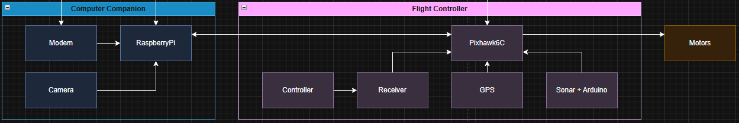
Figure 4.3, Autonomy Hardware Subsystem
Component selection for achieving autonomy was primarily led by Connor Dunn. The essential components include a flight controller, companion computer, power controller, sonar and wireless communication system. The design rationale and detailed evaluation for these components are outlined in his report. Key selection criteria included ArduPilot compatibility, MAVLink support, and component availability.
For completeness, the following key components were selected:
- Pixhawk6C was chosen as the flight controller for its proven ArduPilot support for ASVs and the design housing many ports, increasing the number of integrated peripherals.
- The M10 GPS module was selected to minimise power usage, as its lower accuracy compared with the M9N does not significantly affect navigation performance in this implementation.
- Raspberry Pi Zero 2W was chosen as the computer companion due to its proven MAVLink compatibility and Wi-Fi capabilities.
- ESP32 was chosen as the power controller for its minimum current draw and deep sleep functionality.
- Sonar chosen was the GL041MT for its accessibility and supporting documentation.

Power Supply and Distribution System
Important criteria for the power supply and distribution system include meeting the electrical demands of all onboard hardware, high power density for extended testing whilst fitting the box and supporting easy recharging to facilitate iterative development. Additionally, all components should minimise environmental impact in the event of waterproofing failure. This section outlines the design considerations and component selections made to satisfy these requirements. It is important to note that all components were bought to save on time and to maximise the number of components bought commercially, making the project easier to replicate by anyone.
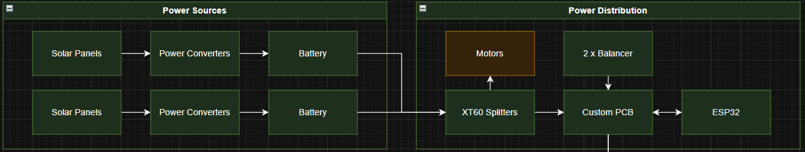
Figure 4.4, Power Subsystem.

Batteries
The commercially available battery types considered included SLA, LiPo, and LiFePO₄. Lead acid batteries, including SLA variants, were excluded early due to their highly toxic chemical composition and environmental risk in the event of leakage.
Due to availability and cost, the following LiFePO₄ and LiPo batteries were compared.
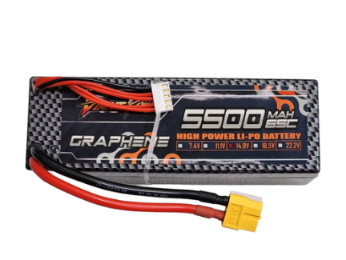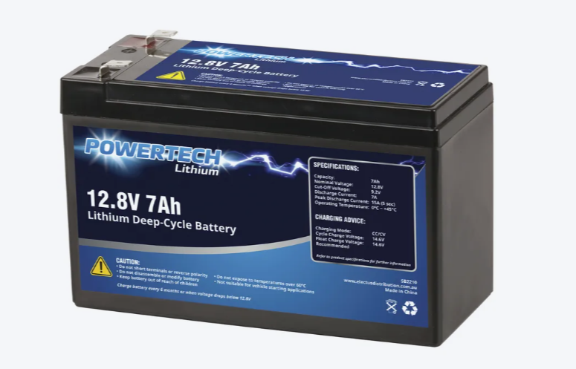
Figure 4.5, LiPo battery from HobbyStation and the LiFePO₄ [5] battery from SaveBarn [6] as shown in Figure 4.6.
Although the LiFePO₄ batteries offers longer lifespans and are well suited to long duration applications, the LiPo batteries were selected for their superior power density and high maximum discharge current required by the T200 motors, as shown in Figure x below.
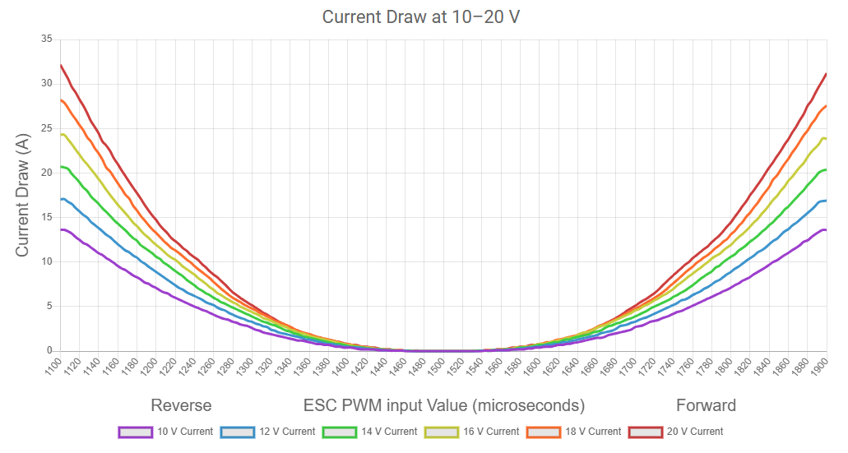
Figure 4.7, Current draw requirements for T200 motors from BlueRobotics [1].
The specific battery chosen was a 5500 mAh capacity 65 C Graphene Hardcase LiPo battery from Hobby Station for testing purposes. Following initial integration, an additional identical battery was incorporated after confirming sufficient space within the box, allowing extended runtime and improved system endurance.
Additionally, appropriate cell balancing boards were implemented to interface with the selected LiPo batteries via the custom designed power distribution board.

Solar Panels(PHOTOS OF SETUP?)
To support the dual battery configuration, two solar panels were implemented to simplify the charging and integration process. The primary requirement was physical compatibility with the hull, as both panels needed to fit securely on the buoy’s surface. Additional considerations included connector simplicity, cost, and local availability. Monocrystalline panels were selected over polycrystalline and thin film alternatives due to their higher efficiency and longer operational lifespan.
The final selected solar panels consisted of two 12 V, 20 W monocrystalline panels from Jaycar [7], chosen for their suitable dimensions, availability, and straightforward two wire connection interface. Supporting hardware for solar integration was sourced from Epartners, a well-established electronics supplier in New Zealand. This hardware included a step-down buck converter and a boost charger to regulate and optimise charging performance. The 18650 Battery Charger Board [8] was selected due to availability and compatibility. Due to a USB-C input, the buck converter chosen [9] had an available USB output, which was selected to allow for a secure connection. The specific setup, hardware and mounting have been shown in Figures 4.8 and 4.9 below.
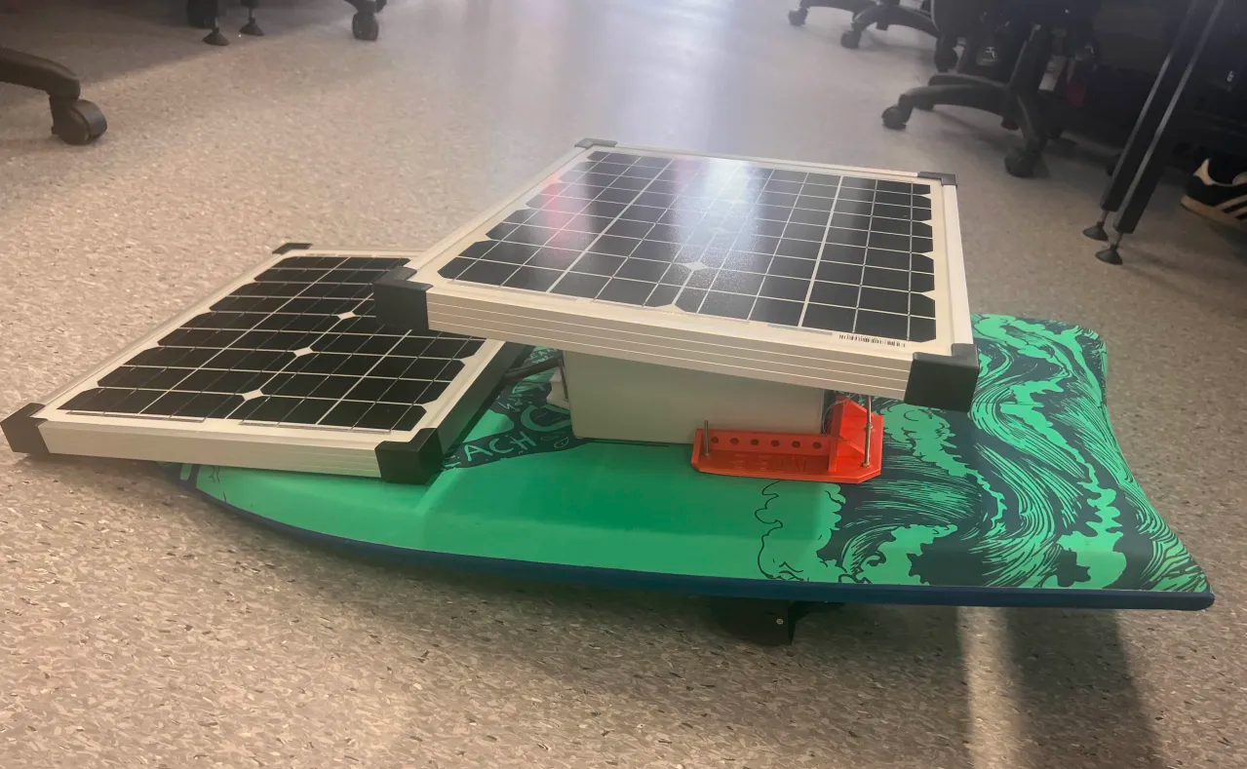
Figure 4.8, Solar panel mounting plan.
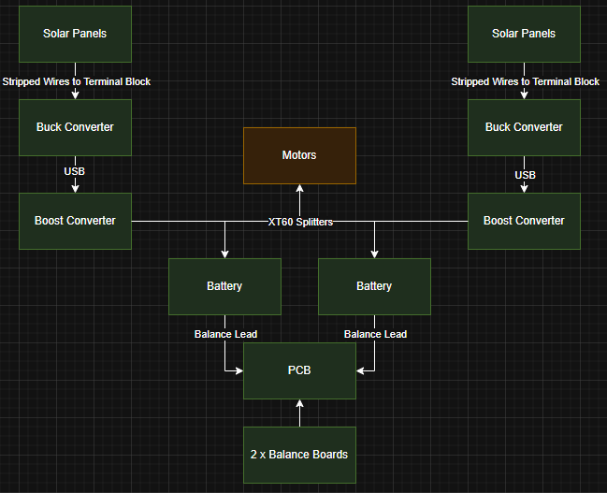
Figure 4.9, Power Sources Connection Diagram

Power Distribution
The primary purpose of the power module was to serve as a temporary power distribution board while the custom one was being designed and built. This board is required to provide power to the motors and flight controller, as these act as the main components for mobility. Additional peripherals would be powered through an external power bank supplied by Connor Dunn.
The commercially available power distribution board options considered were the PM02 [10], PM06 [11], and PM07 [12]. The PM06 and PM07 were preferred over the PM02 due to their ability to distribute power to the ESCs controlling the thrusters directly. The decision to select the PM07 over the PM06 was primarily driven by its enhanced compatibility with both the Pixhawk 6C flight controller and the motor ESCs. Although the PM06 distributes power to the motors, it does not allow for motor control through the board itself. As shown in Figure 4.9, the PM06 only has one connector. This is a power connector and does not allow for motor control through itself. In contrast, in Figure 4.10, the PM07 is shown to have an IO-PWN-in input that connects to a flight controller and controls the motor’s signal pins.
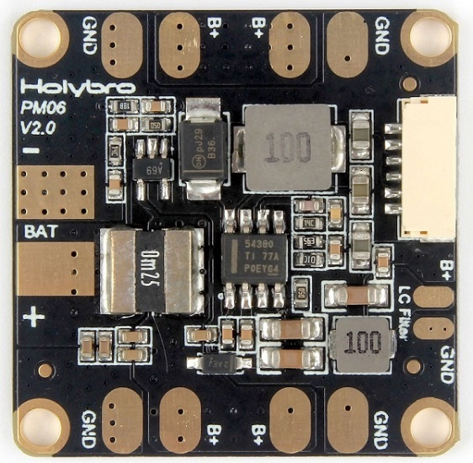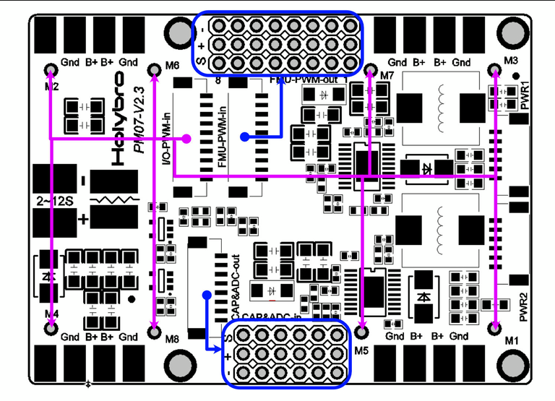
Figure 4.10, PM06 pinout [9]. Figure 4.11, PM07 pinout [10].

PCB Design
A custom PCB was required to incorporate power saving techniques while allowing for power distribution and communications between required hardware. This section covers all the hardware design requirements and features offered by the PCB. The firmware implementation of this hardware can be found in Connor Dunn’s report.

Size Requirements
The batteries and the modem determined the space left over for the PCB, as these could not be directly mounted to fit on top of the PCB. The remaining space was approximately 8cm by 18cm, and Figure 4.11, shown below, illustrates the intended setup.
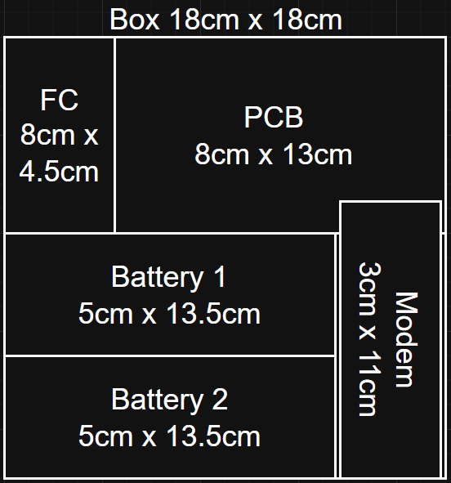
Figure 4.11, Hardware placement diagram.

Power Converter & Distribution
Power needs to be distributed to the motors, flight controller, power controller and computer companion. As a 4S LiPo battery has been chosen, to allow for the peripherals to be powered by the same battery as the motors, the voltage must be stepped down to 5V for the microcontrollers. The same buck used in solar set up was used for this purpose due to availability and size.

Current Sensing
Current sensing is required to fully understand where power is being used, and thus where power can be saved. These current sensors are required to be as compact as possible and be able to match the maximum current output of the buck, which is 3A. The GY – 471 current sensors from Epartners [13] were used due to their compact size, specifications and compatibility with header pins, increasing the space-saving potential.

Battery Balancing & Voltage Sensing
Accessing the battery voltage would allow the buoy to determine what it can turn off and when it should return home. The power hierarchy and return to launch feature implementation specifics can be found in Connor Dunn's report. This feature is achieved using a JST connector on the PCB that connects to the balance lead on the LiPo battery. The lowest cell voltage is sent to an ADC pin on the ESP-32 through a basic resistor divider, for appropriate scaling, and a voltage buffer to reduce the current drawn. The connector is also used to connect to offboard LiPo battery balances, allowing for onboard balancing.
The resistors used to create the divider were sourced from the University of Auckland's component shop, the operational amplifier used to create the voltage buffer was sourced from Digikey based on availability [14], and the balance boards came from AliExpress. They were chosen due to their compatibility, ability to balance 4S LiPo batteries, and availability [15].

Power Switching
Power switching allows the power controller to switch off boards when deemed unnecessary. This action can save on power, allowing the solar panels to recharge the battery while draining a minimal amount of power. To achieve these, active high-relays were chosen from Digikey [16] due to their availability. An active high logic is also preferred in the case of power losss.

Sonar Integration
Obstacle avoidance hinges on the use of an effective sonar. For the appropriate wiring of the GL041MT sonar, a post on DFROBOT [17] was followed, outlining the required pinout, voltage and signal pin specifications. This required an additional Arduino Nano to be included within the design.

Communications
To enable autonomy communication between different microcontrollers and peripherals were required. These connections, including their communication type and connector, are outlined below in Figure 4.12.
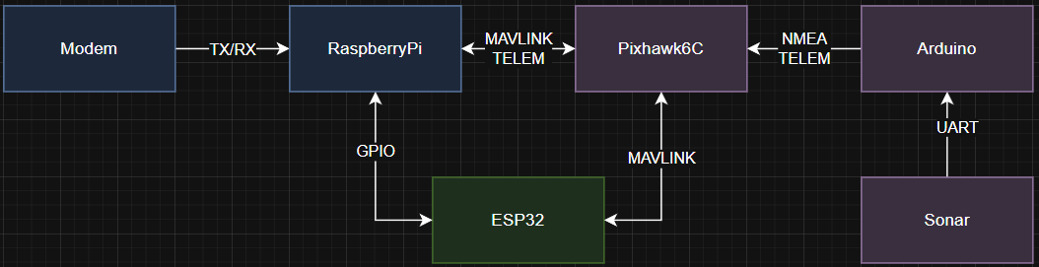
Figure 4.12, PCB Communications Diagram

Jumpers for Current Sensors
Header pins were included in the design to be used alongside header pin jumpers to short circuit past the current sensors to further save on overall power. Allowing the use of the sensors for diagnostic purposes.

ESP Motor Control
The T200 motor specifications, from BlueRobotics [1], include the specific signal pin required to control the ESCs output. This is shown below in Figure 4.13.
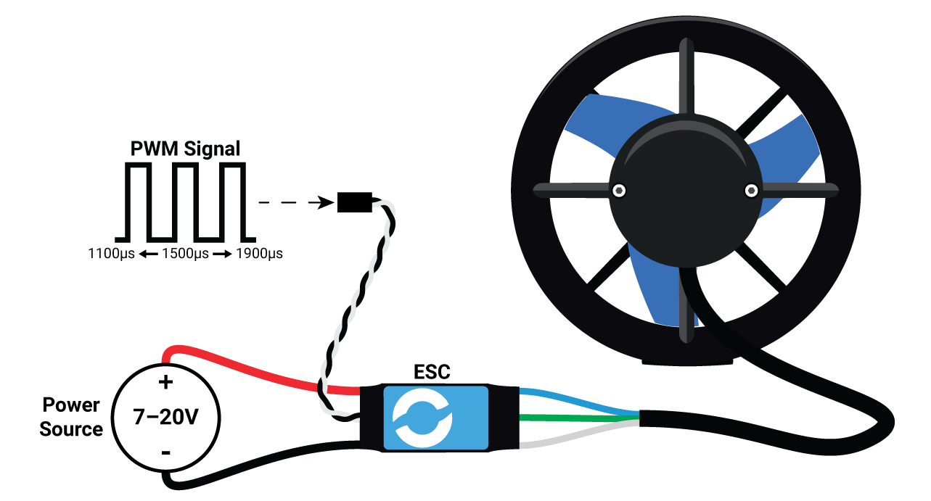
Figure 4.13, T200 ESC Signal Pin Input.
Knowing that the ESCs can be driven by a simple PWM pin allows complete control of the boat through any microcontroller. The PCB has been designed to allow the signal pin of the motors to be controlled by either the PixHawk6c, the flight controller, or the ESP-32. The power-saving potential of this specific design choice is explored in the discussion.

Final PCB Design
Figure 4.14, and 4.15 show the Altium schematic and PCB document for the design PCB.
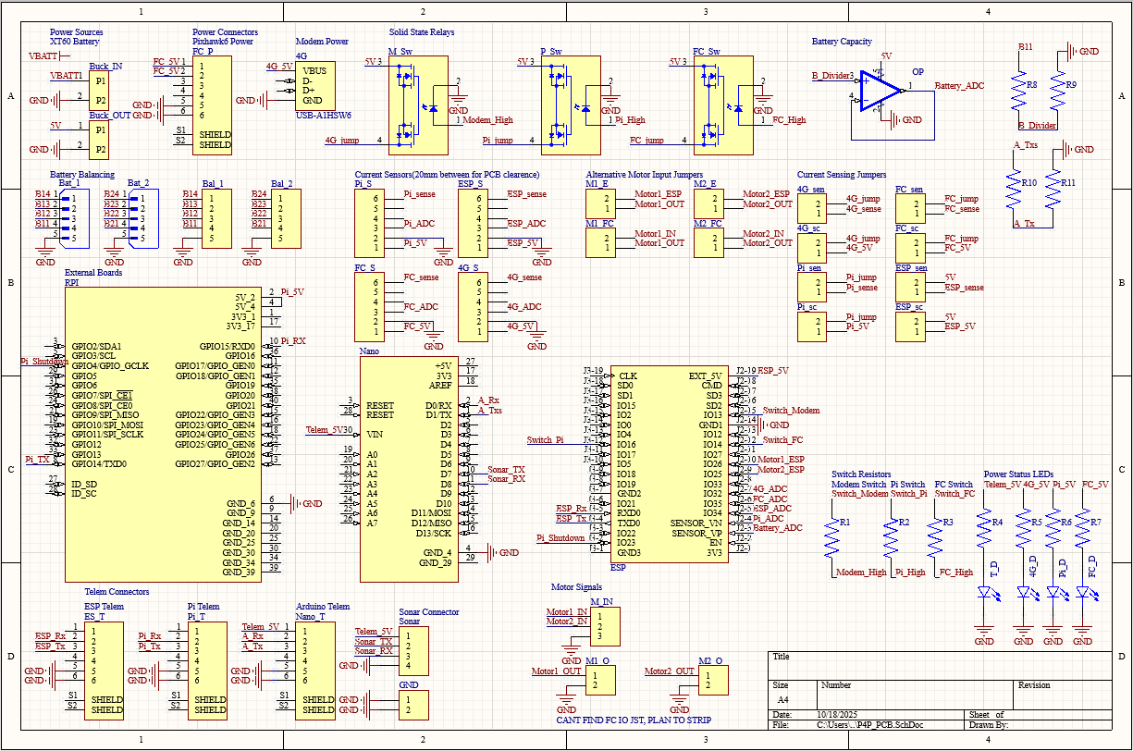
Figure 4.14, Altium Schematic for PCB.
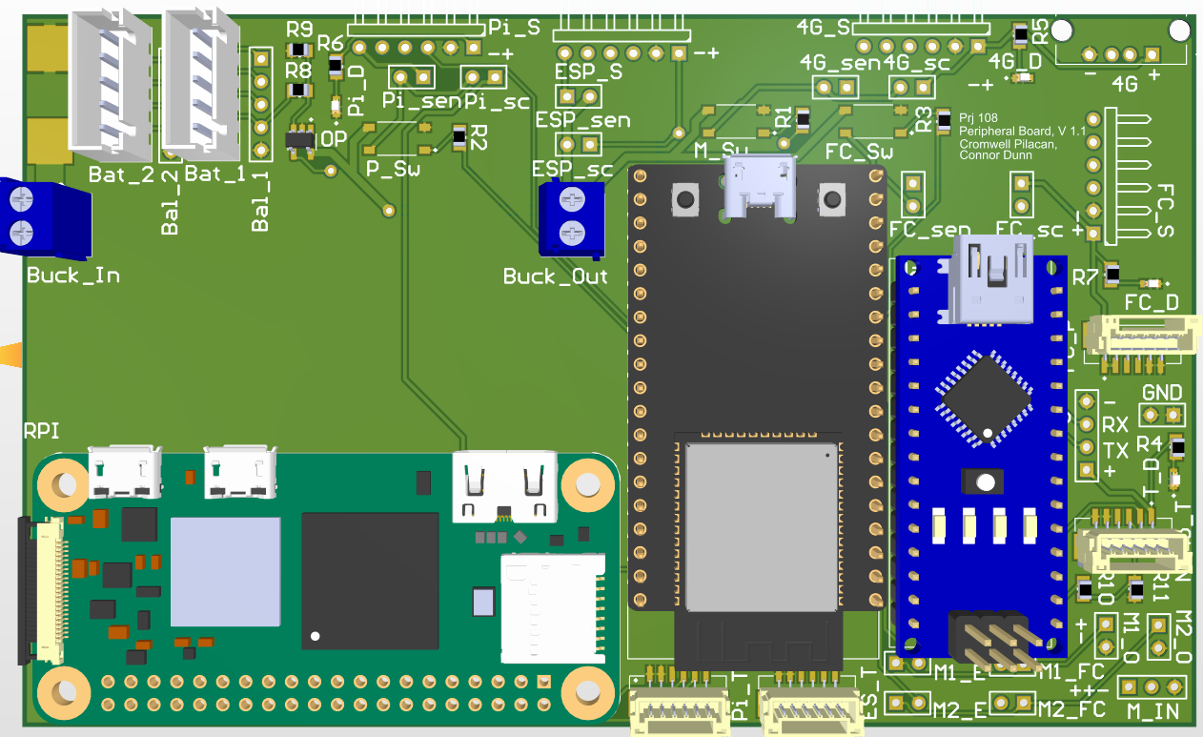
Figure 4.15, Altium 3D View of PCB.

Final Design Implementation
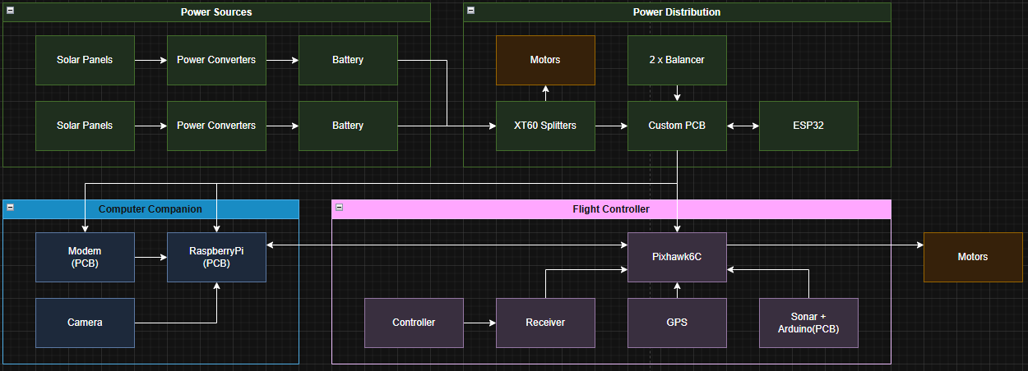
Figure 4.16 Final Design Implementation.

Methodology
Research included lab testing, for benchmarks and expectations.
Design validation to test autonomy.
Power reading autonomy.

Lab Testing

Field Testing

Set up

Autonomy

Power Results

Lab Results

Field Results
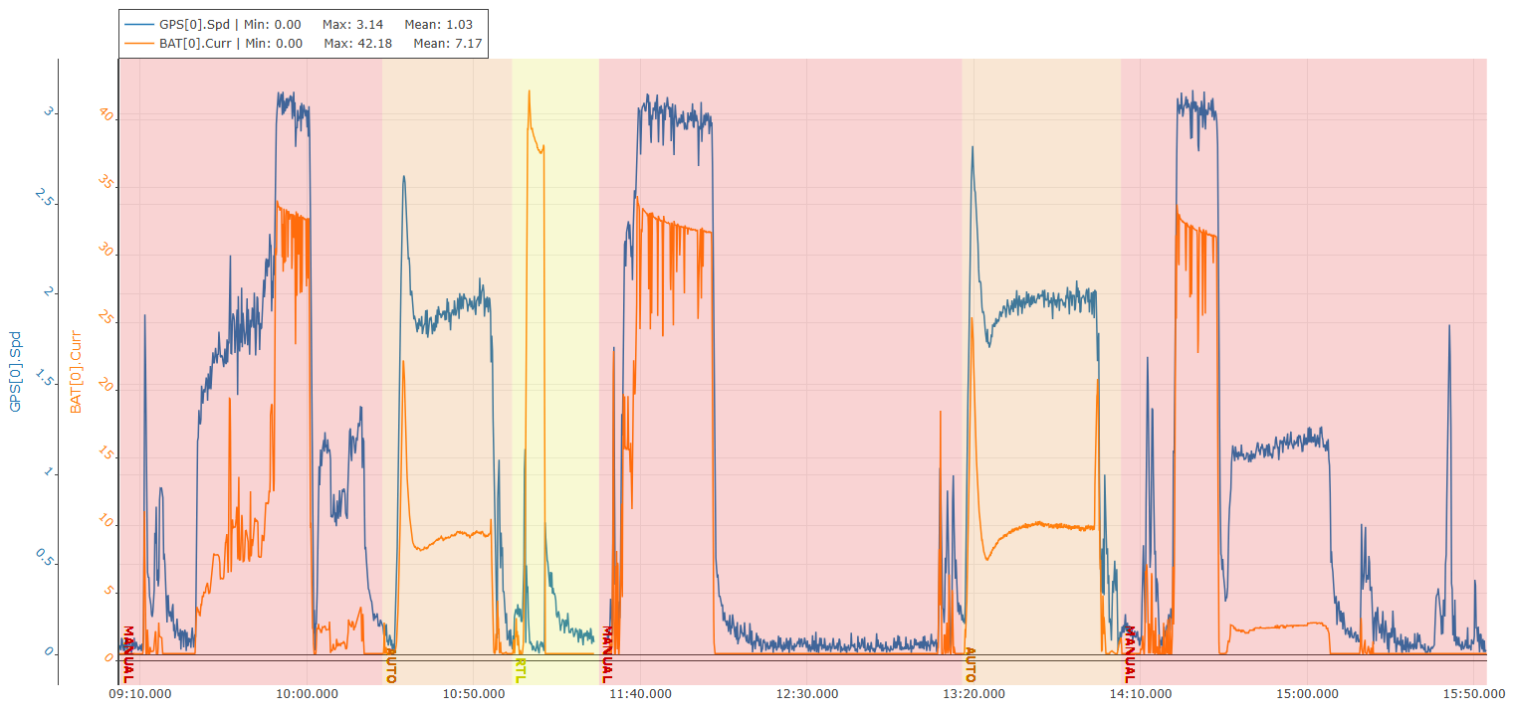
Current & Speed vs Time.
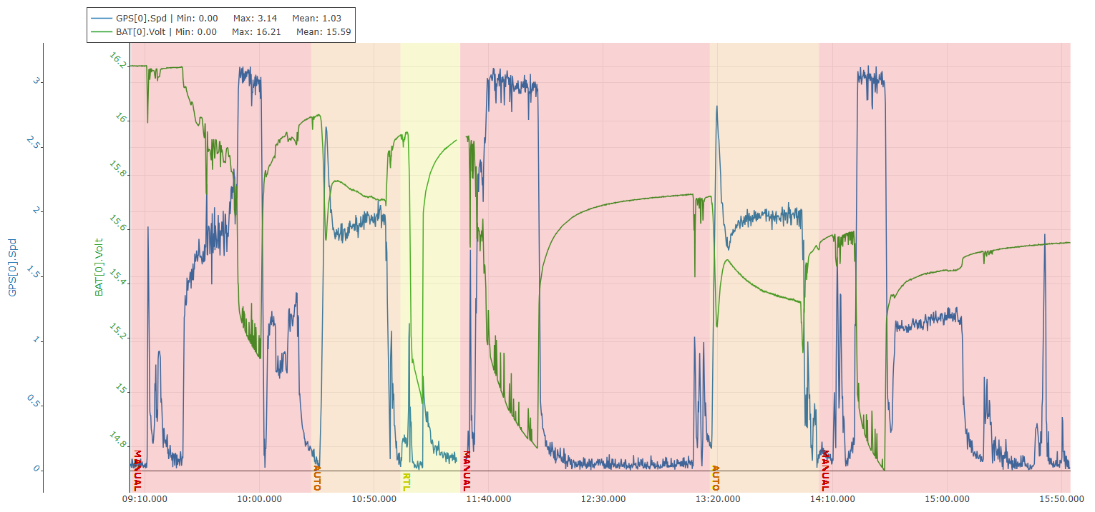
Voltage & Speed vs Time.

Discussion

Current Draw

Calculating Solar Power

Net Energy Expenditure

Deployment Implications

Challenges
- Heavily net negative, loitering as anchor system is power intensive, drop flight controller, ESP >>, additional power source?, fleet.

Future Works
Ardupilot function porting through 2 esps saving on rpi and fc power draw, whilst allowing for deep sleep. Recreate testing with real time autonomy.

Conclusion
- Summary and implications.

References
[1]Blue Robotics, “T200 Thruster for ROVs, AUVs, and marine robotics,” Blue Robotics. https://bluerobotics.com/store/thrusters/t100-t200-thrusters/t200-thruster-r2-rp/
[1]“Basic ESC (Electronic Speed Controller) for Thrusters and Brushless Motors,” Blue Robotics. https://bluerobotics.com/store/thrusters/speed-controllers/besc30-r3/
[1]“T200 Mounting Bracket,” Blue Robotics, Apr. 26, 2025. https://bluerobotics.com/store/thrusters/t100-t200-thrusters/t100-p-bracket-r1/
[1]“Giant Power 4S 14.8V 5500mAh 65C Graphene Hardcase Li-Po Battery w/ XT60 Plug,” Hobby Station, 2015. https://hobbystation.co.nz/giant-power-4s-14-8v-5500mah-65c-graphene-hardcase-li-po-battery-w-xt60-plug/?srsltid=AfmBOoqauM42Eb9uhfwG9sGSv6fBZwQfKn7Z96WXnJmxmgV1x3CmLIez (accessed Oct. 17, 2025).
[1]“12.8V 18Ah Lithium Deep Cycle Battery - LiFePO4,” Savebarn.co.nz, 2024. https://www.savebarn.co.nz/12-8v-18ah-lithium-deep-cycle-battery-lifepo4-53169?gad_source=1&gad_campaignid=22435333337&gbraid=0AAAAAD4vK1PzrcX8wCulRqIR_DJC18snO&gclid=CjwKCAjw0sfHBhB6EiwAQtv5qXR5iIjBmD-K-2Zb5rS5zRbgx5Djy8BwWPMuAk1mciag-u1GvfX9HhoCYf4QAvD_BwE (accessed Oct. 17, 2025).

Appendix A – System Design Diagram and Photos

A1. Power Distribution Diagram

A2. PCB Schematic from Altium

A3. Full System Wiring Diagram

A4. Physical Layout Diagram

A5. Testing Set Up

A6. Final Set Up

Appendix B – Final Implementation Bill of Materials
System | What | Amount | Cost per Unit (NZD) | Total Cost (NZD)

Appendix C – Testing Results

C1. Lab Testing Results

C2. Field Testing Results

