Project 108:
Compendium

Connor Dunn
Cromwell Pilacan

Supervisor: Dr Akshat Bisht

Co-supervisor: Dr Kevin I-Kai Wang

Department of Electrical, Computer and Software Engineering
The University of Auckland

October 2025
1 Testing 3
1.1 BOM 3
1.2 Lab Testing 3
1.2.1 Set Up 3
1.2.2 Code 4
1.2.3 Results 4
1.3 Field Testing 4
1.3.1 Set Up 4

Testing

BOM
Table 1: Complete Testing BOM
Testing BOM
System | Component | Amount | Cost
Power | LiPo Batteries 5500mAh | 2 | 358
Mobility | Pixhawk6C + GPS + PM07 | 1 | 358
Mobility | T200 Motors | 2 | 800
Mobility | ESC | 2 | 140
Hull | Remote Controller + Receiver | 2 | 28
Hull | Mounting | 1 | 229.93
Hull | Boogie Board | 1 | 35
Hull | Water Sealant | 1 | Approximately 20
Hull | Waterproof Box | 1 | Approximately 80
Hull | Mounts | - | -
Hull | Screws | 8 | -
Autonomy | Raspberry Pi 4B | 1 | 26.08
Autonomy | ESP 32 | 1 | 17.38
Autonomy | Modem | 1 | 75.41
 |  | Total Cost | 2207.80

Lab Testing
The goal for lab testing was to get current readings for all peripherals intended for final design. The ESP and Raspberry Pi was testing with and without running their intended code.

Set Up
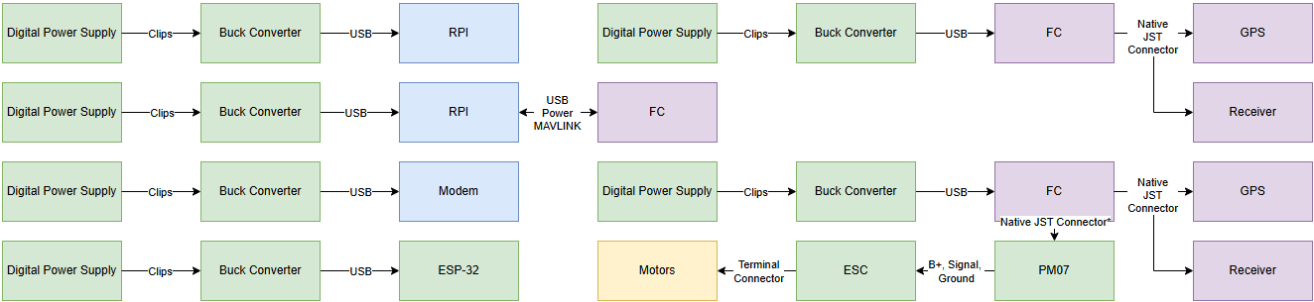
Figure 1.2.1: Lab Testing Connections
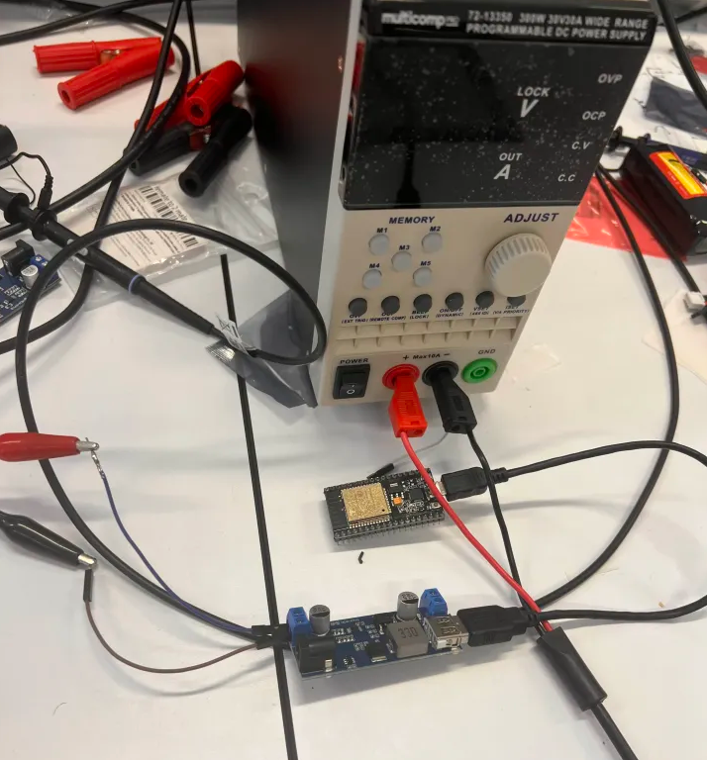
Figure 1.2.2: Photo Example of ESP Testing Set Up.

Code
Code used to test the active states of microcontrollers is included in the zip file.

Results
Table 2: Lab Testing Results.
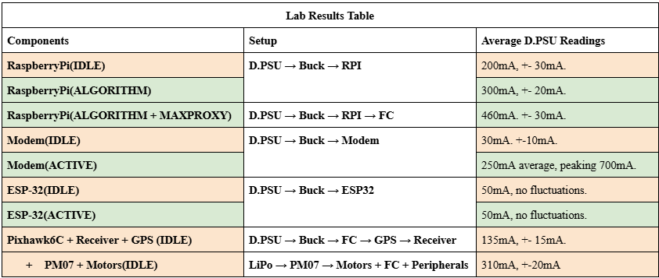

Field Testing
Field testing was done to get buoy speed vs current draw. Readings were taken by installing the flight logs from Mission Planner and uploaded to UAV Logger.

Set Up

Electronics
The power connector between the PM07 and FC was cut such that only current and voltage readings could come from the PM07, but not power.
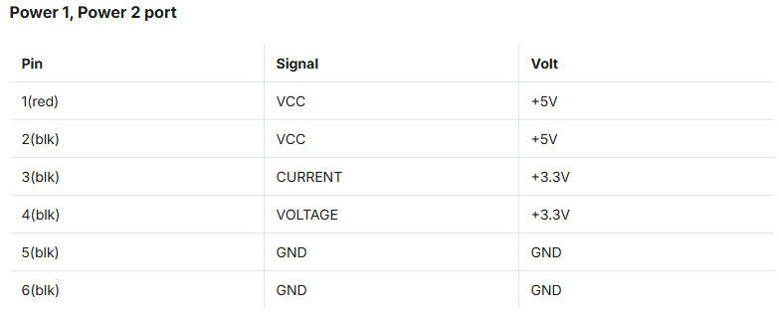
Figure 1.3.1: Power Connector Table from HolyBro.
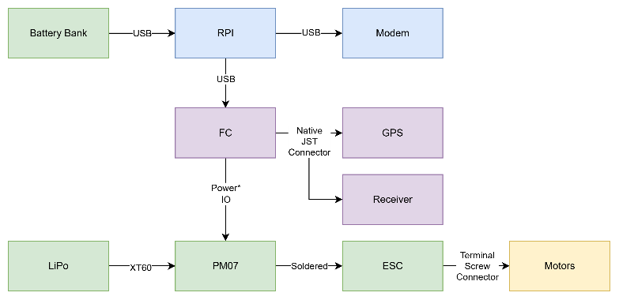
Figure 1.3.2: Electronics Connections
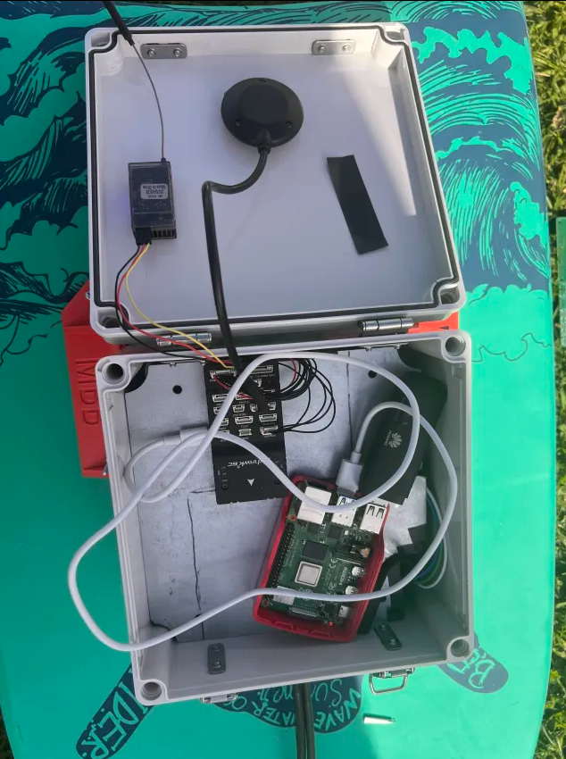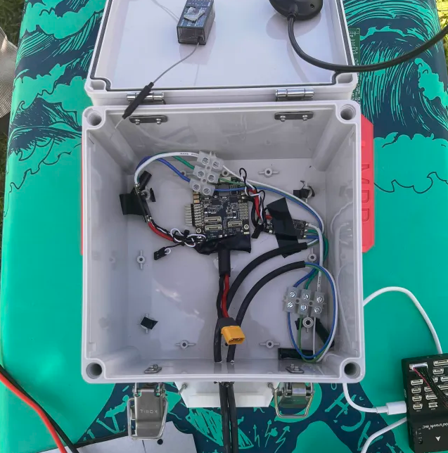
Figure 1.3.3: Photo Example of Electronics Set Up for Field Testing

Hull

Control
To reach specific speeds the remote controller was used to drive the boat in a straight line using the Mission Planner UI to read the boat speed.

Results
Results for our testing can be found in Cromwell Pilacan’s report.

