SYSTEM DESIGN
Pensae Signal Problem-First Opportunity Discovery
Local-first prototype architecture | Version 1.5
Design authority: Pensae_Signal_Problem_First_Opportunity_Discovery_PRD_v2.4 (Accepted)
Target environment: local workstation — native Fedora 44 workstation; browser, Pensae Signal, and llama.cpp run on the same host
Status: Accepted Pensae Signal application-identity design
Date: 28 August 2026
DESIGN GOAL Use the smallest architecture that preserves evidence integrity, deterministic control, safe public retrieval, recoverable local operation, and atomic durability for every completed opportunity.

1. Purpose, scope, and constraints
This accepted design supersedes System Design v1.4 only for the human-facing application identity defined by PRD v2.4. The application is Pensae Signal; Pensae remains the owning company/project. Stable compatibility identifiers remain unchanged, including the Python package and imports `pensae`, `PENSAE_*` environment variables, `.pensae` local paths, the `X-Pensae-Session` header, Compose/database/backup identifiers, API schema keys such as `pensae_feasibility`, and internal prompt, capability-probe, and retrieval user-agent identities. Native-Fedora topology, evidence, security, retention, scoring, lifecycle, persistence, limits, model behavior, and process ownership remain unchanged.

1.1 Phase 7 change and preserved accepted variances
Opportunity breadth: a representative sufficient-evidence run targets five distinct committed opportunities. The workflow evaluates concepts sequentially in deterministic rank order, excludes automatic exact rediscoveries from the target, reserves capacity for remaining finalizations, and reports an honest shortfall instead of weakening a gate or generating filler.
- Model serving: both llama.cpp endpoints run as native Fedora 44 processes on the same host as Pensae Signal, outside Docker Compose. The Fedora launcher reuses healthy compatible endpoints or starts missing servers and owns only the processes it creates.
- Release control: no hosted CI or automated deployment. A repeatable local Fedora 44 `make release-check` replaces the PRD's CI statement.
- Recovery: the design provides native-Linux PostgreSQL dump/restore commands and automatic pre-migration backups; there is still no backup UI or scheduler.
- Container networking: the operator-managed host VPN remains continuously enabled and outside Pensae Signal control. Because its firewall blocks Docker bridge traffic, Compose uses native Linux host networking for exactly PostgreSQL/pgvector, Redis, and SearXNG. Each service has an explicit `127.0.0.1` bind; Compose port publishing, optional administration containers, and non-loopback listeners are prohibited.

1.2 Governing constraints
- One operator, one installation, one active run, and no authentication or remote access.
- One FastAPI process and one in-process asynchronous run task; no queue, worker tier, scheduler, checkpointing, or run resume.
- Evidence is mechanically verified; model output is analysis, never evidence.
- Complete opportunities commit independently and count toward the target only when they create a New or definitely distinct Related retained opportunity; automatic exact rediscoveries, Updated versions, and unresolved Possible rediscoveries do not count. Verdict does not affect counting for an otherwise complete distinct opportunity. Stop, failure, restart, work-limit exhaustion, and later candidates cannot remove earlier commits.
- Full pages, extracted text, prompts, raw model output, rejected candidates, and retries are transient.
- All model inference is local; search uses self-hosted SearXNG with no paid fallback.

1.3 Explicitly deferred
Remote/multi-user deployment, authentication, cloud hosting, paid providers, browser automation, arbitrary agent tools, distributed workers, approximate vector indexes, editable scoring, long-term agent memory, advanced source management, and automatic merge/update remain outside this prototype.

2. Architecture overview and deployment topology
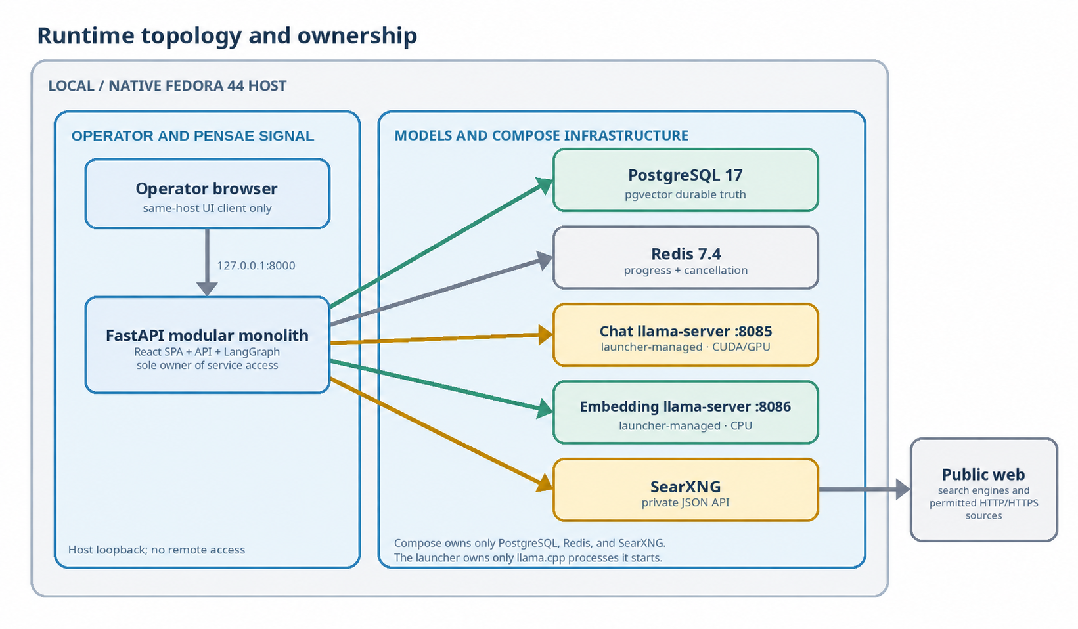
Figure 1. One native Fedora 44 host owns the browser, Pensae Signal, launcher-managed model servers, and loopback-only host-network Compose infrastructure.
FastAPI serves the compiled React SPA and unversioned `/api` routes from one canonical origin. The same-host operator browser reaches FastAPI through IPv4 loopback; FastAPI calls both llama.cpp endpoints and all three Compose-managed infrastructure services through IPv4 loopback in the same native Fedora 44 network namespace.

2.1 Technology baseline
Area | Selected technology
Application | Python 3.13; FastAPI modular monolith; one Uvicorn worker
Web | React + TypeScript SPA; Vite build; React Router; TanStack Query
Workflow | One typed LangGraph StateGraph with four tool-less prompt/schema roles
Persistence | PostgreSQL 17; pgvector 0.8.2; SQLAlchemy; async Psycopg 3; Alembic
Transient control | Redis 7.4 strings and bounded Streams; no persistence or vector index
Search | Self-hosted SearXNG JSON API; Brave + DuckDuckGo + Yandex
Retrieval | aiohttp SafeSourceClient; Trafilatura parser; HTTPX for trusted local services
Models | Native Fedora 44 llama.cpp: Qwen3.6-35B-A3B chat and Qwen3-Embedding-0.6B
Tooling | uv + uv.lock; Node 24 LTS; pnpm 11; Ruff, Pyright, Biome, pytest, Vitest, Playwright

2.2 Runtime ownership
Operator. Starts Pensae Signal through the native Fedora launcher and performs deployments.
Fedora launcher. Starts/stops PostgreSQL/pgvector, Redis, SearXNG, migrations, and FastAPI; it health-checks chat and embedding endpoints, starts only missing llama.cpp servers with fixed argv, records their PIDs, and stops only processes it created. Unknown or incompatible listeners fail safely.
Application startup. Requires database/Redis for normal operation but may open with unavailable model/search dependencies so the UI can show health. Run start performs the complete preflight.
Versioning. Pin Python/Node/package managers, lock dependencies, pin container image versions/digests, and record model and llama.cpp identifiers in run provenance.

3. Components and responsibilities
Component | Responsibility | Hard boundary
React SPA | Current run, portfolio, details, settings, confirmations | No direct service/database calls; server state lives in TanStack Query
FastAPI API | Validation, REST/SSE, security middleware, dependency health | Same-origin loopback only; no business work in request sessions
RunManager | Own exactly one asyncio LangGraph task and cancellation accelerator | In-process only; restart never resumes a run
LangGraph | Fixed two-pass state machine and deterministic routing | No supervisor, dynamic agents, tools, checkpoints, or open-ended loops
Model clients | Typed chat/embedding contracts, token preflight, and launcher process control | Fixed argv and owned PIDs only; no shell execution, SDK abstraction, or direct persistence
Search/retrieval | Discovery, safe public fetch, extraction, evidence spans | Search snippets are discovery-only; retriever is fail-closed
Domain services | Gates, scoring, fingerprints, exact similarity, lifecycle | Application code owns all policy decisions
PostgreSQL | Durable business data and authoritative run snapshots | Short explicit transactions; no network/model work inside
Redis | Cancel flag and bounded progress stream | Transient only; loss safely stops an active run

3.1 Application structure
Use a single repository with `src/pensae/`, `frontend/`, `tests/`, `infra/`, and necessary native-Linux scripts. Organize Python modules by domain capability (runs, research, opportunities, settings) with shared infrastructure adapters. Do not introduce a generic repository layer; services receive explicit SQLAlchemy sessions and own transaction boundaries.

3.2 API and schema ownership
Pydantic API/domain models generate FastAPI OpenAPI. `@hey-api/openapi-ts` generates the REST client into `frontend/src/api/generated/`; generated files are never edited. A custom SSE adapter handles stream framing and reconnection. Release-check regenerates the client to a temporary directory and fails on drift.

4. Research workflow, run lifecycle, and limits
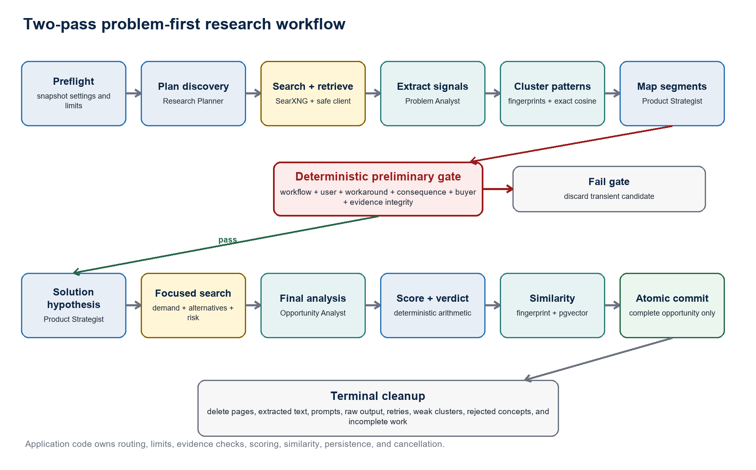
Figure 2. The preliminary evidence gate separates problem discovery from solution and market validation; the admitted-candidate path repeats sequentially until the target or a bounded terminal condition.

4.1 Agent roles and output contracts
Research Planner. Produces bounded discovery and focused-validation queries; it never browses.
Problem Analyst. Extracts source-linked signals and synthesizes normalized patterns from sanitized span IDs.
Product Strategist. Maps segments and proposes the smallest appropriate solution only after the gate passes.
Opportunity Analyst. Analyzes demand/alternatives, writes the negative case and report, and proposes sub-scores.
Every role returns non-streaming schema-constrained JSON. Pydantic validates it; at most one repair attempt is allowed. Invalid optional candidates are discarded, while an invalid required planner node fails the run. Roles cannot select endpoints, change limits, route the graph, browse, or write the database.
Candidate loop. Application code ranks admitted concepts deterministically, starts no more than one candidate finalization at a time, performs focused search → final analysis → scoring → similarity → atomic commit, then rechecks cancellation and remaining reserved work. It stops candidate admission after five distinct commits, pool exhaustion, or a hard ceiling. A candidate that is invalid after repair is discarded without consuming a target slot; an automatic exact rediscovery is recorded but does not consume a target slot.

4.2 Preliminary gate and evaluation
- Recognizable recurring workflow and affected user/role.
- Current workaround, fragmented toolchain, manual process, or unmet need.
- Plausible business consequence and buyer/organizational owner.
- Normally two independent signals; a single exceptional primary source requires an explicit concentration limitation.
- No exact duplicate, prohibited retrieval, or unresolved evidence-integrity failure.
SCORING POLICY Weighted total = Commercial × 35% + Evidence × 30% + Feasibility × 25% + Differentiation × 10%. Scores are 1-5. Promising normally requires ≥3.5 plus strong evidence and no critical blocker; Do not pursue normally applies below 2.5 or with a critical blocker. Completed Do not pursue opportunities remain durable.

4.3 Shipped work bounds
Stage | Initial default | Protected ceiling / rule
Discovery | 8 queries; 10 results/query; 60 unique URLs; 24 pages | Whole run: 40 queries and 96 pages
Pass-one synthesis | 30 signals; 10 patterns; 3 segments/pattern | Deterministically rank at most 12 preliminary survivors; discard weak combinations before complete reasoning
Focused validation | 12 preliminary survivors; 8 concepts; 3 queries and 6 pages/concept | Serialized search; one SearXNG retry; no public-page retry; deterministic candidate admission
Final output | Target 5 distinct committed opportunities; evaluate up to 8 ranked concepts | Only schema-valid, fully evaluated records commit; automatic exact rediscoveries do not count; no filler; explicit shortfall
Whole-run resources | 192 MiB; 160 model calls; 8 repairs; 1.5M tokens | 384 MiB; 256 calls; 16 repairs; 1.5M tokens; reserve remaining finalization capacity before upstream admission

4.4 Candidate admission and finalization reserve
The run budget is partitioned into upstream work and a protected finalization reserve. Before discovery/focused work or a candidate finalization begins, deterministic admission checks use configured worst-case call, repair, token, query, page, transient-byte, embedding, and persistence costs. Upstream stages may not spend the reserve required for the remaining target slots. A candidate starts only when its complete analysis-through-commit path fits the remaining budget; reservation is released after commit or discard and recalculated for the remaining target.
The reserve is capacity, not a promise of evidence. If fewer than five admissible distinct candidates exist, the run performs no filler work and finishes CompletedWithWarnings with target, achieved count, and `bounded_pool_exhausted` or `insufficient_evidence` shortfall. A configured hard ceiling reached during admitted work remains Stopped with `work_limit_exceeded`; all prior commits survive.
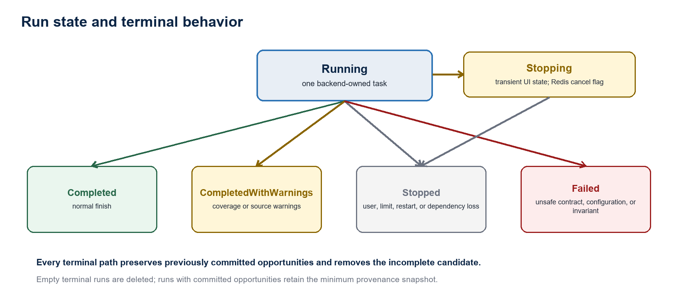
Figure 3. Stopping is transient UI state; terminal states are durable only when a run owns committed provenance.

4.5 Cancellation and terminal policy
Stop is idempotent. Redis is authoritative and an in-process `asyncio.Event` accelerates checks before and after nodes, searches, retrievals, and model calls. Active calls finish or reach their timeout; processes and threads are never force-killed. Startup converts an abandoned run to Stopped if it has commits, otherwise deletes it.
Ordinary source and single-engine failures are warnings. Honest pool/evidence shortfall after bounded evaluation produces CompletedWithWarnings. A hard work/token ceiling, dependency loss, restart, user stop, or Redis loss produces Stopped. Invalid configuration/contracts and database invariants produce Failed. In all cases committed opportunities survive and transient candidate data is deleted.

5. Data model, transactions, and retention
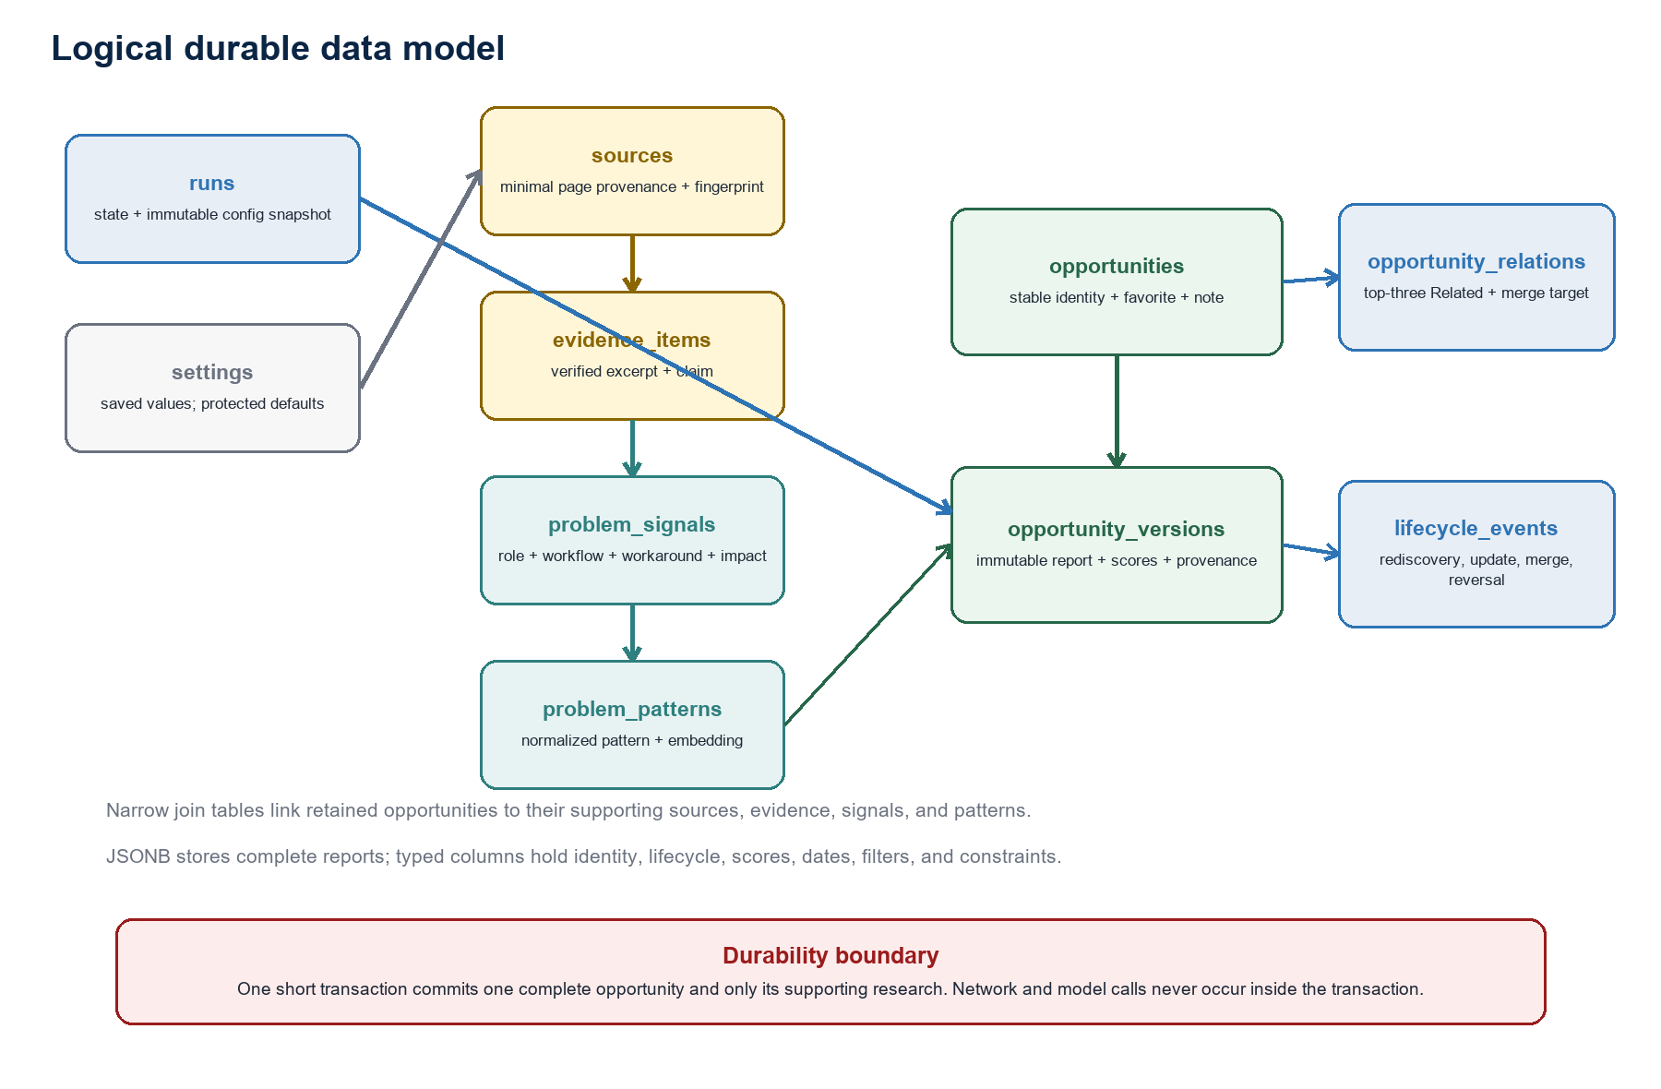
Figure 4. Stable opportunities own immutable versions; supporting research remains only while referenced.

5.1 Physical model
Core tables remain `settings`, `runs`, `sources`, `evidence_items`, `problem_signals`, `problem_patterns`, `opportunities`, `opportunity_versions`, `opportunity_relations`, and `lifecycle_events`, plus narrow many-to-many joins. JSONB stores the complete report, immutable provenance/configuration snapshot, target/achieved/shortfall summary, and versioned work counters; typed columns continue to store identity, status, verdict, scores, industry, dates, current version, merge target, and query/invariant fields. No new durable intermediate-candidate table, queue, or checkpoint is introduced.

5.2 Identity, similarity, and lifecycle
- Exact normalized fingerprints automatically classify Rediscovered; the canonical identity includes problem, solution, target segment, buyer, and workflow.
- Semantic matches are Related and may carry Possible rediscovery until the operator confirms Rediscovered or Updated.
- Updates create immutable versions. Favorite and note remain on the stable opportunity.
- Merge is manual, non-destructive, and reversible. Scores, reports, evidence, favorites, and notes are never combined automatically.
- Each opportunity retains at most three strongest Related links above the calibrated exact-cosine threshold.

5.3 Transaction and deletion rules
One `AsyncSession` serves one request or workflow transaction. After all network/model work and deterministic validation complete, a short transaction inserts one opportunity version and only its supporting sources, evidence, signals, pattern, relations, lifecycle event, and run snapshot. A partial failure rolls back that opportunity only.
Permanent deletion requires typed confirmation. It removes the stable opportunity, versions, relations, favorite, note, and exclusively owned support records; reference-aware orphan cleanup preserves research still used by another opportunity.

5.4 Retention and recovery
Data class | Rule
Durable | Complete opportunities/versions, minimum evidence chain, lifecycle, settings, and run provenance needed by commits
Transient | Search payloads, pages, extracted text, prompts, raw model output, retries, weak clusters, rejected and incomplete candidates
Redis | Cancel string and recent stream only; active TTL 24 h refreshed, terminal expiry 1 h, stream max length ≈1000
Backup | Custom-format PostgreSQL dump before a migration on a non-empty DB and on `make backup`; retain five local dumps
Restore | Application stopped, dump validated, typed confirmation, restore into a fresh database; never restore in place

6. API, SSE, and frontend state

6.1 HTTP contract
FastAPI exposes unversioned `/api` routes because this is one bundled local application. Start returns `202 Accepted` with the run identifier. REST owns snapshots and mutations; SSE carries progress. Pydantic schemas generate OpenAPI and the TypeScript client. Release mode disables Swagger/ReDoc.
Run routes. preflight/status, start, active snapshot, retained run snapshot, SSE events, and idempotent stop. Phase 7 schemas add the protected target, distinct committed count, evaluated/admitted candidates, automatic exact-rediscovery count, reserve/remaining counters, and optional shortfall code/detail. OpenAPI and the generated TypeScript REST client change together during implementation; this candidate document does not pre-edit generated artifacts.
Portfolio routes. list/filter/sort, opportunity detail/version history, favorite, note, rediscovery decision, update, merge/reversal, and deletion.
Settings routes. read/save validated future-run settings, reset to protected defaults, and dependency health.

6.2 Progress and reconnection
The server appends minimal events to a bounded Redis Stream. EventSource reconnects with `Last-Event-ID`; on a trimmed stream or gap, the SPA refetches the authoritative PostgreSQL snapshot. SSE updates or invalidates TanStack Query entries. Browser close/refresh never cancels the backend-owned task.

6.3 Frontend state and presentation
Concern | Decision
Server state | TanStack Query only; `networkMode: always`; SSE updates the query cache
Navigation | React Router Declarative Mode; URL owns selection, industry filter, and sort
Local state | React context/component state only for ephemeral UI; no Redux/Zustand/MobX
Presentation | Semantic HTML, CSS Modules, one token file, and Radix only for complex accessible primitives
Accessibility | Keyboard/focus support, visible labels, live progress, reduced motion, AA contrast; Chromium tests for critical flows

6.4 Minimum screens
Current run. state, stage, recent progress, token/work use, five-opportunity target, distinct committed count, evaluated/admitted candidates, automatic exact rediscoveries, reserve/remaining work, warnings, explicit shortfall, Stop.
Opportunities. industry-only filter and supported sort; verdict/score/evidence/newest default order.
Opportunity detail. report, source-linked evidence, scores, verdict, related/version history, favorite, note, and lifecycle actions.
Settings. saved future-run values, validation, service health, and Reset to defaults.

7. Model integration, retrieval, evidence, and similarity

7.1 Local model endpoints
Endpoint | Pinned baseline | Runtime contract
Chat :8085 | Qwen3.6-35B-A3B-UD-IQ4_XS | Native Fedora; CUDA through the NVIDIA Linux driver; 32K context; all GPU layers; Q8 K/V; flash attention; one slot; Jinja; no tools/vision/MTP/context shift
Embedding :8086 | Qwen3-Embedding-0.6B GGUF Q8_0 | Native Fedora; CPU; 1024 dimensions; 8K context; last pooling; normalized symmetric similarity text
API | Pinned tested llama.cpp build | `/v1/chat/completions`, `/v1/embeddings`, `/health`, `/v1/models`; direct typed HTTPX clients

Thinking is disabled. Initial non-thinking generation is temperature 0.7, top-p 0.8, top-k 20, min-p 0, presence penalty 1.5, and repetition penalty 1.0. A run seed derives per-call seeds. The app token-counts before generation, caps prompt input at 8,192 tokens, and leaves at least 2K context safety.
Output caps are Planner 2,048; Problem Analyst 4,096; Product Strategist 4,096; Opportunity Analyst 6,144 tokens. Repair uses the same cap. These are calibrated against the offline corpus before final release defaults.

7.2 Search and source retrieval
- Serialize SearXNG POST requests to the local JSON endpoint, preserve exact query text, use the explicit Brave, DuckDuckGo, and Yandex engine allowlist, and keep Bing and paid fallbacks disabled. Validate the returned schema, retain only HTTP(S) candidates, and apply URL safety checks before retrieval.
- Canonicalize and deduplicate result URLs before retrieval. Snippets guide discovery but cannot support a strong claim.
- SafeSourceClient resolves and pins public IPs, revalidates every redirect, ignores proxies/cookies/auth, permits only HTTP/HTTPS on default ports, and verifies TLS.
- Accept HTML/XHTML/plain text; Trafilatura parses with comments/images/link targets excluded and tables included. PDF, office documents, OCR, and browser automation are deferred.
Retrieval defaults: four global connections, one per origin, minimum one-second origin delay, five redirects, 5 s connect, 10 s read inactivity, 20 s total, 3 MiB response, `Accept-Encoding: identity`, no compressed responses, and 200k normalized characters. Public pages are not retried.
robots.txt uses the same safe client: 512 KiB cap; 2xx obey, 4xx allow, 5xx/network failure disallow; cache for the run up to 24 h; skip an origin requiring crawl delay above 10 s. Never bypass authentication, CAPTCHA, rate limits, or access controls.

7.3 Evidence integrity
- Normalize extraction with Unicode NFC, line endings, and whitespace; split it into numbered transient spans.
- The model selects span IDs only. Application code constructs the excerpt; the model never writes the quote.
- Reject missing, noncontiguous, cross-source, or transformed references; retain at most 500 characters per evidence item.
- Hash the complete normalized extraction with SHA-256 transiently and create versioned canonical JSON fingerprints for durable identity.
- Retain URL/title/publisher/dates, exact excerpt, supported claim, credibility/limitation/conflict, and fingerprint; never retain the complete extraction.

7.4 Similarity input
Embed only canonical problem text: problem, affected user, current workaround, and desired outcome. Exclude solution, scores, and evidence wording. Compare exactly against retained and current-run accepted records using PostgreSQL cosine distance; calibrate thresholds from labeled duplicate/related/distinct examples and store the model, dimension, fingerprint version, and threshold version.

8. Security and failure handling

8.1 Browser-to-loopback boundary
- Canonical origin `http://127.0.0.1:8000`; bind IPv4 loopback only; validate the exact Host header and reject forwarded host headers.
- Do not enable CORS, cookies, service workers, external scripts/fonts/CDNs, or analytics.
- All mutations use JSON POST/PUT/PATCH/DELETE and require a random per-start `X-Pensae-Session` nonce plus same-origin Fetch Metadata or exact Origin validation.
- GET and SSE are read-only. Reject form, multipart, and text/plain mutation requests; never change state through GET.
- Apply CSP, frame denial, nosniff, no-referrer, same-origin resource policy, restrictive permissions policy, and no-store for API/index/bootstrap responses.
- Permanent delete, merge, reversal, and settings reset require accessible UI confirmation plus an explicit confirmation field in the request body.

8.2 Public content and prompt-injection boundary
Search results can choose only public source URLs, never service endpoints. The validating resolver blocks loopback, private, link-local, multicast, metadata, reserved, unsupported scheme, credentialed URL, and unsafe redirect targets. Retrieved text is delimited as untrusted data; tool-less agents cannot alter prompts, graph policy, security, settings, limits, endpoints, or persistence.

8.3 Failure matrix
Condition | Result
One inaccessible source or search engine | Warning; continue only if evidence gates remain satisfied
Optional candidate invalid after repair | Discard candidate; count repair/failure; no durable record
Required planner/schema/config contract invalid | Failed; cleanup transient work; preserve prior commits
User stop, work/token ceiling, restart, Redis/dependency loss | Stopped cooperatively; preserve commits; delete incomplete candidate
Database invariant or unsafe persistence error | Failed; roll back current transaction; preserve earlier commits
Browser closes or SSE gap | Run continues; reconnect from stream or authoritative REST snapshot
Model endpoint missing, occupied, or incompatible | Launcher starts only a free missing endpoint; unknown listener or readiness/capability failure leaves degraded health, blocks run start, and cleans up only owned partial startup.

9. Configuration, operations, backup, and logging

9.1 Configuration layers
Layer | Contents | Change behavior
Bootstrap environment | DB DSN; app port; data/log path; verbose log switch; llama executable/model paths and fixed argv | Read at startup; protected local values; no browser-exposed values or shell construction
Saved PostgreSQL settings | research focus; endpoints; workflow/time/token bounds; logging rotation | Validated; future runs only; copied into immutable run snapshot
Protected policy | SSRF ceilings; gates/weights; similarity/model/dimension; workflow/prompt/schema versions; repair max | Code/TOML shipped defaults; not normal UI settings

There are no temporary per-run overrides or hidden runtime overrides. Reset to defaults copies the protected baseline into saved settings. Run creation persists the complete effective configuration before work begins.

9.2 Local operation
- At Pensae Signal startup, the Fedora launcher health-checks ports 8085 and 8086, reuses healthy compatible endpoints, and starts only missing servers from protected executable, model-path, and argument configuration. Readiness has a bounded timeout; partial startup is cleaned up, unknown listeners are never killed, and shutdown stops only recorded child PIDs.
- Native-Fedora launcher starts the pinned three-service Compose infrastructure in Linux host-network mode, waits for health, creates a pre-migration backup when required, runs `alembic upgrade head`, and starts the single Uvicorn worker.
- Pensae Signal can display while models are offline, but run start validates chat structured output, embedding dimension, SearXNG, Redis, PostgreSQL/pgvector, and saved ranges.
- Redis persistence is disabled. PostgreSQL uses a named volume. SearXNG persists only required configuration/cache. Compose does not publish or map ports: PostgreSQL, Redis, and SearXNG each bind explicitly to IPv4 loopback inside the shared host network namespace.
- Host-network containers share the host network namespace and can reach loopback services. The three pinned infrastructure images are therefore part of the trusted local computing base. Release checks fail on an extra Compose service, a missing explicit loopback bind, a port mapping, or any non-loopback listener; an occupied protected port is reported and never reclaimed from an unknown owner.

9.3 Backup and restore
`make backup` creates a timestamped PostgreSQL custom-format dump under the native Linux data directory. Keep the five newest dumps. `make restore BACKUP=<file>` refuses while Pensae Signal is running, validates the dump, requires typed confirmation, and restores into a fresh database. Redis, SearXNG cache, frontend assets, llama.cpp, and model files are not backed up. Local dumps do not protect against host-disk loss.

9.4 Logging and status
Use standard Python logging with concise console output and structured JSONL files, rotating at 10 MiB with five files. UTC timestamps and generated request IDs correlate run, opportunity, stage, model role, duration, status, and aggregate work/token counts. `/api/status` reports PostgreSQL, Redis, SearXNG, chat, and embedding availability.
Logging uses an allowlist and never records prompts, model output, extracted text, excerpts, search queries, request bodies, user notes, vectors, session nonce, credentials, headers, cookies, or full query-bearing URLs. Verbose mode may add sanitized counters, timings, and stack traces only. There is no external telemetry or observability stack.

10. Testing, manual release, risks, and deferred work

10.1 Test layers
Layer | Tools | Mandatory coverage
Deterministic | pytest + AnyIO + HTTPX ASGI; Vitest + RTL | gates, scoring, fingerprints, spans, SSRF, output repair, state transitions, browser guards, budget admission/reservation, exact-rediscovery exclusion, no-filler shortfall, five sequential atomic commits, UI behavior
Integration | Disposable host-network PostgreSQL/pgvector + Redis + SearXNG Compose project | explicit loopback listeners, occupied-port refusal, empty migration, API persistence, atomic rollback/survival, Redis loss, startup cleanup, SSE gaps, backup/restore
Browser | Playwright Chromium | fake run start→SSE→five sequential commits→target reached→portfolio/detail; explicit shortfall path; stop/limit after earlier commits leaves them visible
Manual live | local workstation + native Fedora 44 llama.cpp + local SearXNG | native Linux NVIDIA GPU availability, launcher ownership/recovery, model quality, schema adherence, token/context behavior, engine blocking, thresholds, hardware, and a representative sufficient-evidence run that commits at least five distinct opportunities within default bounds

Automated tests require no GPU, live model, or public internet; typed fakes and a legally reusable/synthetic offline corpus supply expected signals, evidence mappings, duplicates/relations, adverse prompt-injection cases, eight ranked concepts, five valid distinct outcomes, exact rediscoveries, invalid candidates, and insufficient-evidence shortfalls. There is no global coverage quota; the listed invariants are mandatory.

10.2 Manual release gate
There is no hosted CI, self-hosted runner, or automated deployment. Before a Phase 7 manual deployment, `make release-check` on Fedora 44 verifies frozen locks, formatting/lint/type checks, deterministic and integration tests, empty-database migration, temporary OpenAPI-client regeneration/diff, production frontend build, five-commit and shortfall Chromium scenarios, and the accepted Phase 6 release gates. A separate native live checklist records a representative sufficient-evidence run with at least five distinct commits, report/evidence audit, exact-rediscovery accounting, work/headroom counters, and clean launcher shutdown. It must not touch unapproved data or leave launcher-owned llama.cpp processes running.

10.3 Principal risks and mitigations
Risk | Mitigation
Weak/invalid local model output | Schema constraints, one repair, fixed roles, offline corpus, explicit discard/fail policy
Search-engine degradation | Small calibrated engine set, serialization/pacing, warnings, source-diversity gates, no false fallback claims
Unsafe or manipulative web content | Validated resolver/redirects, strict limits, untrusted data blocks, tool-less agents, mechanical excerpts
Combinatorial research growth | Fixed funnel, deterministic ranking, preliminary gate, sequential inference, per-candidate admission, protected finalization reserve, atomic commits, complete counter/token ceilings
False duplicates | Automatic exact fingerprints only; semantic matches stay Related until operator review
Manual release omission | One documented `make release-check`; record commit/schema/prompt/model/build provenance
License/model-term mismatch | No model redistribution; dependency notice; pinned versions; release-time upstream license review
Native Linux host-network or GPU/runtime drift | Pin and record Fedora, NVIDIA, llama.cpp, models, and container images; force every Compose service to 127.0.0.1; prohibit port mappings and extra services; audit actual listeners, bounded readiness, process ownership, and GPU behavior in release evidence.
Numeric breadth target creates filler | Evidence/schema gates never weaken; exact rediscoveries do not count; bounded-pool or evidence exhaustion completes with warnings and an explicit shortfall; native release evidence audits all five retained reports

10.4 Evolution triggers
Add paid providers only if measured local/search quality blocks usefulness; ANN only when exact PostgreSQL latency fails at real volume; LangGraph persistence only when restart-resume is required; authentication/remote/multi-user infrastructure only for a real concurrent use case; re-embedding only after a validated model change and migration plan.
PHASE 8 IMPLEMENTATION STARTING POINT Rename human-facing application identity to Pensae Signal across the UI, API metadata, CLI/operator output, active documentation, and SearXNG instance identity. Preserve company references, every stable compatibility identifier, and internal prompt/probe/retrieval identities so model and source behavior do not change. Prove the rename with deterministic repository, API, frontend, and browser tests; preserve all accepted Phase 7 behavior and release evidence.

