# Hardware Requirements

The purpose of this section is to describe processor, storage and network requirements to deploy a DAOS system.

## Deployment Options

As illustrated in the figure below, a DAOS system can be deployed in two different ways:

* **Pooled Storage Model** : The DAOS servers can run on dedicated storage nodes in separate racks. This is a traditional pool model where storage is uniformly accessed by all compute nodes. In order to minimize the number of I/O racks and to optimize floor space, this approach usually requires high density storage servers.
* **Disaggregated Storage Model** : In the disaggregated model, the storage nodes are integrated into compute racks and can be either dedicated or shared (e.g. in a hyper-converged infrastructure) nodes. The DAOS servers are thus massively distributed and storage access is non-uniform and must take locality into account.

While DAOS is mostly deployed following the pooled model, active research is conducted to efficiently support the disaggregated model as well.

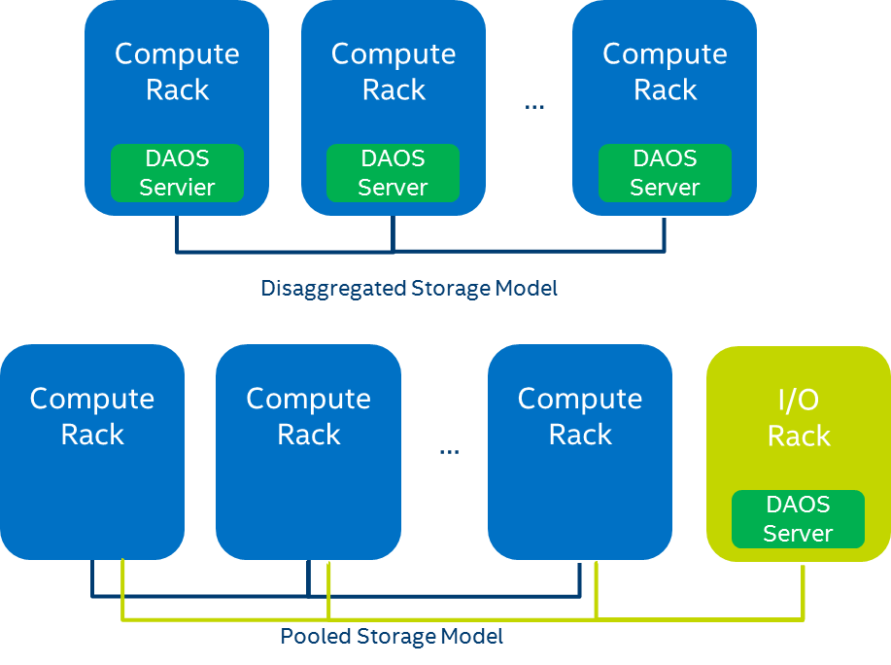

## Processor Requirements

DAOS requires a 64-bit processor architecture and is primarily developed on Intel 64 architecture. The DAOS software and the libraries it depends on (e.g. ISA-L, SPDK, PMDK and DPDK) can take advantage of Intel® SSE and AVX extensions.

DAOS is also regularly tested on 64-bit ARM processors configured in Little Endian mode. The same build instructions that are used for x86-64 are applicable for ARM builds as well. DAOS and its dependencies will make the necessary adjustments automatically in their respective build systems for ARM platforms.

## Network Requirements

The DAOS network layer relies on libfabrics and supports OFI providers for Ethernet/sockets, InfiniBand/verbs, RoCE, Cray’s GNI, and the Intel Omni-Path Architecture. An RDMA-capable fabric is preferred for better performance. DAOS can support multiple rails by binding different instances of the DAOS server to individual network card.

An additional out-of-band network connecting the nodes in the DAOS service cluster is required for DAOS administration. Management traffic uses IP over Fabric.

## Storage Requirements

DAOS requires each storage node to have direct access to storage-class memory (SCM). While DAOS is primarily tested and tuned for Optane DC Persistent Memory, the DAOS software stack is built over the Persistent Memory Development Kit (PMDK) and the DAX feature of the Linux and Windows operating systems as described in the SNIA NVM Programming Model[1]. As a result, the open-source DAOS software stack should be able to run transparently over any type of storage-class memory supported by PMDK.

The storage node can be optionally equipped with NVMe (non-volatile memory express) SSDs to provide capacity. HDDs as well as SATA and SAS SSDs are not supported by DAOS. Both NVMe 3D-NAND and Optane SSDs are supported. Optane SSDs are preferred for DAOS installation that targets a very high IOPS rate. NVMe-oF devices are also supported by the userspace storage stack, but have never been tested.

The minimal recommended ratio between SCM and SSDs capacity is 6% to guarantee that DAOS has enough space in SCM to store internal metadata (e.g. pool metadata, SSD block allocation tracking).

For testing purposes, SCM can be emulated with DRAM by mounting a tmpfs filesystem and NVMe SSDs can be also emulated with DRAM or a loopback file.

## CPU Affinity

On recent Xeon platforms, PCIe slots have a natural affinity to one CPU. Although globally accessible from any of the system cores, NVMe SSDs and network interface cards connected through the PCIe bus may provide different performance characteristics (e.g., higher latency, lower bandwidth) to each CPU. Accessing “remote” PCIe devices may involve traffic over the UPI (Ultra Path Interconnect) link that might become a point of congestion. Similarly, persistent memory is non-uniformly accessible (NUMA), and CPU affinity must be respected for maximal performance.

Therefore, when running in a multi-socket and multi-rail environment, the DAOS service must be able to detect the CPU to PCIe device and persistent memory affinity and minimize as much as possible non-local access. This can be achieved by spawning one instance of the I/O server per CPU, then accessing only local persistent memory and PCI devices from that server instance. The control plane is responsible for detecting the storage and network affinity and starting the I/O servers accordingly.

## Fault Domains

DAOS relies on single-ported storage massively distributed across different storage nodes. Each storage node is thus a single point of failure. DAOS achieves fault tolerance by providing data redundancy across storage nodes in different fault domains.

DAOS assumes that fault domains are hierarchical and do no overlap. For instance, the first level of fault domain could be the racks and the second one the storage nodes.

For efficient placement and optimal data resilience, the more fault domains, the better. As a result, it is preferable to distribute storage nodes across as many racks as possible.

1. <https://www.snia.org/sites/default/files/technical_work/final/NVMProgrammingModel_v1.2.pdf>