核电科研项目设计说明书

目录

1. **引言** ………………………………………………3

1.1 编写目的………………………………………………….3

1.2 项目范围………………………………………………….3

1.3 读者对象………………………………………………….3

2. **设计概述** …………………………………………3

2.1 项目概括………………………………………………….3

2.2 App功能………………………………………………….3

3. **系统详细需求分析** ………………………………4

3.1 人员培训管理模块……………………………………….4

3.2 安全管理模块…………………………………………….4

3.3 移动对讲机模块……………………………………….…4

4. **总体结构设计** ……………………………………5

4.1 总体结构………………………………………………….5

4.2 群聊模块结构…………………………………………….6

4.3 人员培训管理模块结构………………………………….7

4.4 安全施工管理模块结构………………………………….8

4.5 对讲机模块结构………………………………………….9

5. **系统详细设计** …………………………………..10

5.1、主要页面及页面模块……………………………………10

1）登录页面……………………………………………..10

2）群聊列表页面………………………………………..11

3）人员培训管理页面…………………………………..11

4）安全质量管理页面…………………………………..12

5）对讲机联系人页面…………………………………..12

6. **数据库系统设计**…………………………………13

6.1 数据库设计………………………………………………13

6.2 数据库表单列表…………………………………………14

7. **信息编码设计** ………………………………..…15

7.1 代码结构设计…………………………………………….15

1）App代码结构设计…………..……………………….15

2）后台代码结构设计…………………………………...16

7.2 代码编制………………………………………………....17

1）App端 …………..……………………….……………17

2）Web后端……………………………………...............41

2）代码接口编制规则…………………………...............63

8. **系统配置** ……………………………………..….64

8.1 配置原则…………………………………………………..64

8.2 硬件配置…………………………………………………..64

8.3 软件配置…………………………………………………..64

9. **关键技术**…………………………………………65

9.1 关键技术的提出…………………………………………..65

9.2 关键技术的实现方案……………………………………..65

10. **实现后的功能流程**…………………………..…67

10.1 账户登录流程…………………………………………….67

10.2 群聊对讲机功能流程…………………………………….67

10.3 人员培训管理流程……………………………………….68

10.4 安全施工管理流程……………………………………….68

一、**引言**

本文档提供给开发技术人员使用，用于核电科研项目APP 的设计与开发。

**1.1 编写目的**

本文档的目的，旨在规范软件开发，推动项目有序正常的进行，使相关人员遵守统一的规范。节省制作相关文档的时间，降低系统实现的风险，加快项目实施进度，做到系统设计的规范性和全面性，以利于系统的设计、实现、测试、维护和版本升级。

**1.2 项目范围**

本文档用于软件设计阶段的概要设计。

软件概要设计的范围是：移动管理平台共三个模块：其中手机APP +Web 端双端都有的两个模块，分别是人员培训管理模块、安全管理模块（包括区域检查记录登记录入、上传、检查结果消息推送、整改项查询等功能）。

单APP端拥有的移动对讲机模块（对讲、群里等功能）。下面为详细设计描述。

**1.3 读者对象**

系统设计人员、软件开发人员、客户方的系统设计人员和项目评审人员。

二、**设计概述**

**2.1. 核电科研项目概括**

本移动管理平台用于核电工程项目。

**2.2. APP功能**

1、人员在线培训功能

2、安全施工管理功能

3、移动对讲机功能

**三、系统详细需求分析**

**3.1、人员培训管理模块：**

培训种类分为三个种类：基础培训、技能培训、专项培训。

培训课件由Web端分配的人力资源管理权限（负责组织培训的主管）的人负责上传课件；

参与培训人员可以在线查看、学习，并在学习后参与考试功能；

新课件上传或者培训进度更新增添推送通知；

后台管理人员可查看参培人员学习记录列表。

**3.2、安全管理模块**

创建检查记录模板，并根据时间、分类、分版块对检查记录上传；需上传附件（图片）功能；

检查结果上传后推送给责任人，进行整改。

查询整改项信息，跟踪进度。

**3.3、移动对讲机模块**

移动终端联系人实名显示，显示格式：部门+姓名；

群聊功能：可创建群聊、群聊发起人有权删除成员、群成员可以拉成员进群聊；

对讲功能：联系人可互相发送语音，联系人实时接收并选择接听。

四、 总体结构设计

1）总体结构

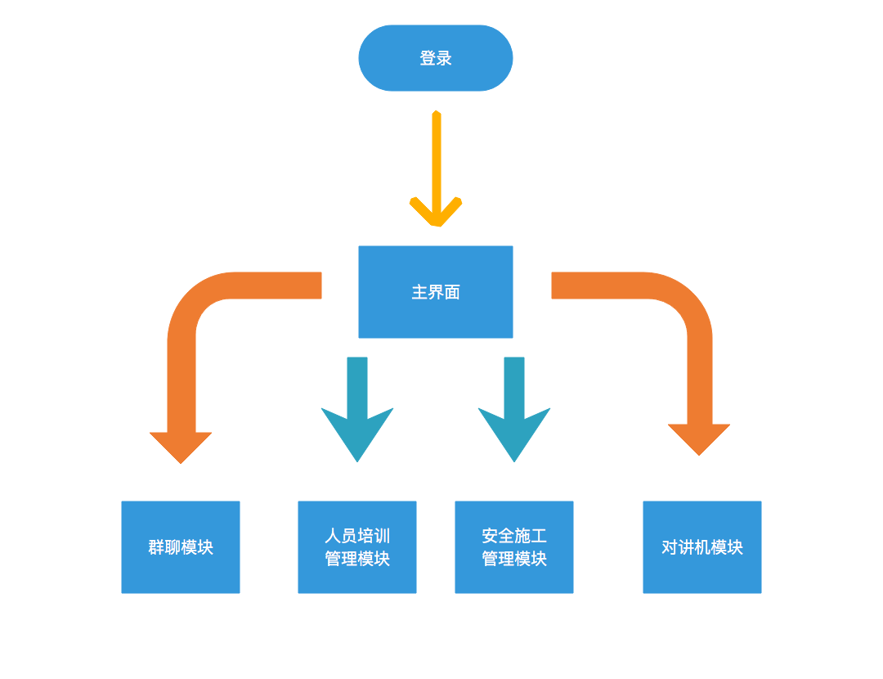

2）群聊模块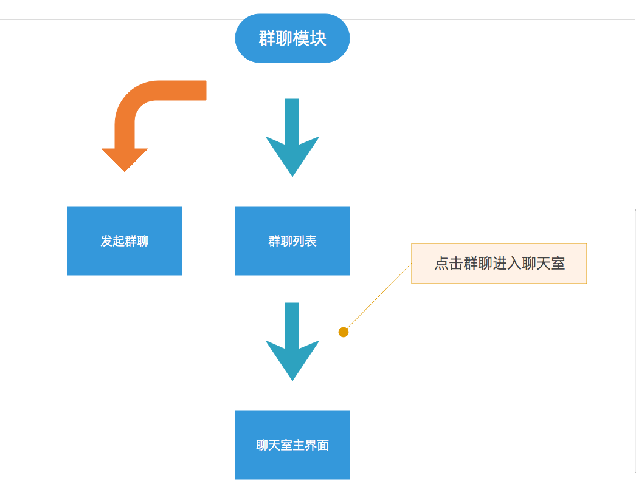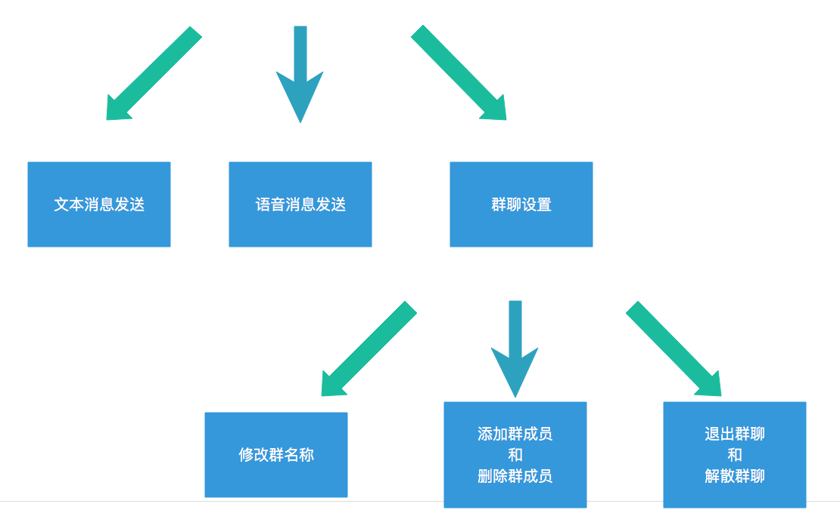

3）人员培训管理模块

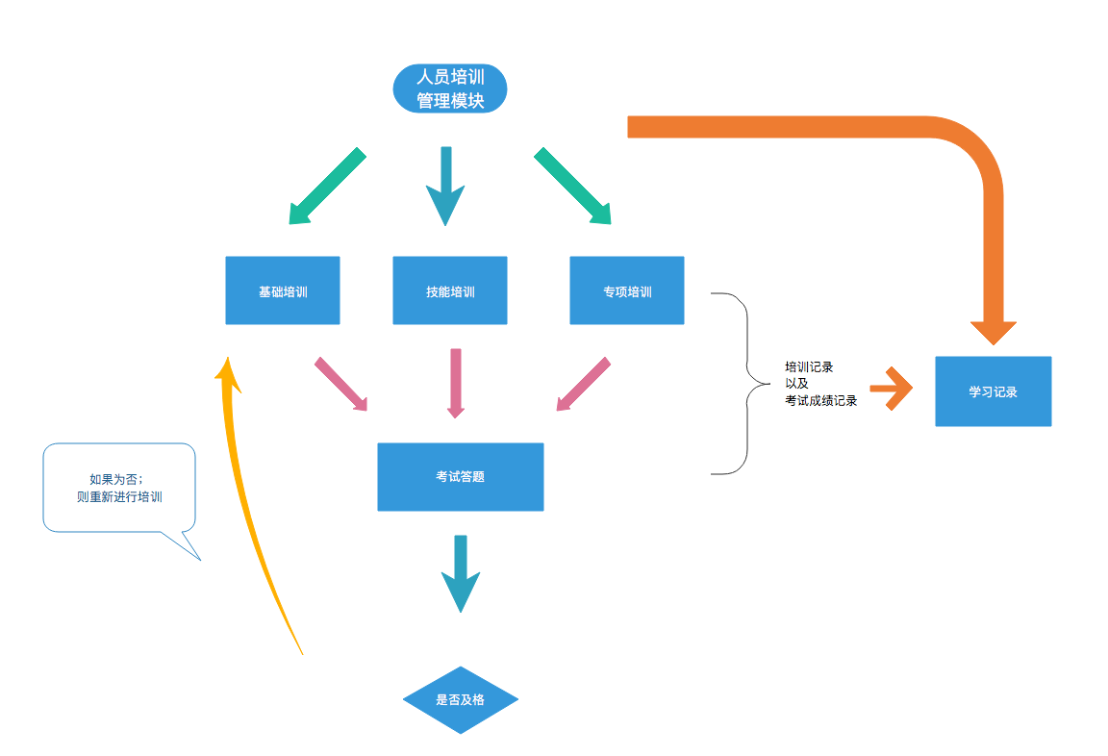

4）安全施工管理模块

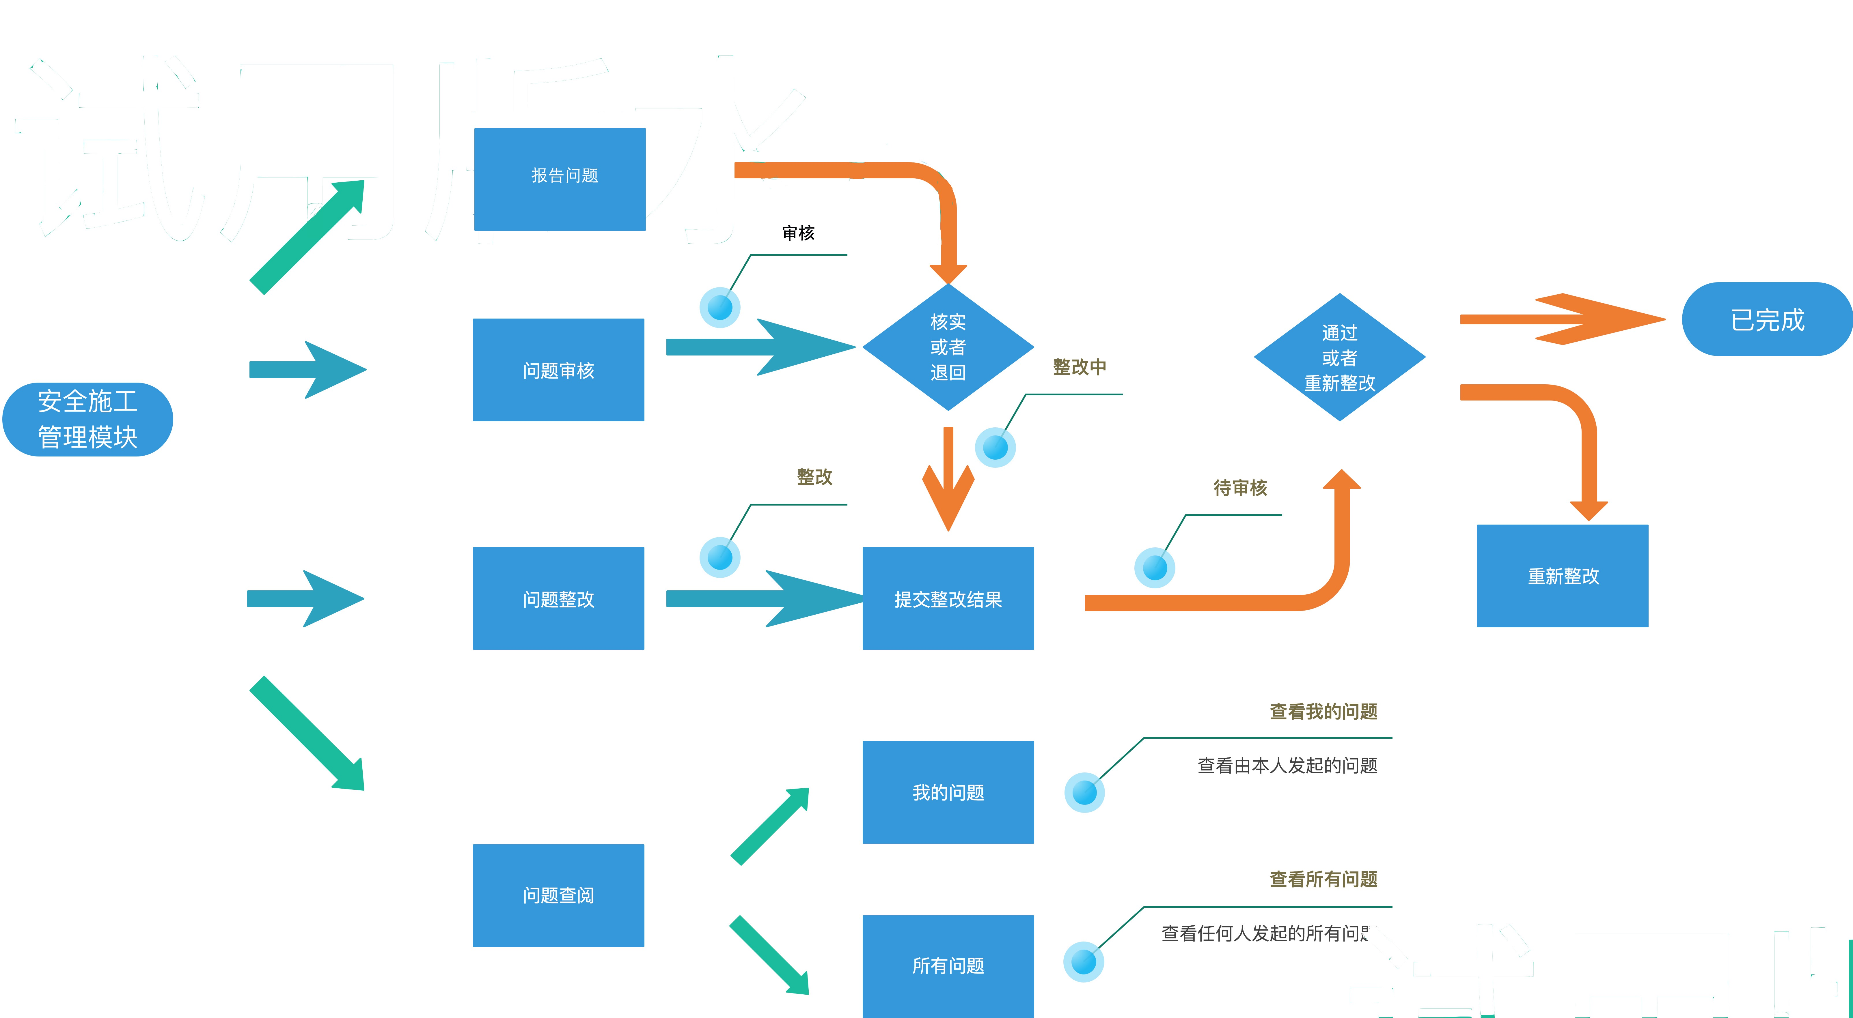

提交问题

5）对讲机模块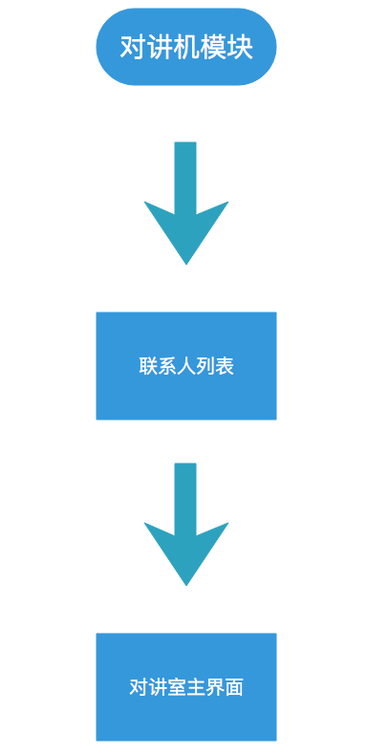

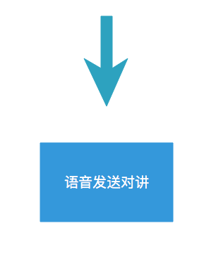

五、 系统详细设计

**5.1、主要页面及页面模块**

1）、登录页面，无密码自定义登录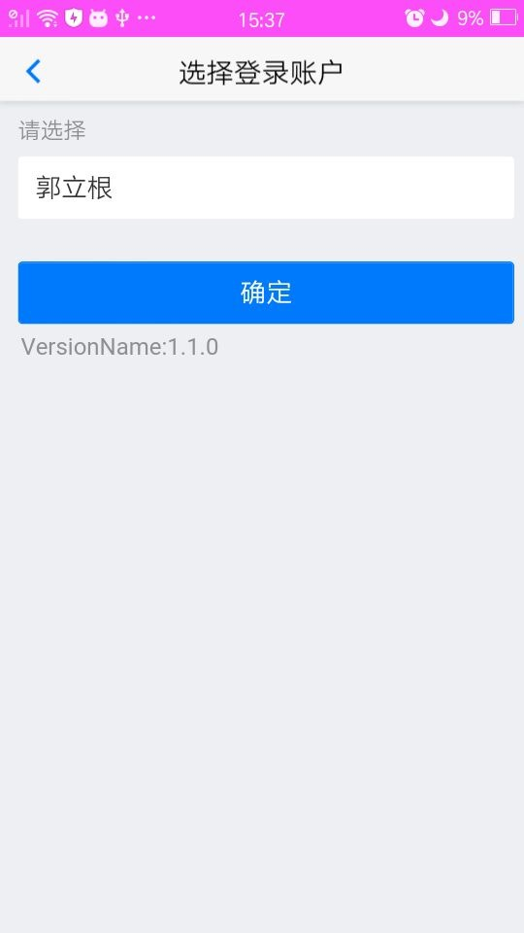

用户列表信息从后台配置，无登录设置

2)、群聊列表页面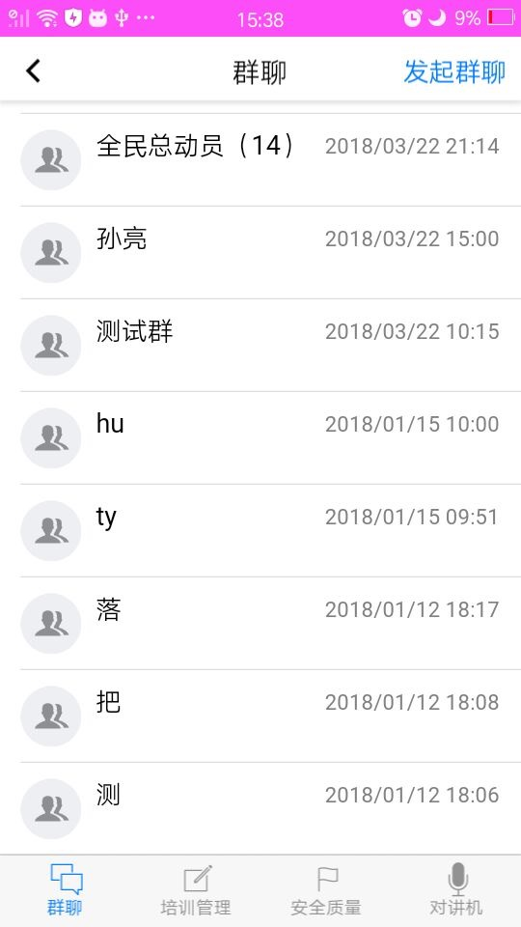

聊天室列表页，获取群聊列表，并进行对应群聊操作。

3）、人员培训管理页面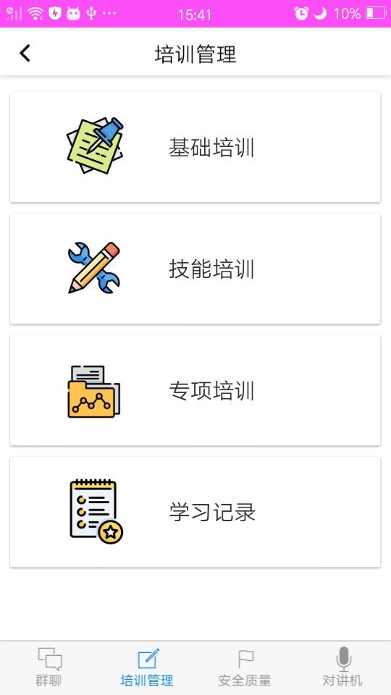

培训模块按培训分类区分区域，分为基础培训、技能培训、专项培训三类功能区

4）、安全质量管理页面

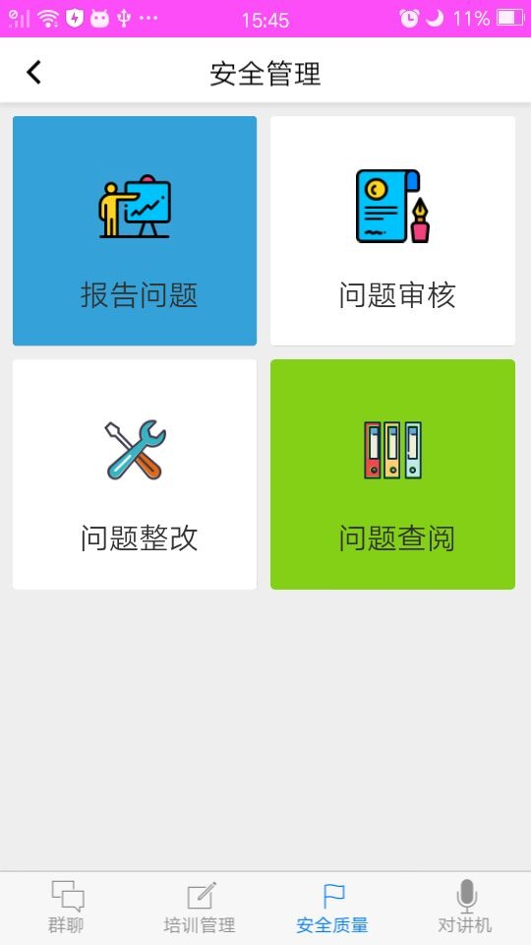

根据功能流程设计，区分为： 报告问题、问题审核、问题整改、问题查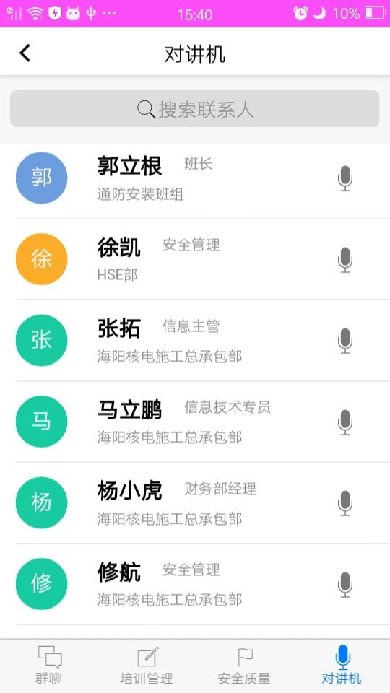阅 四个功能区

5）、对讲机联系人页面

联系人列表，点击联系人进入对讲聊天室实时对讲

六、 数据库系统设计

**6.1、数据库设计**

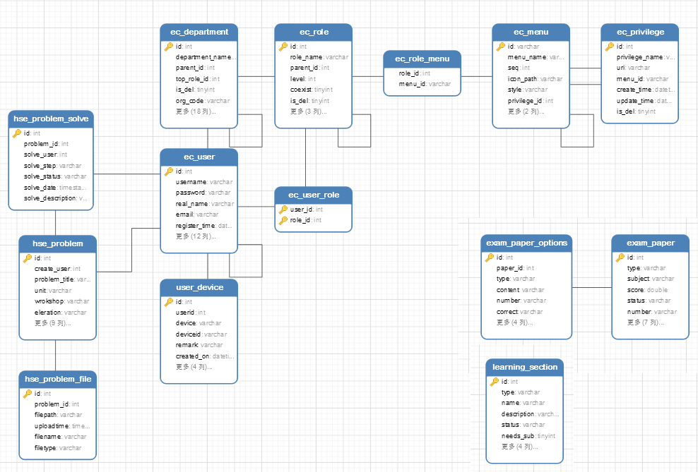

**7.2 数据库表单列表**

|  |  |
| --- | --- |
| ec_department | 部门表 |
| ec_menu | web菜单表 |
| ec_privilege | 权限表 |
| ec_role | 岗位角色表 |
| ec_role_menu | 岗位角色菜单表 |
| ec_user | 人员表 |
| ec_user_role | 人员岗位关联表 |
| exam_paper | 试题表 |
| exam_paper_options | 试题选项表 |
| exam_user_score | 考试成绩表 |
| hse_problem | 安全问题表 |
| hse_problem_file | 安全问题附件表 |
| hse_problem_solve | 安全问题处理记录表 |
| hse_unit_workshop | 安全问题的机组和厂房记录表 |
| learning | 学习 |
| learning_file | 课程文件表 |
| learning_fold | 培训课程模块 |
| learning_history | 学习历史表 |
| learning_section | 培训课程分类 |
| push_log | 推送日志表 |
| user_device | 推送设备关联 |
| variable_set | 参数配置表 |

七、 信息编码设计

**7.1、代码结构设计**

1）App代码结构设计

代码结构按功能模块区分（如下图）：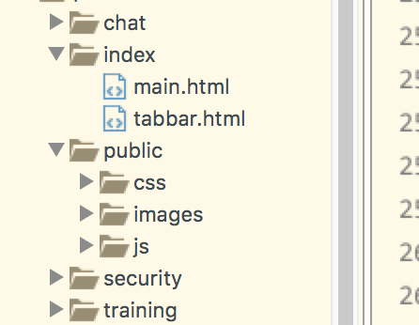

主目录下分别为7个模块：

1、登录模块 ：登录页

2、主页面模块：初始页、首页tabbar组件

tabbar页面 主要业务代码：

3、群聊以及对讲机模块

4、培训模块

5、安全施工模块

6、第三方公共类文件夹：Http 请求类、第三方选择框picker类、第三方全屏图片显示类、第三方页面刷新类、正则格式封装类

7、配置项文件夹：功能权限配置、版本信息、全局配置信息

第3、4、5 三个主功能模块 下都以css样式文件夹、images资源文件夹、js逻辑文件夹、html页面结构文件夹 四部分组成。详情如下图：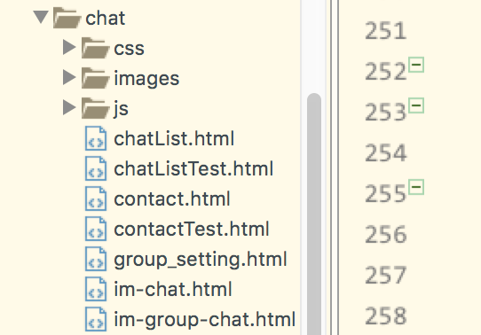

2）后台代码结构设计

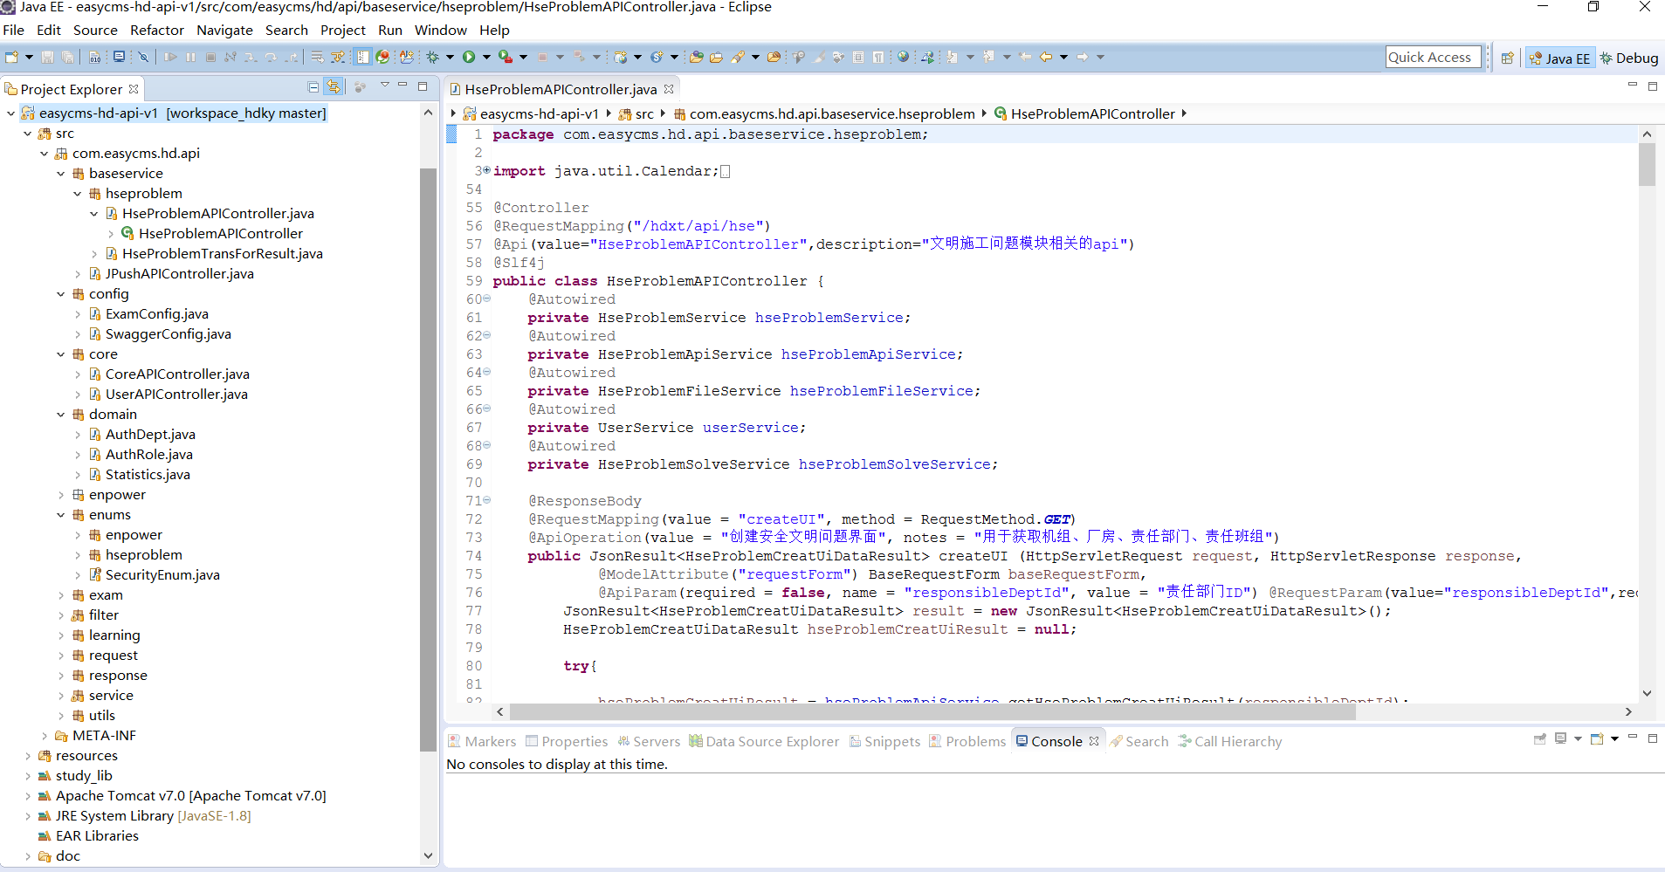

后台代码结构按功能模块区分（如下图）：

主目录下分别为7个模块：

1、登录模块 ：登录页

2、在线培训的数据管理：学习记录管理、培训管理、成绩列表

3、安全文明施工：创建安全问题、安全文明问题管理

4、用户管理

5、菜单管理

6、提供APP使用的接口

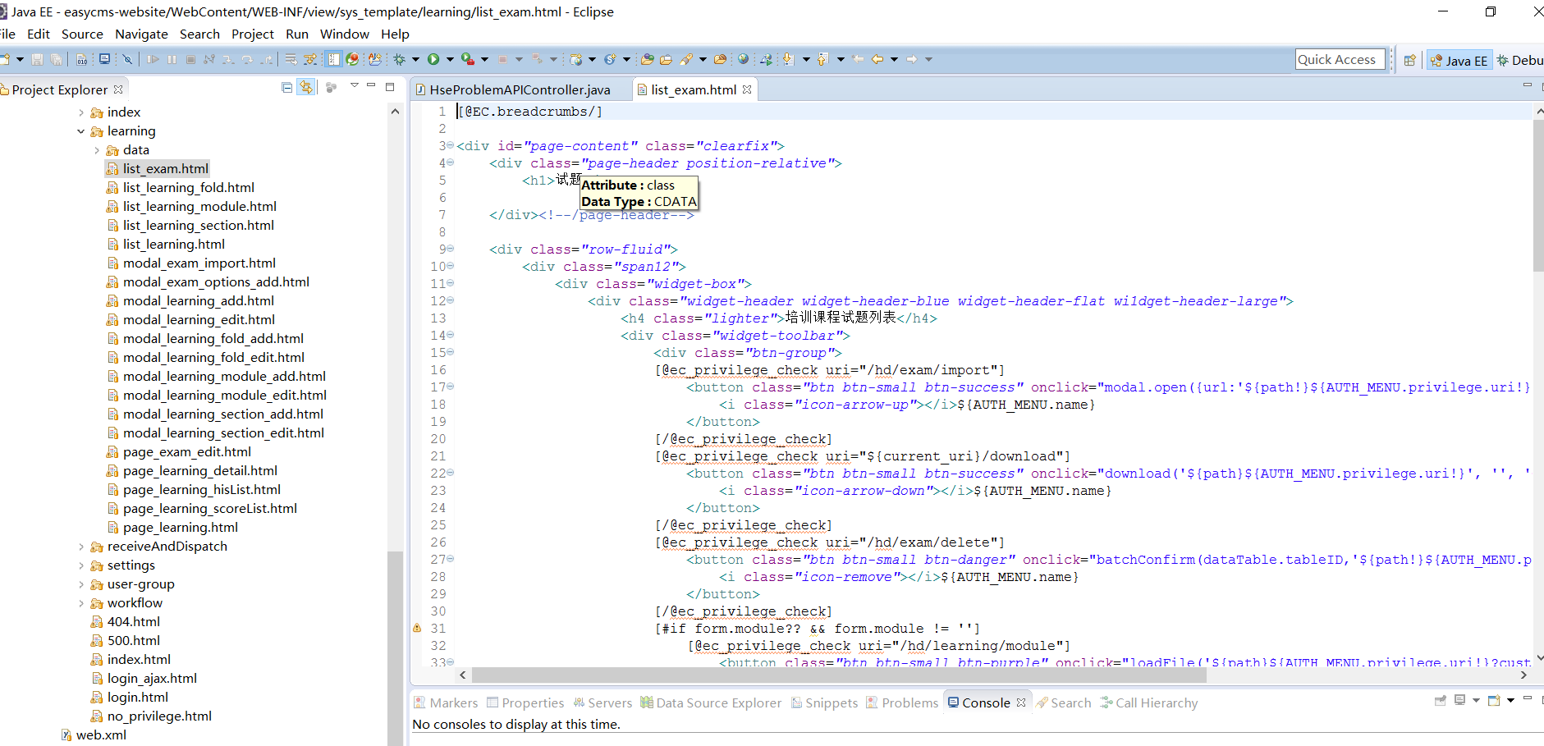

**7.2 代码编制**

**1）APP端**

**tabbar页面代码：tabbar.html**

<!DOCTYPE html>

<html>

<head>

<meta charset="utf-8">

<title>Hello MUI</title>

<meta name="viewport" content="width=device-width, initial-scale=1,maximum-scale=1,user-scalable=no">

<meta name="apple-mobile-web-app-capable" content="yes">

<meta name="apple-mobile-web-app-status-bar-style" content="black">

<!--标准mui.css-->

<link rel="stylesheet" href="../../../public/css/mui.min.css">

<style>

</style>

</head>

<body>

<nav class="mui-bar mui-bar-tab">

<a id="defaultTab" class="mui-tab-item mui-active" href="../chat/chatList.html">

<span class="mui-icon mui-icon-chatboxes"></span>

<span class="mui-tab-label">群聊</span>

</a>

<a class="mui-tab-item" href="../training/training_home.html">

<span class="mui-icon mui-icon-compose"></span>

<span class="mui-tab-label">培训管理</span>

</a>

<a class="mui-tab-item" href="../security/security.html">

<span class="mui-icon mui-icon-flag"></span>

<span class="mui-tab-label">安全质量</span>

</a>

<a class="mui-tab-item" href="../chat/contact.html">

<span class="mui-icon mui-icon-speech"></span>

<span class="mui-tab-label">对讲机</span>

</a>

</nav>

<div class="mui-content">

</div>

</body>

<script src="../../../public/js/mui.min.js"></script>

<script src="../public/js/common.js"></script>

<script type="text/javascript" src="../chat/js/TIMManager.js"></script>

<script>

var subpages = ["../chat/chatList.html", '../training/training_home.html', '../security/security.html', '../chat/contact.html'];

mui.init({

swipeBack: false, //启用右滑关闭功能

});

var subpage_style = {

top: '0px',

bottom: '51px'

};

var aniShow = {};

function createLocalPushMsg() {

var options = {

cover: false

};

var str = "1欢迎使用Html5 Plus创建本地消息！";

plus.push.createMessage(str, "LocalMSG", options);

logAlert("创建本地消息成功！");

}

//创建子页面，首个选项卡页面显示，其它均隐藏；

mui.plusReady(function() {

var clientId = localStorage.getItem("cid");

if(clientId) {

logAlert('hascid')

} else {

logAlert('nocid')

getPushInfo();

}

var self = plus.webview.currentWebview();

for(var i = 0; i < subpages.length; i++) {

var temp = {};

var sub = plus.webview.create(subpages[i], subpages[i], subpage_style);

if(i > 0) {

sub.hide();

} else {

temp[subpages[i]] = "true";

mui.extend(aniShow, temp);

}

self.append(sub);

}

plus.webview.currentWebview().addEventListener('close',

function() {

unregisterListener('action_new_msg', localStorage.newMsgListner + "");

unregisterListener('action_update_conversation', localStorage.conversationUpdateLisnter + "");

localStorage.removeItem('newMsgListner');

localStorage.removeItem('conversationUpdateLisnter');

//unregister

logout();

});

});

function getPushInfo() {

var t1 = window.setInterval(function() {

var info = plus.push.getClientInfo();

var cid = info.clientid;

var token = info.token;

if(cid && token) {

localStorage.setItem("cid", cid);

localStorage.setItem("pushtoken", token);

var cid1 = localStorage.getItem("cid");

var token1 = localStorage.getItem("pushtoken");

logAlert('cid1:' + cid1);

logAlert('token1:' + token1);

authUser(function() {

window.clearInterval(t1);

}, function() {

fail('认证失败');

});

}

}, 1000);

}

var createIframe = function(el, opt) {

var elContainer = document.querySelector(el);

var wrapper = document.querySelector(".mui-iframe-wrapper");

if(!wrapper) {

// 创建wrapper 和 iframe

wrapper = document.createElement('div');

wrapper.className = 'mui-iframe-wrapper';

for(var i in opt.style) {

wrapper.style[i] = opt.style[i];

}

var iframe = document.createElement('iframe');

iframe.src = opt.url;

iframe.id = opt.id || opt.url;

iframe.name = opt.id;

wrapper.appendChild(iframe);

elContainer.appendChild(wrapper);

} else {

var iframe = wrapper.querySelector('iframe');

iframe.src = opt.url;

iframe.id = opt.id || opt.url;

iframe.name = iframe.id;

}

}

mui.ready(function() {

if(!mui.os.plus) {

var defaultTab = document.getElementById("defaultTab");

//模拟首页点击

mui.trigger(defaultTab, 'tap');

}

});

//当前激活选项

var activeTab = subpages[0];

var title = document.getElementById("title");

//选项卡点击事件

mui('.mui-bar-tab').on('tap', 'a', function(e) {

var targetTab = this.getAttribute('href');

if(!mui.os.plus) {

// 创建iframe代替子页面

createIframe('.mui-content', {

url: targetTab,

style: {

top: '0px', //设置距离顶部的距离

bottom: '50px' //设置距离底部的距离

}

});

} else {

if(targetTab == activeTab) {

return;

}

if(mui.os.ios || aniShow[targetTab]) {

plus.webview.show(targetTab);

} else {

//否则，使用fade-in动画，且保存变量

var temp = {};

temp[targetTab] = "true";

mui.extend(aniShow, temp);

plus.webview.show(targetTab, "fade-in", 300);

}

//隐藏当前;

plus.webview.hide(activeTab);

}

//显示目标选项卡

//若为iOS平台或非首次显示，则直接显示

//更改当前活跃的选项卡

activeTab = targetTab;

});

//自定义事件

document.addEventListener('group', function() {

var defaultTab = document.getElementById("defaultTab");

//模拟首页点击

mui.trigger(defaultTab, 'tap');

//切换选项卡高亮

var current = document.querySelector(".mui-bar-tab>.mui-tab-item.mui-active");

if(defaultTab !== current) {

current.classList.remove('mui-active');

defaultTab.classList.add('mui-active');

}

});

</script>

</html>

**群聊页面部分业务代码：chatList.html**

<!DOCTYPE html>

<html>

<head>

<meta charset="utf-8">

<meta name="viewport" content="width=device-width,initial-scale=1,minimum-scale=1,maximum-scale=1,user-scalable=no" />

<title></title>

<link href="../../../public/css/mui.min.css" rel="stylesheet" />

<link rel="stylesheet" type="text/css" href="../../../public/css/app.css" />

<link rel="stylesheet" type="text/css" href="../public/css/common.css" />

<style type="text/css">

.conv-date {

font-size: small;

color: grey;

}

</style>

<style type="text/css">

.card-contact-name {

font-size: large;

color: black;

}

.mui-card,

.mui-btn,

.mui-btn-purple {

margin-top: 20px;

text-align: center;

}

#offCanvasSide {

width: 200px;

text-align: center;

}

.menu-user-card {

display: -webkit-box;

-webkit-box-align: center;

-webkit-box-orient: horizontal;

text-align: center;

}

</style>

</head>

<body>

<header class="mui-bar mui-bar-nav">

<span class="mui-action-back mui-icon mui-icon-left-nav mui-pull-left"></span>

<h1 id="title" class="mui-title">群聊</h1>

<span id="create_group" class="mui-btn mui-btn-blue mui-btn-link mui-pull-right">发起群聊</span>

</header>

<div class="mui-content">

<div>

<ul class="mui-table-view" id=“list">

</ul>

<div id="no_data" style="visibility: hidden; width: 100%;position: absolute;top: 114px;bottom: 0px;left: 0px;justify-content: center;-webkit-justify-content: center;-webkit-align-items:center;align-items:center; display:flex;display: -webkit-flex;">

<p class="" style="font-size: 20px;">没有数据</p>

</div>

</div>

</div>

</body>

</html>

<script src="../../../public/js/mui.min.js"></script>

<script src="../public/js/common.js"></script>

<script type="text/javascript" src="./js/TIMManager.js"></script>

<script>

var chatPage = null;

var conversationUpdateLisnter, newMsgListner;

mui.init({

swipeBack: true //启用右滑关闭功能

});

mui.plusReady(function() {

var self = plus.webview.currentWebview();

var param = {};

param.action = "cmd_init";

if(mui.os.ios) {

var paramios = {};

paramios.action = "cmd_init";

initIMSDK(paramios, function(data) {

self = this;

self.login(loginSuccess,

function(result) {

refreshChatListItems();

}

);

},

function(result) {

logAlert(89);

});

} else {

plus.TIMManager.callIMCmd(JSON.stringify(param),

function(result) {

var self = this;

self.login(loginSuccess,

function(result) {

refreshChatListItems();

}

);

},

function(result) {

}

);

}

plus.webview.currentWebview().addEventListener('close',

function() {

if (mui.os.ios) {

unregisterListener('action_new_msg', localStorage.newMsgListner);

unregisterListener('action_update_conversation', localStorage.conversationUpdateLisnter);

}else{

unregisterListener('action_new_msg', newMsgListner);

unregisterListener('action_update_conversation', conversationUpdateLisnter);

}

//unregister

logout();

});

if(mui.os.ios) {

//

iOSRegisterIMListener('action_new_msg', function(data) {

//

refreshChatListItems();

},

function(result) {

}

);

iOSRegisterIMListener('action_update_conversation', function(data) {

refreshChatListItems();

},

function(result) {

}

);

} else {

newMsgListner = registerListener('action_new_msg', function(data) {

refreshChatListItems();

});

conversationUpdateLisnter = registerListener('action_update_conversation', function(data) {

refreshChatListItems();

});

localStorage.conversationUpdateLisnter = '' + conversationUpdateLisnter;

localStorage.newMsgListner = '' + newMsgListner;

}

});

document.getElementById('create_group').addEventListener('tap', function(e) {

mui.openWindow({

id: 'contact.html',

url: 'contact.html',

extras: {

createGroup: true,

}

});

});

mui(".mui-content").on("tap", ".mui-table-view-cell", function() {

//获取id

var identifier = this.dataset.tag;

var chat_type = this.dataset.type;

//获得详情页面

if(!chatPage) {

if(mui.os.plus) {

chatPage = plus.webview.getWebviewById('im-chat.html');

}

}

var contact = {

realname: this.dataset.name

};

if(chatPage) {

//传值给详情页面，通知加载新数据

mui.fire(chatPage, 'chatDetail', {

identifier: identifier,

chat_type: chat_type,

contact: contact

});

}

//打开详情

mui.openWindow({

id: 'im-chat.html',

url: 'im-chat.html',

extras: {

identifier: identifier,

chat_type: chat_type,

contact: contact

}

});

//打开详情

});

if(mui.os.ios) {

initUI();

} else {

initUI();

}

function loginSuccess(result) {

setTimeout(function() {

refreshChatListItems();

}, 2000);

}

function sendPush() {

var user = getCurrentUser();

var param = {

title: "12iOS推送测试",

message: "推送的消息内容34",

userId: user.id

};

post('/jpush/user', param, success, error);

function success(data, param, dataStringify) {

//

logAlert("数据数据-----" + dataStringify);

}

function error(info) {

mui.alert("请求失败！" + info);

}

}

function initUI() {

// logAlert(2);

refreshChatListItems();

fetchContacts();

}

function compare(property) {

return function(a, b) {

var value1 = a[property];

var value2 = b[property];

return value2 - value1;

}

}

function refreshChatListItems() {

getConvList("group", function(data) {

mui.hideLoading();

if(data.length == 0) {

document.getElementById('list').innerHTML = '';

document.getElementById('list').style.visibility = 'hidden';

document.getElementById('no_data').style.visibility = 'visible';

return

}

data.sort(compare('timestamp'));

var htmlCells = '';

for(var i = 0; i < data.length; i++) {

var item = data[i];

var msg = item.lastmsg;

var content = '';

var unread = 0;

var timestamp = 0;

unread = item.unread;

if(msg) {

content = msg.content;

// logAlert('msg'+msg);

if(msg.type == 'sound') {

content = '[语音消息]';

} else if(msg.type == 'tips') {

content = replaceUser(msg.content);

}

}

var unreadStyle = 'style="display:none"';

if(unread > 0) {

unreadStyle = '';

}

timestamp = formatChatDate(item.timestamp * 1000);

htmlCells += '<li data-name="' + item.name + '" data-tag="' + item.identifier + '" data-type="' + item.type + '" class="mui-table-view-cell mui-media">' +

' <a>' +

' <img src="./images/group_chat_icon.png" class="mui-media-object mui-pull-left">' +

' <div class="mui-media-body">' +

' <span class="conv-name">' + item.name + '</span> <span class="conv-date mui-pull-right">' + timestamp + '</span>' +

' <p class=\'mui-ellipsis \'>' +

' <span class="conv-message">' + content + '</span>' +

' <span class="mui-badge mui-badge-danger mui-pull-right" ' + unreadStyle + ' >' +

unread +

' </span>' +

' </p>' +

' </div>' +

' </a>' +

' </li>';

}

document.getElementById('list').innerHTML = htmlCells;

document.getElementById('list').style.visibility = 'visible';

document.getElementById('no_data').style.visibility = 'hidden';

},

function(result) {

mui.hideLoading();

document.getElementById('no_data').style.visibility = 'visible';

}

);

}

</script>

**人员培训管理页面代码：training_home.html**

<!DOCTYPE html>

<html>

<head>

<meta charset="utf-8">

<title>Hello MUI</title>

<meta name="viewport" content="width=device-width, initial-scale=1,maximum-scale=1,user-scalable=no">

<meta name="apple-mobile-web-app-capable" content="yes">

<meta name="apple-mobile-web-app-status-bar-style" content="black">

<!--标准mui.css-->

<link rel="stylesheet" href="../../../public/css/mui.min.css">

<!--App自定义的css-->

<link rel="stylesheet" type="text/css" href="../../../public/css/app.css" />

<style>

.item-box-icon {

display: inline-block;

width: 90px;

height: 60px;

margin-left: 5%;

position: relative;

display: -webkit-box;

display: -webkit-flex;

display: flex;

-webkit-box-pack: justify;

-webkit-box-align: center;

-webkit-align-items: center;

align-items: center;

}

.item-box-text {

margin-left: 5%;

font-size: 18px;

}

.mui-card-content {

width: 100%;

border: 0px;

}

.mui-card-box {

padding: 0px 0px;

margin: 0px;

position: relative;

display: -webkit-box;

display: -webkit-flex;

display: flex;

min-height: 44px;

-webkit-box-pack: justify;

-webkit-box-align: center;

-webkit-align-items: center;

align-items: center;

}

img {

width: 70px;

height: 70px;

}

</style>

</head>

<body>

<header class="mui-bar mui-bar-nav">

<span class="mui-action-back mui-icon mui-icon-left-nav mui-pull-left"></span>

<h1 class="mui-title">培训管理</h1>

</header>

<div class="mui-content">

<div class="mui-card">

<button id="base" class="mui-card-content" data-type="JCPX" href="training_skill_subpage.html">

<div class="mui-card-content-inner">

<div class="mui-card-box">

<div class="item-box-icon">

<img src="../public/images/basicIcon.png" />

</div>

<div class="item-box-text">

<span>基础培训</span>

</div>

</div>

</div>

</button>

</div>

<div class="mui-card">

<button id="skill" class="mui-card-content" data-type="JNPX" href="training_skill_subpage.html">

<div class="mui-card-content-inner">

<div class="mui-card-box">

<div class="item-box-icon">

<img src="../public/images/skillIcon.png" />

</div>

<div class="item-box-text">

<span>技能培训</span>

</div>

</div>

</div>

</button>

</div>

<div class="mui-card">

<button id="special" class="mui-card-content" data-type="ZXPX" href="training_skill_subpage.html">

<div class="mui-card-content-inner">

<div class="mui-card-box">

<div class="item-box-icon">

<img src="../public/images/specialIcon.png" />

</div>

<div class="item-box-text">

<span>专项培训</span>

</div>

</div>

</div>

</button>

</div>

<div class="mui-card">

<button id="record" class="mui-card-content" href="learn_records.html">

<div class="mui-card-content-inner">

<div class="mui-card-box">

<div class="item-box-icon">

<img src="../public/images/recordIcon.png" />

</div>

<div class="item-box-text">

<span>学习记录</span>

</div>

</div>

</div>

</button>

</div>

<script src="../../../public/js/mui.min.js"></script>

<script src="../public/js/common.js"></script>

<script type="text/javascript" charset="utf-8">

mui.init({

swipeBack: true //启用右滑关闭功能

});

mui(".mui-content").on("tap", "button", function() {

var id = this.getAttribute("id");

var href = this.getAttribute("href");

var text = this.querySelector('.item-box-text').innerText;

console.log('current Type:' + this.dataset.type+";text="+text);

localStorage.training_type = this.dataset.type;

localStorage.training_title = text;

mui.openWindow({

url: href,

id: id,

extras: {

type: this.dataset.type,

title:text

}

});

});

var param = {};

get('/learning/section', param, success, error);

function success(data, param, dataStringify) {

}

function error(info) {

console.log("请求失败！" + info);

}

</script>

</body>

</html>

**安全文明施工页面代码：security.html**

<!DOCTYPE html>

<html>

<head>

<title>安全</title>

<meta http-equiv="Content-Type" content="text/html; charset=UTF-8">

<meta name="viewport" content="width=device-width, initial-scale=1,maximum-scale=1,user-scalable=no">

<meta name="apple-mobile-web-app-capable" content="yes">

<meta name="apple-mobile-web-app-status-bar-style" content="black">

<meta charset="utf-8" />

<link href="../../../public/css/mui.min.css" rel="stylesheet" />

<link rel="stylesheet" type="text/css" href="../../../public/css/app.css" />

<style type="text/css">

html,

img {

border: 0;

}

ul {

list-style: none outside none;

margin: 0;

padding: 0;

}

body {

background-color: #eee;

}

body .mainmenu:after {

clear: both;

content: " ";

display: block;

}

body .mainmenu li {

float: left;

margin-left: 2.5%;

margin-top: 2.5%;

width: 46%;

border-radius: 3px;

overflow: hidden;

}

body .mainmenu li img {

margin: 15px auto 15px;

width: 50px;

height: 50px;

}

.item-box-text {

margin-left: 5%;

font-size: 18px;

}

.mui-card-content {

width: 100%;

border: 0px;

}

.mui-card{

margin: 0px;

}

#report{

background-color: #36A1DB!important;

solid #36A1DB!important;

}

#report:active {

color: #fff;

background-color: #36A1FB!important;

}

#look{

background-color: #84d018!important;

solid #84d018!important;

}

#look:active {

color: #fff;

background-color: #2AC845!important;

}

</style>

</head>

<body>

<header class="mui-bar mui-bar-nav">

<span class="mui-action-back mui-icon mui-icon-left-nav mui-pull-left"></span>

<h1 class="mui-title">安全管理</h1>

</header>

<div class="mui-content">

<ul class="mainmenu">

<li>

<div class="mui-card">

<button id="report" class="mui-card-content" href="qc_report.html">

<div class="mui-card-content-inner">

<div class="mui-card-box">

<div class="item-box-icon">

<img src="../public/images/reportIcon.png" />

</div>

<div class="item-box-text">

<span>报告问题</span>

</div>

</div>

</div>

</button>

</div>

</li>

<li>

<div class="mui-card">

<button id="review" class="mui-card-content" href="qc_review.html">

<div class="mui-card-content-inner">

<div class="mui-card-box">

<div class="item-box-icon">

<img src="../public/images/checkIcon.png" />

</div>

<div class="item-box-text">

<span>问题审核</span>

</div>

</div>

</div>

</button>

</div>

</li>

<li>

<div class="mui-card">

<button id="reform" href="qc_reform.html" class="mui-card-content">

<div class="mui-card-content-inner">

<div class="mui-card-box">

<div class="item-box-icon">

<img src="../public/images/correctionIcon.png" />

</div>

<div class="item-box-text">

<span>问题整改</span>

</div>

</div>

</div>

</button>

</div>

</li>

<li>

<div class="mui-card">

<button id="look" href="qc_inquire.html" class="mui-card-content">

<div class="mui-card-content-inner">

<div class="mui-card-box">

<div class="item-box-icon">

<img src="../public/images/lookIcon.png" />

</div>

<div class="item-box-text">

<span>问题查阅</span>

</div>

</div>

</div>

</button>

</div>

</li>

</ul>

</div>

<script src="../../../public/js/mui.min.js"></script>

<script src="../public/js/common.js"></script>

<script type="text/javascript" charset="utf-8">

mui.init({

swipeBack: true //启用右滑关闭功能

});

mui(".mui-content").on("tap", "button", function() {

var id = this.getAttribute("id");

var href = this.getAttribute("href");

logAlert('id');

if(id =='review'){

var isHse = isHSE();

if(isHse){

mui.openWindow({

url: href,

id: id

});

}else{

mui.alert('当前用户不是HSE部门成员,无法执行该操作');

}

}else if(id =='reform'){

var isReformUser = isReformTeam();

if(isReformUser){

mui.openWindow({

url: href,

id: id

});

}else{

mui.alert('当前用户没有权限,无法执行该操作');

}

}else{

mui.openWindow({

url: href,

id: id

});

}

});

</script>

</body>

</html>

请求公共类部分逻辑代码：common.js

function uploadFile(apiName, body, sucs, fail) {

mui.showLoading("正在加载..", "div");

var user = getCurrentUser();

if(!user) {

authUser(function() {

get(apiName, body, sucs, fail);

}, function() {

fail('认证失败');

});

return;

}

mui.ajax(httpDomain + apiName+"?loginId="+user.id, {

crossDomain: true,

data: body,

processData: false, // 告诉jQuery不要去处理发送的数据

contentType: false, // 告诉jQuery不要去设置Content-Type请求头

dataType: 'json', //服务器返回json格式数据

type: 'POST', //HTTP请求类型

timeout: 20000, //超时时间设置为20秒；

success: function(data) {

//服务器返回响应，根据响应结果，分析是否登录成功；

mui.hideLoading();

var info = JSON.stringify(data);

console.log("返回请求地址->：" + apiName + "服务器内容-->" + info);

if(data.code == 1000) {

sucs(data, body, info);

} else if(data.code == -1002) { //没有认证

//

} else {

if(data.message) {

fail(data.message);

console.log('Upload request error:' + apiName + ":response Message=" + data.message);

} else {

fail(info);

}

}

},

error: function(xhr, type, errorThrown) {

mui.hideLoading();

//异常处理；

fail("code=" + xhr.status + " error:" + type); //type错误描述，可取值："timeout", "error", "abort", "parsererror"、"null"

if(xhr.status == 0) {

networkWarning();

return

}

}

});

}

function mock(type, apiName, body, succ) {

setTimeout(function() {

callMock(type, apiName, body, succ);

mui.hideLoading();

}, 1000);

}

function post(apiName, body, sucs, fail) {

if(!body.disableLoading) {

mui.showLoading("正在加载..", "div");

}

var user = getCurrentUser();

if(!user) {

authUser(function() {

post(apiName, body, sucs, fail);

}, function() {

fail('认证失败');

});

return;

}

body.loginId = user.id;

if(mockData) {

mock('post', apiName, body, sucs);

return;

}

mui.ajax(httpDomain + apiName, {

crossDomain: true,

data: body,

dataType: 'json', //服务器返回json格式数据

type: 'POST', //HTTP请求类型

timeout: 20000, //超时时间设置为20秒；

success: function(data) {

//服务器返回响应，根据响应结果，分析是否登录成功；

mui.hideLoading();

var info = JSON.stringify(data);

// logAlert("请求地址和参数" + apiName + "参数" + JSON.stringify(data));

console.log("返回请求地址->：" + apiName + "服务器内容-->" + info);

if(data.code == 1000) {

sucs(data, body, info);

} else if(data.code == -1002) { //没有认证

//

} else {

if(data.message) {

fail(data.message);

console.log('Post request error:' + apiName + ":response Message=" + data.message);

} else {

fail(info);

}

}

},

error: function(xhr, type, errorThrown) {

mui.hideLoading();

//异常处理；

fail("code=" + xhr.status + " error:" + type); //type错误描述，可取值："timeout", "error", "abort", "parsererror"、"null"

logAlert("code=" + xhr.status + " apiName=" + apiName + " HttpRequestPostReusltErr:" + type);

if(xhr.status == 0 && !body.disableLoading) {

networkWarning();

return

}

}

});

}

function authUser(authSucc, authFailed) {

//from login get userId,

var cid = localStorage.getItem("cid");

var name = getLoginUserId();

var body = {

username: name,

uuid:cid

}

if (mui.os.ios) {

body.androidOrIOS = "IOS";

} else{

body.androidOrIOS = "android";

}

mui.ajax(httpDomain + '/getUserId', {

crossDomain: true,

data: body,

dataType: 'json', //服务器返回json格式数据

type: 'POST', //HTTP请求类型

timeout: 20000, //超时时间设置为20秒；

success: function(data) {

//服务器返回响应，根据响应结果，分析是否登录成功；

var info = JSON.stringify(data);

console.log("返回请求地址->：" + " auth " + "服务器内容-->" + info);

if(data.code == 1000) {

storeUserInfo(data.responseResult);

authSucc();

} else if(data.code == -1002) {

//user not exsit

authFailed();

} else {

authFailed();

}

},

error: function(xhr, type, errorThrown) {

mui.toast("code=" + xhr.status + " " + " 请求错误:" + type);

console.log("code=" + xhr.status + " " + " HttpRequestAuthReusltErr:" + type);

authFailed();

if(xhr.status == 0) {

networkWarning();

return

}

}

});

}

function networkWarning() {

mui.toast('请检查网络');

}

function getLoginUserId() {

var myId = localStorage.getItem("usersname");

return myId;

}

function storeUserInfo(userInfo) {

localStorage.UserInfo = JSON.stringify(userInfo);

}

function getUserInfo() {

var userStr = localStorage.UserInfo;

if(!userStr) {

return null;

}

var user = JSON.parse(userStr);

return user;

}

function deleteCurrentUserInfo() {

localStorage.removeItem('UserInfo');

}

function getCurrentUser() {

//

var user = getUserInfo();

if(!user) {

return null;

}

if(user.username != getLoginUserId()) {

deleteCurrentUserInfo();

return null;

}

return user;

}

function getStepNameWithProblemStatus(problemStatus){

if(problemStatus == 'Need_Handle') {

return "待处理";

} else if(problemStatus == 'Renovating') {

return "整改中";

} else if(problemStatus == 'Need_Check') {

return "待审核";

} else if(problemStatus == 'None') {

return "不需处理";

} else {

return "已完成";

}

}

function get(apiName, body, sucs, fail) {

var user = getCurrentUser();

if(!user) {

authUser(function() {

get(apiName, body, sucs, fail);

}, function() {

fail('认证失败');

});

return;

}

body.loginId = user.id;

//body.loginId = '514';

var url = httpDomain + apiName;

var param = "";

for(var element in body) {

param += element + "=" + body[element] + "&";

}

url = url + "?" + param;

console.log("请求地址和参数" + url);

// mui.alert('请求地址和参数:'+url);

if(mockData) {

mock('get', apiName, body, sucs);

return;

}

mui.ajax(url, {

crossDomain: true,

dataType: 'json', //服务器返回json格式数据

type: 'GET', //HTTP请求类型

timeout: 20000, //超时时间设置为20秒；

headers: {

'Accept': 'application/json',

'Content-Type': 'application/json'

},

success: function(data) {

//服务器返回响应，根据响应结果，分析是否登录成功；

var info = JSON.stringify(data);

console.log("返回请求地址->：" + apiName + "服务器内容-->" + info);

if(data.code == 1000) {

sucs(data, body, info);

} else {

if(data.message) {

fail(data.message);

console.log('Get request error:' + apiName + ":response Message=" + data.message);

} else {

fail(info);

}

}

},

error: function(xhr, type, errorThrown) {

//异常处理；

fail("code=" + xhr.status + " error:" + type); //type错误描述，可取值："timeout", "error", "abort", "parsererror"、"null"

console.log("code=" + xhr.status + " apiName=" + apiName + " HttpRequestGetReusltErr:" + type);

if(xhr.status == 0) {

networkWarning();

return

}

}

});

}

**2）Web后端**

**2.1 登陆安全认证接口：CoreAPIController.java**

package com.easycms.hd.api.core;

import java.io.File;

import java.io.FileInputStream;

import java.io.IOException;

import java.io.InputStream;

import java.io.OutputStream;

import java.util.ArrayList;

import java.util.Arrays;

import java.util.Calendar;

import java.util.Date;

import java.util.List;

import java.util.Set;

import java.util.stream.Collectors;

import javax.servlet.http.HttpServletRequest;

import javax.servlet.http.HttpServletResponse;

import javax.validation.Valid;

import org.springframework.beans.factory.annotation.Autowired;

import org.springframework.beans.factory.annotation.Value;

import org.springframework.stereotype.Controller;

import org.springframework.web.bind.annotation.ModelAttribute;

import org.springframework.web.bind.annotation.PathVariable;

import org.springframework.web.bind.annotation.RequestMapping;

import org.springframework.web.bind.annotation.RequestMethod;

import org.springframework.web.bind.annotation.RequestParam;

import org.springframework.web.bind.annotation.ResponseBody;

import com.easycms.common.util.CommonUtility;

import com.easycms.hd.api.domain.AuthRole;

import com.easycms.hd.api.request.LoginRequestForm;

import com.easycms.hd.api.request.UserRequestForm;

import com.easycms.hd.api.request.base.BaseRequestForm;

import com.easycms.hd.api.response.AuthorizationResult;

import com.easycms.hd.api.response.ModulesResult;

import com.easycms.hd.api.response.TLSResult;

import com.easycms.hd.api.response.UserResult;

import com.easycms.hd.api.service.DepartmentApiService;

import com.easycms.hd.api.service.RoleApiService;

import com.easycms.hd.modules.domain.Modules;

import com.easycms.hd.modules.service.ModulesService;

import com.easycms.hd.response.JsonResult;

import com.easycms.hd.tls.TLSUtils;

import com.easycms.management.user.domain.User;

import com.easycms.management.user.domain.UserDevice;

import com.easycms.management.user.service.UserDeviceService;

import com.easycms.management.user.service.UserService;

import com.wordnik.swagger.annotations.Api;

import com.wordnik.swagger.annotations.ApiOperation;

import com.wordnik.swagger.annotations.ApiParam;

import lombok.extern.slf4j.Slf4j;

@Controller

@RequestMapping("/hdxt/api")

@Api(value = "CoreAPIController", description = "登录与主页相关api")

@Slf4j

public class CoreAPIController {

@Autowired

private UserService userService;

@Autowired

private UserDeviceService userDeviceService;

@Autowired

private RoleApiService roleApiService;

@Autowired

private DepartmentApiService departmentApiService;

@Autowired

private ModulesService modulesService;

@Value("#{APP_SETTING['user_sig']}")

private boolean userSig;

@Value("#{APP_SETTING['file_base_path']}")

private String basePath;

@Value("#{APP_SETTING['windows_file_base_path']}")

private String winBasePath;

@Value("#{APP_SETTING['video_suffix']}")

private String videoSuffix;

/**

* 认证用户

*

* @param request

* @param response

* @param loginForm

* @return

*/

@ResponseBody

@RequestMapping(value = "/authenticate", method = RequestMethod.POST)

@ApiOperation(value = "Mobile端登录", notes = "用于移动端登录。")

public JsonResult<AuthorizationResult> authenticate(HttpServletRequest request, HttpServletResponse response,

@ModelAttribute("requestForm") @Valid LoginRequestForm requestForm) {

JsonResult<AuthorizationResult> result = new JsonResult<AuthorizationResult>();

AuthorizationResult auth = new AuthorizationResult();

String username = requestForm.getUsername();

String password = requestForm.getPassword();

String uuid = requestForm.getUuid();

log.info("==> username ：" + username);

log.info("==> password ：" + password);

log.info("==> device ：" + uuid);

// LOGIN ID非空判断

if (!CommonUtility.isNonEmpty(username)) {

result.setCode("-1001");

result.setMessage("用户名不能为空");

return result;

}

// PASSWORD 非空判断

if (!CommonUtility.isNonEmpty(password)) {

result.setCode("-1001");

result.setMessage("密码不能为空");

return result;

}

// LOGIN ID有效判断

User user = userService.findUser(username);

if (user == null) {

user = userService.findByNameIsDel1(username);

if(user!=null){

result.setCode("-1001");

result.setMessage("用户" + username + "被冻结");

return result;

}else{

result.setCode("-1001");

result.setMessage("用户" + username + "不存在");

return result;

}

}

// 登录认证

user = userService.userLogin(username, password, false);

if (user == null) {

result.setCode("-1002");

result.setMessage("The cause: the password is wrong");

return result;

}

if (CommonUtility.isNonEmpty(uuid)) {

if (null == userDeviceService.getDeviceByDeviceIdAndUserId(user.getId(), uuid)) {

UserDevice userDevice = new UserDevice();

userDevice.setUser(user);

userDevice.setDeviceid(uuid);

userDevice.setCreatedOn(new Date());

userDevice.setCreatedBy("Core_API");

userDeviceService.add(userDevice);

}

}

auth.setId(user.getId());

auth.setRealname(user.getRealname());

auth.setUsername(user.getName());

if (user.getRoles() != null && user.getRoles().size() > 0) {

Set<AuthRole> roles = roleApiService.getAuthRole(user);

auth.setRoles(roles);

}

// //设置模块属性

// List<Modules> modules = user.getModules();

// if(modules!=null && modules.size()>0){

// Set<AuthModule> m = roleApiService.getAuthModule(user);

// auth.setModules(m);

// }

if (null != user.getDepartment()) {

auth.setDepartment(departmentApiService.departmentTransferToDepartmentResult(user.getDepartment()));

}

if (userSig) {

TLSResult tls = new TLSResult();

try {

tls = TLSUtils.getUserSig(user.getName());

auth.setTls(tls);

} catch (Exception e) {

e.printStackTrace();

log.error(e.getMessage());

}

}

result.setResponseResult(auth);

return result;

}

@ResponseBody

@RequestMapping(value = "/user", method = RequestMethod.GET)

@ApiOperation(value = "Mobile端获取用户信息", notes = "用于移动端获取指定用户ID的用户信息。")

public JsonResult<UserResult> user(HttpServletRequest request, HttpServletResponse response,

@ModelAttribute("form") UserRequestForm form) {

JsonResult<UserResult> result = new JsonResult<UserResult>();

UserResult auth = new UserResult();

// LOGIN ID非空判断

if (null == form.getUserId()) {

result.setCode("-1001");

result.setMessage("用户ID不能为空");

return result;

}

// 获取用户信息

User user = userService.findUserById(form.getUserId());

if (user == null) {

result.setCode("-1002");

result.setMessage("提定用户ID[" + form.getUserId() + "]的用户不存在。");

return result;

}

auth.setId(user.getId());

auth.setRealname(user.getRealname());

auth.setUsername(user.getName());

if (user.getRoles() != null && user.getRoles().size() > 0) {

Set<AuthRole> roles = roleApiService.getAuthRole(user);

auth.setRoles(roles);

}

result.setResponseResult(auth);

return result;

}

@ResponseBody

@RequestMapping(value = "/getUserId", method = RequestMethod.POST)

@ApiOperation(value = "Mobile端获取用户id", notes = "用于移动端获取指定用户的ID用户信息。")

public JsonResult<UserResult> getUserId(HttpServletRequest request, HttpServletResponse response,

@ApiParam(required = true, name = "username", value = "username")@RequestParam(value="username",required=true) String username,

@ApiParam(required = false, name = "uuid", value = "uuid")@RequestParam(value="uuid",required=false) String uuid,

@ApiParam(required = false, name = "androidOrIOS", value = "androidOrIOS")@RequestParam(value="androidOrIOS",required=false) String androidOrIOS) {

JsonResult<UserResult> result = new JsonResult<UserResult>();

UserResult auth = new UserResult();

// LOGIN username非空判断

if (null == username || "".equals(username.trim())) {

result.setCode("-1001");

result.setMessage("用户ID不能为空");

return result;

}

// 获取用户信息

User user = userService.findUser(username.trim());

if (user == null) {

result.setCode("-1002");

result.setMessage("指定用户ID[" + username + "]的用户不存在。");

return result;

}

if (CommonUtility.isNonEmpty(androidOrIOS) && CommonUtility.isNonEmpty(uuid)) {

List<UserDevice> deviceList = userDeviceService.getDeviceByUserId(user.getId());

if(deviceList==null || deviceList.size()==0){

UserDevice userDevice = new UserDevice();

userDevice.setUser(user);

userDevice.setDeviceid(uuid);

userDevice.setAndroidOrIOS(androidOrIOS);

userDevice.setCreatedOn(new Date());

userDevice.setCreatedBy("Core_API");

userDeviceService.add(userDevice);

}else{

if(deviceList.size()==1){

UserDevice userDevice = deviceList.get(0);

userDevice.setDeviceid(uuid);

userDevice.setAndroidOrIOS(androidOrIOS);

userDevice.setUpdatedOn(Calendar.getInstance().getTime());

userDeviceService.add(userDevice);

}else if(deviceList.size()>1){

//首记录更新使用，其它记录删除掉

UserDevice userDevice = deviceList.get(0);

deviceList.remove(0);

userDevice.setDeviceid(uuid);

userDevice.setAndroidOrIOS(androidOrIOS);

userDevice.setUpdatedOn(Calendar.getInstance().getTime());

userDeviceService.add(userDevice);

deviceList.stream().forEach(d->userDeviceService.delete(d.getId()));

}

}

}

// if (user == null) {

// result.setCode("-1003");

// result.setMessage("提定用户ID[" + username + "]的用户不存在。");

// return result;

// }

auth.setId(user.getId());

auth.setRealname(user.getRealname());

auth.setUsername(user.getName());

if (user.getRoles() != null && user.getRoles().size() > 0) {

Set<AuthRole> roles = roleApiService.getAuthRole(user);

auth.setRoles(roles);

}

if (null != user.getDepartment()) {

auth.setDepartment(departmentApiService.departmentTransferToDepartmentResult(user.getDepartment()));

}

result.setResponseResult(auth);

return result;

}

/**

* 登出，清除clientid

* @param request

* @param response

* @param username

* @param uuid

* @param androidOrIOS

* @return

*/

@ResponseBody

@RequestMapping(value = "/logout", method = RequestMethod.POST)

@ApiOperation(value = "Mobile端获取用户id", notes = "用于移动端获取指定用户的ID用户信息。")

public JsonResult<UserResult> logout(HttpServletRequest request, HttpServletResponse response,

@ApiParam(required = true, name = "username", value = "username")@RequestParam(value="username",required=true) String username) {

JsonResult<UserResult> result = new JsonResult<UserResult>();

UserResult auth = new UserResult();

if (null == username || "".equals(username.trim())) {

result.setCode("-1001");

result.setMessage("用户ID不能为空");

return result;

}

// 获取用户信息

User user = userService.findUser(username.trim());

if (user == null) {

result.setCode("-1002");

result.setMessage("指定用户ID[" + username + "]的用户不存在。");

return result;

}

List<UserDevice> deviceList = userDeviceService.getDeviceByUserId(user.getId());

if(deviceList==null || deviceList.size()==0){

}else{

if(deviceList.size()==1){

UserDevice userDevice = deviceList.get(0);

userDevice.setDeviceid("");

userDevice.setAndroidOrIOS("");

userDevice.setUpdatedOn(Calendar.getInstance().getTime());

userDeviceService.add(userDevice);

}else if(deviceList.size()>1){

//首记录更新使用，其它记录删除掉

UserDevice userDevice = deviceList.get(0);

deviceList.remove(0);

userDevice.setDeviceid("");

userDevice.setAndroidOrIOS("");

userDevice.setUpdatedOn(Calendar.getInstance().getTime());

userDeviceService.add(userDevice);

deviceList.stream().forEach(d->userDeviceService.delete(d.getId()));

}

}

auth.setId(user.getId());

auth.setRealname(user.getRealname());

auth.setUsername(user.getName());

if (user.getRoles() != null && user.getRoles().size() > 0) {

Set<AuthRole> roles = roleApiService.getAuthRole(user);

auth.setRoles(roles);

}

if (null != user.getDepartment()) {

auth.setDepartment(departmentApiService.departmentTransferToDepartmentResult(user.getDepartment()));

}

result.setResponseResult(auth);

return result;

}

@ResponseBody

@RequestMapping(value = "/module", method = RequestMethod.GET)

@ApiOperation(value = "Mobile端module列表", notes = "在移动端登录之后主界面中间module列表")

public JsonResult<List<ModulesResult>> getModules(HttpServletRequest request, HttpServletResponse response,

@RequestParam(value = "loginId", required = true) @ApiParam(value = "用户登录之后的用户ID", required = true) Long loginId) {

JsonResult<List<ModulesResult>> result = new JsonResult<List<ModulesResult>>();

List<ModulesResult> modulesResults = new ArrayList<ModulesResult>();

List<Modules> modules = modulesService.findByStatus("ACTIVE");

modulesResults = modules.stream().map(module -> {

ModulesResult modulesResult = new ModulesResult();

modulesResult.setName(module.getName());

modulesResult.setId(module.getId());

modulesResult.setOrderNumber(module.getOrderNumber());

modulesResult.setType(module.getType());

return modulesResult;

}).collect(Collectors.toList());

result.setResponseResult(modulesResults);

return result;

}

@ResponseBody

@RequestMapping(value = "/tls", method = RequestMethod.POST)

@ApiOperation(value = "Mobile端获取用户TLS", notes = "用于移动端获取指定用户名的TLS信息。")

public JsonResult<TLSResult> tls(HttpServletRequest request, HttpServletResponse response,

@ModelAttribute("form") BaseRequestForm form) {

JsonResult<TLSResult> result = new JsonResult<TLSResult>();

User user = userService.findUserById(form.getLoginId());

if (user == null) {

result.setCode("-1002");

result.setMessage("提定用户ID[" + form.getLoginId() + "]的用户不存在。");

return result;

}

TLSResult tls = new TLSResult();

try {

tls = TLSUtils.getUserSig(user.getName());

} catch (Exception e) {

e.printStackTrace();

log.error(e.getMessage());

}

result.setResponseResult(tls);

return result;

}

public static void main(String[] args) {

File f = new File("D:\\tmp\\zhierxing.pdf");

System.out.println(f.length());

}

@RequestMapping(value = {"/files/{filePath:.+}"}, method = RequestMethod.GET)

@ApiOperation(value = "Mobile端得到文件", notes = "将uri跟在id上则可得到相应流文件")

public void getConferenceFile(HttpServletRequest request, HttpServletResponse response,

@PathVariable("filePath") @ApiParam(value = "文件路径，约定*代替为/", required = true) String filePath)

throws Exception {

response.setDateHeader("Expires", 0);

response.setHeader("Cache-Control", "no-store, no-cache, must-revalidate");

response.addHeader("Cache-Control", "post-check=0, pre-check=0");

response.setHeader("Pragma", "no-cache");

InputStream in = null;

OutputStream out = null;

try {

if( false == com.easycms.common.logic.context.ContextPath.Linux.equals(com.easycms.common.logic.context.ContextPath.os_name)){

basePath = winBasePath ;

}

String streamFilePath = basePath + filePath.replace("*", "/");

String suffix = filePath.substring(filePath.lastIndexOf(".") + 1, filePath.length());

log.debug("文件类型："+ suffix);

List<String> videoSuffixList = Arrays.asList(videoSuffix.split(","));

if(videoSuffixList.contains(suffix) || "mp4".equals(suffix)){//视频文件

response.setContentType("video/x-msvideo");

response.setContentType("APPLICATION/OCTET-STREAM");

response.setHeader("Content-Type","video/x-msvideo");

}

File f = new File(streamFilePath);

if(f!=null && f.exists()){

response.setHeader("Content-Length", f.length()+"");

}

in = new FileInputStream(streamFilePath); // 获取文件的流

int len = 0;

byte buf[] = new byte[1024];// 缓存作用

out = response.getOutputStream();// 输出流

while ((len = in.read(buf)) > 0) {// 切忌这后面不能加 分号 ”;“

out.write(buf, 0, len);// 向客户端输出，实际是把数据存放在response中，然后web服务器再去response中读取

}

} catch (Exception e) {

e.printStackTrace();

} finally {

if (in != null) {

try {

in.close();

} catch (IOException e) {

e.printStackTrace();

}

}

if (out != null) {

try {

out.close();

} catch (IOException e) {

e.printStackTrace();

}

}

}

}

}

**2.2 安全文明施工接口：HseProblemAPIController.java**

package com.easycms.hd.api.baseservice.hseproblem;

import java.util.Calendar;

import java.util.List;

import javax.servlet.http.HttpServletRequest;

import javax.servlet.http.HttpServletResponse;

import org.springframework.beans.factory.annotation.Autowired;

import org.springframework.stereotype.Controller;

import org.springframework.web.bind.annotation.ModelAttribute;

import org.springframework.web.bind.annotation.PathVariable;

import org.springframework.web.bind.annotation.RequestMapping;

import org.springframework.web.bind.annotation.RequestMethod;

import org.springframework.web.bind.annotation.RequestParam;

import org.springframework.web.bind.annotation.ResponseBody;

import org.springframework.web.multipart.commons.CommonsMultipartFile;

import com.easycms.common.logic.context.ContextPath;

import com.easycms.common.upload.FileInfo;

import com.easycms.common.upload.UploadUtil;

import com.easycms.common.util.CommonUtility;

import com.easycms.common.util.FileUtils;

import com.easycms.core.util.Page;

import com.easycms.hd.api.enums.hseproblem.HseProbelmTypeEnum;

import com.easycms.hd.api.enums.hseproblem.HseProblemSolveStatusEnum;

import com.easycms.hd.api.enums.hseproblem.HseProblemStatusEnum;

import com.easycms.hd.api.request.base.BaseRequestForm;

import com.easycms.hd.api.request.hseproblem.HseProblemAssignRequestForm;

import com.easycms.hd.api.request.hseproblem.HseProblemListRequestFormByStatus;

import com.easycms.hd.api.request.hseproblem.HseProblemRenovateForm;

import com.easycms.hd.api.request.hseproblem.HseProblemRequestForm;

import com.easycms.hd.api.response.hseproblem.HseProblemCreatUiDataResult;

import com.easycms.hd.api.response.hseproblem.HseProblemPageDataResult;

import com.easycms.hd.api.response.hseproblem.HseProblemResult;

import com.easycms.hd.api.service.HseProblemApiService;

import com.easycms.hd.hseproblem.domain.HseProblem;

import com.easycms.hd.hseproblem.domain.HseProblemFile;

import com.easycms.hd.hseproblem.domain.HseProblemFileType;

import com.easycms.hd.hseproblem.domain.HseProblemSolve;

import com.easycms.hd.hseproblem.domain.HseProblemSolveStep;

import com.easycms.hd.hseproblem.domain.HseProblemStep;

import com.easycms.hd.hseproblem.service.HseProblemFileService;

import com.easycms.hd.hseproblem.service.HseProblemService;

import com.easycms.hd.hseproblem.service.HseProblemSolveService;

import com.easycms.hd.response.JsonResult;

import com.easycms.management.user.domain.User;

import com.easycms.management.user.service.UserService;

import com.wordnik.swagger.annotations.Api;

import com.wordnik.swagger.annotations.ApiOperation;

import com.wordnik.swagger.annotations.ApiParam;

import lombok.extern.slf4j.Slf4j;

@Controller

@RequestMapping("/hdxt/api/hse")

@Api(value="HseProblemAPIController",description="文明施工问题模块相关的api")

@Slf4j

public class HseProblemAPIController {

@Autowired

private HseProblemService hseProblemService;

@Autowired

private HseProblemApiService hseProblemApiService;

@Autowired

private HseProblemFileService hseProblemFileService;

@Autowired

private UserService userService;

@Autowired

private HseProblemSolveService hseProblemSolveService;

@ResponseBody

@RequestMapping(value = "createUI", method = RequestMethod.GET)

@ApiOperation(value = "创建安全文明问题界面", notes = "用于获取机组、厂房、责任部门、责任班组")

public JsonResult<HseProblemCreatUiDataResult> createUI (HttpServletRequest request, HttpServletResponse response,

@ModelAttribute("requestForm") BaseRequestForm baseRequestForm,

@ApiParam(required = false, name = "responsibleDeptId", value = "责任部门ID") @RequestParam(value="responsibleDeptId",required=false) Integer responsibleDeptId){

JsonResult<HseProblemCreatUiDataResult> result = new JsonResult<HseProblemCreatUiDataResult>();

HseProblemCreatUiDataResult hseProblemCreatUiResult = null;

try{

hseProblemCreatUiResult = hseProblemApiService.getHseProblemCreatUiResult(responsibleDeptId);

}catch(Exception e){

e.printStackTrace();

result.setMessage("操作异常:"+e.getMessage());

result.setResponseResult(hseProblemCreatUiResult);

return result;

}

result.setResponseResult(hseProblemCreatUiResult);

return result;

}

@ResponseBody

@RequestMapping(value = "create", method = RequestMethod.POST)

@ApiOperation(value = "创建安全文明问题", notes = "用于创建安全文明问题")

public JsonResult<Boolean> create(HttpServletRequest request, HttpServletResponse response,

@ModelAttribute("requestForm") HseProblemRequestForm hseProblemRequestForm,@RequestParam(value="file",required=false) CommonsMultipartFile[] files){

JsonResult<Boolean> result = new JsonResult<Boolean>();

Boolean status = false ;

Integer loginId = hseProblemRequestForm.getLoginId();

if (null == loginId || loginId.intValue()==0) {

result.setCode("-1001");

result.setMessage("Error/s occurred, loginId is not available");

return result;

}

if(!CommonUtility.isNonEmpty(hseProblemRequestForm.getUnit())){

result.setCode("-1001");

result.setMessage("Error/s occurred, Unit is not available");

return result;

}

if(!CommonUtility.isNonEmpty(hseProblemRequestForm.getWrokshop())){

result.setCode("-1001");

result.setMessage("Error/s occurred, Wrokshop is not available");

return result;

}

if(!CommonUtility.isNonEmpty(hseProblemRequestForm.getEleration())){

result.setCode("-1001");

result.setMessage("Error/s occurred, Eleration is not available");

return result;

}

if(!CommonUtility.isNonEmpty(hseProblemRequestForm.getRoomno())){

result.setCode("-1001");

result.setMessage("Error/s occurred, Roomno is not available");

return result;

}

try{

status = hseProblemApiService.createHseProblem(hseProblemRequestForm, files,request);

}catch(Exception e){

e.printStackTrace();

result.setMessage("操作异常:"+e.getMessage());

result.setResponseResult(false);

return result;

}

if(!status){

result.setCode("-1001");

result.setMessage("create problem error!");

return result;

}

result.setResponseResult(status);

return result;

}

@ResponseBody

@RequestMapping(value = "createFile", method = RequestMethod.POST)

@ApiOperation(value = "创建安全文明问题", notes = "用于创建安全文明问题")

public JsonResult<Boolean> createFile(HttpServletRequest request, HttpServletResponse response,

@RequestParam(value="file") CommonsMultipartFile[] files){

JsonResult<Boolean> result = new JsonResult<Boolean>();

Boolean status = false ;

if(files==null){

result.setCode("-1001");

result.setMessage("Error/s occurred,files is not available");

return result;

}

try{

if(files!=null) {

testmoreUpload(files,HseProblemFileType.before.toString());

}

}catch(Exception e){

e.printStackTrace();

result.setMessage("操作异常:"+e.getMessage());

result.setResponseResult(false);

return result;

}

result.setResponseResult(status);

return result;

}

/**

* 文件上传

* @param problemId

* @param files

* @param request

* @return

*/

private boolean testmoreUpload(CommonsMultipartFile files[], String type) {

// 上传位置 设定文件保存的目录

String filePath = ContextPath.fileBasePath+FileUtils.questionFilePath;

List<FileInfo> fileInfos = UploadUtil.moreUpload(filePath, "utf-8", true, files);

if (fileInfos != null && fileInfos.size() > 0) {

for (FileInfo fileInfo : fileInfos) {

HseProblemFile file = new HseProblemFile();

file.setFilepath(fileInfo.getNewFilename());

file.setUploadtime(Calendar.getInstance().getTime());

file.setProblemId(1);

if(fileInfo.getFilename()!=null && fileInfo.getFilename().length()>50){

file.setFilename(fileInfo.getFilename().substring(0, 50));

}else{

file.setFilename(fileInfo.getFilename());

}

file.setFiletype(type);

hseProblemFileService.add(file);

}

}

return true;

}

@ResponseBody

@RequestMapping(value = "problemList", method = RequestMethod.GET)

@ApiOperation(value = "查询安全文明问题分页列表", notes = "用于查询各状态安全文明问题列表，问题进度状态：need_handle:待处理;renovating:整改中;need_check:待审查;finish:已完成;none:不需要处理")

public JsonResult<HseProblemPageDataResult> problemList(HttpServletRequest request, HttpServletResponse response,

@ModelAttribute("requestForm") HseProblemListRequestFormByStatus hseProblemRequestForm){

JsonResult<HseProblemPageDataResult> result = new JsonResult<HseProblemPageDataResult>();

HseProblemPageDataResult hseProblemPageDataResult = new HseProblemPageDataResult();

Page<HseProblem> page = new Page<HseProblem>();

String problemStatus = null;

String solveStatus = null;

String problemType = null;

//问题类型判断

if(hseProblemRequestForm.getProbelmType()!=null){

problemType = hseProblemRequestForm.getProbelmType().toString();

}

//问题状态判断

if(hseProblemRequestForm.getProblemStatus()!=null){

problemStatus = hseProblemRequestForm.getProblemStatus().toString();

}

//判断处理情况是否为空

if(hseProblemRequestForm.getProblemSolveStatus()!=null){

solveStatus = hseProblemRequestForm.getProblemSolveStatus().toString();

}

if (null != hseProblemRequestForm.getPagenum() && null != hseProblemRequestForm.getPagesize()) {

page.setPageNum(hseProblemRequestForm.getPagenum());

page.setPagesize(hseProblemRequestForm.getPagesize());

}

try{

if(hseProblemRequestForm.getLoginId()!=null){

User user = userService.findUserById(hseProblemRequestForm.getLoginId());

if(user == null){

result.setCode("-1001");

result.setMessage("用户不存在！");

return result;

}

if(HseProbelmTypeEnum.mine.toString().equals(problemType)){

hseProblemPageDataResult = hseProblemApiService.getHseProblemResultByUser(page, problemStatus, user);

}else{

hseProblemPageDataResult = hseProblemApiService.getHseProblemPageDataResult(page, problemStatus,solveStatus,user);

}

}

}catch(Exception e){

e.printStackTrace();

result.setCode("-1001");

result.setMessage("操作异常："+e.getMessage());

}

result.setResponseResult(hseProblemPageDataResult);

return result;

}

@ResponseBody

@RequestMapping(value = "problem/{id}", method = RequestMethod.GET)

@ApiOperation(value = "查询安全文明问题", notes = "用于查询单个安全文明问题")

public JsonResult<HseProblemResult> problemListOne(HttpServletRequest request, HttpServletResponse response,

@ModelAttribute("requestForm") BaseRequestForm hpRequestForm,@PathVariable("id") Integer id) throws Exception {

JsonResult<HseProblemResult> result = new JsonResult<HseProblemResult>();

HseProblemResult hpResult = null;

HseProblem hp = hseProblemService.findById(id);

if(hp != null){

hpResult = hseProblemApiService.transferForList(hp, null);

result.setResponseResult(hpResult);

}else{

result.setCode("-1001");

result.setMessage("查询的安全问题不存在！");

}

return result;

}

@ResponseBody

@RequestMapping(value = "assign", method = RequestMethod.POST)

@ApiOperation(value = "HSE执行分派", notes = "用于HSE分派整改任务,responsibleTeamId责任班组id，problemId问题id")

public JsonResult<Boolean> assign (HttpServletRequest request, HttpServletResponse response,

@ModelAttribute("requestForm") HseProblemAssignRequestForm hseProblemAssignRequestForm){

JsonResult<Boolean> result = new JsonResult<Boolean>();

boolean status = false;

Integer loginId = null;

if(hseProblemAssignRequestForm.getLoginId() != null){

loginId = hseProblemAssignRequestForm.getLoginId();

}

User loginUser = userService.findUserById(loginId);

if(loginUser == null){

result.setCode("-1000");

result.setMessage("当前用户不存在！");

return result;

}

try{

//登录用户是否是HSE部门成员

if(!userService.isDepartmentOf(loginUser, "HSEDepartment")){

result.setCode("-1000");

result.setMessage("当前用户不是HSE部门成员，无法执行该操作！");

return result;

}

}catch(Exception e){

log.error("something error");

e.printStackTrace();

result.setMessage("操作异常:"+e.getMessage());

result.setResponseResult(false);

return result;

}

if(hseProblemAssignRequestForm.getProblemId() == null){

result.setCode("-1000");

result.setMessage("必要参数problemID为空！");

return result;

}

status = hseProblemApiService.hseAssignTasks(hseProblemAssignRequestForm);

if(!status){

result.setCode("-1001");

result.setMessage("执行分派出错！");

}

result.setResponseResult(status);

return result;

}

@ResponseBody

@RequestMapping(value = "unAssign", method = RequestMethod.POST)

@ApiOperation(value = "HSE执行不需要处理问题", notes = "用于HSE将问题设为不需要处理状态，problemId问题id")

public JsonResult<Boolean> unAssign(HttpServletRequest request, HttpServletResponse response,

@ApiParam(required = true, name = "problemId", value = "文明施工问题ID") @RequestParam(value="problemId",required=true) Integer problemId,@ModelAttribute("requestForm") BaseRequestForm baseRequestForm){

JsonResult<Boolean> result = new JsonResult<Boolean>();

boolean status = false;

try{

Integer loginId = null;

if(baseRequestForm.getLoginId() != null){

loginId = baseRequestForm.getLoginId();

}

User loginUser = userService.findUserById(loginId);

if(loginUser == null){

result.setCode("-1000");

result.setMessage("当前用户不存在！");

return result;

}

//登录用户是否是HSE部门成员

if(!userService.isDepartmentOf(loginUser, "HSEDepartment")){

result.setCode("-1000");

result.setMessage("当前用户不是HSE部门成员，无法执行该操作！");

return result;

}

//将问题状态改为不需要处理状态

HseProblem hseProblem = hseProblemService.findById(problemId);

boolean isNeedHandle = false;

if(hseProblem != null){

isNeedHandle = hseProblem.getProblemStatus().equals(HseProblemStatusEnum.Need_Handle.toString());

}else{

result.setCode("-1001");

result.setMessage("当前问题不存在！");

return result;

}

if(!isNeedHandle){

result.setCode("-1001");

result.setMessage("当前状态不允许关闭问题！");

return result;

}

hseProblem.setProblemStatus(HseProblemStatusEnum.None.toString());

hseProblem.setProblemStep(HseProblemStep.isFinished.toString());//问题关闭

hseProblem.setFinishDate(Calendar.getInstance().getTime());//问题关闭时间

hseProblemService.update(hseProblem);

//将HSE处理情况更新为已处理

List<HseProblemSolve> hseProblemSolves =hseProblemSolveService.findByProblenIdAndSolveStep(problemId, HseProblemSolveStep.hseConfirm.toString());

if(hseProblemSolves != null && !hseProblemSolves.isEmpty()){

HseProblemSolve hseProblemSolve = hseProblemSolves.get(0);

hseProblemSolve.setSolveUser(baseRequestForm.getLoginId());

hseProblemSolve.setSolveDate(Calendar.getInstance().getTime());

hseProblemSolve.setSolveStatus(HseProblemSolveStatusEnum.Done.toString());

hseProblemSolveService.update(hseProblemSolve);

}

status=true;

}catch(Exception e){

log.error("something error");

e.getMessage();

}

if(!status){

result.setCode("-1001");

result.setMessage("操作失败！");

}

result.setResponseResult(status);

return result;

}

@ResponseBody

@RequestMapping(value = "submitRenovateResult", method = RequestMethod.POST)

@ApiOperation(value = "提交整改结果", notes = "用于整改责任部门提交整改结果，problemId问题id")

public JsonResult<Boolean> submitRenovateResult(HttpServletRequest request, HttpServletResponse response,

@ModelAttribute("requestForm") HseProblemRenovateForm form,

@RequestParam(value="file",required=false) CommonsMultipartFile[] files){

JsonResult<Boolean> result = new JsonResult<Boolean>();

boolean status = false;

status = hseProblemApiService.processRenovateResult(form, files,request);

if(!status){

result.setCode("-1001");

result.setMessage("提交结果失败！");

}

result.setResponseResult(status);

return result;

}

@ResponseBody

@RequestMapping(value = "checkRenovateResult", method = RequestMethod.POST)

@ApiOperation(value = "HSE审查整改结果", notes = "用于HSE审查整改结果，problemId问题id，checkResult：通过或者重新整改")

public JsonResult<Boolean> checkRenovateResult(HttpServletRequest request, HttpServletResponse response,

@ApiParam(required = true, name = "problemId", value = "文明施工问题ID") @RequestParam(value="problemId",required=true) Integer problemId,

@ApiParam(required = true, name = "checkResult", value = "审查结果，1-通过，2-不通过") @RequestParam(value="checkResult",required=true) Integer checkResult,

@ModelAttribute("requestForm") BaseRequestForm baseRequestForm){

JsonResult<Boolean> result = new JsonResult<Boolean>();

Integer loginId = null;

if(baseRequestForm.getLoginId() != null){

loginId = baseRequestForm.getLoginId();

}

User loginUser = userService.findUserById(loginId);

if(loginUser == null){

result.setCode("-1000");

result.setMessage("当前用户不存在！");

return result;

}

//登录用户是否是HSE部门成员

if(!userService.isDepartmentOf(loginUser, "HSEDepartment")){

result.setCode("-1000");

result.setMessage("当前用户不是HSE部门成员，无法执行该操作！");

return result;

}

boolean status = hseProblemApiService.checkRenovateResult(baseRequestForm,problemId,checkResult);

if(!status){

result.setCode("-1001");

result.setMessage("操作失败！");

}

result.setResponseResult(status);

return result;

}

}

**2.3 培训考试答题获取接口：ExamAPIController.java**

package com.easycms.hd.api.exam;

import java.util.Date;

import java.util.HashMap;

import java.util.List;

import java.util.Map;

import javax.servlet.http.HttpServletRequest;

import javax.servlet.http.HttpServletResponse;

import org.springframework.beans.factory.annotation.Autowired;

import org.springframework.stereotype.Controller;

import org.springframework.web.bind.annotation.ModelAttribute;

import org.springframework.web.bind.annotation.RequestMapping;

import org.springframework.web.bind.annotation.RequestMethod;

import org.springframework.web.bind.annotation.ResponseBody;

import com.easycms.common.util.CommonUtility;

import com.easycms.hd.api.exam.request.ExamPaperRequestForm;

import com.easycms.hd.api.exam.response.ExamPaperResult;

import com.easycms.hd.api.exam.response.ExamScoreResult;

import com.easycms.hd.api.request.base.BasePagenationRequestForm;

import com.easycms.hd.api.service.ExamApiService;

import com.easycms.hd.exam.domain.ExamUserScore;

import com.easycms.hd.exam.enums.ExamStatus;

import com.easycms.hd.exam.service.ExamUserScoreService;

import com.easycms.hd.learning.domain.LearningFold;

import com.easycms.hd.learning.service.LearningFoldService;

import com.easycms.hd.response.JsonResult;

import com.wordnik.swagger.annotations.Api;

import com.wordnik.swagger.annotations.ApiOperation;

import lombok.extern.slf4j.Slf4j;

@Slf4j

@Controller

@RequestMapping("/hdxt/api/exam")

@Api(value = "ExamAPIController", description = "考试相关的api")

public class ExamAPIController {

@Autowired

private ExamApiService examApiService;

@Autowired

private ExamUserScoreService examUserScoreService;

@Autowired

private LearningFoldService learningFoldService;

/**

* @param request

* @param response

* @return

* @throws Exception

*/

@ResponseBody

@RequestMapping(value = "", method = RequestMethod.GET)

@ApiOperation(value = "获取考试题目", notes = "获取考试题目")

public JsonResult<ExamPaperResult> getTestPaper(HttpServletRequest request, HttpServletResponse response,

@ModelAttribute("form") ExamPaperRequestForm form){

JsonResult<ExamPaperResult> result = new JsonResult<ExamPaperResult>();

boolean status = false;

if(!CommonUtility.isNonEmpty(form.getSection())){

result.setCode("-1001");

result.setMessage("Error/s occurred, Section is not available");

return result;

}

if("JNPX".equals(form.getSection()) && !CommonUtility.isNonEmpty(form.getModule())){

result.setCode("-1001");

result.setMessage("Error/s occurred, Module is not available");

return result;

}

Map<String,Object> res = new HashMap<>();

ExamPaperResult examPaperResult = null;

String msg = "";

try {

if("ZXPX".equals(form.getSection())){

if(!CommonUtility.isNonEmpty(form.getModule())){

result.setCode("-1001");

result.setMessage("Error/s occurred, Module is not available");

return result;

}

examPaperResult = examApiService.getAllExamPaper(form.getSection(), form.getModule());

}else{

res = examApiService.generateTestPaper(form);

if(res.isEmpty()){

result.setCode("-1000");

result.setMessage("服务器繁忙，稍后再试");

return result;

}

examPaperResult = (ExamPaperResult) res.get("data");

msg = (String) res.get("msg");

}

} catch (Exception e) {

log.error(e.getMessage());

e.printStackTrace();

result.setCode("-1004");

result.setMessage("服务器繁忙，稍后再试");

return result;

}

if(examPaperResult != null){

status = true;

}else{

result.setCode("-1000");

result.setMessage(msg);

return result;

}

//获取试题，考试开始，并记录考试基础信息，用户交卷时考试结束

List<ExamUserScore> examing = examUserScoreService.findByUserAndExamStatus(form.getLoginId(), ExamStatus.DOING.toString());

ExamUserScore examUserScore = null;

if(examing.isEmpty() || examing.size()==0){

examUserScore = new ExamUserScore();

examUserScore.setExamStatus(ExamStatus.DOING.toString());

}else if(examing != null && examing.size() < 2){

examUserScore = examing.get(0);

}else{

status = false;

}

if(status){

examUserScore.setExamStartDate(new Date());

examUserScore.setExamType(form.getSection());

examUserScore.setUserId(form.getLoginId());

LearningFold learningFold = null;

if(form.getFold() != null){

Integer foldId = Integer.parseInt(form.getFold());

learningFold = learningFoldService.findById(foldId);

}

examUserScore.setLearningFold(learningFold);

examUserScoreService.add(examUserScore);

}else{

result.setCode("-1000");

result.setMessage("服务器繁忙，稍后再试");

return result;

}

result.setResponseResult(examPaperResult);

return result;

}

@ResponseBody

@RequestMapping(value = "/examScore", method = RequestMethod.GET)

@ApiOperation(value = "获取考试成绩", notes = "获取用户所有考试成绩")

public JsonResult<ExamScoreResult> getTestScore(HttpServletRequest request, HttpServletResponse response,

@ModelAttribute("form") BasePagenationRequestForm form) throws Exception {

JsonResult<ExamScoreResult> result = new JsonResult<ExamScoreResult>();

if(form.getLoginId() == null){

result.setCode("-1001");

result.setMessage("Error/s occurred, LoginId is not available");

return result;

}

ExamScoreResult examScoreResult = examApiService.getExamScore(form);

if(examScoreResult != null){

result.setResponseResult(examScoreResult);

}else{

result.setCode("-1000");

result.setMessage("执行操作失败！");

}

return result;

}

}

**2.4 培训课件学习接口：LearningAPIController.java**

package com.easycms.hd.api.learning;

import java.util.ArrayList;

import java.util.List;

import java.util.stream.Collectors;

import javax.servlet.http.HttpServletRequest;

import javax.servlet.http.HttpServletResponse;

import org.springframework.beans.factory.annotation.Autowired;

import org.springframework.stereotype.Controller;

import org.springframework.web.bind.annotation.ModelAttribute;

import org.springframework.web.bind.annotation.PathVariable;

import org.springframework.web.bind.annotation.RequestMapping;

import org.springframework.web.bind.annotation.RequestMethod;

import org.springframework.web.bind.annotation.ResponseBody;

import com.easycms.hd.api.learning.response.LearningResult;

import com.easycms.hd.api.learning.response.SectionDetailResult;

import com.easycms.hd.api.learning.response.SectionResult;

import com.easycms.hd.api.learning.service.LearningApiService;

import com.easycms.hd.api.request.base.BaseRequestForm;

import com.easycms.hd.learning.domain.LearningSection;

import com.easycms.hd.learning.service.LearningSectionService;

import com.easycms.hd.response.JsonResult;

import com.wordnik.swagger.annotations.Api;

import com.wordnik.swagger.annotations.ApiOperation;

import com.wordnik.swagger.annotations.ApiParam;

@Controller

@RequestMapping("/hdxt/api/learning")

@Api(value = "LearningAPIController", description = "培训管理相关的api")

public class LearningAPIController {

@Autowired

private LearningSectionService learningSectionService;

@Autowired

private LearningApiService learningApiService;

/**

* @param request

* @param response

* @return

* @throws Exception

*/

@ResponseBody

@RequestMapping(value = "/section", method = RequestMethod.GET)

@ApiOperation(value = "培训页面主模块", notes = "培训管理页面主模块的获取")

public JsonResult<List<SectionResult>> module(HttpServletRequest request, HttpServletResponse response,

@ModelAttribute("form") BaseRequestForm form) throws Exception {

JsonResult<List<SectionResult>> result = new JsonResult<List<SectionResult>>();

List<SectionResult> sectionResults = new ArrayList<SectionResult>();

List<LearningSection> learningSections = learningSectionService.findByStatus("ACTIVE");

sectionResults = learningSections.stream().map(sections -> {

SectionResult sectionResult = new SectionResult();

sectionResult.setName(sections.getName());

sectionResult.setId(sections.getId());

sectionResult.setType(sections.getType());

return sectionResult;

}).collect(Collectors.toList());

result.setResponseResult(sectionResults);

return result;

}

/**

* @param request

* @param response

* @return

* @throws Exception

*/

@ResponseBody

@RequestMapping(value = "/section/{section}", method = RequestMethod.GET)

@ApiOperation(value = "培训页面主模块下的分支", notes = "培训管理页面主模块分支的获取")

public JsonResult<SectionDetailResult> section(HttpServletRequest request, HttpServletResponse response,

@ApiParam(value = "例如基础培训则传入JCPX",required=true) @PathVariable("section") String section,

@ModelAttribute("form") BaseRequestForm form) throws Exception {

JsonResult<SectionDetailResult> result = new JsonResult<SectionDetailResult>();

result.setResponseResult(learningApiService.getSection(section, form.getLoginId()));

return result;

}

/**

* @param request

* @param response

* @return

* @throws Exception

*/

@ResponseBody

@RequestMapping(value = "/detail/{id}", method = RequestMethod.GET)

@ApiOperation(value = "培训详细信息", notes = "培训管理详细页面的获取")

public JsonResult<LearningResult> detail(HttpServletRequest request, HttpServletResponse response,

@ApiParam(value = "培训课程的ID",required=true) @PathVariable("id") Integer id,

@ModelAttribute("form") BaseRequestForm form) throws Exception {

JsonResult<LearningResult> result = new JsonResult<LearningResult>();

result.setResponseResult(learningApiService.getDetail(id));

return result;

}

}

**3）代码接口编制规则**

**安全施工问题状态：**

problemStatus 字段

‘Need_Handle' 待处理

‘Renovating' 整改中

‘Need_Check' 待审核

‘None' 不需处理

‘Finish’ 已完成

**用户身份判断：**

roleType 字段

‘monitor' 班长

‘team’ 组长

‘captain’ 队长

'member' 成员

八、 系统配置

**8.1、配置原则**

能良好地为移动管理平台系统服务，便于开发。

1） 支持系统中人员培训与安全培训记录 <= 1万份，所包含主信息总数<= 20万条

2）单条数据文件附件上传 <=2M。

3）人员基础信息<= 1万条。

**8.2、硬件配置**

后台服务器：

1）16G内存

2）2T 硬盘

**8.3、软件配置**

1）HBuilder 移动端开发工具

2）SourceTree 版本控制系统工具

3）Eclipse 后台开发工具

4）Navicat Premium 数据库管理工具

5）MySQL 关系型数据库管理系统

九、 关键技术

**9.1 关键技术的提出**

1）混合开发

2）即时聊天

3）推送

4) 原生与H5之间的数据通信

**9.2 关键技术的实现方案**

1）混合开发

1.利用HBuilder 开发移动App项目；

2.使用MUI框架开发UI

HBuilder是DCloud（数字天堂）推出一款支持HTML5的Web开发IDE。“快，是HBuilder的最大优势，通过完整的语法提示和代码输入法、代码块及很多配套，HBuilder能大幅提升HTML、js、css的开发效率。

2）即时聊天

1.集成腾讯云通信IM

云通信（Instant Messaging）承载亿级 QQ 用户即时通信技术，数十年技术积累，腾讯云为您提供超乎寻常即时通信聊天服务。针对开发者的不同阶段需求及不同场景，云通信提供了一系列解决方案，包括： Android/iOS/Windows/Web 的 SDK 组件、服务端集成接口、第三方回调接口等，利用这些组件，可以在应用中构建自己的即时通信产品，解决开发者面临的高并发、高可用性的一系列问题。

3）推送

集成个推开放平台；

个推推送提供移动智能终端消息推送技术方案，通过高效稳定推送SDK，使APP快速集成云推送功能，免去自行开发成本，有效提升产品活跃度和用户黏性。

个推推送核心技术于2012年10月正式对外开放，并于2014年5月率先推出“智能精准推送“方案，提供基于用户属性的标签分析，以及A/B分组测试推送功能，帮助找到APP用户中最精准的人群。

2015年4月，个推推送发布 “应景推送”，可根据大数据分析人群属性，同时利用LBS地理围栏技术，实现消息的精准触发。

4) 原生与H5之间的数据通信

在编写扩展插件的JS时需要调用Javascript Plugin Bridge的API用来完成对Native层代码的调用和运行结果的返回。编写JS API 处理Native与H5 之间的数据通信。

十、 实现后的功能流程

详情图示功能流程，请参考应用操作图文手册；

**10.1 账户登录流程**

步骤1：登录页点击账户选择框 —> 选择登录账户 —> 确定

**10.2 群聊对讲机功能流程**

1）创建群聊：

步骤1：群聊列表页—> 点击发起群聊 —> 选择添加初始群聊联系人 —> 点击完成 —>输入群名称— > 确定

2）修改群名称：

步骤2：点击进入群聊聊天室 —> 选择右上角齿轮设置按钮 —> 进入群聊设置页面—>点击右上角编辑 —>修改群名称— > 点击右上角保存 —> 修改成功

3）删除群成员：

步骤3：点击进入群聊聊天室 —> 选择右上角齿轮设置按钮 —> 进入群聊设置页面—>点击右上角编辑 —>点击红色减号删除群成员— > 点击确认

4）解散群聊或者退出群聊：

两种情况：

1、当前用户为群聊发起人时，退出群聊将会解散群聊。

2、当前用户为普通群聊成员时，退出群聊为当前用户退出该群，群聊不会解散。

步骤4：点击进入群聊聊天室 —> 选择右上角齿轮设置按钮—> 进入群聊设置页面—>退出群聊

**5）对讲机：**

步骤5：对讲机联系人列表 —> 选择联系人—> 进入对讲语音框

—>长按 “按住说话”按钮进行语音录制 —> 松开“按住说话”按钮即发送语音对讲

ps：点击对讲语音框中历史语音记录可重听语音。

**10.3 人员培训管理流程**

1）学习培训流程：

步骤1：选择基础培训或技能培训或者专项培训 ，三选其一 —> 选择学习的培训课件 —> 进入培训课件详情进行学习—> 视频播放或图文阅读— > 培训完成

2）考试答题流程：

步骤2：选择基础培训或技能培训或者专项培训 ，三选其一 —>选择要进行考试的类目（高亮为选择类目，默认选择为第一项） —> 点击右上角考试—> 显示要考试的目录— > 开始考试 — > 进行考试答题 —> 右上角交卷 —>重新考试或再次培训

3）学习记录查询：

步骤3：学习记录 —>选择查看培训记录 —> 选择查看考试成绩

**10.4 安全施工管理流程**

附上人员施工流程图: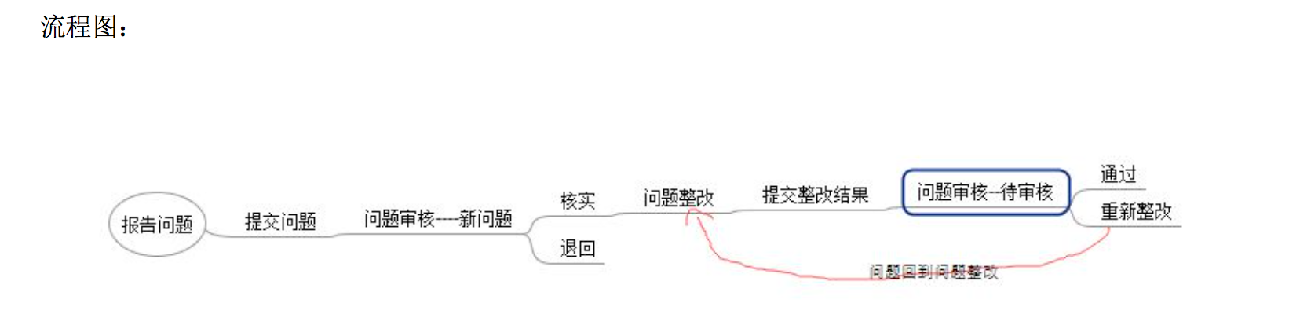

详情步骤如下：

1）报告问题：

问题发起人（任何人）报告问题

步骤1：报告问题 —> 填写问题详情—> 确认提交问题

2）问题审核：

HSE部门权限账户才可进入问题审核模块,否则将出现权限不足提示

步骤2：问题审核 —> 待处理状态下 问题审核项—> 问题详情查看 —> 核实或者退回 —> 提交成功

ps:提交成功后问题出现在问题整改模块

3）问题整改：

拥有作业部门领导（作业班长）权限账户才可进入问题整改模块,否则将出现权限不足提示

步骤3：问题整改 —> 待处理状态下 问题—> 问题详情查看 —> 整改描述输入以及整改照片附近添加 —> 提交整改结果

ps:提交成功后问题重新出现在问题审核模块，待HSE部门人员验证

4）整改验证审核：

HSE部门权限账户才可进入问题审核模块,否则将出现权限不足提示

步骤4：问题审核 —> 待处理状态下 整改验证项—> 问题详情查看 —> 通过或者重新整改 —> 审核成功

ps:重新整改后问题重新出现在问题整改模块，状态变更为整改中；

通过后问题状态变更为已完成，可在问题查阅模块查询，HSE部门人员也可在问题审核模块已完成项查询

5）问题查阅：

HSE部门权限账户可进入问题审核模块查阅，任何人都可在问题查阅模块下查阅

步骤5：问题查阅 —> 我的问题或者查看所有问题—> 问题详情查看

ps: 我的问题只出现发起人为自己的问题，所有问题中按时间顺序显示出现所有问题