**EE 417 - Computer Vision**

**Assignment 2**

Comparison of Edge Detectors

**Name:** Çiğdem Ceyda Düzgeç

**Student ID:** 23928



**Date: 28.11.2020**

1. **Prewitt**

In Prewitt operation we have two different parameters that we can change. Threshold and direction. Threshold determines the limit of the pixel value that we can get between 0 and 1, direction determines which direction is the function going to process. Prewitt uses two kernels which are [-1 0 1;-1 0 1 ; -1 0 1 ] and [-1 -1 -1; 0 0 0; 1 1 1]

So, I used both in different values. First row shows the horizontal directional Prewitt operation. Since it is processed in horizontal direction horizontal edges are more distinct. Also, the second row is processed in vertical direction and the vertical edges are more distinct. When I changed the threshold values it affected the white areas. When I decreased the threshold more pixels could exceed it and can be processed as white. But when I increased it the less pixels could exceed it which resulted in blacker image outcome. And last row shows both directional processed images. Because of that we can see both the horizontal and vertical edges. And when I put tic-toc and measure time elapsed for all operations Prewitt was the fastest with 0.015499 seconds.

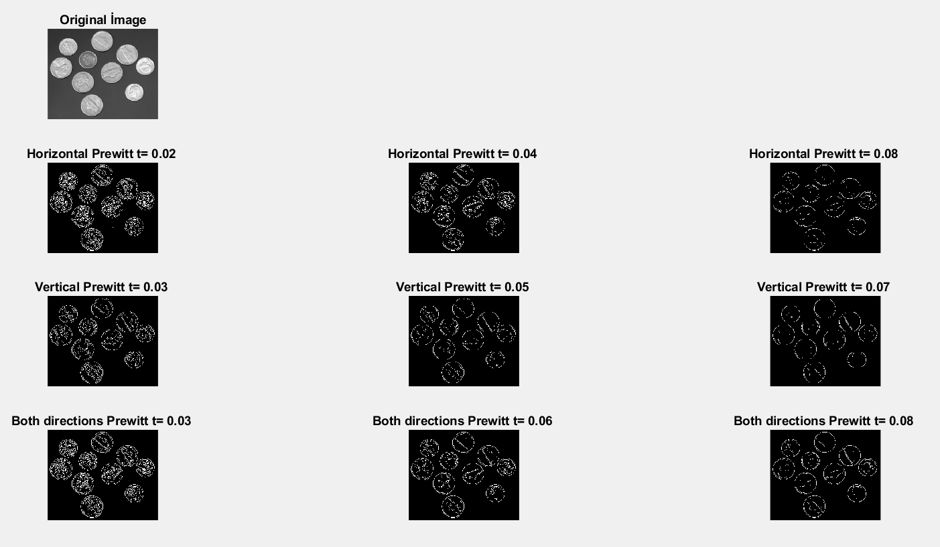

1. **Roberts**

Roberts operator is similar to Sobel and Prewitt but instead of using 3x3 kernels Roberts use 2x2 kernels which are [1 0 : 0 -1] and [0 -1: 1 0] which results in minimum entropy. When applying Roberts it has two parameters like Prewitt but in Roberts method the horizontal direction actually detects edges at an angle of 135 from horizontal and the vertical direction detects edges at an angle of 45 from horizontal. Roberts operator effects less pixels around the center comparing the Prewitt because of this Roberts gives more white pixels around the edges.

And when I put tic-toc and measure time elapsed for all operations Roberts was the second fastest with 0.051820 seconds.

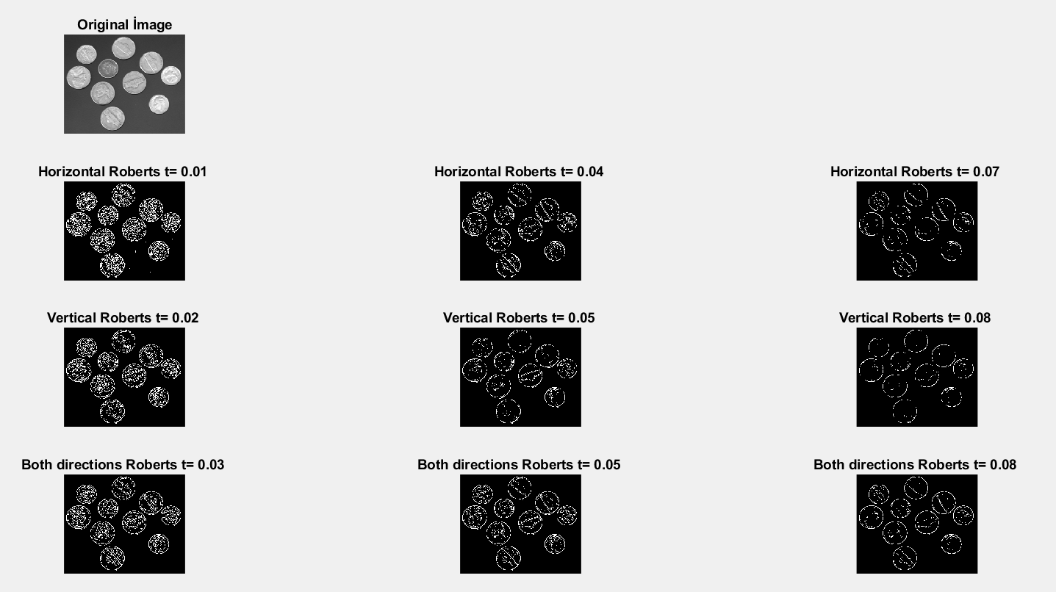

1. **Canny**

Although Canny is the slowest operator between all of them with 0.2786 seconds. It produces higher accuracy in detection of objects with higher entropy since it uses multiple-state algorithm with two thresholds which are low and high and it reduces noise with these parameters. It processes the pixel if the pixel exceeds high threshold automatically. Then it looks up for the neighbor pixels to check if they exceed low threshold if they do, they are processed as extensions of the edge. And if they do not exceed low threshold they are automatically left out from the edge. Because of this Canny gives sharper one-line results instead of a blurry edge.

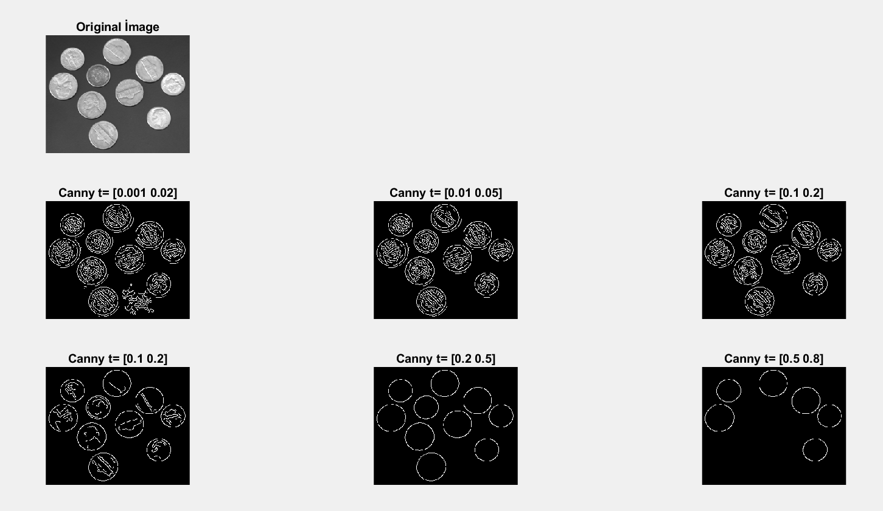

1. **Laplacian of Gaussian (LoG)**

Kernel of Laplacian of Gaussian is [0 1 0 ; 1 -4 1; 0 1 0]. Laplacian of Gaussian elapsed 0.0972 seconds which is slower than Prewitt and Roberts but faster than Canny. Since Log uses second derivative and more checks on pixels it takes more time. It uses both convolution with Gaussian with threshold and Laplacian. It does not provide information about direction.

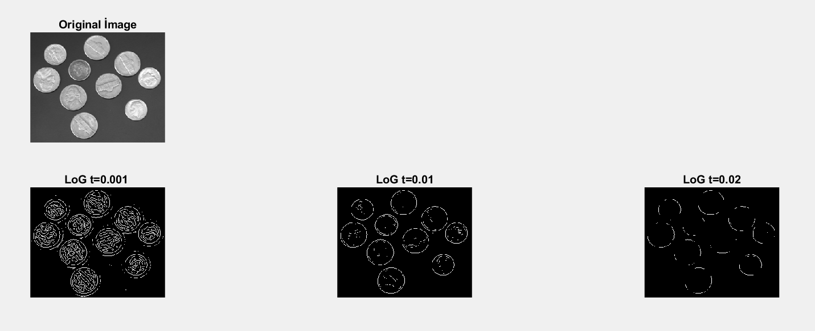

**Appendix**

1. **Prewitt**

%% Prewitt

clear all; close all; clc;

I = imread('coins.png');

[r,c,ch] = size(I);

if ch == 3

I = rgb2gray(I);

end

PH1 = edge(I,'prewitt',0.02, 'horizontal');

PH2 = edge(I,'prewitt',0.04, 'horizontal');

PH3 = edge(I,'prewitt',0.08, 'horizontal');

PV1 = edge(I,'prewitt',0.03,'vertical');

PV2 = edge(I,'prewitt',0.05,'vertical');

PV3 = edge(I,'prewitt',0.07,'vertical');

PB1 = edge(I,'prewitt',0.03,'both');

PB2 = edge(I,'prewitt',0.06,'both');

PB3 = edge(I,'prewitt',0.08,'both');

figure

subplot(4,3,1), imshow(I)

title ('Original ?mage')

subplot(4,3,4), imshow(PH1)

title ('Horizontal Prewitt t= 0.02 ')

subplot(4,3,5), imshow(PH2)

title ('Horizontal Prewitt t= 0.04 ')

subplot(4,3,6), imshow(PH3)

title ('Horizontal Prewitt t= 0.08 ')

subplot(4,3,7), imshow(PV1)

title ('Vertical Prewitt t= 0.03 ')

subplot(4,3,8), imshow(PV2)

title ('Vertical Prewitt t= 0.05 ')

subplot(4,3,9), imshow(PV3)

title ('Vertical Prewitt t= 0.07 ')

subplot(4,3,10), imshow(PB1)

title ('Both directions Prewitt t= 0.03 ')

subplot(4,3,11), imshow(PB2)

title ('Both directions Prewitt t= 0.06 ')

subplot(4,3,12), imshow(PB3)

title ('Both directions Prewitt t= 0.08 ')

1. **Roberts**

clear all; close all; clc;

I = imread('coins.png');

[r,c,ch] = size(I);

if ch == 3

I = rgb2gray(I);

end

PH1 = edge(I,'roberts',0.01, 'horizontal');

PH2 = edge(I,'roberts',0.04, 'horizontal');

PH3 = edge(I,'roberts',0.07, 'horizontal');

PV1 = edge(I,'roberts',0.02,'vertical');

PV2 = edge(I,'roberts',0.05,'vertical');

PV3 = edge(I,'roberts',0.08,'vertical');

PB1 = edge(I,'roberts',0.03,'both');

PB2 = edge(I,'roberts',0.05,'both');

PB3 = edge(I,'roberts',0.08,'both');

figure

subplot(4,3,1), imshow(I)

title ('Original Image')

subplot(4,3,4), imshow(PH1)

title ('Horizontal Roberts t= 0.01 ')

subplot(4,3,5), imshow(PH2)

title ('Horizontal Roberts t= 0.04 ')

subplot(4,3,6), imshow(PH3)

title ('Horizontal Roberts t= 0.07 ')

subplot(4,3,7), imshow(PV1)

title ('Vertical Roberts t= 0.02 ')

subplot(4,3,8), imshow(PV2)

title ('Vertical Roberts t= 0.05 ')

subplot(4,3,9), imshow(PV3)

title ('Vertical Roberts t= 0.08 ')

subplot(4,3,10), imshow(PB1)

title ('Both directions Roberts t= 0.03 ')

subplot(4,3,11), imshow(PB2)

title ('Both directions Roberts t= 0.05 ')

subplot(4,3,12), imshow(PB3)

title ('Both directions Roberts t= 0.08 ')

1. **Canny**

clear all; close all; clc;

I = imread('coins.png');

[r,c,ch] = size(I);

if ch == 3

I = rgb2gray(I);

end

C1 = edge(I,'canny',[0.001 0.02]);

C2 = edge(I,'canny',[0.01 0.05]);

C3 = edge(I,'canny',[0.05 0.08]);

C4 = edge(I,'canny',[0.1 0.2]);

C5 = edge(I,'canny',[0.2 0.5]);

C6 = edge(I,'canny',[0.5 0.8]);

figure

subplot(3,3,1), imshow(I)

title ('Original Image')

subplot(3,3,4), imshow(C1)

title ('Canny t= [0.001 0.02]')

subplot(3,3,5), imshow(C2)

title ('Canny t= [0.01 0.05]')

subplot(3,3,6), imshow(C3)

title ('Canny t= [0.1 0.2]')

subplot(3,3,7), imshow(C4)

title ('Canny t= [0.1 0.2]')

subplot(3,3,8), imshow(C5)

title ('Canny t= [0.2 0.5]')

subplot(3,3,9), imshow(C6)

title ('Canny t= [0.5 0.8]')

1. **Laplacian of Gaussian(LoG)**

clear all; close all; clc;

I = imread('coins.png');

[r,c,ch] = size(I);

if ch == 3

I = rgb2gray(I);

end

L1 = edge(I,'log',0.001);

L2 = edge(I,'log',0.01);

L3 = edge(I,'log',0.02);

figure

subplot(3,3,1), imshow(I)

title ('Original Image')

subplot(3,3,4), imshow(L1)

title ('LoG t=0.001 ')

subplot(3,3,5), imshow(L2)

title ('LoG t=0.01')

subplot(3,3,6), imshow(L3)

title ('LoG t=0.02')