My first two years into unit testing: How (not) to use unit tests with embedded code.


About me:



Cedric de Wijs

- Embedded C programmer

-cedric.dewijs@eclipso.eu


https://github.com/cdwijs/
What we are going to talk about:

Unit test techniques:

combining test code with production code in the same .c file

Separate files for test code and production code, using the extern keyword to access private variables

mockup all the functions the production code requires in a single .c/h pair

Run the entire production code from the test program.

Advantages / disadvantages of unit tests

Advantages / disadvantages of porting a microcontroller code to a PC

Questions / discussion

Technique: combining test code with production code in the same .c file

Advantages:
- easy, only need to include unity.h, and have access to ASSERT functions
- has access to all the local variables

Disadvantages:
- Code cannot be compiled for the microcontroller as is.
- Measures have to be taken like #define constructions to keep testcode out of the final production version.
- Harder to figure out what is testcode and what is production code.
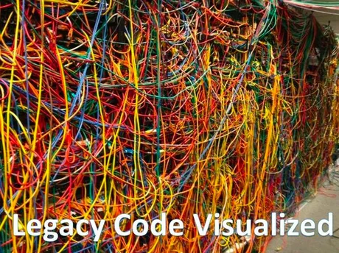

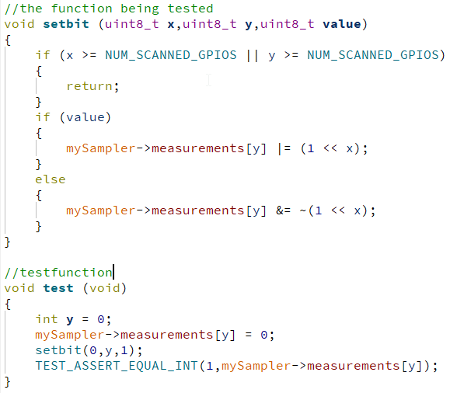
Technique: Separate files for test code and production code, using the extern keyword to access private variables

Advantages:
- testcode is separate from production code → production code does not have to be modified for testing.


Disadvantages:
- variable declarations need to be repeated in the testcode.
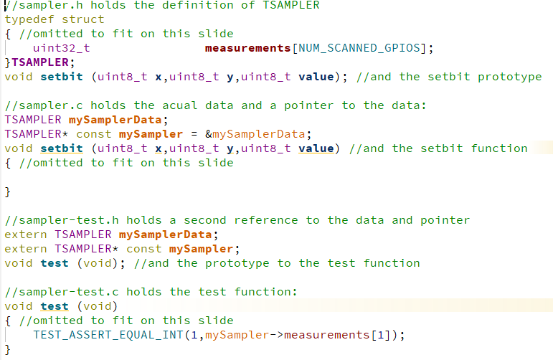
Technique: mockup all the functions the production code requires in a single .c/h pair

Advantages:
- Allows a single c file to be tested in isolation.

Disadvantages:
- Violates every industry standard for code structure.
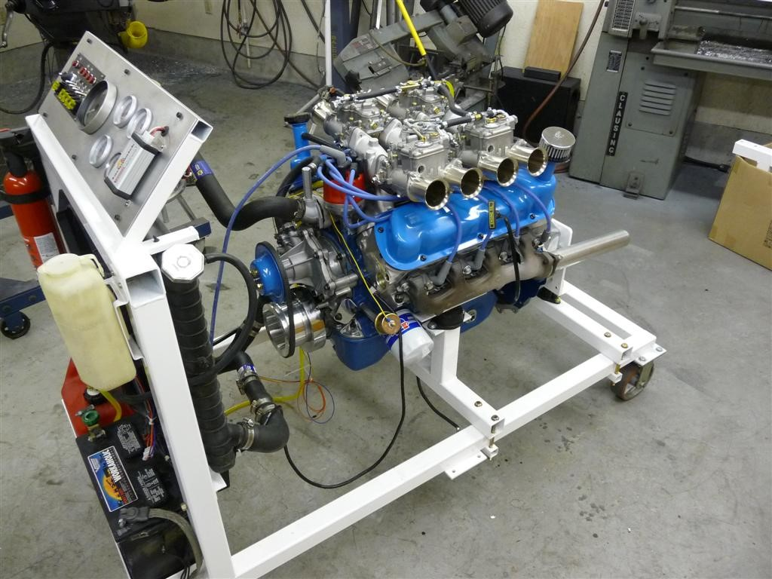
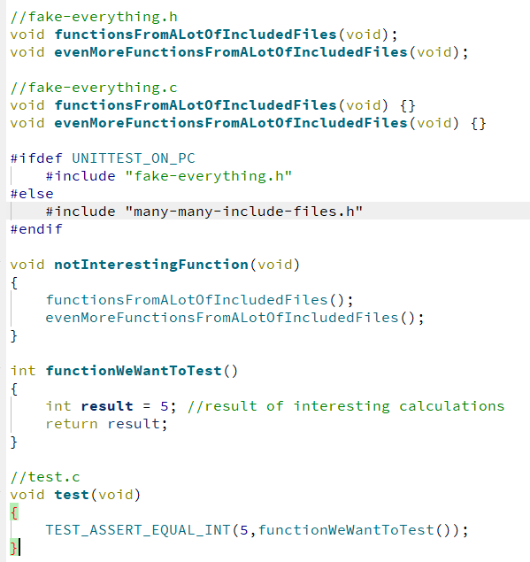
Technique: Run the entire production code from the test program.

Advantages:
- Allows complete end-to end integration tests.

Disadvantages:
- requires a #ifdef construction, to run one cycle per call to the main function.
- Integration tests are more involved, as more stuff needs to be simulated at the same time.
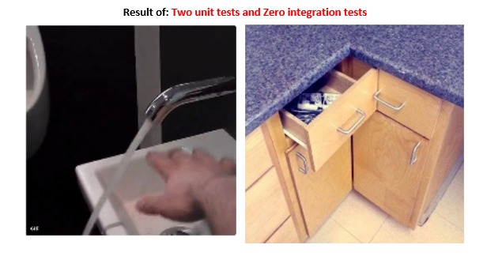
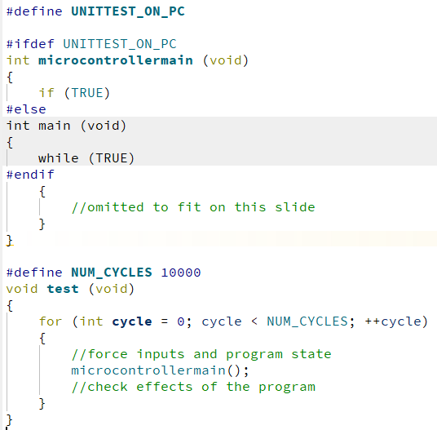
Advantages of unit tests:
- Lets you express the program in two different ways (implementation and effects of the program), increasing the odds of catching a bug.
- Problems in the code are caught early
- Regressions are caught early.

- Unit tests can be easier to understand than the code that is being tested.
- Unit tests can act like documentation to the code.
- Unit tests can be used to guarantee state diagrams are correct.

Disadvantages of unit tests
- The tests take time to write
- If code is changed, the tests need to be changed too.
- Takes up extra code and data space, so it might not fit.
- Unit tests use a serial port to report the test results.
- Only one function can be called main(),
so the microcontroller main() function has to be renamed

Advantages of porting microcontroller code to a PC:
- Debugger and runtime are on the same device → debugging is very fast.
- A PC has a faster processor → Hours of runtime can be simulated in seconds.
- A PC has more memory → A large number of unit tests will fit on the SSD and the RAM.
- A PC has much more memory → Hours of simulated runtime can be logged in memory.
- A PC has a graphical screen →Hours of simulated runtime can be displayed in charts.
- Code has to pass all the checks of another compiler → code becomes more portable.
- No need to for a microcontroller when working from home.
- The code can also run in a CICD pipeline → The tests can run at every push to git.

Disadvantages of porting microcontroller code to a PC:
- The used functions of the microcontroller SDK have to be simulated (stubbed)
- Inputs and outputs have to be simulated
- Interrupts and timing cannot be fully simulated.
- Code has to pass all the checks of another compiler → this takes time.
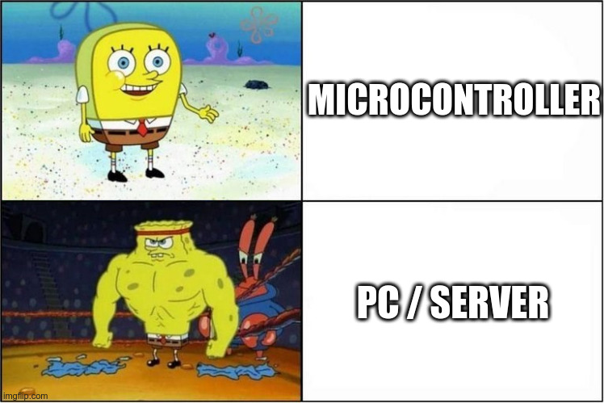

Thank you.

Discussion & Questions

This presentation can be downloaded here:

https://github.com/cdwijs/cable-tester/tree/main/documents/presentation

