ANA 515 - Week 5 Visualizations

Cesar Riano

2022-09-24

## section 1: loading the packages needed and the data

#The include = FALSE function hides both the code and output in my output document  
#Packages needed:   
library(ggplot2)  
  
#Read in the data  
CR_data<-read.csv("student-mat.csv")

## Section 2: Exploratory visualizations plots - First plot: Distribution of age and school absences

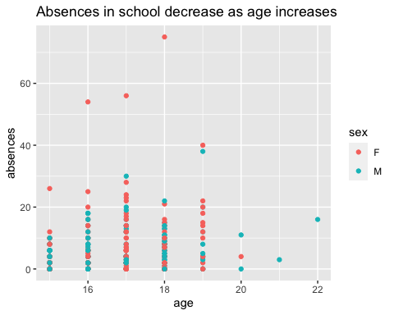 ## Section 3: Exploratory visualizations plots - Second plot: Distribution of exam grades

## `stat_bin()` using `bins = 30`. Pick better value with `binwidth`.

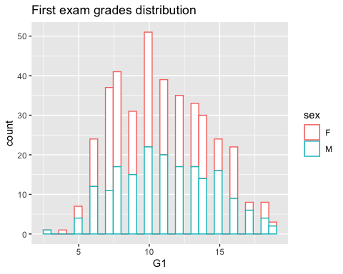

Note that the echo = FALSE parameter was added to the code chunk to prevent printing of the R code that generated the plot.