Wall_law_VEF_validation_2

Type of flow:
Pure diffusion in a channel with bottom and up walls at uniform fixed temperature
respectively T1 and T2 with account of turbulent diffusivity

Validated Model:
• Wall law for VEF discretization
-Validation of diffusive flux in turbulent diffusive operator with non zero turbulent conductivity
-Validation of “turbulent” equivalent distance

Validation with:
Comparison between calculations performed with and without wall law, when accounting for a turbulent viscosity and therefore a turbulent diffusivity.
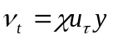 for 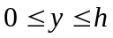
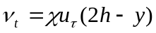 for 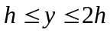

The situation considered here is the one of a uniform temperature gradient in the span-wise direction (y) with fixed temperature value T1 and T2 at the bottom and up walls. The analytic expression of the temperature is derived for a specific expression of the turbulent viscosity.
In the first case, the calculations are performed with and without wall law for a pure diffusion situation. In the second case, “shearing effects” are imposed through 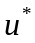, the velocity field still being fixed to zero, and the calculation is performed with a wall law. The results are analysed in term of flux at the boundary which is compared to the theoretical value. The temperature profile in a section of the channel is compared to the theoretical solution and an estimation on the error made on the temperature is also presented.

Test Description:

Geometry:
T2 (2) T2
(1)

U=0, 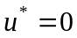 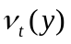 U=0, 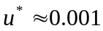

T1 T1
Dimensions:5m x 1m x 1m
Mesh: 16 X (2-3-7-13-25) X 3 + tetraedriser_homogene
Discretization : VEFPreP1b

Initial conditions : Hydraulic: u=0 m/s
Temperature: T=502.5 °K

Boundary conditions: hydraulic inlet, outlet : fixed velocity (u=0) up, bottom : wall
energy inlet, outlet : T_analytic(y), bottom : 500, up : 505
lateral : periodic (z direction)

Physical properties:

Incompressible fluid :
ρ = 6 Kg.m⁻³
μ = 2.10⁻⁵ N.m⁻².s⁻¹
λ = 8.10⁻² W.m⁻¹.K⁻¹
C_{P} = 4000 J.kg⁻¹.K⁻¹
beta_th =0 K⁻¹

Solving of equations:
dimension 3
Pb_ThermoHydraulique_turbulent
Schema_Euler_explicite
Fluide_Incompressible
VEFPreP1b
Navier_Stokes_turbulent
convection scheme : negligeable
diffusion : negligeable
Futhermore velocity is fixed to zero during calculation
Turbulence model : combinaison (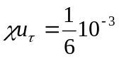) loi_standar_hydr or none
Convection_Diffusion_Temperature_Turbulent
convection scheme : negligeable
diffusion : standard
Turbulence model : Prandtl loi_standard_hydr_scalaire or none

Input data set:

Wall_law_VEF_validation_2/SANS_LP_RES2.data
Wall_law_VEF_validation_2/LP_RES2.data
Wall_law_VEF_validation_2/LP_U_TAU_RES_2.data

Calculation method:

Transitory calculation time : 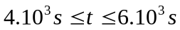
Average time step: 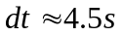for 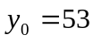
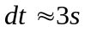for 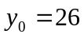
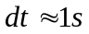for 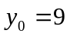
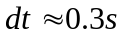for 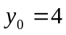
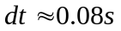for 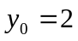
Stationary threshold value : 1.10⁻⁶
(*) 2.3.10⁻⁷

Post processing can be found in: Wall_law_VEF_validation_2

Analytic solution:

In the case considered, the expression of the energy equations reads :
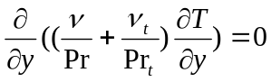
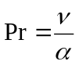with the cinematic viscosity and the molecular diffusivity.
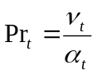with 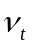the cinematic viscosity and 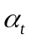 the turbulent diffusivity.
The expression of the turbulent viscosity is as follows :
si
si
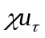is taken equal to 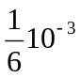and is the half height channel.
The temperature field solution reads :
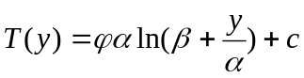 si
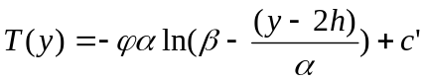 si

with 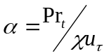and 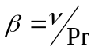
, and are integration constants obtained from boundaries conditions at the walls and continuity of the solution at half height channel.
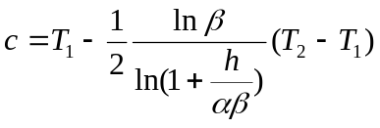
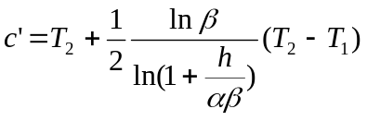
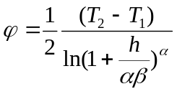

The diffusive flux at the wall reads :
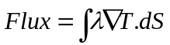
where denotes the fluid conductivity.
It leads to the following expression at y=0, when accounting for the analytic solution oh the temperature :
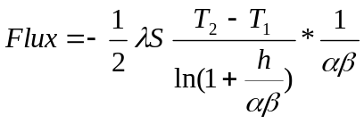 where denotes the surface of the wall.

Wall law associated :

The “equivalent distance” 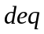expression specific to the case considered here is derived from the flux expression.
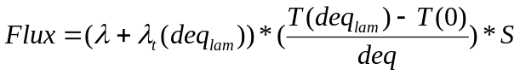

It has to be noticed that the flux is expressed with the value of conductivity and temperature a the height 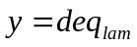. It is recalled that 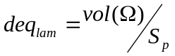with an element and 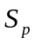his surface at the wall.
It leads to the following expression :
with 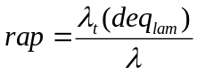

Remark :
In order to avoid numerical error for the case 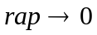for which 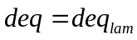, the previous expression is reformulated as follows :

Two methods may now be applied to perform calculations with wall law. A first method is to use the expression given above but in that case, the value 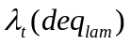must be used when evaluating the flux at the wall instead of 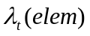 which is estimated at the centre of the gravity of the element. This method implies to modify the calculated by the turbulence model for the meshes close to the wall. A second method is to express as a function of 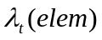and to use un-modified value of close to the wall when calculating the flux at the wall.

For the second methodis expressed as follows :
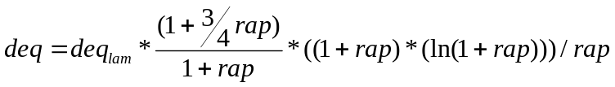
It may be noticed that for the case considered here, for which 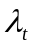 is a linear function of :
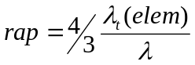.
In the results presented below, the first method has been considered but it has also been checked that the second method leads to the same results (only the cases , 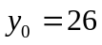and 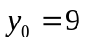have been considered for the second method).

Results:

In the following table, the value of the temperature diffusive flux at the bottom boundary is given for the calculations with (WL) and without wall law (no WL). For the calculation performed with wall law and fixed to zero, the value of remains the one calculated by the turbulence model. The percentage of error for the flux calculated in comparison with the analytical value is given for each calculation.
(*) The calculation for has been performed until final time 5000s corresponding to a stationary threshold value of nearly 2.3e-7 since the flux has not reached a steady state for a stationary threshold value of 1e-6.

Flux_bord (bottom) (Watt) |  |  |  |  | (*)
Analytic | -16.54 | -16.54 | -16.54 | -16.54 | -16.54
no WL | -25.63 (55%) | -21.08 (27%) | -17.74 (7%) | -16.99 (3%) | -16.69 (1%)
WL (=0) | -25.63 (55%) | -21.08 (27%) | -17.74 (7%) | -16.99 (3%) | -16.69 (1%)
WL (=0.001054) | -16.48 (0%) | -16.53 (0%) | -16.53 (0%) | -16.55 (0%) | -16.55 (0%)

The calculations without wall law (no WL) leads to an error on the diffusive flux which decreases with the size of the mesh. A good agreement with the analytical value is obtained only for the finest meshing ().
The calculations carried with a wall law (WL) and fixed to zero show that identical results are obtained as with the case without wall law.
The calculations performed with the wall law derived above and 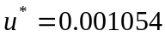 show an excellent agreement with the theoretical value. This value is retrieved for each resolution considered. It is recalled that for the results presented here, the value of is modified for the meshes close to the wall.
Remark :
The use of the “Kader expression” for the wall law leads to an error on the diffusive flux since it is not well adapted to the physics considered here.

The second table below gives the value of the equivalent distance () for the two cases with wall law (=0 and =0.001054). 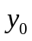is defined as 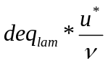where 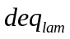denotes the “laminar” equivalent distance.
In the first case () equals the laminar value. In the second case () , results from the expression derived above.

(m) |  |  |  |  | (*)
WL (=0) | 1.67e-1 | 8.33e-2 | 2.77e-2 | 1.39e-2 | 6.94e-3
WL (=0.001054) | 4.30e-1 | 1.75e-1 | 4.27e-2 | 1.82e-2 | 8.14e-3

The following figures show the temperature profiles calculated with wall law () and without wall law for the section x=2.1. The profiles are compared with the analytical solution. The results are presented for the three different resolutions (;;(*)).
The error on the temperature calculated in comparison with the analytical solution (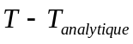) is estimated at the face centre of the elements located in the section x=2.1 and is presented for each resolution considered.

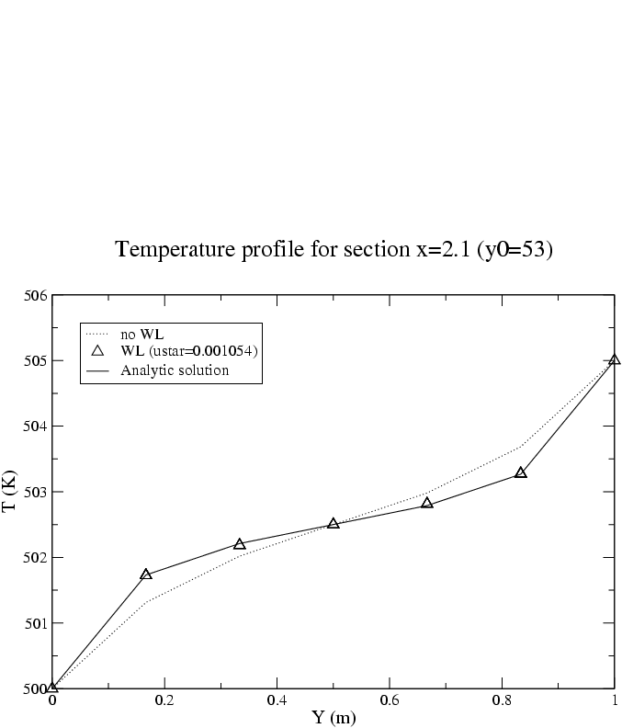
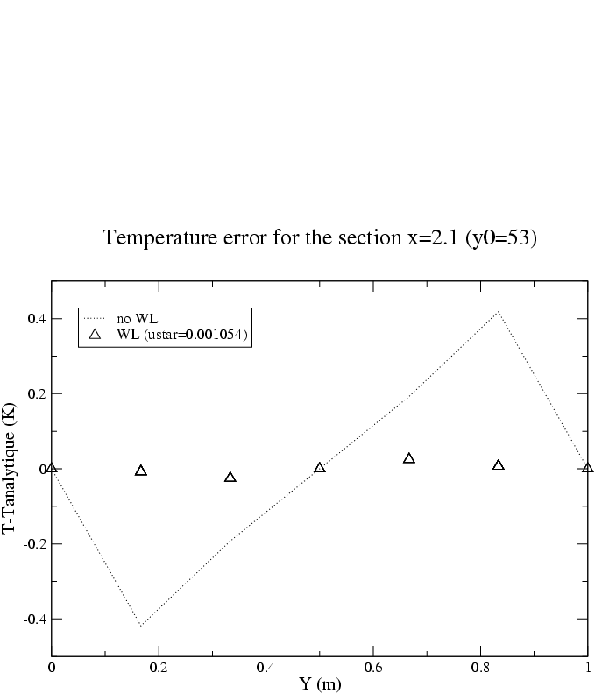

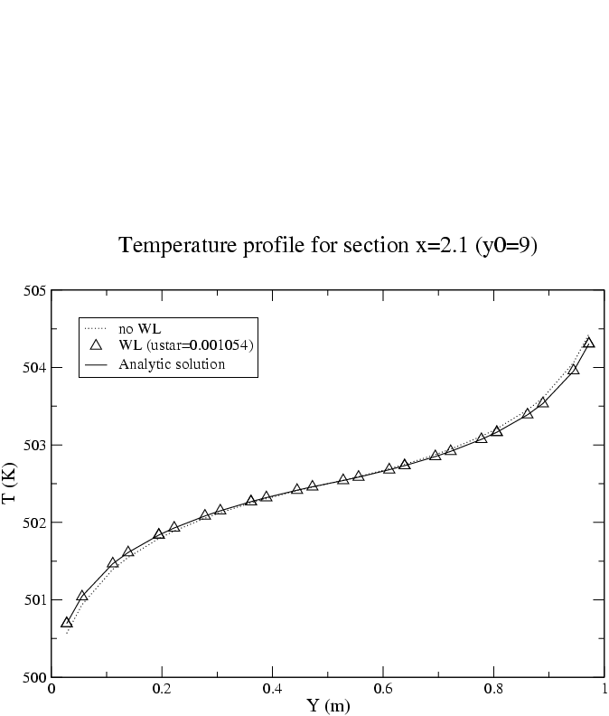
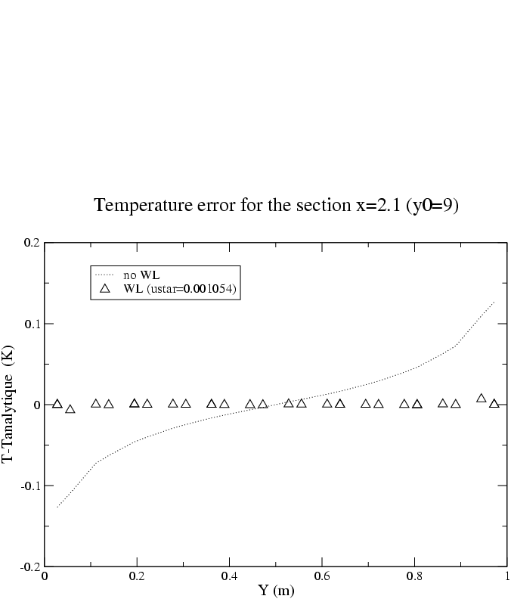

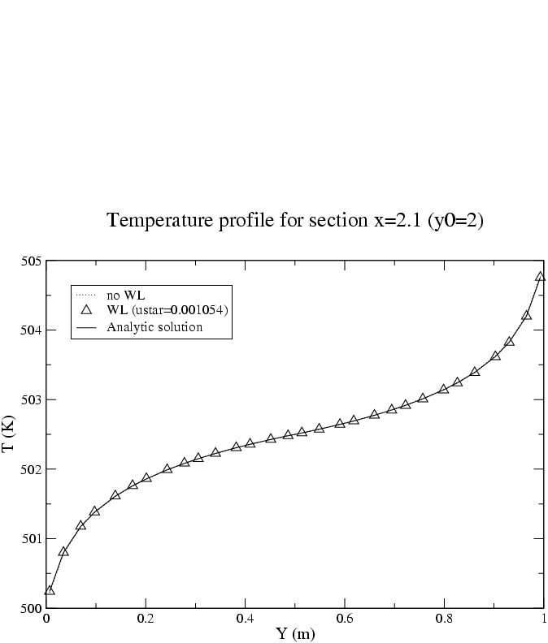

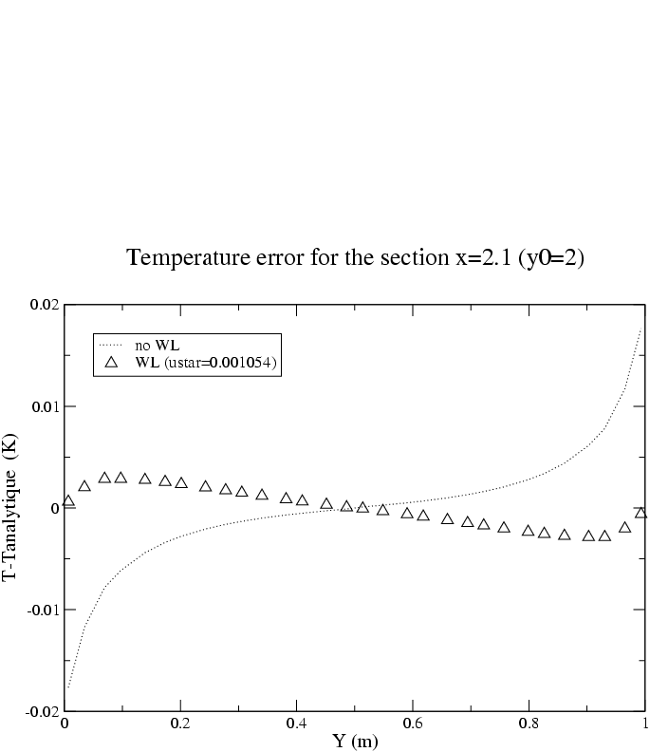
It is observed as previously for the diffusive flux at the wall that the use of a wall law improved the results obtained without one. The temperatures profiles in the section considered well reproduce the analytic solution when a wall law is accounting for. In that case, the error made in comparison with the analytical solution is weak. At the opposite, the calculations carried out without wall law lead to a stronger error for the temperature profiles.
The following figure shows the error made on the temperature when taking into account a wall law, for the three different resolutions (;;(*)). It is observed that the error made on the temperature decreases as the meshing is refined.

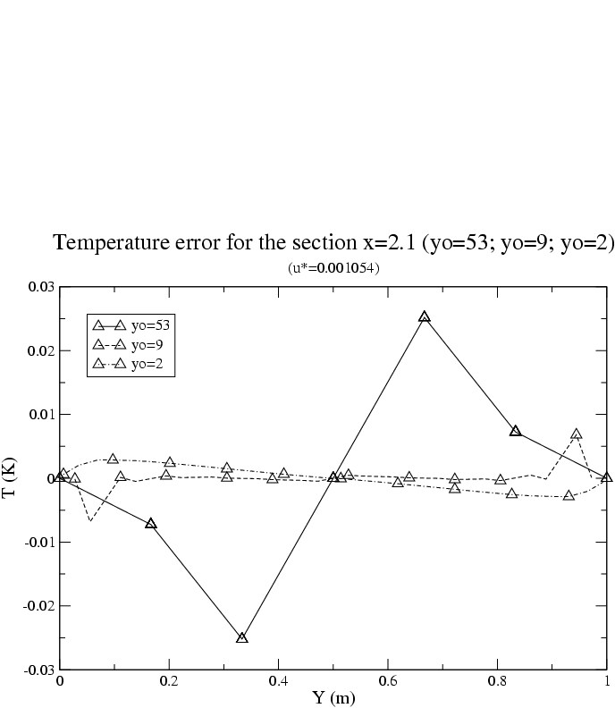

Conclusion:

The tests performed show that :

-the diffusive flux is well implemented in the turbulent diffusion operator when accounting of a non zero turbulent conductivity. It may be noticed that in the general case the turbulent viscosity has not to be modified by the wall law in the vicinity of the wall. Nevertheless for the particular case considered here, the turbulent viscosity and therefore the turbulent diffusivity are modified close to the wall to correct the error generated by the discretization.

-the wall law derived to fit the physics considered here leads to good results since it is observed that the theoretical solution is well reproduced. The use of a model at the wall strongly improved the results obtained without a wall law.

Recommandations for users:
-Insure that the wall law is well adapted to the physics considered.

References:
Kader B. Temperature and concentration profiles in fully turbulent boundary-layers.
Int. J. Heat Mass Transf. 24, 9 (1981), 1541-1544

Computer performance:

Type of computer | Characteristics | Total CPU [s]  (see file Performance.TU) | CPU dt/cell [ms]  (see file Performance.TU) | CPU dt [s]  (see file Performance.TU)
PC |  | 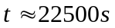(opt) |  | 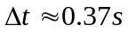(opt)

