Wall_law_VEF_validation_3

Type of flow:
Turbulent flow in a plane channel with bottom and up walls at uniform fixed temperature T1
with account for a uniform heat release.

Validated Model:
• Wall law for VEF discretization

Evaluation of the model with:
Comparison with Nusselt number derived from asymptotic expansion technique

The situation considered here is the one of a plane channel periodic in x and z directions. A fixed temperature  is imposed at the up and bottom walls. A uniform thermal power is released in the whole domain to reach a steady state for the temperature field. The first calculations are performed with a wall law for different Reynolds numbers and a fixed Prandtl number then calculations are carried out at a fixed Reynolds number for different Prandtl numbers.The Nusselt number is then calculated and compared to a law derived from an asymptotic expansion technique (1).

The Nusselt number is defined as follows :
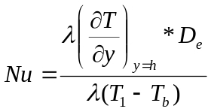
with is the thermal conductivity of the fluid, 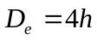is the equivalent diameter, being the half height of the channel, is the temperature at the wall and 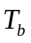is the bulk temperature defines by the following expression
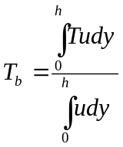 where and are respectively the x-component of the velocity and the temperature field.
For 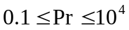and 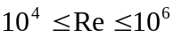, the expression derived by Shibani and Ozisik (1) is as follows
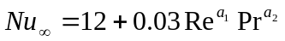() with 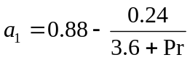and 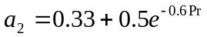

For 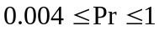and 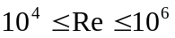, the expression derived by Shibani and Ozisik is as follows
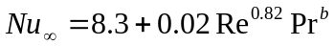 (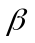) with 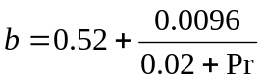

Test Description:

Geometry:

T1
perio (z)

perio (x) P=cte

T1

Dimensions:5mX1mx1m
Mesh: 16 X 3 X 3 + tetraedriser_homogene

Discretization VEFPreP1b :

Initial conditions Hydraulic: u=0.33333 pour Re=2e4
u=1.66665 pour Re=1e5
u=8.33325 pour Re=5e5
v=0, w=0
Temperature: T=500 K

Boundary conditions: hydraulic up and bottom walls
energy fixed temperature T1= 500 K
periox, perioz : periodic

Power heat release : P=10 Watts

Physical properties:

Incompressible fluid :
ρ = 6 Kg.m⁻³
μ = 1.10⁻⁴ N.m⁻².s⁻¹
λ = 40.10⁻² W.m⁻¹.K⁻¹(Pr=1); =1.33333W.m⁻¹.K⁻¹(Pr=0.3); λ = 4.10⁻² W.m⁻¹.K⁻¹(Pr=10)
C_{P} = 4000 J.kg⁻¹.K⁻¹
beta_th =0 K⁻¹

Solving of equations:
dimension 3
Pb_ThermoHydraulique_turbulent
Fluide_Incompressible
VEFPreP1b
Navier_Stokes_turbulent
convection scheme : muscl
diffusion : standard
Turbulence model : K_Epsilon loi_standar_hydr
Convection_Diffusion_Temperature_Turbulent
convection scheme : muscl
diffusion : standard
Sources Puissance_thermique
Prandtl loi_standard_hydr_scalaire

Input data set:

Wall_law_VEF_Validation_3/LP_K_EPS_RE2E4.data
Wall_law_VEF_Validation_3/LP_K_EPS_RE1E5_U.data
Wall_law_VEF_Validation_3/LP_K_EPS_RE5E5_U.data
Wall_law_VEF_Validation_3/LP_K_EPS_PR03.data
Wall_law_VEF_Validation_3/LP_K_EPS_PR10.data

Calculation method:

Transitory calculation time:
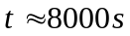 for Re=2e4 and Pr=1; 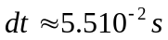
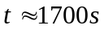 for Re=1e5 and Pr=1; 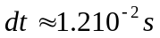
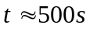 for Re=5e5 and Pr=1; 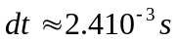

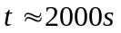 for Re=2e4 and Pr=0.3; 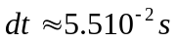
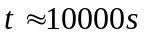 for Re=2e4 and Pr=10;

Post processing can be found in: Wall_law_VEF_Validation_3

Results:
The power term allows to reach a stationary state for the temperature field. The following figure shows the time evolution of the temperature at a point located at x=2.1; y=0.5; z=0.5 for the three Reynolds numbers considered (Re=2e4; Re=1e5; Re=5e5). . It is seen that the stationary value of the temperature decreases for increasing Reynolds value since the “mixing” of the temperature field is improved.
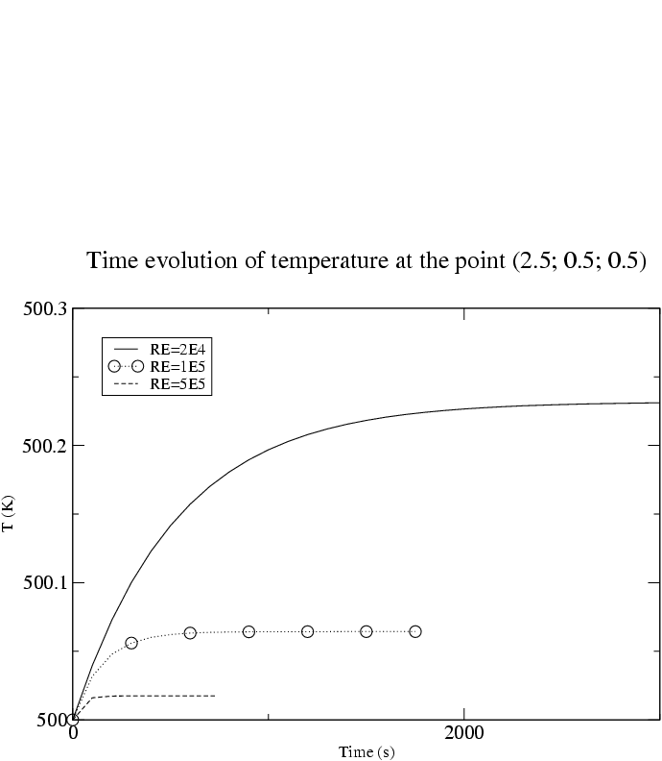
The following figures show respectively the mean velocity profiles (u component) and mean temperature profiles in the section x=2.1 for the three Reynolds numbers considered (Re=2e4; Re=1e5; Re=5e5).

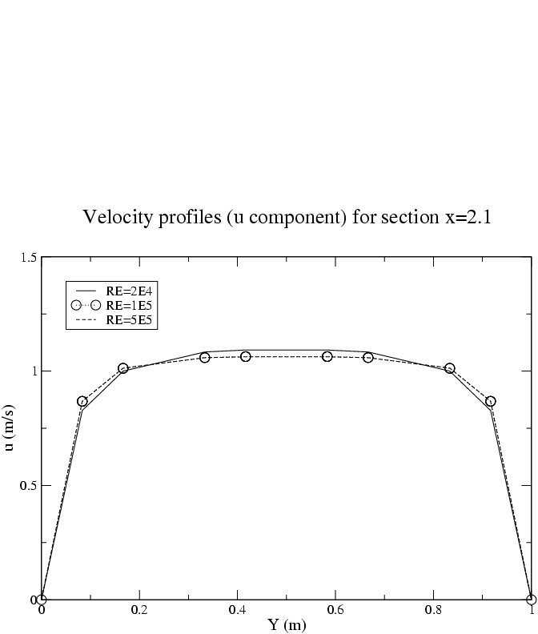
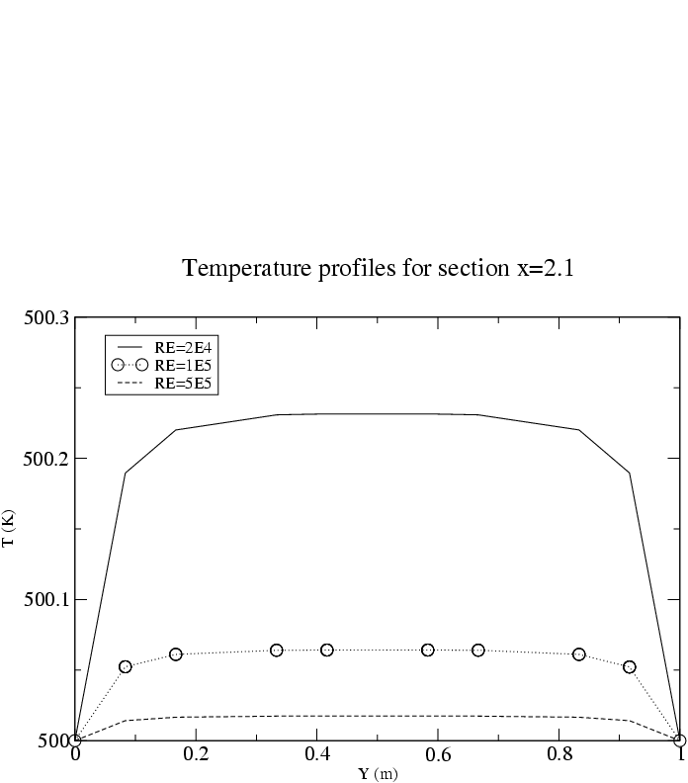
It is seen that the velocity profile is characteristic of a turbulent flow in a channel. The profile is identical for the two higher values of the Reynolds number (Re=1e5; Re=5e5) since an asymptotic state is reached for these values. The mean temperature profiles are also characteristic of turbulent mixing.

The value of the Nusselt number is given in the following table for the three different Reynolds numbers. The percentage error on the Nusselt calculated in comparison with the one obtained from a correlation is also given.
It is seen that the error is nearly 10% for the three cases considered.
Re | Flux at the wall (W) | (K) | 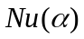 | 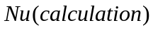 | 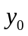
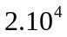 | -23.87 | 500.22 | 121 | 109 (10%) | 84
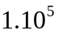 | -23.89 | 500.061 | 426 | 392 (8%) | 362
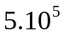 | -23.86 | 500.017 | 1581 | 1404 (11%) | 1540

The following figure shows the mean temperature profiles for the section x=2.1 for the three Prandtl numbers considered (Pr=0.3; Pr=1; Pr=10). It is observed that the mixing is increased when the Prandtl number value decreases since diffusion effects are more efficient.
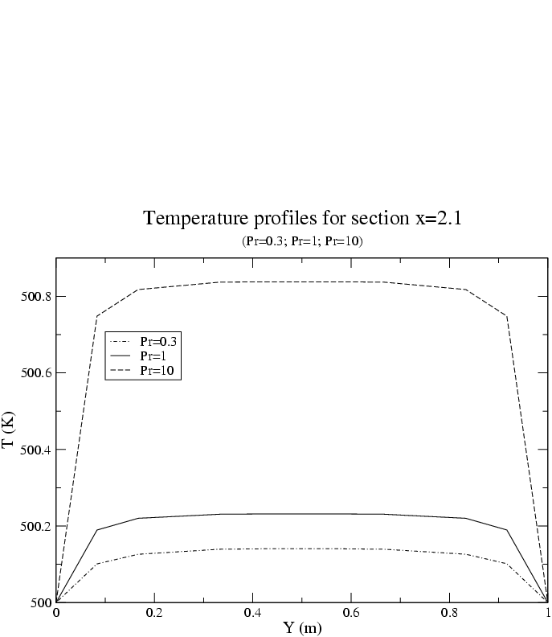

The value of the Nusselt number is given in the following table for the three Prandtl numbers considered with a percentage error obtained in comparison with the one obtained from a correlation. It is observed that for the Prandtl value of 0.3 and 1, the error is as previously for the different Reynolds numbers near 10%. In the case of higher value of Prandtl (10), the error increases.
Pr | Flux at the wall (W) | (K)
0.3 | -23.88 | 500.129 | 52 | 56 (8%) | 84
1 | -23.87 | 500.220 | 121 | 109 (10%) | 84
10 | -23.70 | 500.814 | 340 | 291 (14%) | 84

Conclusion:

The K_epsilon calculations performed with a wall to simulate a plane channel with walls at a fixed temperature and with a uniform heat release leads to an error about Nusselt number of nearly 10% for the meshing resolution considered.
This result may be used as a criteria of comparison when the aim of the validation will be for instance to assess a LES calculation with a wall law.

Recommandations for users:

References:
- A solution to heat transfer in turbulent flow between parallel plates.
Ali A. Shibani and M. N. Ozisik
Int. J. Heat Mass Transfer. Vol. 20, pp. 565-573

Computer performance:

Type of computer | Characteristics | Total CPU [s]  (see file Performance.TU) | CPU dt/cell [ms]  (see file Performance.TU) | CPU dt [s]  (see file Performance.TU)
PC |  | 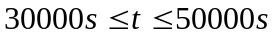 |  | 