Wall_law_VEF_validation_4

Type of flow:
Pure diffusion in a coupled domain fluid-solid with bottom fluid wall and up solid wall at fixed temperature respectively T1(x) and T2

Validated Model:
• Wall law for VEF discretization with Champ_front_contact_VEF

Validation with:

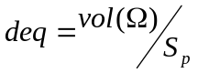and 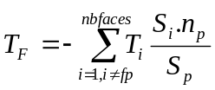
(see Wall_law_VEF_validation_1)

The case considered here is the one of pure diffusion for two coupled domains (fluid and solid). A temperature gradient is imposed both in the streamwise (x) direction and spanwise (y) direction. Calculation of the thermal diffusive flux at the wall and the interface (fluid domain) needs an expression of the equivalent distance 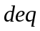and a mean fluid temperature estimation. The laminar expression of and a weighted average for the mean fluid temperature are retained. The calculations are performed with and without wall laws respectively. In the first case considered an explicit time scheme is used and in the second case an implicit method is applied. The results are analysed in terms of flux at the boundary. Temperatures profiles are also compared to the theoretical solution.

Test Description:
up
Geometry: T2=cte
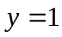 solid

interface
U=0 fluid
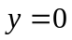
T1(x) bottom
Fluid domain and problem :
Dimensions:5m x 0.5m x 1m
Mesh: 16 X 3 X 3 + tetraedriser_homogene
Discretization : VEFPreP1b

Initial conditions : Hydraulic: u=0 (m/s)
Temperature: T=505 °K

Boundaries conditions: hydraulic : inlet, outlet : fixed velocity (u=0) bottom : wall, interface : wall
lateral : periodic (z direction)
energy : fixed temperature
inlet : 500+5.*y outlet : 505, bottom : 500+x, interface (contact)
lateral : periodic (z direction)
Solid domain and problem :
Dimensions:5m x 0.5m x 1m
Mesh: 16 X 3 X 3 + tetraedriser_homogene
Discretization : VEFPreP1b

Initial conditions : Temperature: T=505 °K
Boundaries conditions: energy : fixed temperature
inlet : 500+5.*y outlet : 505, up : 505, interface (contact)
lateral : periodic (z direction)

Physical properties:

Fluid incompressible :
ρ = 6 Kg.m⁻³
μ = 2.10⁻⁵ N.m⁻².s⁻¹
λ = 8.10⁻² W.m⁻¹.K⁻¹
C_{P} = 4000 J.kg⁻¹.K⁻¹
beta_th =0 K⁻¹

Solid :
ρ = 6 Kg.m⁻³
λ = 8.10⁻² W.m⁻¹.K⁻¹
C_{P} = 4000 J.kg⁻¹.K⁻¹

Solving of equations:

Coupled Pb_ThermoHydraulique_turbulent – Pb_Conduction
Schema_Euler_explicite or Schema_Euler_Implicite
Fluide_Incompressible-Solide
VEFPreP1b
Convection scheme (fluid) Momentum : negligeable
Temperature : negligeable
Diffusion (fluid) Momentum : negligeable
Temperature : standard
(solid) Temperature : standard

Navier_Stokes_turbulent combinaison (0) loi_standar_hydr (or none)
Convection_Diffusion_Temperature_Turbulent Prandtl loi_standard_hydr_scalaire (or none)
Boundaries conditions: u=0 in x direction, wall at up and bottom (y direction) and
periodic in z direction
fixed temperature (inlet and outlet, up and bottom
periodic in z direction
paroi_contact at the interface
Type of fluid : incompressible with uniform properties
Type of solid : solide with uniform properties

Input data set:

Wall_law_VEF_validation_4/LP_explicite.data
Wall_law_VEF_validation_4/SANS_LP_explicite.data
Wall_law_VEF_validation_4/LP_implicite.data
Wall_law_VEF_validation_4/SANS_LP_implicite.data

Calculation method:

Transitory calculation time : 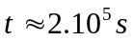
Average time step: 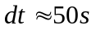(implicite 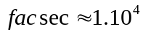)
Stationary threshold value : 1.10⁻⁶

Post processing can be found in: Wall_law_VEF_validation_4

Analytic solution:

The analytic solution is as follows :
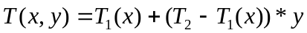
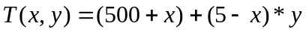
The diffusive flux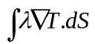 takes the value –1 and 1 respectively at bottom and up walls and also at the interface respectively solid and fluid.

Results:

Case 1 (explicit calculation)

In the following table, the value of the temperature diffusive flux at the bottom (fluid), interface (fluid-solid) and up (solid) boundaries are given for the calculations with and without wall law.

Flux_bords | Analytic solution | no WL | WL (weighted Tf)
bottom | -1 | -1 | -1
up | 1 | 0.9995 | 0.9995
interface (fluid) | 1 | 1 | 1
Interface (solid) | -1 | -1 | -1

The following figures show the temperature profiles for different sections (x=0.1; x=2.5; x=4.9).It is seen that the calculations with wall law give results identical to the ones obtained without wall law. It confirms that the wall law model used in the turbulent diffusion operator allows to reproduce the expected flux at the wall and it indicates that the flux estimated at the “fluid interface” is also well calculated. It may be also observed that the results obtained with and without wall law show a very good agreement with the analytical solution.
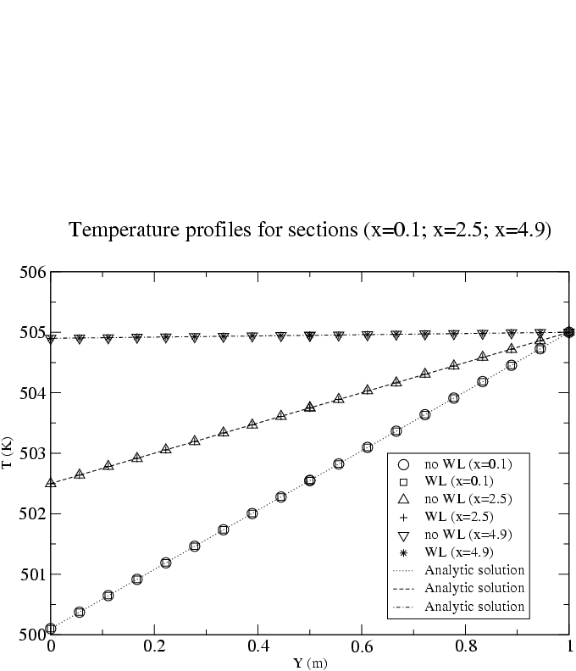

Case 2 (implicit calculation)

In the following table, the value of the temperature diffusive flux at the bottom (fluid), interface (fluid-solid) and up (solid) boundaries are given for the calculations with and without wall law.

Flux_bords | Analytic solution | no WL | WL (weighted Tf)
bottom | -1 | -1.0060 | -1.0060
up | 1 | 0.9946 | 0.9946
interface (fluid) | 1 | 0.9997 | 0.9997
Interface (solid) | -1 | -0.9997 | -0.9997

The following figures show the temperature profiles for different sections (x=0.1; x=2.5; x=4.9). Conclusions are the same as previously for the explicit case.
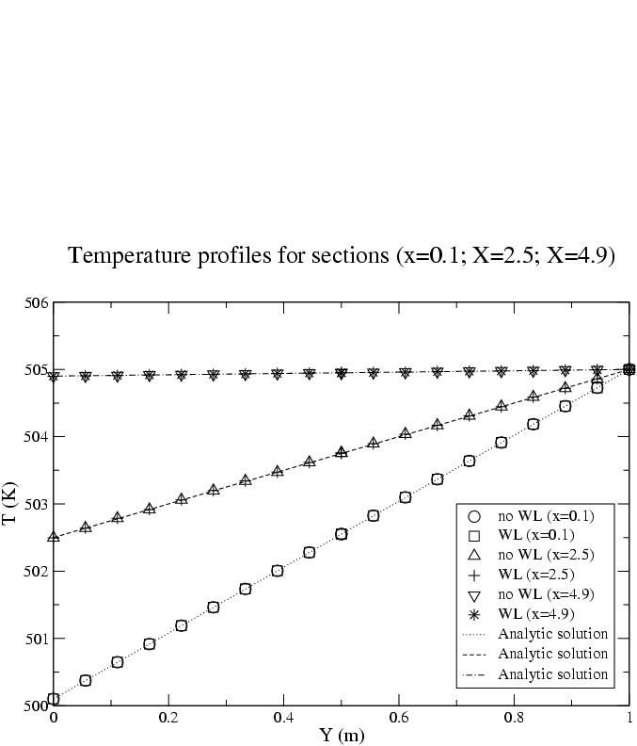

Conclusion:
It has been shown that account for a wall law in the case of coupled problems leads to good results in comparison with the theoretical solution. The flux at the “fluid interface” is well modelled when accounting for a wall law. This model can be used for explicit or implicit calculations.

Recommandations for users:

References:

Computer performance:

Type of computer | Characteristics | Total CPU [s]  (see file Performance.TU)  executable semi-optimisé | CPU dt/cell [ms]  (see file Performance.TU) | CPU dt [s]  (see file Performance.TU)
PC |  | - SANS_LP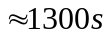  LP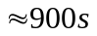  - SANS_LP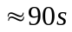  LP 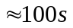 |  | (1) 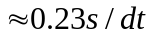  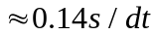  (2) 