Wall_law_VEF_validation_1

Type of flow:
Pure diffusion in a channel with bottom and up walls at uniform fixed temperature
respectively T1 and T2

Validated Model:
• Wall law for VEF discretization
-Validation of the “laminar” equivalent distance (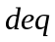) expression.
-Validation of diffusive flux implementation for the diffusive turbulent operator when accounting for a wall law
-Validation of the mean fluid temperature used to calculate this diffusive flux

Validation with:
Comparison between calculations performed with and without wall law in a pure diffusion case.

n1 n2
T1,S1 Tf T2,S2
 k

Tp,Sp np

denotes an element.
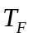is the mean fluid temperature inside an element. 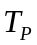is the temperature at the wall, and 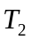denotes the temperature at the two others faces of the element (2D case).
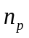, 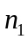, 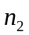and 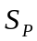, 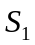 ,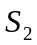denotes respectively the normal vector at the faces and the faces area.
and 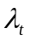are respectively the “laminar” and turbulent thermal conductivity.
Flux expression taking account of wall law must equal classical turbulent heat flux :
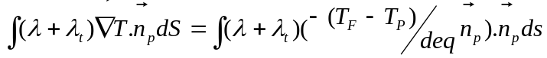
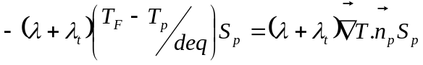
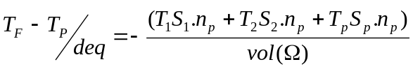
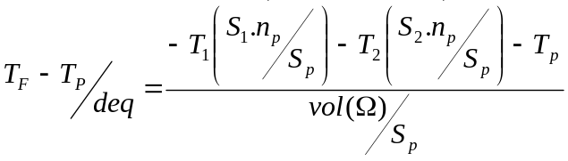
where is the equivalent distance.

It leads to the following expression for respectively and

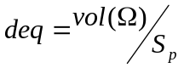and 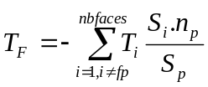 where 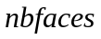is the faces number by element and 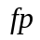denotes the local face at the wall for a given element.
The expression of also reads :
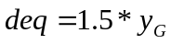in the 2D case
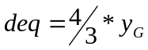in the 3D case
where 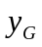denotes the height of the element gravity centre.

Two situations are considered for simulations of pure diffusion in a channel. In the first case, a uniform temperature gradient is considered in the span-wise direction (y) with fixed temperature value T1 and T2 respectively at the bottom and up walls. A first calculation is performed without wall law (no WL) then two others calculations are carried out with a wall law (WL), the mean fluid temperature close to the wall being calculated either by a rough average or by a weighted one. The expression of used to calculate the thermal diffusive flux at the wall is the one cited above. In the second case, a temperature gradient is imposed both in the stream-wise (x) and span-wise directions. The calculations performed are the same as previously.
The results are analysed in term of flux at the boundary which is compared to the theoretical value. Temperature profiles in different sections of the channel are also compared to the theoretical solution.

Test Description:

Geometry:
T2 (2) T2=cte
(1)

U=0 U=0

T1 T1(x)
Dimensions:5m x 1m x 1m
Mesh: 16 X 3 X 3 + tetraedriser_homogene
Discretization : VEFPreP1b

Initial conditions : Hydraulic: u=0 m/s
Temperature: (1) T=502.5 °K (2) T=505 °K

Boundary conditions: hydraulic : inlet, outlet : fixed velocity (u=0) up, bottom : wall

energy : fixed temperature
(1) inlet, outlet : 500.+5.*y, bottom : 500, up : 505
(2) inlet : 500+5.*y outlet : 505, bottom : 500+x, up : 505
lateral : periodic (z direction)

Physical properties:

Incompressible fluid:
ρ = 6 Kg.m⁻³
μ = 2.10⁻⁵ N.m⁻².s⁻¹
λ = 8.10⁻² W.m⁻¹.K⁻¹
C_{P} = 4000 J.kg⁻¹.K⁻¹
beta_th =0 K⁻¹

Solving of equations:
dimension 3
Pb_ThermoHydraulique_turbulent
Schema_Euler_explicite
Fluide_Incompressible
VEFPreP1b
Navier_Stokes_turbulent
convection scheme : negligeable
diffusion : negligeable
Futhermore velocity is fixed to zero during calculation.
Turbulence model : combinaison (value 0) loi_standar_hydr (or none)
Convection_Diffusion_Temperature_Turbulent
convection scheme : negligeable
diffusion : standard
Turbulence model : Prandtl loi_standard_hydr_scalaire (or none)

Input data set:

Wall_law_VEF_validation_1/LP_UNIFORME.data
Wall_law_VEF_validation_1/SANS_LP_UNIFORME.data
Wall_law_VEF_validation_1/LP_LINEAIRE.data
Wall_law_VEF_validation_1/SANS_LP_LINEAIRE.data

Calculation method:

Transitory calculation time : 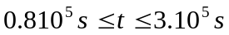
Average time step: 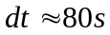
Stationary threshold value : 1.10⁻⁶

Post processing can be found in: Wall_law_VEF_validation_1

Analytic solution:

Cas (1) :
The analytic solution for the case (1) is as follows :
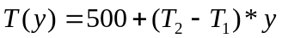
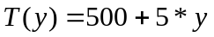

The diffusive flux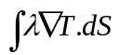 takes respectively the value –2 and 2 at the bottom and up walls.

Cas (2) :

The analytic solution for the case (2) is as follows :
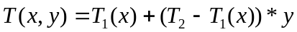
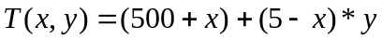
The diffusive flux takes respectively the value –1 and 1 at the bottom and up walls.

Results:

Case (1)

In the following table, the value of the temperature diffusive flux at the bottom and up boundaries of the domain are given for the calculations with and without wall law.
Flux_bords (W) | Analytic solution | no WL | WL (not weighted Tf) | WL (weighted Tf)
bottom | -2 | -2 | -2 | -2
up | 2 | 2 | 2 | 2

The following figures show the temperature profiles calculated for different sections (x=0.1; x=2.5; x=4.9) as well as the analytic solution.

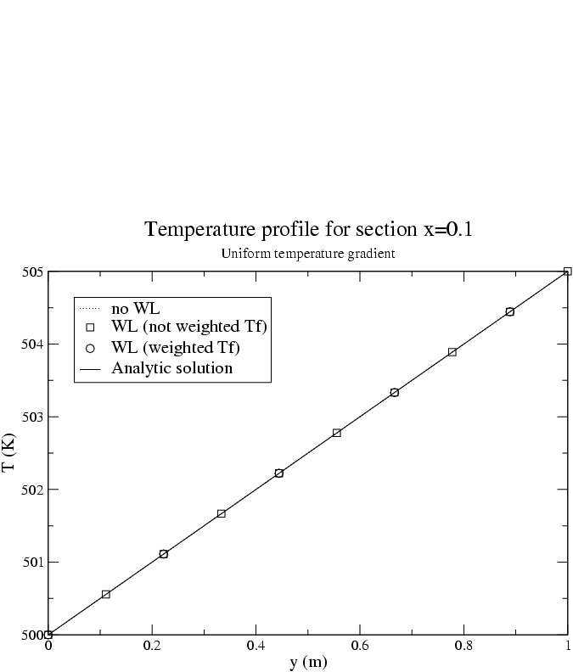
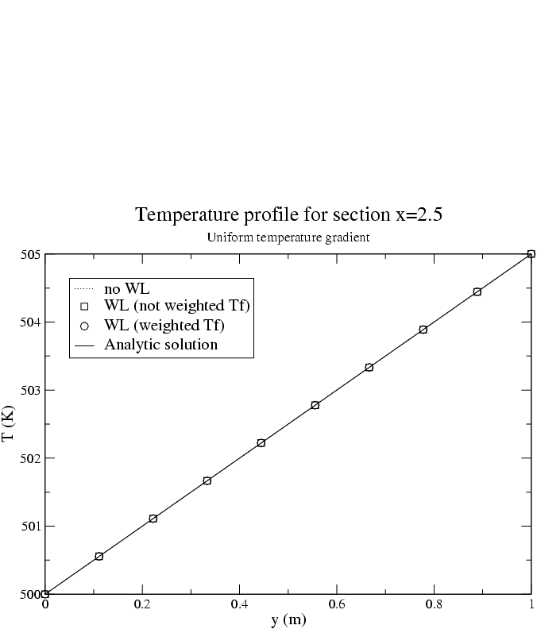
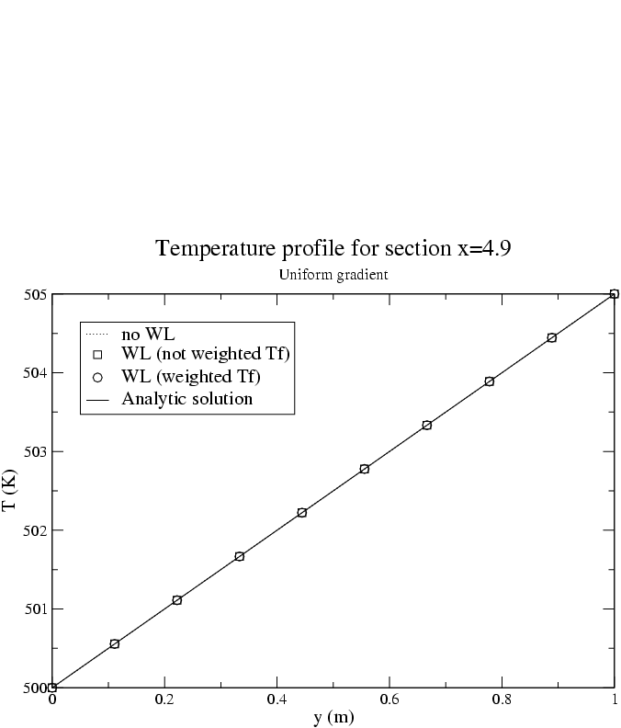

The calculations with or without wall law gives results identical to the analytic solution in terms of diffusive flux or temperature profiles. It indicates that for that case the diffusive flux is well estimated when accounting for the wall law. It is also observed that the results do not depend on the way the mean temperature Tf is calculated. This observation results from the fact that the fluid temperature is uniform at constant y.

Case (2)

The quantities presented below are the same as for the case (1).

Flux_bords (W) | Analytic solution | no WL | WL (not weighted Tf) | WL (weighted Tf)
bottom | -1 | -1 | -1 | -1
up | 1 | 0.9997 | 0.9997 | 0.9997
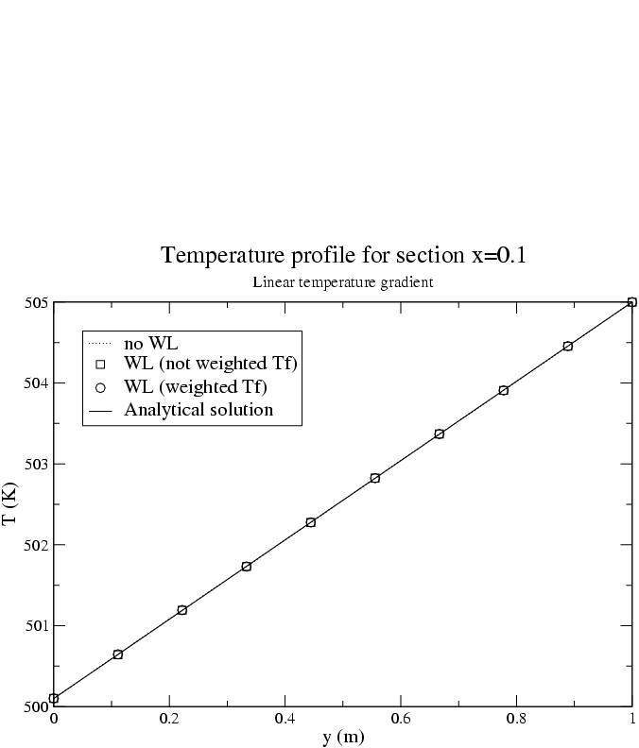
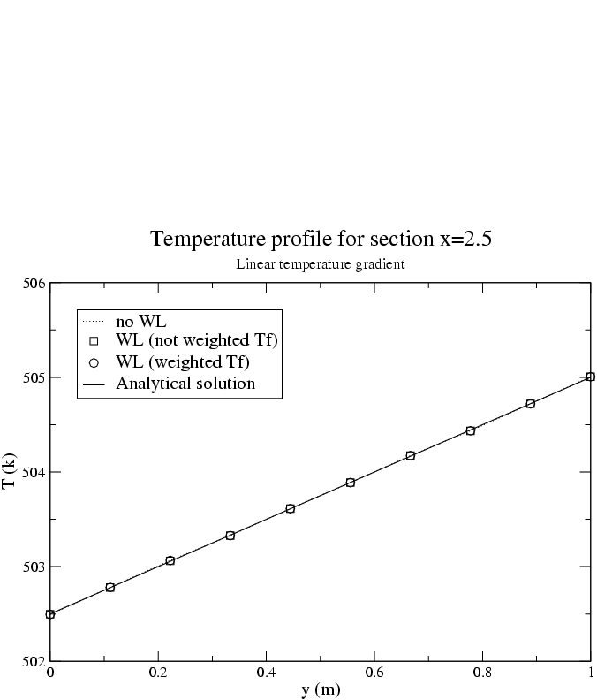

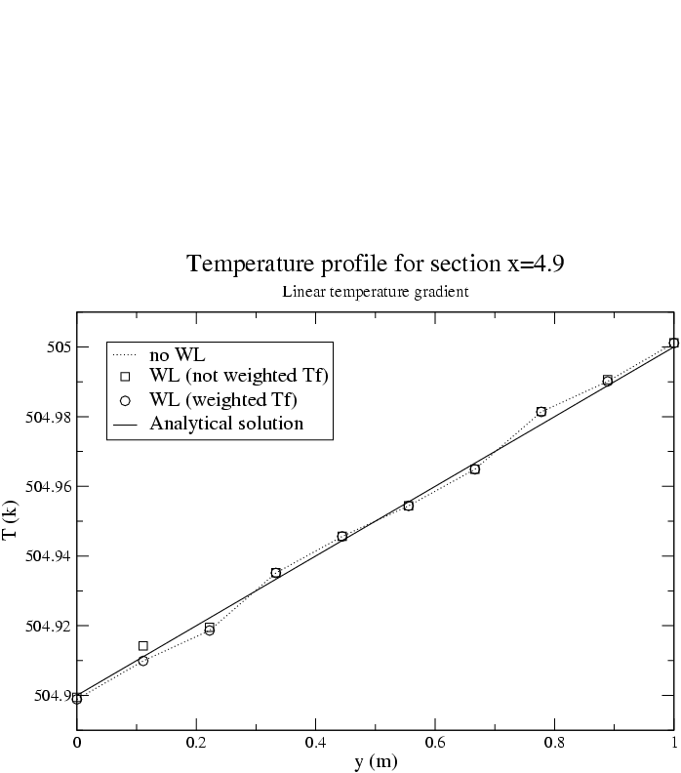

It is observed that the results are identical with and without wall when the mean fluid temperature close to the wall is estimated by accounting for a surface weighting. A rough mean without surface weighting is not sufficient to reproduce the diffusive flux since the temperature varies in the x direction.
The slight differences between the temperature profile calculated and the analytic solution for the section x=4.9 may be due to the meshing resolution.

Conclusion:
These tests validate the expression of the “laminar” equivalent distance (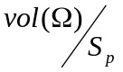).
This expression must be considered in the laminar layer.
The diffusive flux implementation in the diffusive turbulent operator is also validated when accounting for a wall law
as well as the mean fluid temperature expression used to calculate it.

Recommandations for users:

References:

Computer performance:

Type of computer | Characteristics | Total CPU [s]  (see file Performance.TU) | CPU dt/cell [ms]  (see file Performance.TU) | CPU dt [s]  (see file Performance.TU)
PC |  | (1) 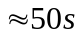  (2) 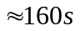 |  | (1) 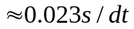  (2) 