Direction de l’Energie Nucléaire
Direction déléguée aux Activités Nucléaires de Saclay
Département de Modélisation des Systèmes et Structures
Service de Thermohydraulique et de Mécanique des Fluides

Base de Validation du logiciel Trio_U
Guide des bonnes pratiques

Trio_U code Validation Data Base
Best Practice guidelines

S. Vandroux
V. Barthel

N° d'identification

Niveau de confidentialité
DO | DR | CCEA | CD | SD
X

partenaires/clients | accord | Type d’action
CEA

références internes CEA
Direction d’objectifs | Domaine | Projet | EOTP
DISN | SIMU | SITHY | A-SITHY-03-03-04
Jalon | Intitulé du jalon | Délai contractuel de confidentialité | Cahiers de laboratoire

Suivi des versions
Indice | Date | Nature de l’évolution | Pages, chapitres
A | 08/10/2013 | Document initial | 59, 7
 |  | Document rédigé sur la base de la note technique DEN/CAD/DER/SSTH/LDAL/NT/2009-008/A

 | Nom | fonction | Visas | Dates
Rédacteurs | S. VANDROUX  V. BARTHEL | Ingénieur  Ingénieur
Vérificateur | U. BIEDER | Ingénieur
Contrôle QSE | D. DUMONT | Correspondant Qualité
Approbateur | O. ANTONI | Chef de Laboratoire
Emetteur | B. FAYDIDE | Chef de Service

Mots clefs
TRIO_U, CFD, LES, k-ε, BPG

Résumé / Conclusions de même niveau de confidentialité que le document
Ce document donne un état de la validation du logiciel de CFD Trio_U développé au CEA/DEN/DANS/DM2S/STMF/LMSF. L’accent est mis sur les modèles de turbulence k-ε haut Reynolds et LES pour la discrétisation VEF en maillages non structurés, dans la mesure où un gros travail sur ces thématiques a été réalisé ces dernières années. Une méthodologie d’automatisation de la réalisation des fiches de validation est en place, elle permet une mise à jour plus facile de la base de validation au cours des versions.
Le travail de validation permet entre autres la connaissance de l’adéquation des modèles aux problèmes traités. De ce fait, il a conduit à fournir des recommandations d’utilisation du code. Nous les avons incluses dans ce document, ce qui permettra aux utilisateurs d’avoir un guide des modèles les plus pertinents – ou non – pour modéliser au mieux les géométries et configurations souhaitées.
La liste des différentes fiches de validation disponibles à ce jour est donnée dans un tableau dont des liens directs permettront aux personnes destinataires d’accéder à leur contenu via le CD-ROM.
La validation est une part intégrante du projet Trio_U. Les efforts sont continus et porteront à présent sur les derniers modèles développés ou en cours de développement et de perfectionnement. Ces évolutions seront prises en compte dans les prochaines versions de ce document.

This document gives a validation state of the Trio_U code developed at the CEA/DEN/DANS/DM2S/STMF/LMSF. An emphasis is given to the high Reynolds k-ε and LES turbulence models for VEF discretization, since an important work has been done during the last years on these subjects. A new methodology for achieving the validation reports in an automatic way is used It makes the evolution of the database along the versions easier.
The validation work allows, among other things, the knowledge of the adequacy of the models to the handled problems. So it naturally leads to some recommendations in using the code. We included them in the present document in order to help the user to take the best models to represent the wished geometries and configurations.
The available validation reports are listed in a specific table and direct links will lead the authorized reader to access to their contents through the delivered CD-ROM.
The validation is an integrant part of the Trio_U project. The effort given on this work is regular and will focus on the last developed or modified models. These evolutions will be taken into account in the future versions of this document.

Diffusion initiale

(Diffusion par email, document DO)

Diffusion interne CEA
(For an access to the validation report files, please ask for a CD-ROM)

Simone VANDROUX, Auteur DEN/DANS/DM2S/STMF/LMSF
Valérie BARTHEL, Auteur DEN/DANS/DM2S/STMF/LMSF
Ulrich BIEDER, Vérificateur DEN/DANS/DM2S/STMF/LMSF
Tous les salariés du DEN/DANS/DM2S/STMF/LMSF
Gauthier FAUCHET, DEN/DANS/DM2S/STMF/LGLS
Vincent BERGEAUD, Chef du DM2S/STMF/LGLS DEN/DANS/DM2S/STMF/LGLS
Didier JAMET, Chef du DM2S/STMF/LMEC DEN/DANS/DM2S/STMF/LMEC
Danielle GALLO, Chef du DM2S/STMF/LATF DEN/DANS/DM2S/STMF/LATF
Philippe EMONOT, Chef du DM2S/STMF/LMES DEN/DANS/DM2S/STMF/LMES
Olivier ANTONI, Chef du DM2S/STMF/LMSF DEN/DANS/DM2S/STMF/LMSF
Frédéric DUCROS, Adjoint au chef du STMF DEN/DANS/DM2S/STMF
Bernard FAYDIDE, Chef du DM2S/STMF DEN/DANS/DM2S/STMF/DIR
Christian CAVATA, Chef du DM2S DEN/DANS/DM2S/DIR
Anne NICOLAS, Adjoint du chef du DM2S DEN/DANS/DM2S/DIR
Philippe MONTARNAL, Chef de projet SITHY DEN/DANS/DM2S/DIR

Diffusion externe CEA
(For an access to the validation report files, please ask for a CD-ROM)

Pierre LEDAC, CS-SI
Marthe ROUX, CS-SI
Cyril MALOD, CS-SI

Diffusion résumé
Jacques SEGRÉ, Assistant Scientifique du DM2S DEN/DANS/DM2S/DIR
Murielle MARUEJOULS, Secrétaire du DM2S DEN/DANS/DM2S/DIR
Xavier AVERTY, Chef du DM2S/SEMT DEN/DANS/DM2S/SEMT
Patrick BLANC-TRANCHANT, Chef du DM2S/SERMA DEN/DANS/DM2S/SERMA
Jean-Paul DEFFAIN, Chef de programme SIMU DEN/DISN/SIMU
Daniel CARUGE, Adjoint au chef de programme SIMU DEN/DISN/SIMU
François GAUCHE, Chef de programme R4G DEN/DISN/R4G
Nicolas DEVICTOR, Adjoint au chef de programme R4G DEN/DISN/R4G
Michel DURIN, Chef de programme GEN23 DEN/DISN/GEN23
Marc DELPECH, Chef de programme AMONT DEN/DISN/AMONT

Table of content

1.Introduction 9
2.The validation project 10
3.The validation of turbulent modelling 12
4.User recommendations 16
5.The global validation state 26
6.Conclusion 31
7.References 32
8.ANNEX 1 33
9.ANNEX 2 38
10.ANNEX 3 40

List of TABLES

Introduction
The objective of this document is to give an overview of the validation state of the Trio_U code, according to the most recent versions. The validation purpose is to give insurance of some basic physical phenomena and to show the best way to model them in terms of discretization schemes proposed by the code. When beginning a new study, searching or even running some validation tests could be useful to guide the user in building his data or meshing files.
Historically, Trio_U offers two types of space discretization, the Finite Difference Volumes (VDF) and the Finite Element Volumes (VEF). The code is developed for the calculation of single and multiphase fluid flow with heat and mass transfer within both an academic as well as an industrial environment.
Since the current uses of Trio_U code concern the turbulent flows with RANS or LES modelling in VEF discretization or industrial purposes, the main part of this document will focus on these two models and try to give some guidelines. But the document will also include numerical validation, laminar and quasi-compressible flow validation files. Other modelisations concerning for instance the chemical-, two-phase flow- or porous modelling will have a greater representation in the future validation reports and it the next versions of this document.

Recommendations issued from this validation database are provided for the use of turbulent models. We stress that these recommendations are not exhaustive and the interested readers are asked to find out dedicated guidelines like 1].

The validation project
The global purpose of a CFD validation project is to Verify and Validate (V&V) the code behaviour on a large panel of test cases, from the simplest to much more complex ones 2].
Since this work is very close to a Trio_U code version, it should be done for each important delivery. But in fact many other tools help a code not to digress from a version to another. For instance the 385 no-regression tests are run every night to measure the differences due to integration of some new-developments, code evolutions and also bug corrections.

The validation organisation
Trio_U is developed and maintained with configuration management software. It allows managing and storing the different versions and the modifications done by the developers. Some automatic work like running tests every night is programmed too. These necessary jobs are very useful to insure a good stability of the code and avoid important regression. Thanks to these regular calculation tests, running old validation exercises should always be successful except if the models are voluntarily modified. These procedures were set from the beginning of Trio_U.
A new objective of the project is to have automatic verification and validation calculations. This work has begun in 2008 and has been enriched since. All the new validation work is done according to the new procedures described in a previous project document [3]. Most of the work done before 2008 has been adapted to these new automatic procedures. However, a few old and ‘manual’ test cases still exist.
The great advantage of this automatic procedure is that it has become very easy for a developer to test the effect of a new model on some relevant calculations, or for a user to try and see the effect of changing options, schemes, models, physical properties… before using them in a study.

The validation classification
The different validation tests are classified in three families that are described in this section, but the rest of this document will mostly concern the second one: the validation tests.

- Verification tests

This is the first step to have a good trust in the models that have been developed. The verification can concern the code writing, the code using, and of course the respect of the model to give the expected result. The number of this kind of tests can be very large because each option, each scheme, each model should be verified. Since the developer has the responsibility to verify the functionality of what he has coded, he delivers a data file that should be a verification test and that becomes a non-regression test. This part will not be described more precisely in this document.

- Validation tests

The validation problems play an important role for the user. They have to insure the efficiency of the modelisation by comparing calculation results to analytical or experimental ones on a large range of physical problems. These problems must be a representative sample of the thermalhydraulic cases studied with Trio_U and must be consistent with the project objectives. The different physical problems can be studied in an isolated or coupled way but generally it is relevant to examine the effect of several models in order to make some recommendations for the user. The user can then evaluate and take the best models to fit the physical phenomena he wants to represent. It is sometimes interesting to show also the models or options which may not be used because they are physically or numerically not appropriate. This is sometimes done in order to notify the possible bad effects of some models on the results.
The main purpose of this document concerns these validation tests, especially for the great objectives of the Trio_U code, that is to say the turbulent modelling.
The classified validation test cases are presented in the following sections.

The final objective of developing a CFD code is to simulate some complex phenomena that can’t be represented in another way, by experimental facilities for example.
It can also be used to do a lot of parametric calculations changing physical or other parameters in order to measure their effects on local or global behaviour. In this case, comparisons with “real physical” behaviour are not usually possible.
Thus it is important to have a panel of global studies that can be a reference for the code studying full industrial problems which combine various complex physical phenomena.
This part will not be developed here but in each topic, for which Trio_U has to answer to some project questions, we try to have one or more complex studies to build an industrial reference. Mainly of these tests correspond to international experimental facilities.
Some examples are given in 1 for typically recent nuclear applications.

Industrial theme | Qualification studies
Pressurised Water Reactors | Lacydon, Rocom , UPTF
Sodium Fast Reactors | Cormoran, Monju
Jet mixing, thermal striping | Hypi, Watlon, Najeco, Wajeco, Plajest
Sub-assembly bundles | Agate, Esthair, Plandtl, GR16
Atmospheric dispersion | Bugey case

Table : Global studies with Trio_U corresponding to experimental facilities

The validation of turbulent modelling
As written in the introduction, we now focus on the CFD turbulent modelling that is the most important part of the problems studied with Trio_U. A global description of the solved equations can be found in the referred project document [5].
Three different possibilities exist in Trio_U to simulate turbulent flows:
- Direct numerical simulation (DNS),
- Large eddy simulations (LES),
- Reynolds averaged Navier-Stokes equations (RANS).

Being very greedy in computing time and in processors number, the DNS is essentially used for research work and very little for industrial calculations so it will not be developed here.

For many years, Trio_U was developed for local and small-scale calculations using Large Eddy Simulation (LES) models and massive parallel technology (HPC). More recently the project needs evolved in using also statistical modelling of turbulence, by means of RANS equations. So, particular validation work has been done for the last years in order to improve the high Reynolds k-ε model in VEF discretization, since it was not a priority before.
Making more and more calculations on unstructured meshes leads to a reflexion about time schemes. Actually the VEF discretization needs to solve a great number of unknowns so the calculation time can be much more important than for VDF discretization. Implicit or semi-implicit schemes have then been introduced for calculating stationary problems. Thus in the more recent validation tests these two subjects (high Reynolds k-ε in VEF and implicit methods) are very present.

RANS modelling, k-ε equations
Two approaches for industrial applications are used in Trio_U in order to determine the turbulent viscosity, conductivity and diffusivity: the mixing length model and the k-ε model.
The mixing length approach is especially dedicated to simple wall bounded turbulence (as e.g. tube flow). For the most industrial cases it is not very convenient except to obtain a first result approach or when using a simple geometry. The k-ε model is then much more used and therefore described more accurately in this section.

General use of k-ε equations
The high Reynolds form of the model is “appropriate” to fully developed turbulent flows and allows to some extent the presence of buoyancy effects. In the Boussinesq hypothesis framework, the turbulent viscosity is linked to the turbulent kinetic energy k and the dissipation rate of the turbulent kinetic energy ε via:

Conservation equations are written for both the turbulent kinetic energy k and the turbulent dissipation rate ε [4]. The turbulent thermal diffusivity α_{t} is then deduced from the hypothesis of the similarity of heat- and momentum transfer. The Prandtl model links viscosity and diffusivity:

where Pr_{t} is the turbulent Prandtl number.

Even if the standard k-ε model is mainly available for fully developed high Reynolds number flows it is sometimes used for CFD calculations involving detachment or mixed convection effects because of its “low cost” use and because some results can be assumed acceptable.

Validation state of k-ε model
The following characteristics have to be taken into account for proper application of the standard k-ε model:
- Meshing: special attention will be given in order to have good physical profiles and a cell size acceptable according to the use of wall law and calculation time.
- Reynolds number: as written before, the standard version of k-ε is more adapted to high Reynolds number flows. But it can be useful to see the results given with low Reynolds number since it can be the case in some local regions of global high Reynolds phenomena. Mixed convection is also an interesting phenomenon to study in this context.
- The forced convection flow is then a good purpose: some research work has been conducted to find less diffusive convection scheme in VEF discretization. The “EF_stab” scheme that is a mix between a centred scheme and an upwind one has been improved and is widely used.
- Wall law: the logarithmic law is used in Trio_U so the first discretization point has to be located in the logarithmic zone.
- Turbulent Prandtl number: the current used value is 0.9 which is the standard value in Trio_U. For some fluids like liquid metal, this value must be greater to take into account the large conductivity especially in the boundary layer.

The next table presents the themes covered by the k-ε validation in VEF discretization. The files indicated in the last column can be joined in a CD-Rom if asked. Some authorized people have a direct access by the link.

One typical example of a validation test case is given in ANNEX 2 of this document. Just note that characters in italic refer to non-automatic files (see section 2.1).

Flow type | Studied parameters | File reference with  direct link to online directory
Turbulent wall flow in channels | Meshing and convection effects | Channelkeps3DVDF_fNydxdz  Channelkeps3DVEF_fNydxdz  ChannelkepsPerio3DVEF_fRe  ChannelkepsPerio3DVEF_fRe_tetrafin
Turbulent wall flow in tubes | Meshing and convection effects | Tube_turb_perio_EF_stab  Tube_turb_perio_muscl
Flow with detachment | Convection scheme, meshing and wall law effects | Backward_Facing_Step  Backward_Facing_Step_3D  Backward_Facing_Step_impl  Cube_Atmo
Sudden expansion | Correlations against Reynolds numbers | expansion_2D_axi_3D_VEF_circular  expansion_3D_VDF_VEF  OBI_diffuser_VEF_k_eps
Sudden contraction | Meshing and convection scheme effects | ContractionTurbFlow_3D_VEF
Flow in curved pipe | Effect of pipe curve | Flow_in_curved_pipe
Mixing and unsteady free jets | Boundary conditions and convection scheme effects | Turbulent_Simple_water_jet  Jet_impingement_on_a_hot_flat_plate
Rod subassembly flow | Rod bundles, implicit schemes | EsthairNoWire
Imposed wall heated flow | Turbulent Prandtl number and convection scheme effects  Meshing and post-treating effects on Twall | Conv_Pipe_InOut  Conv_Pipe_Perio_Impl  Conv_Pipe_Perio_Expl  Heated_floor_k_eps  Heated_Backward_Facing_Step_2D
Flow with imposed wall temperature | Meshing effects | Channel_T1_T2_incompressible  Channel_T1_T2_QC
Fluid-Solid coupling | Convection scheme effects | ThermalCoupling_TurbulentFlow_VEF
Mixed convection flow | Limit of standard k-ε validity  Thermal coupling effects | Convection_kEps_QC
Stratified flows | Limit of standard k-ε validity  Turbulence of thermal effects | Two_Layers_Stratif  Two_Layers_Stratif_impl

Table : Validation themes for LES flows in VEF discretization

LES modelling

General use of LES calculations
In recent years, the use of LES modelling is getting more and more usual for industrial applications. Trio_U had been developed and optimized for this kind of applications, especially to overcome the well-known limitations of RANS (k-ε) modelling, although the resolution times are still very high. Being only relevant in 3D, these calculations need also fine meshes.
The application of LES modelling is recommended in the following cases:

- Unsteady flow,
  - The objective of the analysis is to gain access to mechanical or thermal fluctuations,
  - Mixing phenomena,
  - Free and impinging jets,
- Flow with important secondary structures,
  - Tube bends and tube bundles in axial flow or rectangular channels (for reduced Reynolds number),
- Flow with detachment and/or reattachment like in the case of,
  - Backward facing steps,
  - Obstacles,
  - Tube bundles in transfers flow,
- Flow at slow regimes including volume forces,
  - Natural convection and thermal stratified flow.

Validation state of the LES model
The next table presents the themes covered by the LES validation in VEF discretization. The files indicated in the last column can be found in the joined CD-Rom, one can access to them by a direct link. One typical example is given in ANNEX 3 of this document. Just note that characters in italic refer to non-automatic files (see section 2.1).

Flow type | Studied parameters | File reference with  direct link to online directory
Isotropic Homogeneous Turbulence | Convection scheme effects | les_THI_T_scalaire_VEF
Turbulent wall resolved flow  Flow with imposed wall temperature  at Re_tau = 180 | Convection scheme, meshing effects | Channel_T1_T2_VDF_LES_ReT180  Channel_T1_T2_QC_VDF_LES_ReT180  Channel_T1_T2_VEF_LES_ReT180  les_Re180Pr071_T0Q
Turbulent wall flow with wall law  at several Re numbers  Imposed wall heated flow  at Re_tau = 395 | Convection scheme, meshing and wall law effects | CHANNEL_LES_VEF_RE_TAU_1110  Channel_VEF_LES_ReT400_1100  les_Re395Pr0025_T0Q  les_Re395Pr0025_T0Q_couple  les_Re395Pr071_T0Q
Flow with detachment | Convection scheme, meshing and wall law effects | In progress
Mixing and unsteady jets | Convection scheme, meshing and boundary conditions effects | In progress

Table : Validation themes for LES flows in VEF discretization

User recommendations
The validation effort makes it necessary to be aware of the best practice guidelines (BPG) and to apply them for each physical model which is studied.

Some recommendations for the turbulent models, especially in the VEF discretization are given here. They are of course adapted to the current version of Trio_U and might evolve with the future ones.

The first sections will concern common recommendations for k-ε and LES models. Then, specific recommendations for each model will then be given. For more precisions on their use and data file construction one can refer to the User’s manual delivered with the code or contact the Trio_U team.

Meshing
- Mesh refinement:
  - Around ten discretization points between two walls (which correspond generally to a number of faces) are necessary to get correct profiles. This can sometimes be incompatible with a correct y+ placement (see below) so a compromise must be done. With less than five points, the profiles will be irrelevant.
  - If only global exchanges are the objectives, fewer cells might be used since wall laws and mass and heat conservation are sufficient to respect the flux balances.
  - It is better to avoid small cells in regions of high velocity (impact on the stability time step).
  - In order to avoid small meshes in corners, it is better not to use the option ”verifierCoin” but to swap the orientation of the tetrahedrons in corners during the mesh generation process.
- Boundary layers:
  - The evaluation of wall influenced quantities (pressure loss, wall temperature, fluxes) is influenced by the near wall mesh quality and especially the control of cell size. Two or three layers of regular cells allow good prediction. This can be obtained on some geometry by using prismatic elements and then cut them in regular tetrahedral cells, or by using the Trio_U “Extruder_bord” data.
- Tetra quality for “general” meshes:
  - In VEF discretization, attention will be given to angles between two cell faces. A histogram giving the proportion of cells in several ranges can be found in the “.err” file since the 1.6.1 version. In case of a great part of obtuse cells, some non-physical phenomena due to the diffusion operator features can be observed.
  - When using optimization tools of mesh generators, several optimization steps should be performed on the whole mesh (e.g. Laplace smoothing) with the objective to reduce globally the angles of the dihedral between two adjacent tetra faces.
  - Significant changes in the mesh size of two adjacent tetras should be avoided. A propagation factor of 20% seems to be an upper limit (5% recommended).
  - Meshing a 3D geometry with isotropic cells in all directions is the ideal way not to disturb the numerical models for a 3D flow. However for a flow with slow physical variation in a given direction (1D-flow), it can be shown that stretching the mesh up to a hundred times in this preferred direction doesn’t much degrade the results. A stretch in both the preferred and the transverse directions up to thirty times doesn’t affect them either.
- Tetra quality for “Trio_U made” meshes:
  - Using Trio_U extruding tools: the “Extrude” option (one hexahedron divided in 14 tetrahedra) can lead to cells having angles over 90°. Prefer “Extruder_en20”, unless the number of cells is limited as cutting into 20 tetrahedrons can lead to a great number of very thin cells.. In that case, “Extruder_en3” can be used, but the result must be checked carefully.
  - Using Trio_U tetrahedrisation tools: the “Tetrahedriser_homogene_fin” option is recommended since it gives the most regular cells which can be useful near the boundaries. But this option leads to 48 per tetrahedron so the user must be careful choosing the initial number and size of hexahedral cells. For some stretched mesh and directional flow, the “Tetrahedriser” option can be better.
  - Using Trio_U triangularisation tools: the “Trianguler_fin” option is recommended since it gives the most regular cells which can be useful near the boundaries and for measuring pressure loss or friction velocity.

Pressure solver
The pressure solver is the “pilot” who assures a correct mass balances which is essential for a high-quality solution of the Navier-Stokes Equations.
For a number of CPUs under 500, or a Quasi Compressible calculation, PETSC Cholesky as a pressure solver should be tried first.
In other cases, an iterative method should be used: a conjugated gradient solver with local SSOR preconditioning:

Solveur_Pression GCP
{
precond precond_local ssor { omega 1.5 }
seuil 1.00e-8
impr
}

The “seuil” characterizes the quality of the mass conservation. It defines the threshold of the residuum which is accepted for the iterative solution. The choice of the threshold should guaranty that during the iteration process, the residues decrease from about three orders of magnitude. This should be verified in the output file (by “impr” data command). This file will also enable to check that no unnecessary calculation is done by choosing a too small value.

Boundary conditions
- Inlet conditions (Dirichlet type):
  - The velocity and temperature are usually known at the inlets, thus, these values can be directly imposed by the user. Given mass flow rates can also be used, both for incompressible and for quasi-compressible calculations. As a result of small differences in the inflow area due to the discretization, the correct mass-flow rate must be controlled in the “debit” output file. Please note that the boundary condition is to be specified using “face-mean” values. This can lead to small discrepancies between the imposed profile and an analytical function, which usually presents local values.
  - Pressure boundary conditions (von Neumann type) at the flow inlet are not recommended!
  - One can introduce periodic boxes that allow knowing the inlet profiles quickly. This can be done by extruding the inlet boundary mesh on a few cell layers, and put periodic conditions with initial conditions set to the mean inlet conditions for final geometry. Profiles of the inflow velocity, turbulence parameters (k and ε) and scalar quantities (temperature and concentration) are obtained on the periodic boundary and are then injected at the inlet of the studied model. “Modif_div_face_dirichlet” should then be set to 1 when describing the discretization (Lire dis).

- Outlet conditions (von Neumann type):
  - Usually, a constant pressure is imposed at the outlet and free outstream conditions are selected for all scalar quantities. If there are several outlets, the option “Cl_pression_sommet_faible” should be set to 1 when describing the discretization (Lire dis).
  - It is not recommended to use Dirichlet type conditions at the outlet for incompressible calculations.

- Wall conditions:
  - Standard logarithmic laws are usually used in order to make the turbulent models valid and get correct profiles and transfers without having to mesh very thinly near the walls. The first discretization point should ideally be located at a distance y for which the non-dimensional distance y⁺ = y u_{τ} / ν lays between 40 and 500 (to verify with the post processing quantity “yplus”). Higher values can be acceptable; however in regions of high interest, the y⁺ value should not be significantly below 40. This condition will ensure being in the turbulent boundary layer (logarithmic profile) with the first calculation point and thus guarantee a good connection to the off-wall turbulent field. This is also true when using the TBLE wall law. Two methods are available to impose the wall laws :
- turbulence_paroi loi_expert_hydr { methode_calcul_face_keps_impose que_les_faces_des_elts_dirichlet }
- turbulence_paroi loi_expert_hydr { methode_calcul_face_keps_impose toutes_les_faces_accrochees }

The first method is to be preferred when a homogeneous meshing (in terms of equally sized tetras) has been created on the wall. It is the default one for “loi_standard_hydr” since 1.5.7 version. However, when this method produces numerical fluctuations near the wall, the more robust second method should be applied.

  - Thermal Kader law: this is the law used by Trio_U to insure thermal turbulent profile near the walls. Like the hydraulic logarithmic law, it is universal, since its validity concerns a great range of fluids, from very low Prandtl numbers to very high ones.

Initial conditions
- In case of long transients, it can be recommended to accelerate the formation of a physically correct solution, by using the following initializing procedure:
  - If necessary, develop a fully turbulent flow in the periodic inflow boxes (see above).
  - Initialize the calculation domain with a mean velocity, a mean temperature and mean turbulent quantities.
  - Calculate a thermalhydraulic state until the profiles of the main quantities stabilize everywhere in the domain.
  - After stabilization, analyze the results for constant boundary conditions or, if it is the case, start the final transient simulation with temporal variable boundary conditions.

- For thermal and hydraulic coupled calculations, the Boussinesq source term needs an initial temperature. One must put the mean initial temperature in order to get the buoyancy effects on this mean temperature:

Sources { Boussinesq_Temperature { T0 738. } }

Post-processing
- Fields representation:
The way code results are visualized has a real impact on the quality of the presented solution. The fields can be visualized at element-, vertex- or face level. Depending on where the post processed quantity is discretized, the representation can be exact or interpolated, i.e. smoothed. Although smoothing provides rather “pretty” pictures, the associated filtering operation can discard the visualization from reality. To observe the closest results from the calculated fields, we give in 4 the discretization localization of each main quantity, although the visualization on this location might show some irregularities. Thus, our user recommendation is a compromise between reality and “smooth” solution, which leads to a location for visualization at the element (‘elem’). This choice also has the advantage of using less memory capacity than storage at the vertices (‘som’).

Quantity | Discretization location
Velocity | faces
Pressure | elem and som
Temperature | faces
Scalars (concentration) | faces
k | faces
ε | faces
Turbulent viscosity | elem
Physical properties | elem
y⁺ | elem

Table : Localisation of the variables in VEF discretization

For big meshes –depending of course on the computer capacity- it is mandatory to store the field values in binary format in order to reduce considerably the charging time of the visualization tools (default format since the 1.6.1 version of Trio_U).
In all cases, prefer a “lata” format that can be converted in all other Trio_U formats.
In VDF, all fields are located at elements except velocity (on faces) but only “elem” or “som” post-treatment are possible yet.

- Probes (« point » and « segment » visualisation):
Concerning the visualisation of probes (single values within the mesh), several methods exist (default, “nodes”, “grav”, “chsom”), leading either to smoothing by interpolation or to meshing effects that are not always easy to avoid in a non-structured mesh. The default probe (interpolation without location notification) should be generally correct.

- Wall temperature:
Some results which are needed for the analysis are not directly available for the post-processing since they are not used by Trio_U as a calculation quantity. It is the case of the wall temperature, but only when calculating a turbulent thermal hydraulic flow with an imposed heat flux at the wall. In this case the wall surface temperature is not part of the unknowns and thus not calculated. If needed (e.g. for calculating a heat exchange coefficient or knowing hot spots on the walls) use the “temperature_physique” field (post-processed on the faces). However, this surface temperature is an extrapolation from calculated values to the wall and not fully consistent to a calculation with the same imposed temperatures.

Specific recommendations for k-ε modelling

Time schemes
- Explicit time schemes :
Each time scheme can be used, however the Euler_explicite scheme is usually the best choice concerning the rapidity of explicit solutions.

- Euler_Implicit time schemes :
The “implicite” scheme for solving steady state or transient flows will reduce the calculation time.

For the momentum equations, the GMRES solver is recommended, usually defined as default solver:

Schema_Euler_implicite sch
Lire sch
{
dt_start dt_calc
solveur implicite
{
Solveur GMRES { diag seuil 1.e-12 nb_it_max 5 impr }
}
}
The chosen value for convergence threshold must be small. The implicit solver iterates nb_it_max times.
A maximal number of iterations can be specified with nb_it_max keyword. In that case, ‘5’ is a good value.

It is possible to specify a solver for each equation.
- For Momentum equation, GMRES solver usually works well
- For scalar equations, BICGSTAB/ILU is recommended if GMRES converges slowly, or not at all
- For the transport equations of k and ε, if problems occur in implicit, it is sometimes better to solve these equations in an explicit way, using:

parametre_equation parametre_implicite
{
resolution_explicite
}

The “facsec” and the “facsec_max” parameters determine the minimum (used at the beginning of the calculation) and the maximum values of the multiplying coefficient of the stability time step. Some divergence or infinite iterations can indicate that these values are too high. Oscillations in the convergence curves can be observed if the time step is higher than the necessary time to cross the domain.

For stretched mesh, the implicit matrix solving can be badly conditioned and the calculations will not converge. One can reduce the time step by limiting the “facsec_max” value.

Some recommendations can be given for the “facsec” values, depending on the type of calculation:
- For hydraulic calculations, or for thermalhydraulic calculations, without or with low coupling between temperature and velocity: use a value of “facsec_max” between 20 and 30.
- For thermalhydraulic calculations, with forced convection and strong coupling between velocity and temperature, use a value of “facsec_max” between 90 and 100.
- For thermalhydraulic with natural convection, use a value of “facsec_max” around 300.
- For conduction calculations, much higher values are allowed.
If no convergence occurs with these values of “facsec_max”, a reduced value from 5 to 10 should be tested.

Convection schemes:
In VEF discretization the second order “EF_stab” is the most appropriate scheme for solving scalar convection-diffusion equations (temperature, concentration) and Navier-Stokes momentum equations. The EF_stab scheme is a centered scheme stabilized more or less by an upwind scheme through an alpha factor. By default α = 1.

convection { EF_stab { alpha 1.0 } }

The α factor allows modifying the compromise between robustness and diffusive properties. By using an α value near from 1, the scheme is stable but diffusive. By using a lower value, the Ef_stab scheme becomes closer to a centered scheme, less robust but less diffusive too. That can be useful in capturing fluid motion in some geometry breaks like sudden contraction and for free mixing flows. It can also be interesting in a better approach of temperature or scalar gradients. The drawback is that it can create instabilities in the motion equations especially when meshes are irregular or stretched.
Generally speaking, it can be noted that:

- EF_stab with α=0.2 usually gives generally better results. It is necessary when some obstacles are present in the geometry or for capturing more precise gradients. In case of numerical instabilities (i.e. the solution diverges), the α value must be increased or the time step must be reduced by putting a “facsec” value under 0.5,
- EF_stab with α=1 insures the robustness and gives equivalent results to α=0.2 for a lot of cases when the forced convection flow has a preferred direction.

For very perturbed or mixing flows, the 2nd order “muscl" or 1st order “amont” schemes can also be an efficient choice. The drawback of the muscle scheme is that the wall friction is not calculated very accurately. So, for now, this scheme should be avoided for calculations with significant wall friction, and encouraged in other cases.

In VDF discretization, the third order “quick” scheme can be used as a default but instabilities can be observed. Limiting the time step by using a “facsec” value near 0.2 is then useful. For the use of the upwind scheme (amont), the recommendations for VEF are valid.

Inlet boundary conditions:
It is important to specify properly the initial turbulent conditions because the k-ε model can be very sensitive to them. For simple “jet flow” and a turbulence rate of 10%, the following standard values for k and ε can be used:
ε =
where U₀ is the bulk velocity and l_{m} the characteristic mixing length given by:
- l_{m} / δ = 0,090 for a plan jet
- l_{m} / δ = 0,075 for a round jet, 2δ is the jet diameter

For many cases it is difficult to estimate the values of k and ε necessary for an input data file. If they are not known, it becomes necessary to simulate an inlet flow in a very long pipe or channel upstream the inlet boundary condition, to lead to a developed flow. As written in section 4.3, periodic boxes can reduce the calculation domain and simulation time.

Model parameters
- Turbulent viscosity
Temporally during transients, high values of the turbulent viscosity ν_{t}, calculated by the k-ε model, can lead to a very small diffusive time step. In this case, it is possible to use an option to reduce locally the turbulent diffusivity in a way that the calculation goes forward with the convection stability time step:

Correction_visco_turb_pour_controle_pas_de_temps

However, it is mandatory to check that this correction occurs only temporally during the transient. For the steady state solution, the correction should disappear what can be verified by post processing the field “corr_visco_turb“.

- Turbulent Prandtl number:
As written in section 3.1.1, the thermal and hydraulic turbulent models are coupled by the turbulent Prandtl number Pr_{t}.
- For most fluids the thermal and hydraulic behavior is similar what leads to a Prandtl number () near to 1.
- The turbulent Prandtl number Pr_{t} is normally taken constant and equal to 0.9. For Pr >>1 or Pr <<1 this is no more the case and it can be useful to take these changes into account. One objective of the Trio_U code is to study the liquid metal flows in order to develop a model for the future sodium fast reactors. The sodium Prandtl number is very low (under 0.01 depending on the temperature), its conductivity is very high and so the conductive boundary layer is much thicker than the viscous boundary layer. This makes the turbulent Prandtl number being high in the log law region and thus a special function can be given in the data file:
where
This formula insures a good thermal behavior for liquid metal flows, especially near the walls and has been validated in VEF discretization.
- A constant value can also be chosen for Pr_{t} (or Schmidt number in case of concentration), different from the default ones (0.9 for Pr_{t} and 0.7 for Sc_{t}).

Specific recommendations for LES modelling

Numerical schemes
- Time schemes:

  - Explicit time schemes:
Higher order schemes are recommended. The “Runge_Kutta_ordre_3” (3rd order) or the “Schema_predictor_corrector” (2nd order) schemes are often a good compromise between the speed and the accuracy of the solution. In case of numerical instabilities, third order schemes are recommended.

  - Euler_Implicit time schemes:
The implicit time should possibly be avoided for LES calculations. As long as the time step is governed by convection, it is highly recommended to use an explicit time scheme.
However, if the time step is very low due to small diffusion time steps, it can be tempting to use an implicit solution. Two possibilities are then available:
  - The implicit scheme, but for LES calculations, the time step should not exceed the stability time step of the convection term, so it can be necessary to limit the “facsec_max” value.
  - The ‘diffusion implicite’ scheme.
However, for these two possibilities, some calculations have shown good or bad results, depending on the configuration. So, the user should keep in mind that his solution might be somehow distorted, and use it with great care.

- Convection schemes:

In VEF discretization the second order “EF_stab” scheme is the most appropriate scheme for solving scalar convection-diffusion equations (temperature, concentration) and Navier-Stokes momentum equations.
  - For momentum convection term: using an α factor near 0.2 (by default α = 1.), the Ef_stab becomes a more centered scheme, preferable for LES calculations.
  - For scalar convection equations: an α factor equal to 1 have to be used to avoid a non-positive behavior.
  - In the case of numerical instabilities, an α factor near 1 can stabilize the calculation, however, in this case, an extensive analysis of the energy spectra is necessary in order to avoid a simulation with a too high numerical dissipation.

In VDF discretization, the second order “centre” or the fourth order “centre4” scheme can be used as a default but instabilities can be observed. Limiting the time step by using a “facsec” value near 0.2 is then useful too.

Boundary conditions
- Inlet conditions (Dirichlet type):
It is important to specify the inlet turbulent conditions properly, i.e. all the components of the “fluctuating” velocities and scalar quantities. For this purpose, it is highly recommended to introduce periodic boxes at the inlet faces that allow the generation of the time dependent inlet profiles quickly.
This box can be created by extruding the inlet boundary mesh to 15 to 20 cell layers in opposite direction of the inlet geometry (6 better 8 hydraulic diameters). This layer number is necessary to limit an autocorrelation of the fluctuations (to test in any case). Periodic conditions with initial conditions set to the inlet conditions for final geometry will rapidly generate the mean velocity profiles as well as the fluctuations.
The occurrence of laminar/turbulent transition must be verified: during the transient, the axial velocity in the centre of the box should first be overestimated and then decrease to the correct value of the turbulent profile.
The velocities obtained on the periodic boundary are then injected at the inlet of the studied model.

- Wall conditions:
For industrial cases the LES modeling cannot generally be wall resolved calculations since the necessary refinement of the mesh near the walls would lead to a very long computing time and a huge cell number. So the use of hydraulic and thermal wall laws in the same way than for k-ε model (see §4.3) are recommended.

- Symmetry:
Symmetry conditions cannot be used in LES calculations. A periodic condition can however be used if it is possible.

Initial conditions
- In order to accelerate the formation of a physically correct solution, the following initializing procedure is recommended:
  - Develop a fully turbulent flow in the periodic inflow boxes, if possible.
  - Initialize the calculation domain with a mean velocity and a mean temperature.
  - Calculate an initial transient with connected periodic boxes in the whole domain, until transition occurs everywhere in the domain and both the mean values and the fluctuations of the main quantities stabilize.
  - After stabilization, start collecting statistics for the detailed analysis of the calculation.

Model parameters
- Sub-grid model
Various sub-grid models are available in Trio_U with very specific application fields. Generally, it is a good choice to start a LES-analysis with the WALE sub-grid model. Any adaptation of model parameters is not recommended. In combination with logarithmic wall functions, the WALE model treats correctly wall near flows. A restriction concerning the localization of the first wall near point does not exist (as for k-ε modeling). Only if that the WALE model does not dissipate sufficiently the high frequency fluctuations, which can be seen by checking the spectra of the turbulence energy, the Smagorinsky model with standard model parameters can be used. In any case it is necessary to verify the spectra of the turbulent energy, the mean profiles as well as the RMS of the fluctuations in a post processing procedure.

- Turbulent viscosity ν_{t}
As explained in chapter 4.7 locally high values of the turbulent viscosity ν_{t}, calculated here by the LES sub-grid model, can lead to a very small diffusive time step. The same model option can be used:

Correction_visco_turb_pour_controle_pas_de_temps

However, it is mandatory to check that this correction occurs only locally during the transient or at the steady state by post processing the field “corr_visco_turb“. The user should always keep in mind that this option can result in an accumulation of turbulent kinetic energy (near the cut-off frequency).

Convergence analysis
- Before using the calculation results, it is essential for the user to check the convergence of his calculation. He must be able to answer positively to the following questions:
- Are the time averaged values (velocities, temperatures…) of my calculation converged?
- Are the averaged fluctuation intensities (velocity, temperature…) of my calculation converged?
- Are the calculated values of average velocity close from the expected ones?
- Is it sure that there is no auto-correlation between two periodic boundaries?
- Does the Fourier transformation of the velocity meet the condition of the expected -5/3 slope?

Post-processing
- In addition to chapter 4.5, due to the unsteady character of LES simulations, flow statistics should be calculated and visualized. As already mentioned, the statistics of the flow can be assembled as soon as the unsteady flow is stabilized in the whole calculation domain (after the occurrence of laminar/turbulent transition). Mean values (“moyenne”) and standard deviations (“ecart type”) of the main quantities can be assembled in the post-processing block:

statistiques dt_post 0.01
{
t_deb 0.055 t_fin 1.0
Moyenne vitesse elem
Ecart_type vitesse elem
}

It is highly recommended to interpret only the mean fields and not to derive general conclusions from instantaneous fields.

- It is mandatory to control the frequency spectra of the turbulent kinetic energy. For this purpose it is necessary to place velocity probes in the zone of interest of the calculation domain. The velocity should be stored at each time step in order to avoid temporal filtering of the results. When the signal has stabilized (and only then), a Fourier transformation of the temporal course of the norm of the velocity of the probes has to be performed. When using the xmgrace freeware, realistic energy spectra can be achieved by applying additionally Hamming data window (through Fourier Transformations menu).
The resulting energy spectra should represent in a part of its course the well-known -5/3 slope of the turbulent transition regime (log-log representation of the turbulent kinetic energy over the frequency). A too steep slope might indicate the use of an excessively dissipative numerical scheme; a too flat slope might indicate insufficient dissipation what can result in the presence of numerical instabilities.

The global validation state
This section presents all the models under validation since the last Trio_U versions. 5 gathers them in 11 groups in which the files validating the k-ε and LES models already presented in Table 2 and in 3 are included again. So this table gives the global vision of the files that you can find in the validation database. By clicking on the file name, the authorized people will be able to open the file in a “.pdf” form.
For the others, please ask for a CD-ROM or USB key. Once again, note that characters in italic refer to non automatic files (see section 2.1)

Group of tested models and specific description |  | Discretization | Dimension |  | File reference with  direct link to online directory
- Numerics

Convection and time scheme effects on a passive scalar transport through a channel |  | VEF | 2D/3D |  | Comp_conv
Convection and time scheme effects on a passive scalar transport on a rotating table |  | VEF | 2D |  | Convection_Rotating_Table
Natural convection in a cavity |  | VEF / VDF | 2D |  | Convection_Vahl_Davis
Diffusion effect of the convection schemes |  | VEF | 3D |  | Diagonale_Cube
- Hydraulic Laminar flows:

Poiseuille flow in a plane channel, with imposed pressure drop and various meshing |  | VDF/VEF | 2D |  | PoiseuilleInOut2DVDFVEF_prismes  PoiseuilleInOut2DVDFVEF_trianfin  PoiseuilleInOutVDFVEF
Poiseuille flow in a plane periodic channel, with various mesh size and various meshing |  | VEF | 2D |  | PoiseuillePerio2DVEF_fNcells  PoiseuillePerio2DVEF_fNcells_trianfin  PoiseuillePerio2DVEF_prismes
Poiseuille flow in a plane periodic channel, with various Reynolds numbers and various meshing |  | VEF / VDF | 3D |  | Poiseuille_3D_Channel  PoiseuillePerio3DVDFVEF_fRe  PoiseuillePerio3DVDFVEF_fRe_prismes  PoiseuillePerio3DVDFVEF_fRe_tetrafin
Poiseuille flow in a pipe with imposed velocity profile |  | VEF | 3D |  | Poiseuille_Pipe_Velocity
Poiseuille flow in a pipe with imposed pressure loss |  | VEF | 3D |  | Poiseuille_3D
Oscillating flow behind a circular cylinder perpendicular to the flow |  | VEF | 2D |  | Cir_Cyl_Re100
- Thermohydraulic Laminar flows:
Wall temperature verification with Neumann conditions |  | VEF | 2D |  | T_paroi
Imposed Nusselt number verification in an heated plane channel |  | VEF / VDF | 2D |  | Nusselt_Correlation_2D
Flow using a Nusselt number correlation, coupled to a conduction problem |  | VDF | 2D |  | Nusselt_Correlation_Coupling_Pb
Flow in rectangular pipe with heat transfer from solid to fluid |  | VDF | 2D |  | Pb_couple_2D
Osclillating flow in a non symmetric heated cavity |  |  |  |  | Oscillating_Flow
Incompressible or QC flow on a vertical heated plate ; natural or mixed convection |  | VEF / VDF | 2D |  | laminar_flow_vertical_plate
Heated Plane Channel with QC flow |  | VEF/VDF | 2D/3D |  | INEEL_VDF_QC_1D_2D  INEEL_VEF_QC
Heated Pipe with QC flow |  | VEF | 3D |  | INEEL_VEF_QC_PIPE
Natural Convection ; stratification |  | VDF/VEF | 2D / 3D |  | Therm_stratif_water_tank  Thermal_stratification_flow
Fluid-Solid coupling ; Convection scheme effects |  | VEF | 3D |  | ThermalCoupling_LaminarFlow_VEF
- Hydraulic RANS:

a) Mixing Length modelling:

Turbulent periodic wall flow ; Convection scheme and Reynolds number effects |  | VEF | 3D |  | ChannelMLPerio3DVEF_fRe  ChannelMLPerio3DVEF_fRe_tetrafin
Turbulent periodic wall flow ; mesh and convection scheme effects) |  | VEF/VDF | 3D |  | ChannelML3DVDF_fNydxdz  ChannelML3DVEF_fNydxdz
b) k-ε modelling:

Turbulent wall flow in channels  Meshing and convection effects |  |  |  |  | Channelkeps3DVDF_fNydxdz  Channelkeps3DVEF_fNydxdz  ChannelkepsPerio3DVEF_fRe  ChannelkepsPerio3DVEF_fRe_tetrafin
Turbulent wall flow in tubes  Meshing and convection effects |  |  |  |  | Tube_turb_perio_EF_stab  Tube_turb_perio_muscl
Flow with detachment  Convection scheme, meshing and wall law effects |  |  |  |  | Backward_Facing_Step  Backward_Facing_Step_3D  Backward_Facing_Step_impl  Cube_Atmo
Sudden expansion  Correlations against Reynolds numbers |  |  |  |  | expansion_2D_axi_3D_VEF_circular  expansion_3D_VDF_VEF  OBI_diffuser_VEF_k_eps
Sudden contraction  Meshing and convection scheme effects |  |  |  |  | ContractionTurbFlow_3D_VEF
Flow in curved pipe  Effect of pipe curve |  |  |  |  | Flow_in_curved_pipe
Mixing and unsteady free jets  Boundary conditions and convection scheme effects |  |  |  |  | Turbulent_Simple_water_jet  Jet_impingement_on_a_hot_flat_plate
Rod subassembly flow  Rod bundles, implicit schemes |  |  |  |  | EsthairNoWire
- Thermohydraulic RANS
k-ε modelling:
Imposed wall heated flow  Turbulent Prandtl number and convection scheme effects  Meshing and post-treating effects on Twall |  | VEF | 2D/3D |  | Conv_Pipe_InOut  Conv_Pipe_Perio_Impl  Conv_Pipe_Perio_Expl  Heated_floor_k_eps  Heated_Backward_Facing_Step_2D
Flow with imposed wall temperature  Meshing effects |  | VEF | 3D |  | Channel_T1_T2_incompressible  Channel_T1_T2_QC
Fluid-Solid coupling  Convection scheme effects |  | VEF | 3D |  | ThermalCoupling_TurbulentFlow_VEF
Mixed convection flow  Limit of standard k-ε validity  Thermal coupling effects |  | VEF/VDF | 2D |  | Convection_kEps_QC
Stratified flows  Limit of standard k-ε validity  Turbulence of thermal effects |  | VEF / VDF | 2D |  | Two_Layers_Stratif  Two_Layers_Stratif_impl
- Hydraulic LES modelling:

Turbulent wall resolved flow  at several Re numbers  Convection scheme, meshing effects |  |  |  |  |  | CHANNEL_LES_VEF_RE_TAU_1110  Channel_VEF_LES_ReT400_1100
- Thermohydraulic LES modelling:
Isotropic Homogeneous Turbulence  Convection scheme effects |  |  |  |  |  | les_THI_T_scalaire_VEF
Turbulent wall resolved flow  at Re_tau = 180  Convection scheme, meshing effects |  |  |  |  |  | Channel_T1_T2_VDF_LES_ReT180  Channel_T1_T2_QC_VDF_LES_ReT180  Channel_T1_T2_VEF_LES_ReT180  les_Re180Pr071_T0Q
Turbulent wall flow with wall law  at Re_tau = 395  Convection scheme, meshing and wall law effects |  |  |  |  |  | les_Re395Pr0025_T0Q  les_Re395Pr0025_T0Q_couple  les_Re395Pr071_T0Q
Flow with detachment  Convection scheme, meshing and wall law effects |  |  |  |  |  | In progress
Mixing and unsteady jets  Convection scheme, meshing and boundary conditions effects |  |  |  |  |  | In progress
- Front tracking:

Bubble growth | VDF |  |  | 3D |  | Bulle_3D_VDF_FT
Bubble growth | VEF |  |  | 3D |  | Bulle_3D_VEF_FT
 |  |  |  |  |  | ftd_gravite
 |  |  |  |  |  | FTD_hanging_drop
 |  |  |  |  |  | FTD_oscillating_bubble
 |  |  |  |  |  | FTD_rising_drop
 |  |  |  |  |  | FTD_sloshing
- Radiation:

Solid fluid coupled problem with radiation | VEF / VDF |  |  | 2D / 3D |  | Radiation
- Porous media:

Channel flow with variable porosity |  |  |  |  |  | Poreux_VEF  PorousWithPLoss_VEF
- Pure or coupled conduction:
Pure conduction problem with oscillating temperature imposed at the boundary. | VEF |  |  | 3D |  | conduction_T_oscillant
Fluid solid coupling for channel flow  Effect of Nusselt number | VEF / VDF |  |  | 1D |  | Nusselt_Correlation_Coupling_Pb
Fluid solid coupling for pipe flow  Energy balance | VEF / VDF |  |  | 2D |  | Pb_couple_2D
Fluid-Solid coupling for channel flow  Convection scheme effects | VEF |  |  | 3D |  | ThermalCoupling_LaminarFlow_VEF  ThermalCoupling_TurbulentFlow_VEF
Fluid solid coupling for sodium flow in pipe | VEF |  |  | 3D |  | Turb_coupled_pipeflow

Table : Global validation files for Trio_U

The subjects noted “In progress” in the different Tables are either achieved but not formalised or about to be started.

To give the reader an idea of the form and the contents of the automatic validation reports, one will find examples in ANNEX 2 and in ANNEX 3 of the document.

Conclusion
The validation work of the CFD code Trio_U has been described in this document with a focus on the LES and k-ε turbulent models in VEF discretization. A big effort has been done during the last years in order to expand the vision of the efficiency of turbulence models in non-structured geometries. This is a real need of the Trio_U project and it seems essential to have a real confidence in the code behaviour.

The validation files, too big to be included in the present document are delivered in “.pdf” form with this document in a CD-Rom. 2, 3 and 5 have direct links to these files.

All these validation calculations using a lot of options and models have led to some prescribed recommendations. Therefore, some guidelines for turbulent flows are presented in this the document in order to help the user to have the best results for the case he wants to deal with. These conditions and of course all the basic CFD recommendations should be respected.

The process which has been established to get the validation reports by an automatic and systematic way will help the code to be under evolving validation. Most of the work achieved in the past is under this process.

An objective was to make some improvement and validation for low Reynolds number flows and to go on with the EF_stab convection scheme especially for laminar flows. Another goal was to achieve the Pironneau wall laws, which give very good results for wall friction, whatever convection scheme is used.

The others themes that have been developed in the past years concern the chemical, two-phase flows and porous modelling which are more and more used.

References
[] ERCOFTAC Best Practice Guidelines for Industrial Computational Fluid Dynamics of Single-Phase Flows, http://www.ercoftac.org/

[] AIAA, “Guide for the Verification and Validation of Computational Fluid Dynamics Simulations,” AIAA G-077-1998, 1998

[3] S. Vandroux & al, Trio_U validation test cases data base organisation. Automatic validation or verification test cases. NT DEN/CAD/DER/SSTH/LMDL/NT/2009-108/A

[4] U. Bieder & al, Trio_U Users Manual: Methodology for incompressible single phase flow in industrial applications. NT CEA-DEN DER/SSTH/LMDL/2007-058

[5] Trio_U User Manual.pdf: online document delivered with each Trio_U version

ANNEX 1
Some guidelines of using Trio_U with turbulent models – Version 1.6.6 – April 2013
For more details and precisions, refer to the present document section 4.
Tetra-meshing

Mesh refinement adapted to modelling
Meshing homogeneous in size
Optimized Tetrahedron angles
Meshing of gaps
Meshing of boundary layers
Pressure solver

CGP with SSOR preconditioning
Convection scheme

Ef_stab with α =0.2
Instable? → α =1.0
Still instable? → muscl
Still instable? → amont
Boundary Conditions

Inlet: → imposed values
Fluctuations: →periodic boxes at the inlet
Outlet: → Imposed pressure
Walls: → logarithmic wall functions
Initialization

Transient calculations until:
→ The whole domain is crossed by the flow
→ Laminar/turbulent transition took place in the whole domain (LES only)
Post processing

Verification of the correct:
→ Localization of the first wall near calculation point (y+>40)
→ Stabilization of the solution
→ Energy spectra (LES only)
Turbulence modeling

Objective:
Mean values → RANS (k-ε)
Fluctuations → LES
Natural convection → LES

Time scheme

Stationary solution (RANS):
Implicit time scheme: → Euler implicit scheme
GMRES solver for Momentum
(BICGSTAB for Scalars)
Explicit resolution for k-ε

Transient solution (RANS or LES):
Explicit time scheme:
→ Euler explicit scheme (1st order)
→ Implicit (Euler or diffusion) but with great CAUTION
→ Runge-Kutta (2nd order)

ANNEX 2

Example of a Validation file for k-ε model

Thermalhydraulic flow of a liquid metal in a circular heated pipe
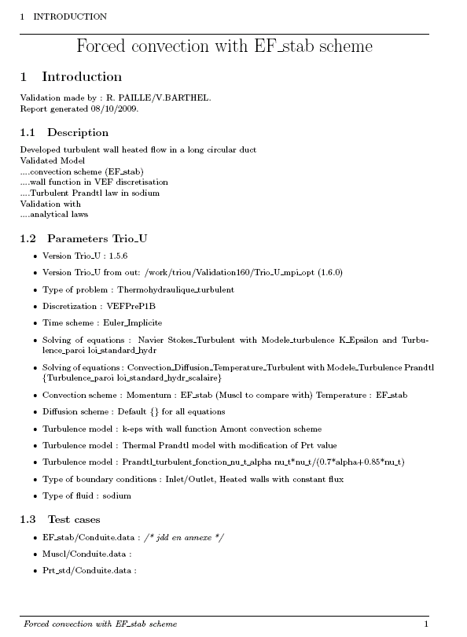
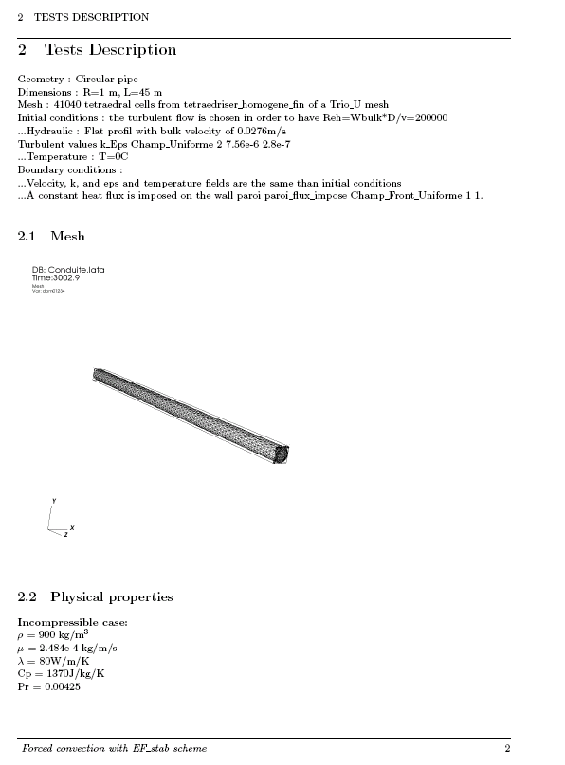
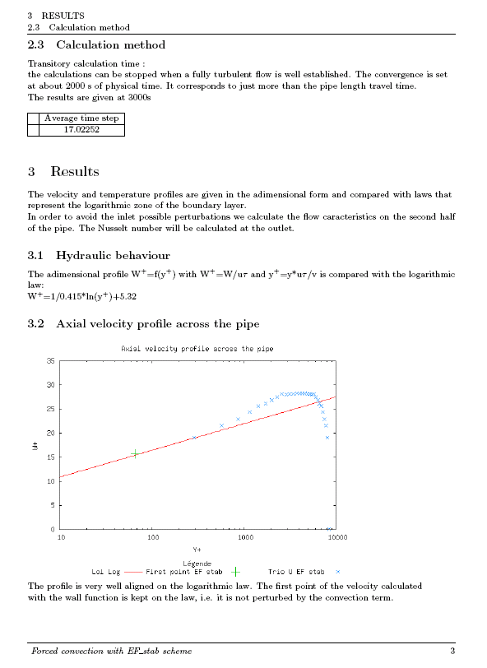
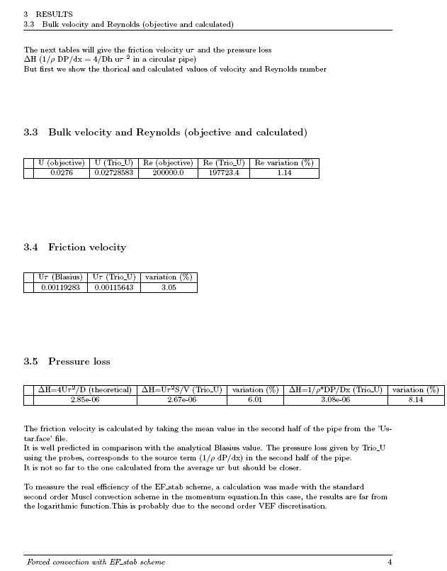
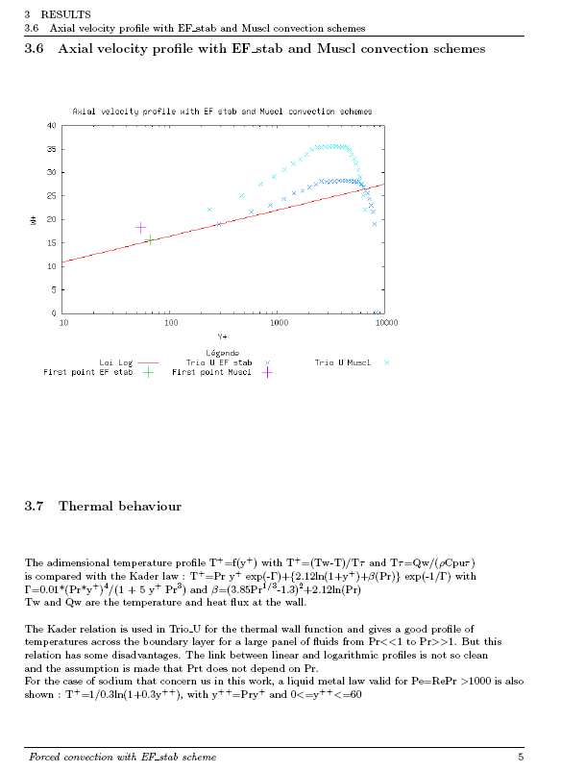
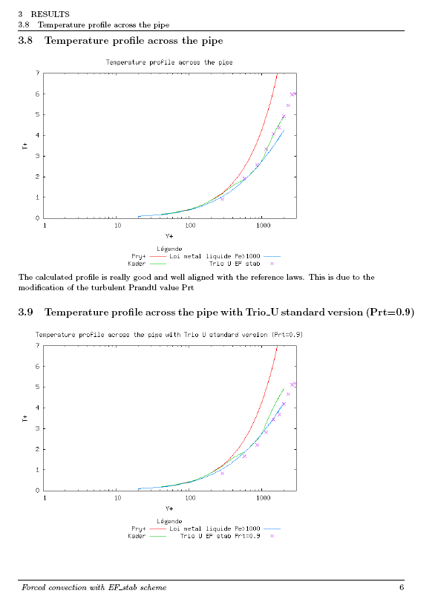
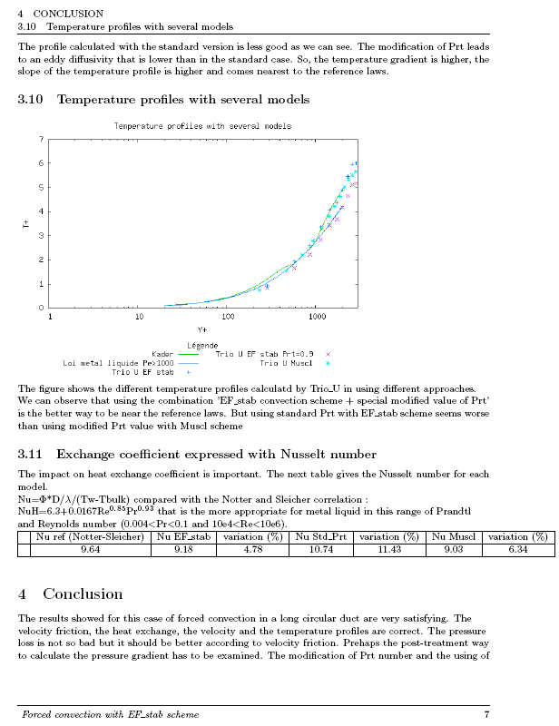
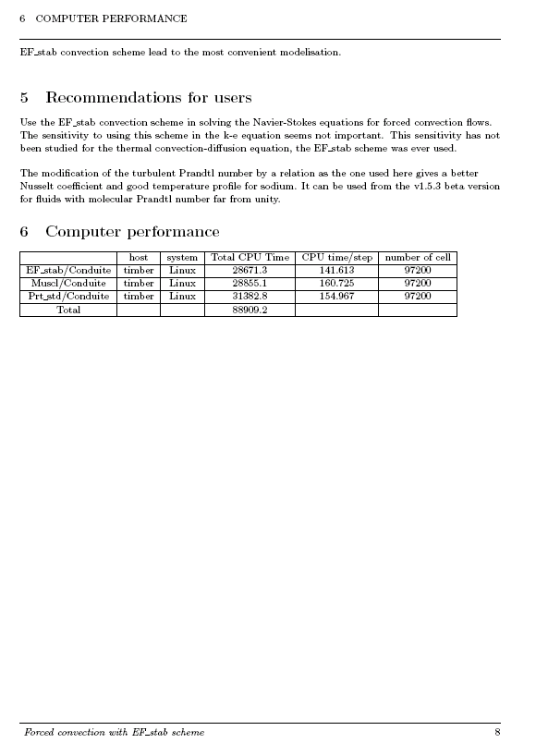
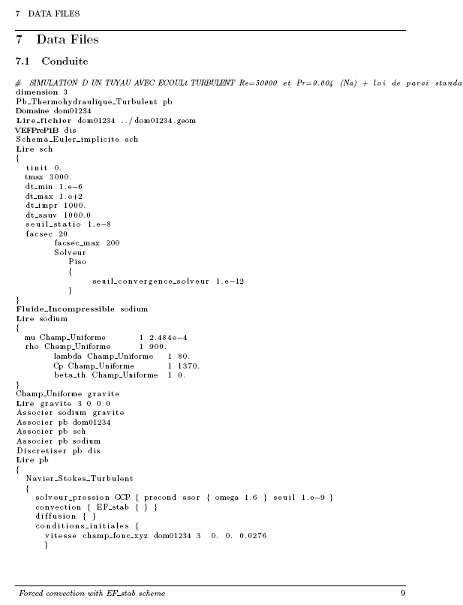
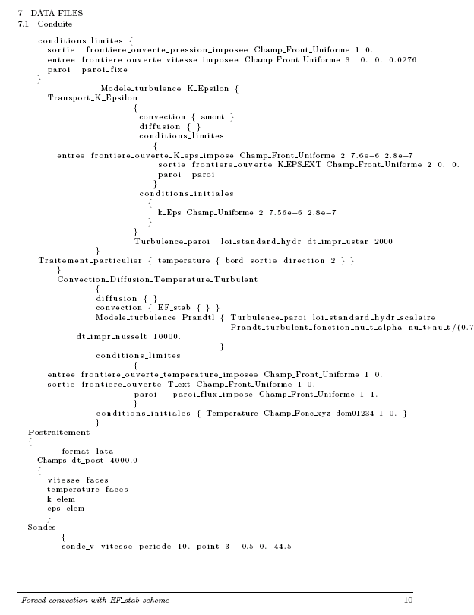
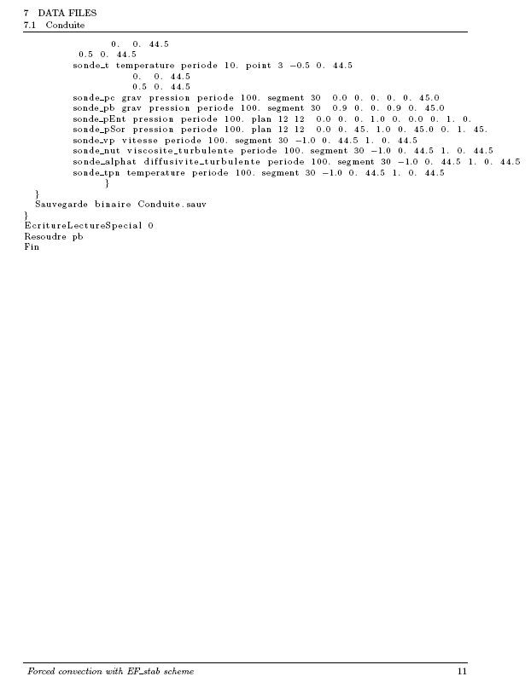

ANNEX 3

Example of a Validation file for LES model

Bi-periodic Channel Flow at low Reynolds number (Reτ = 395)

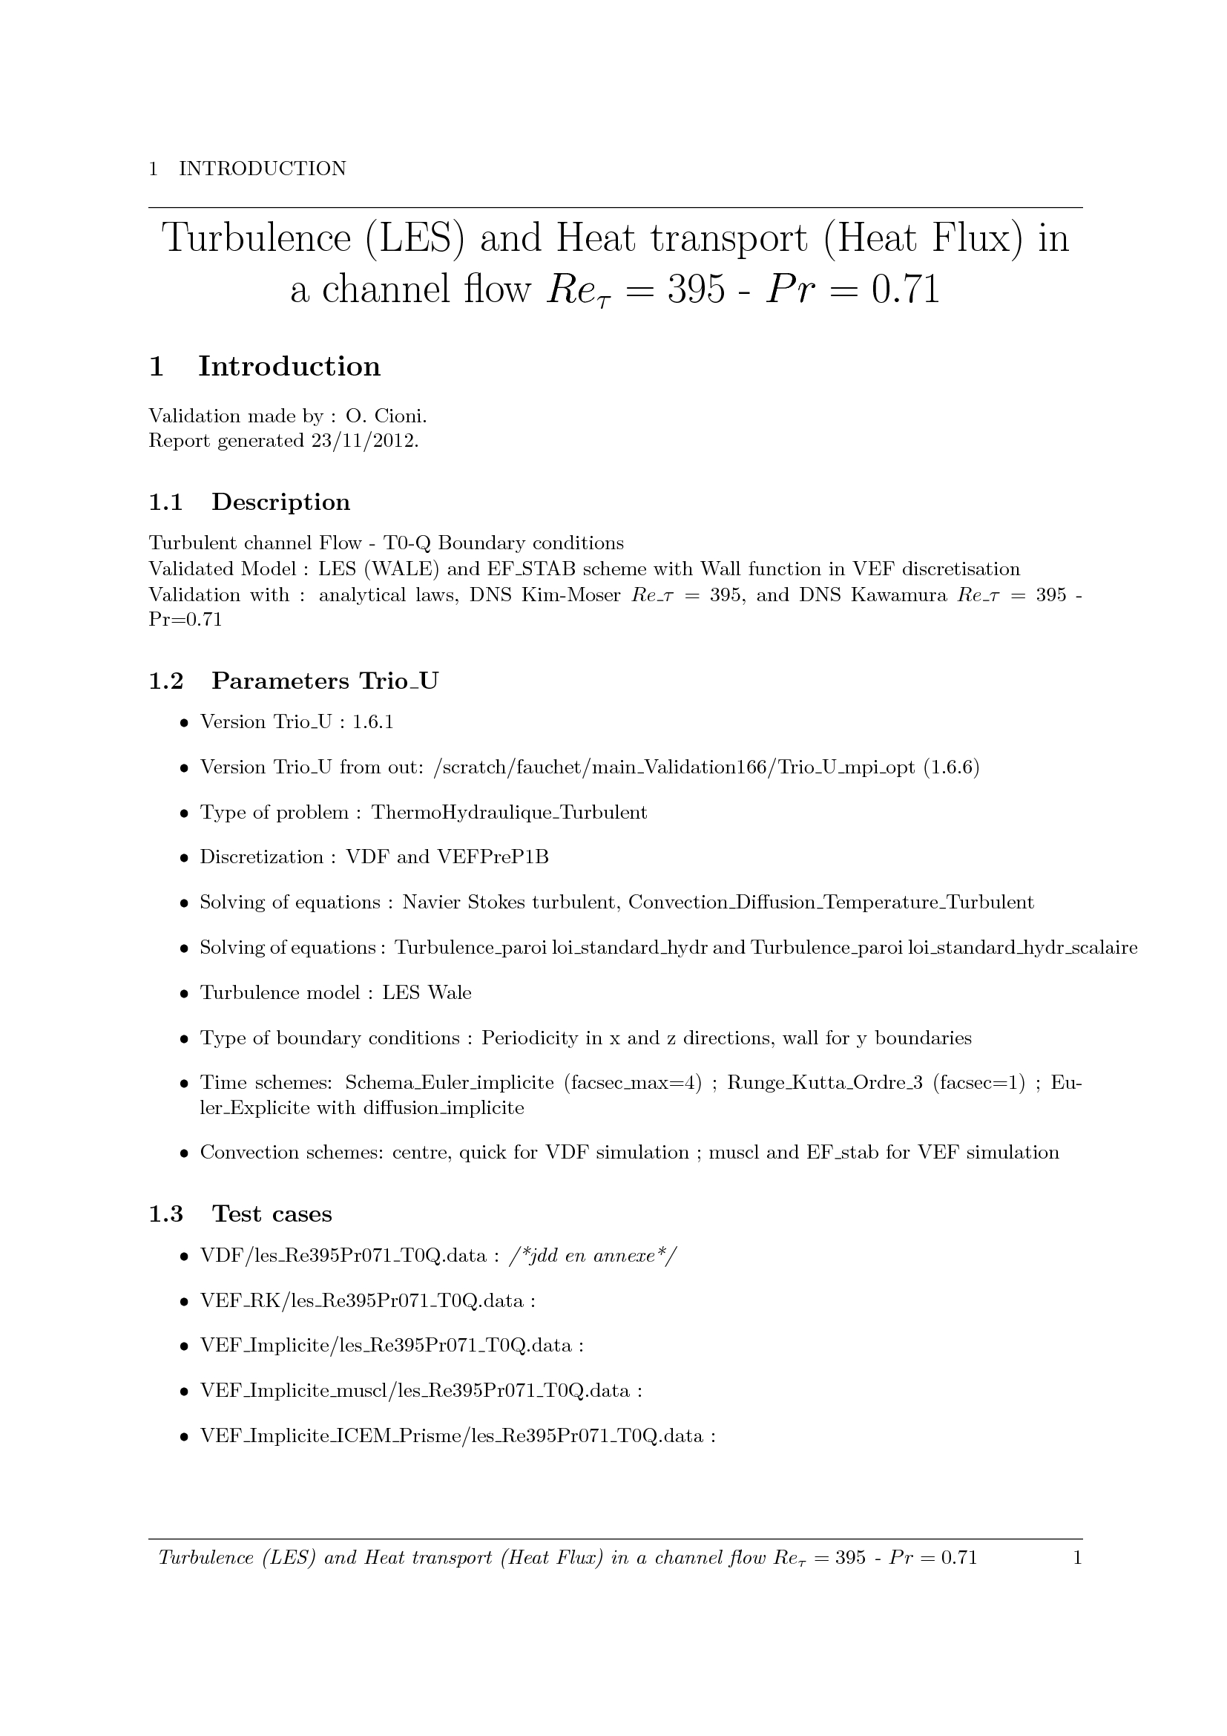
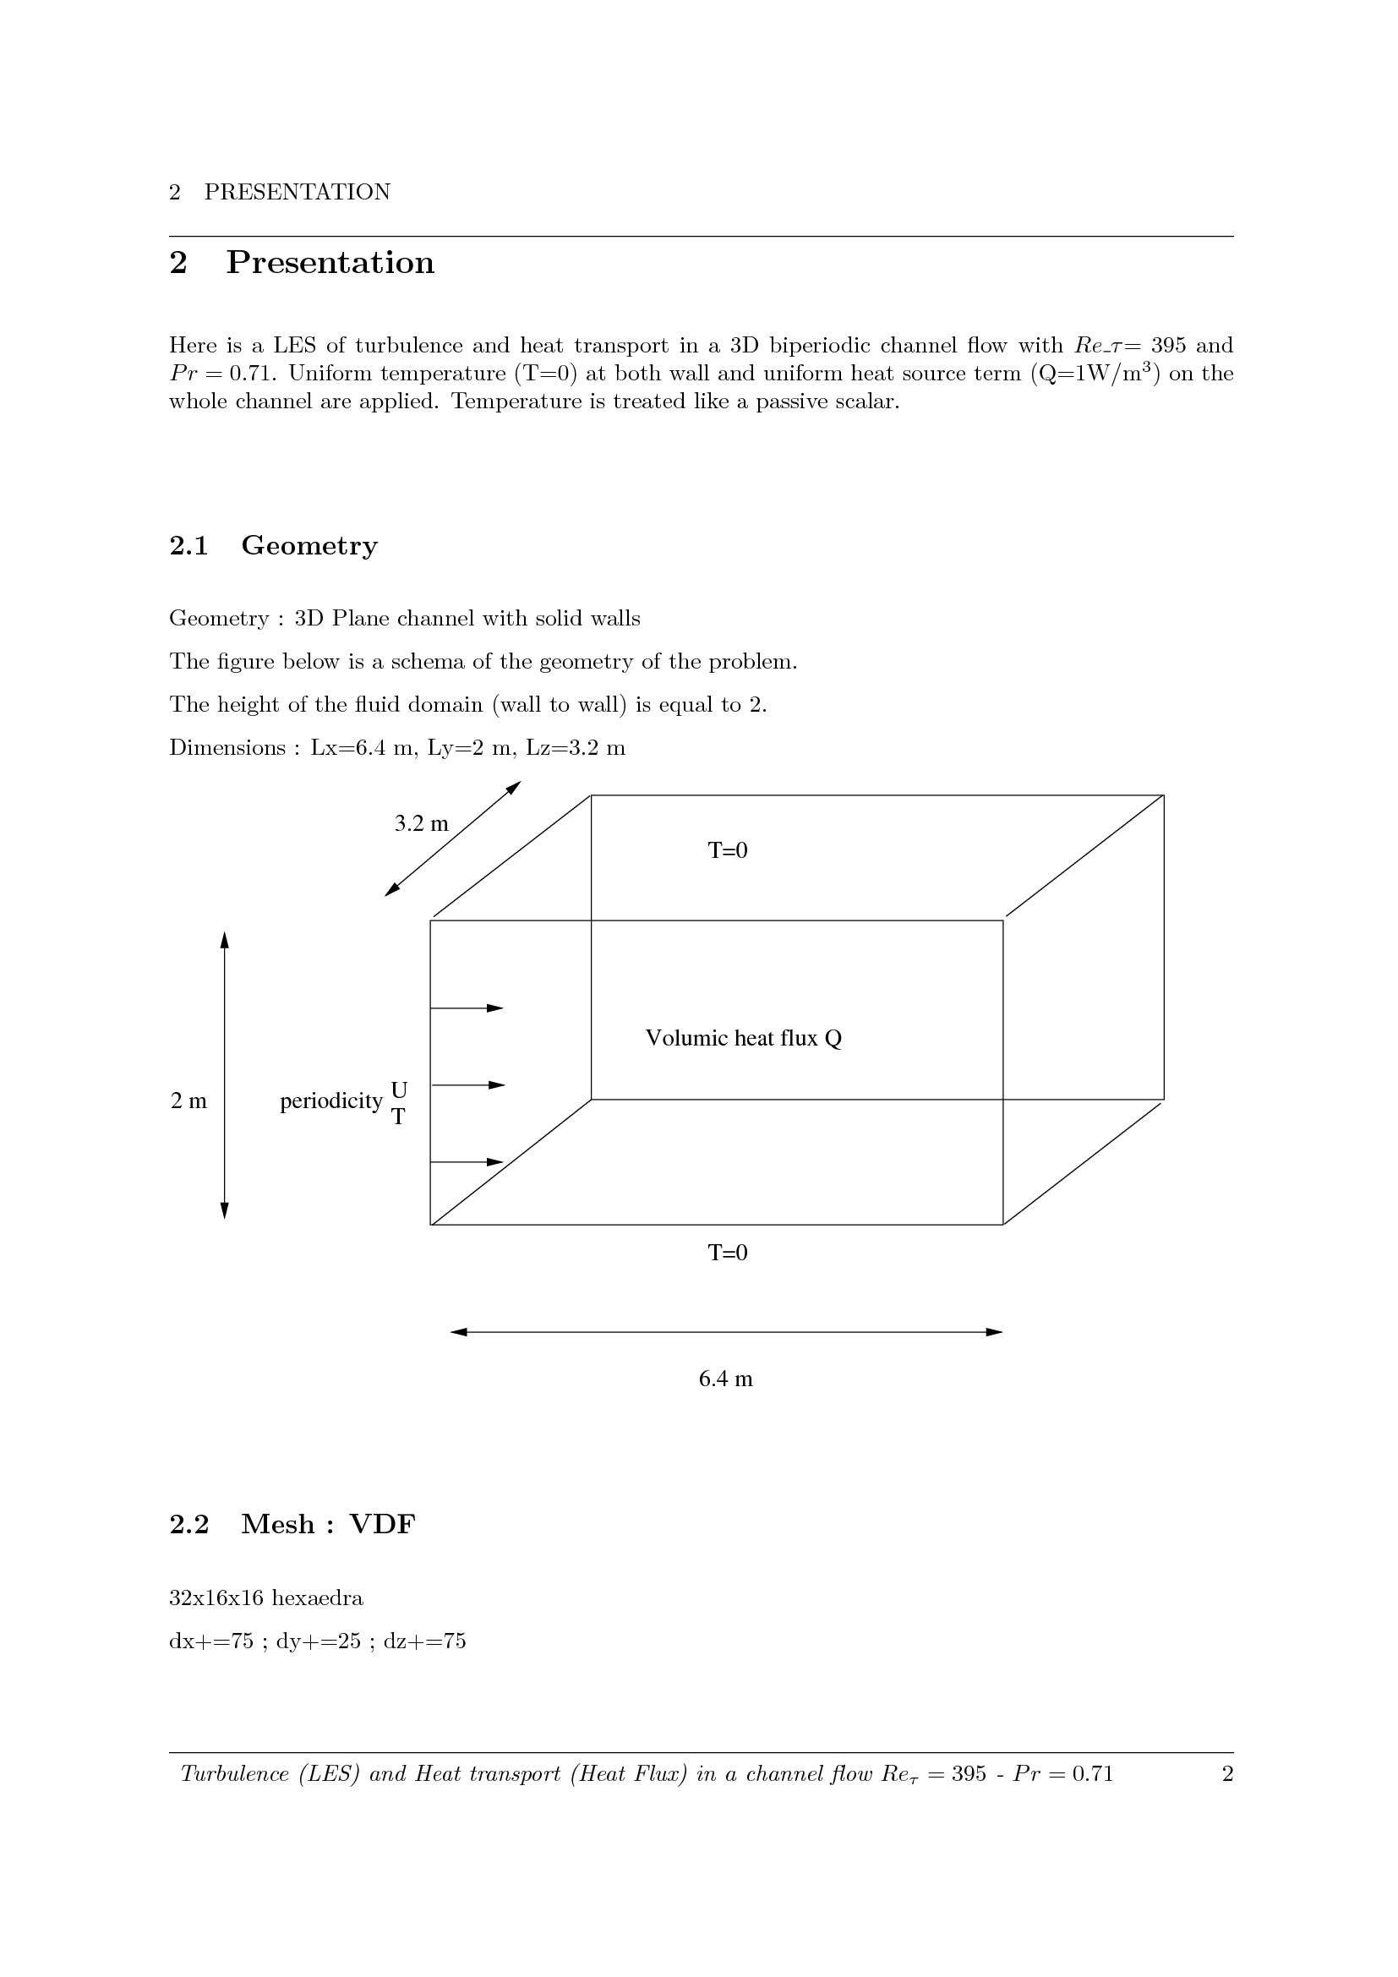
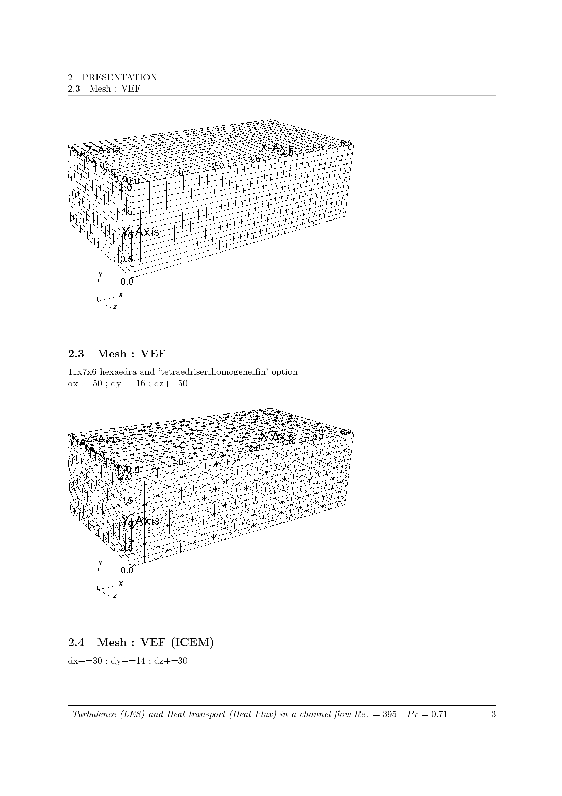
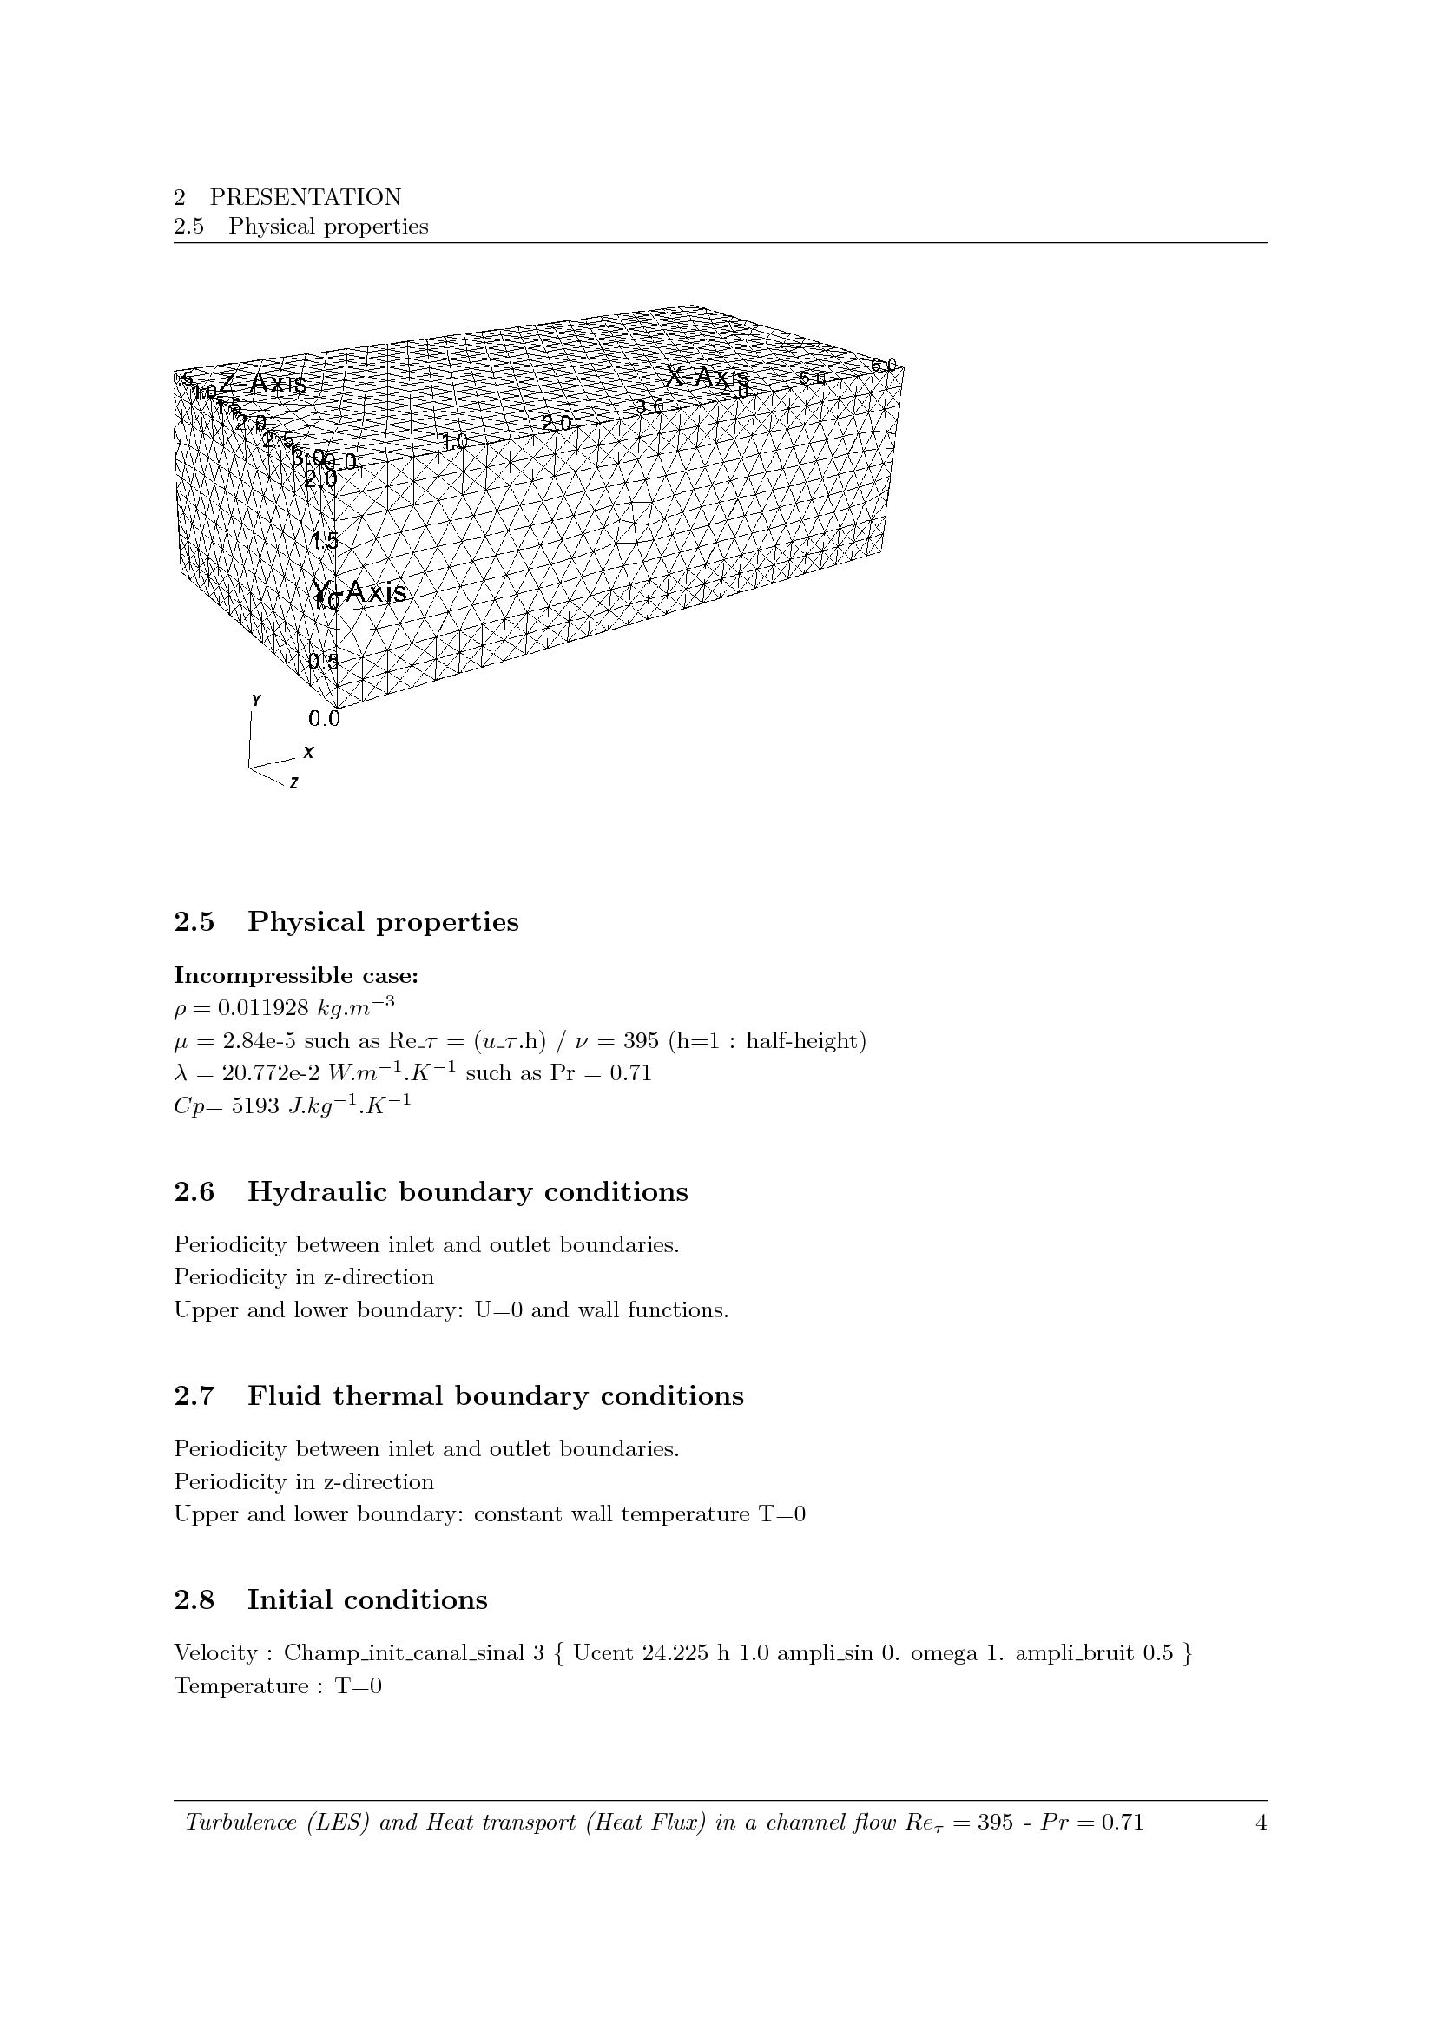
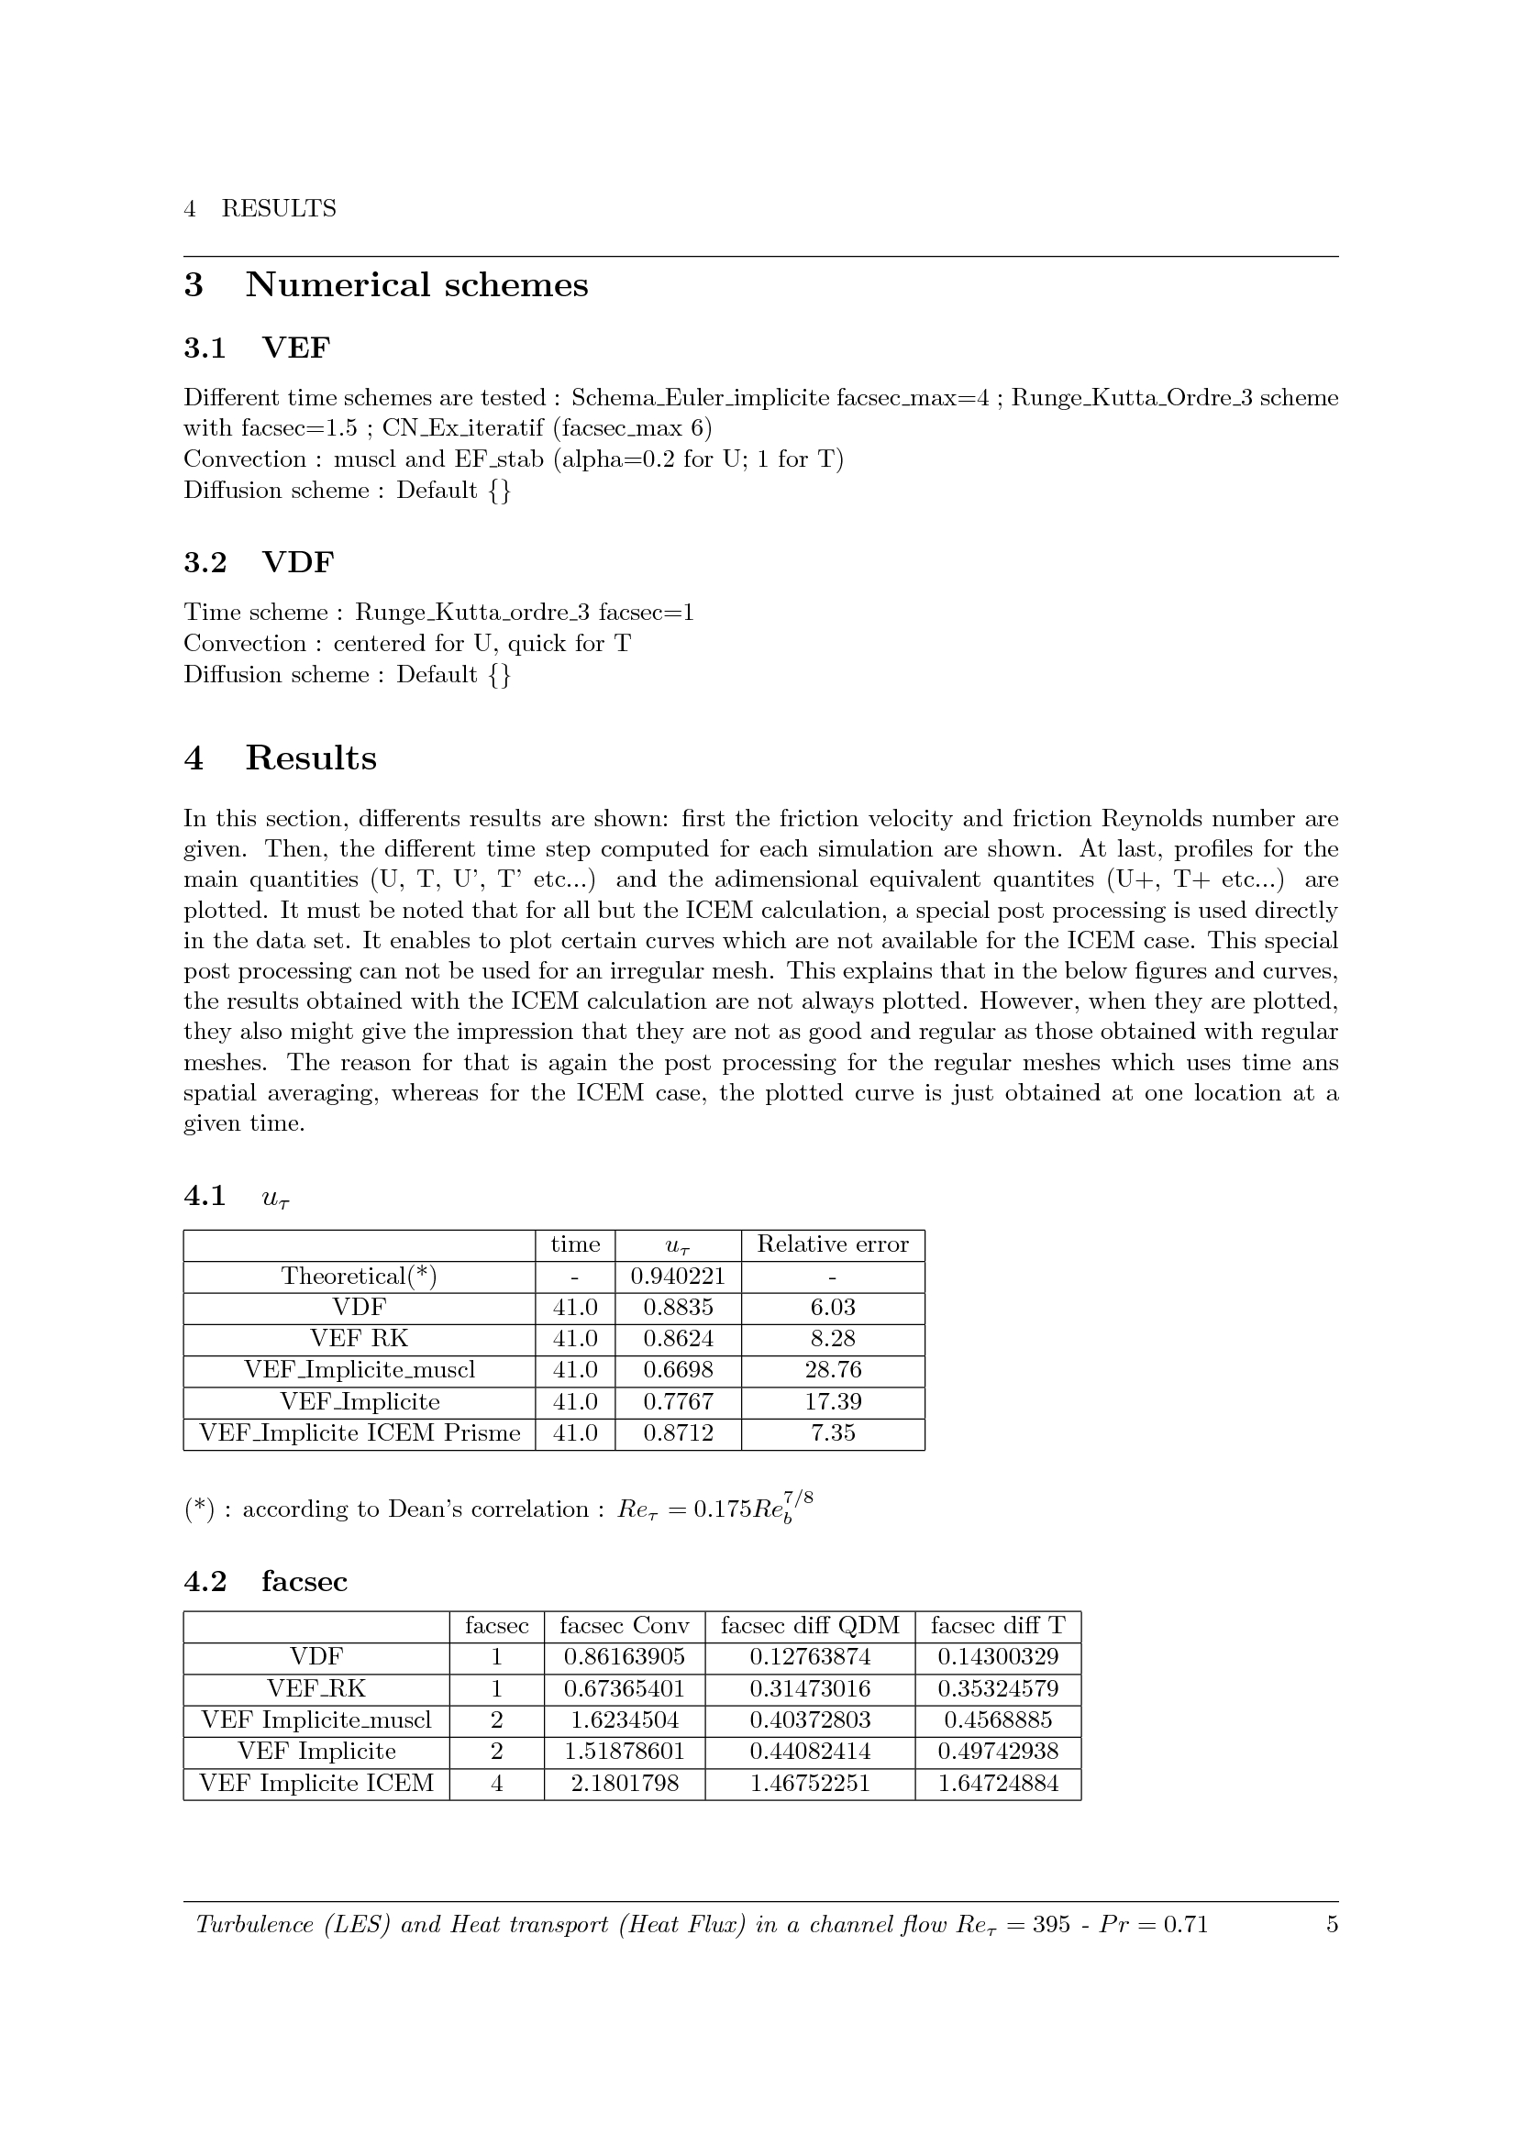
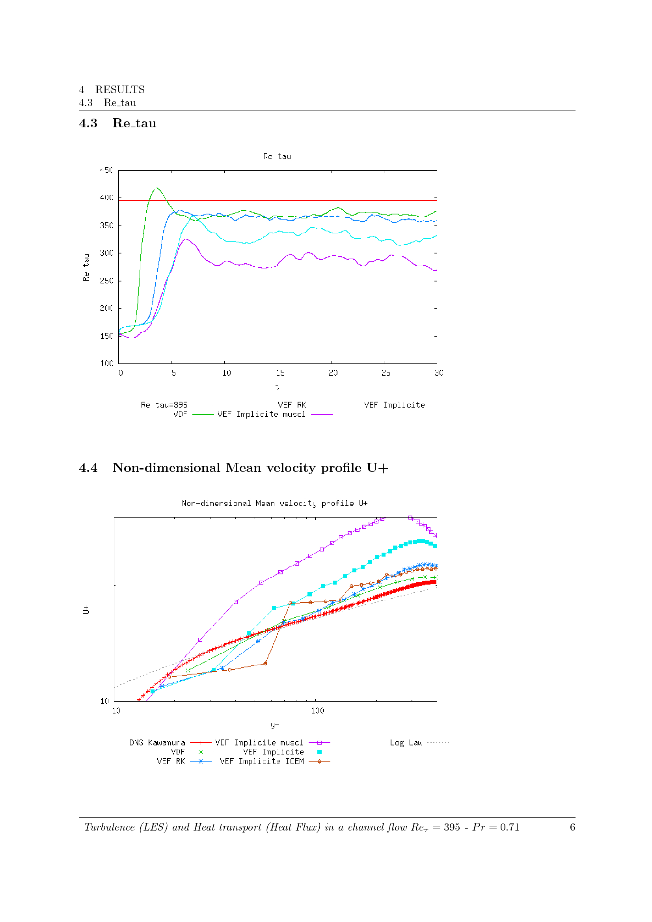
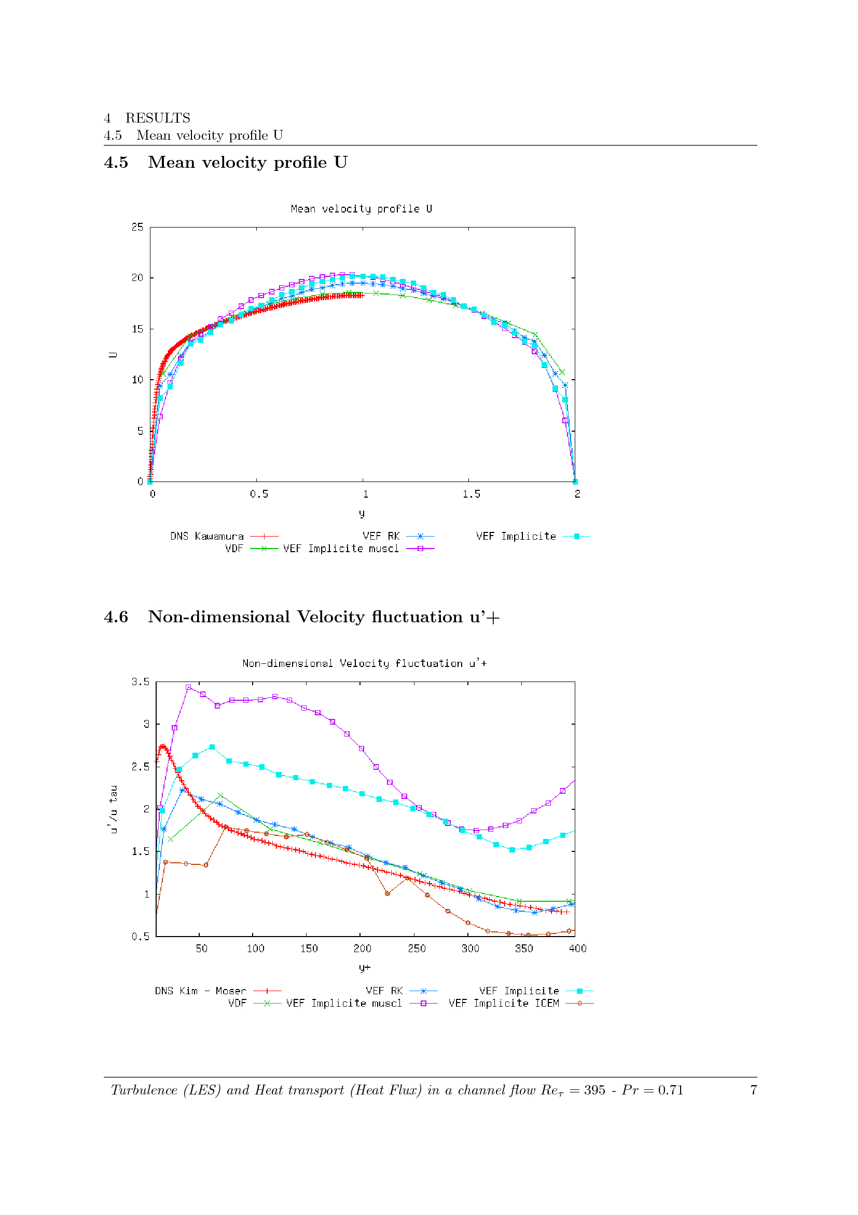
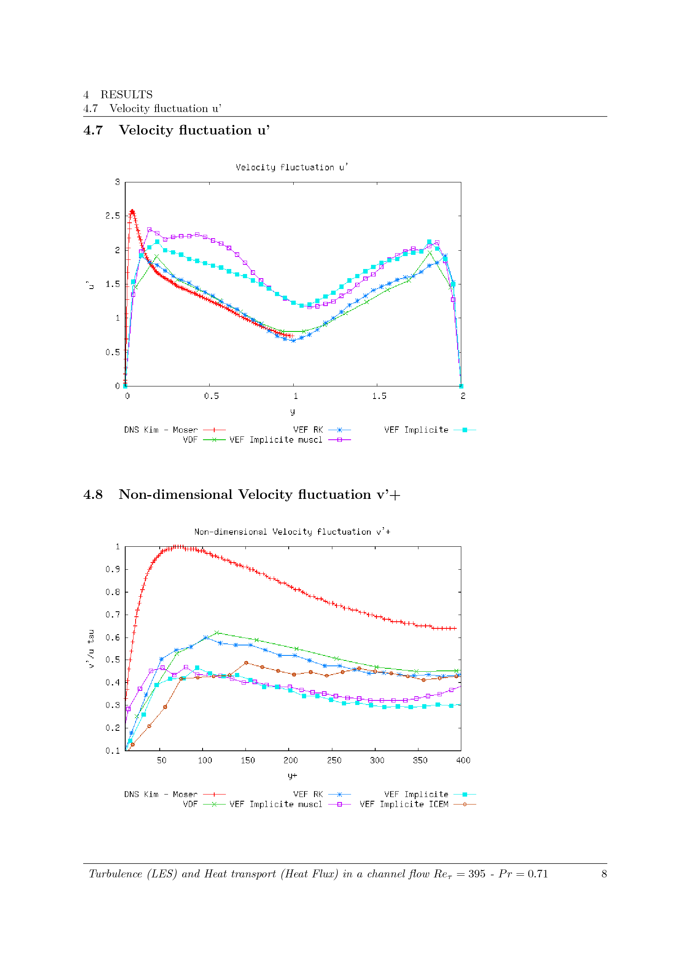
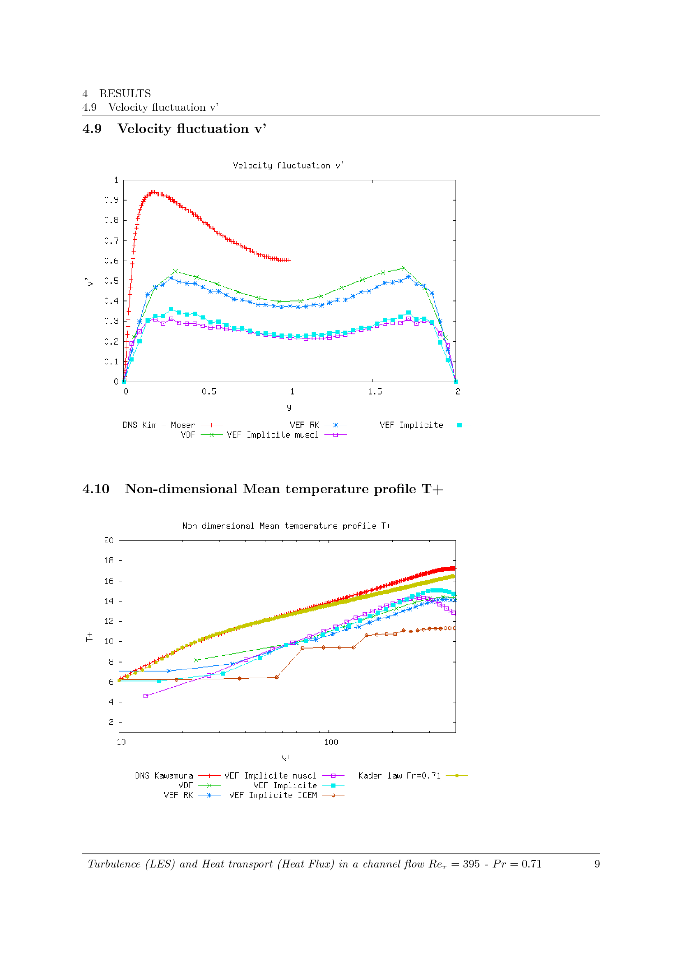
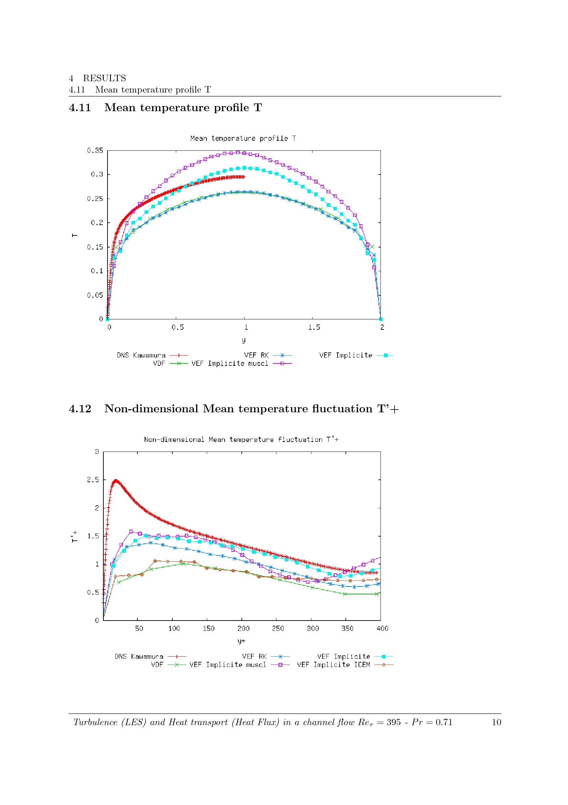
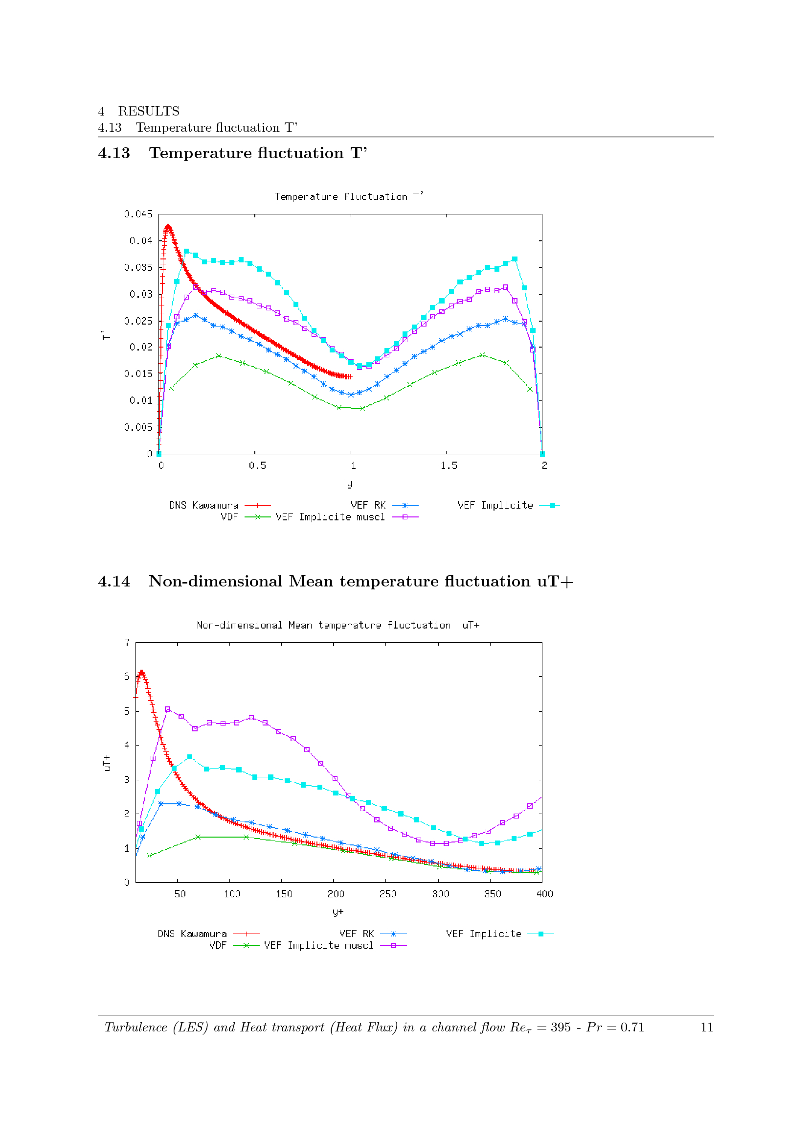
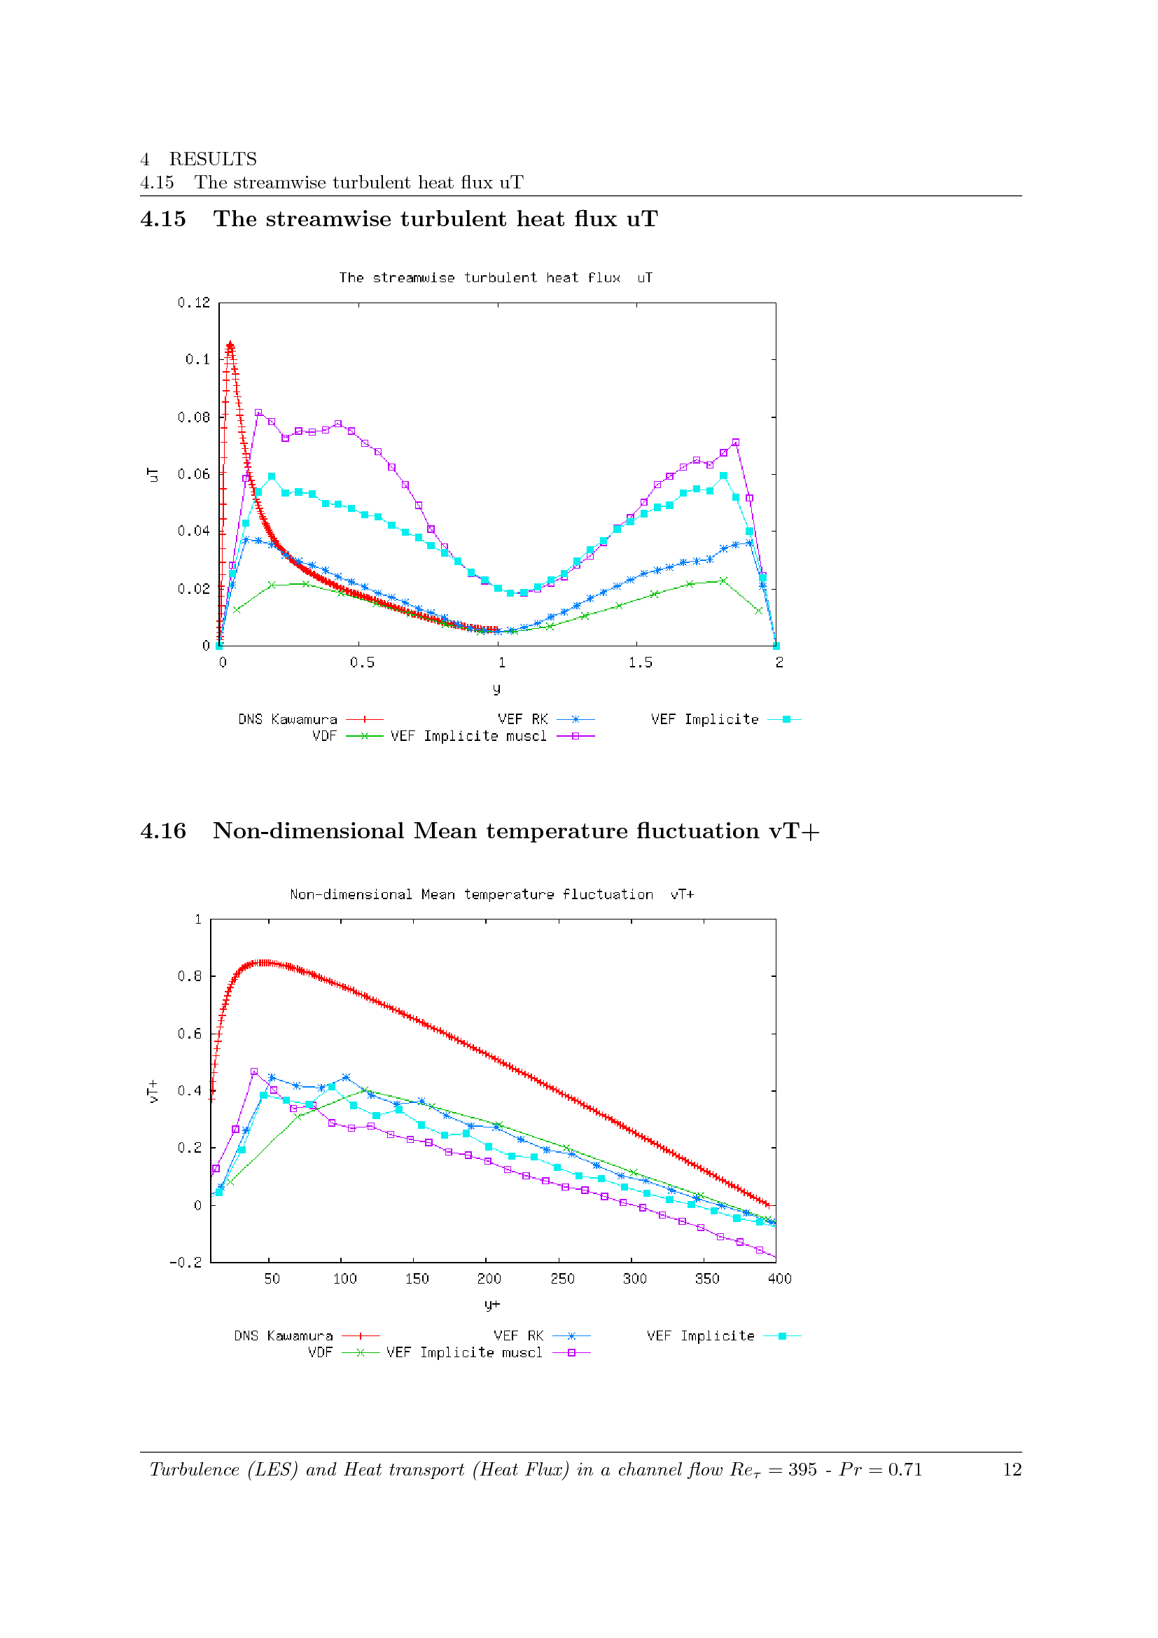
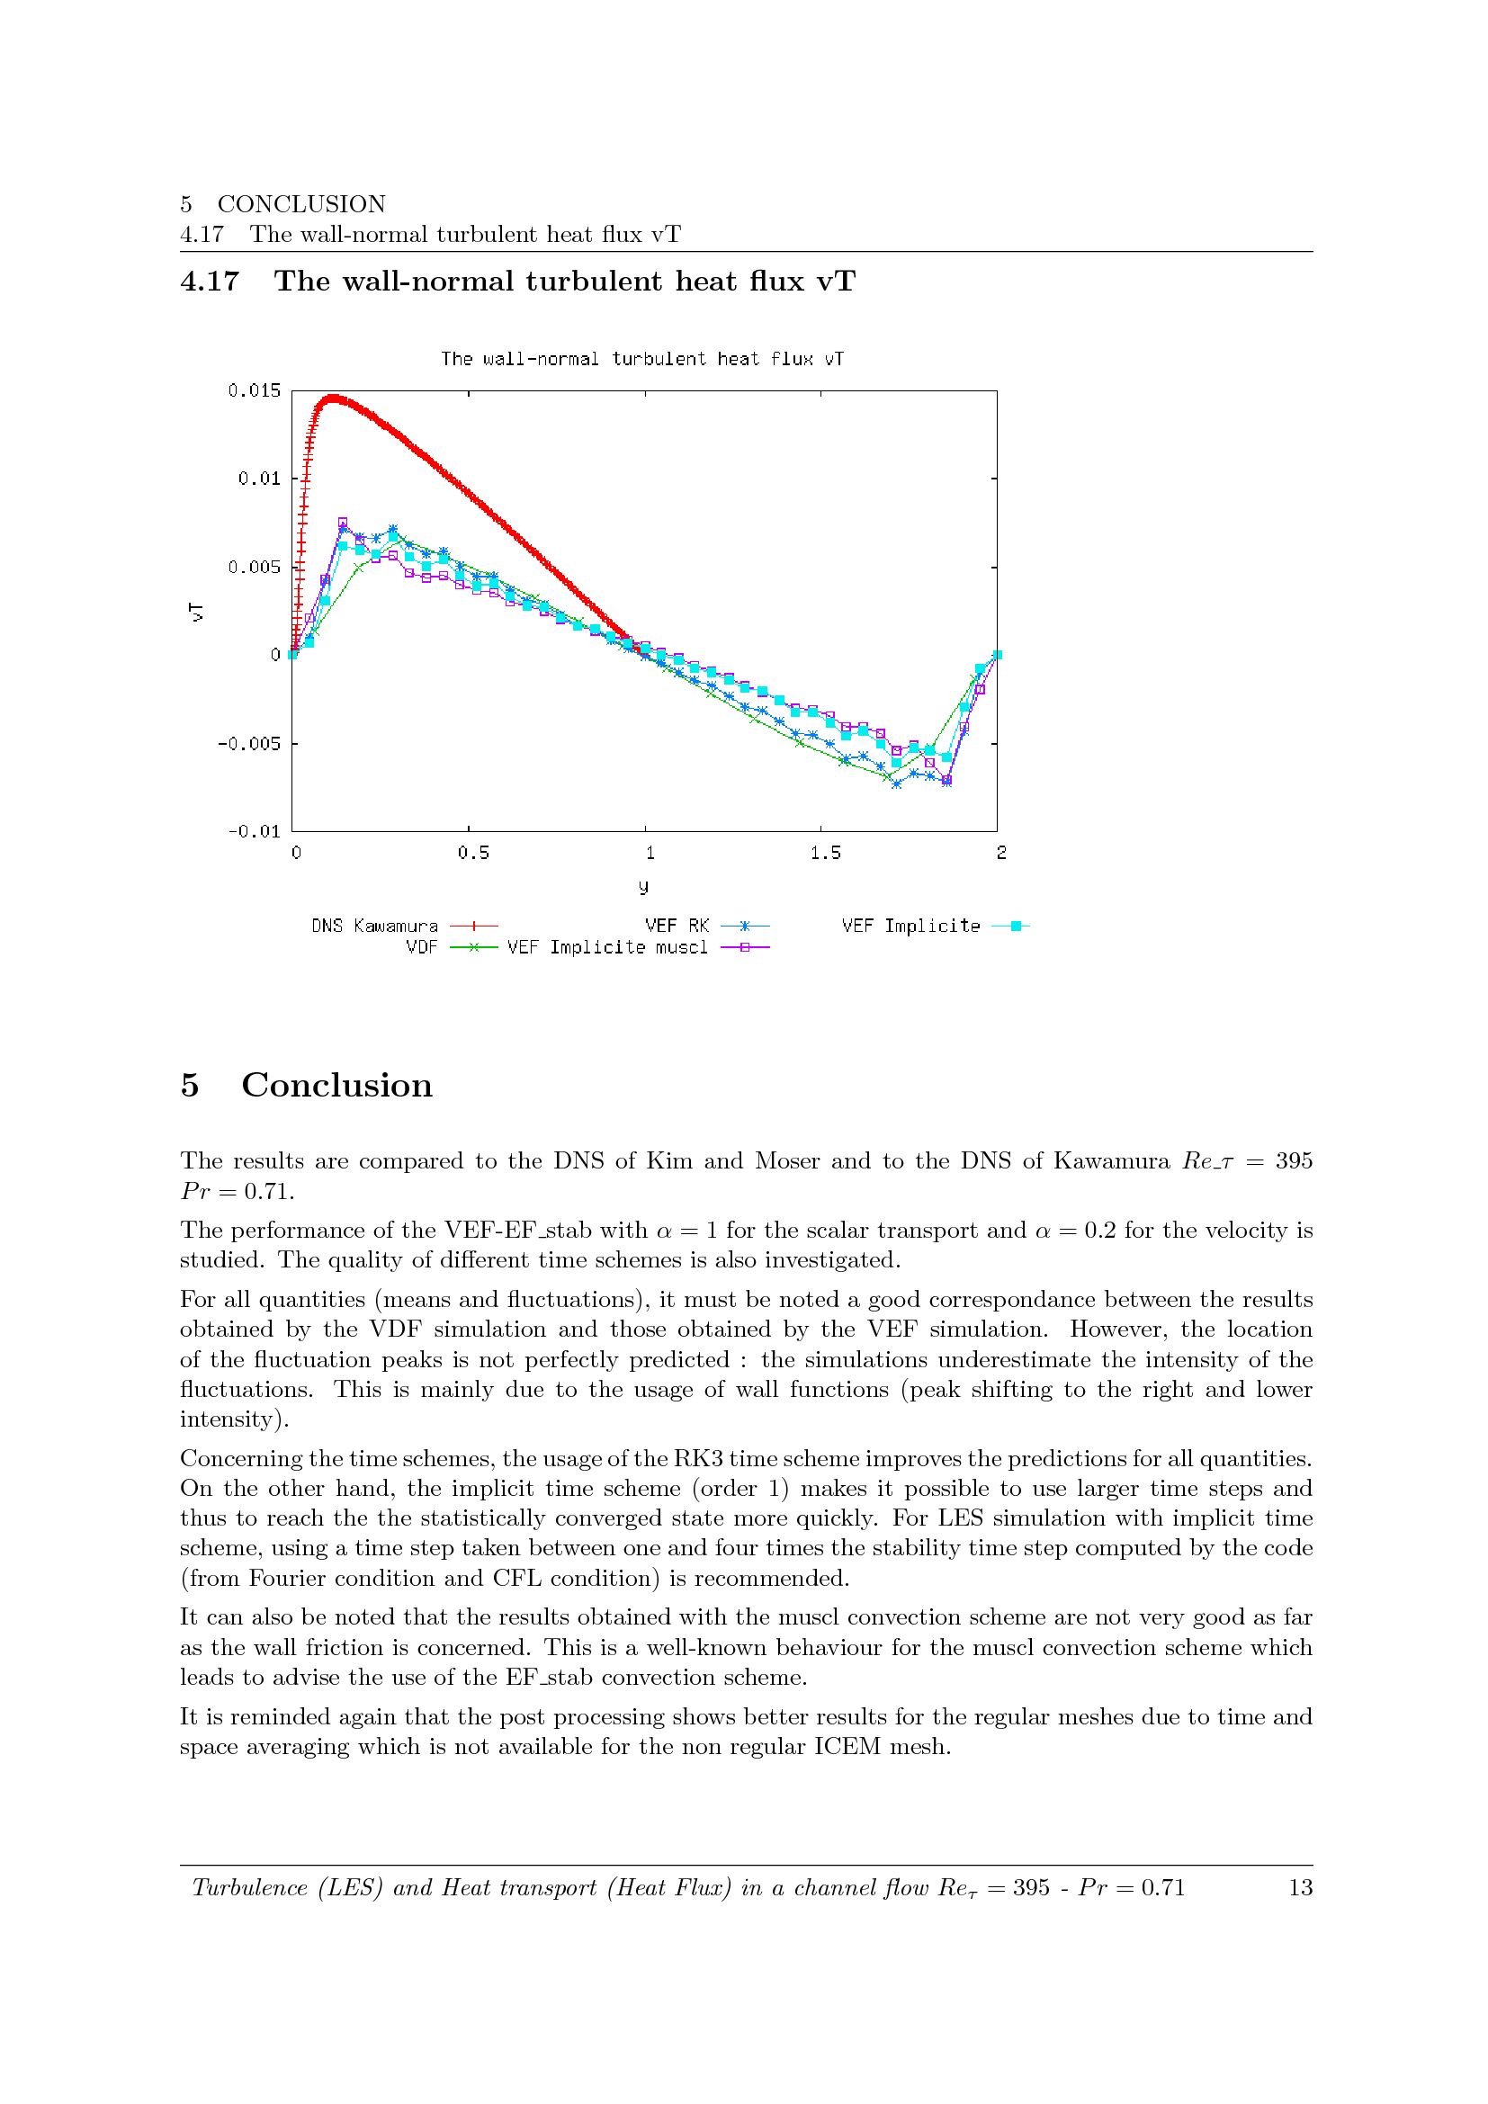
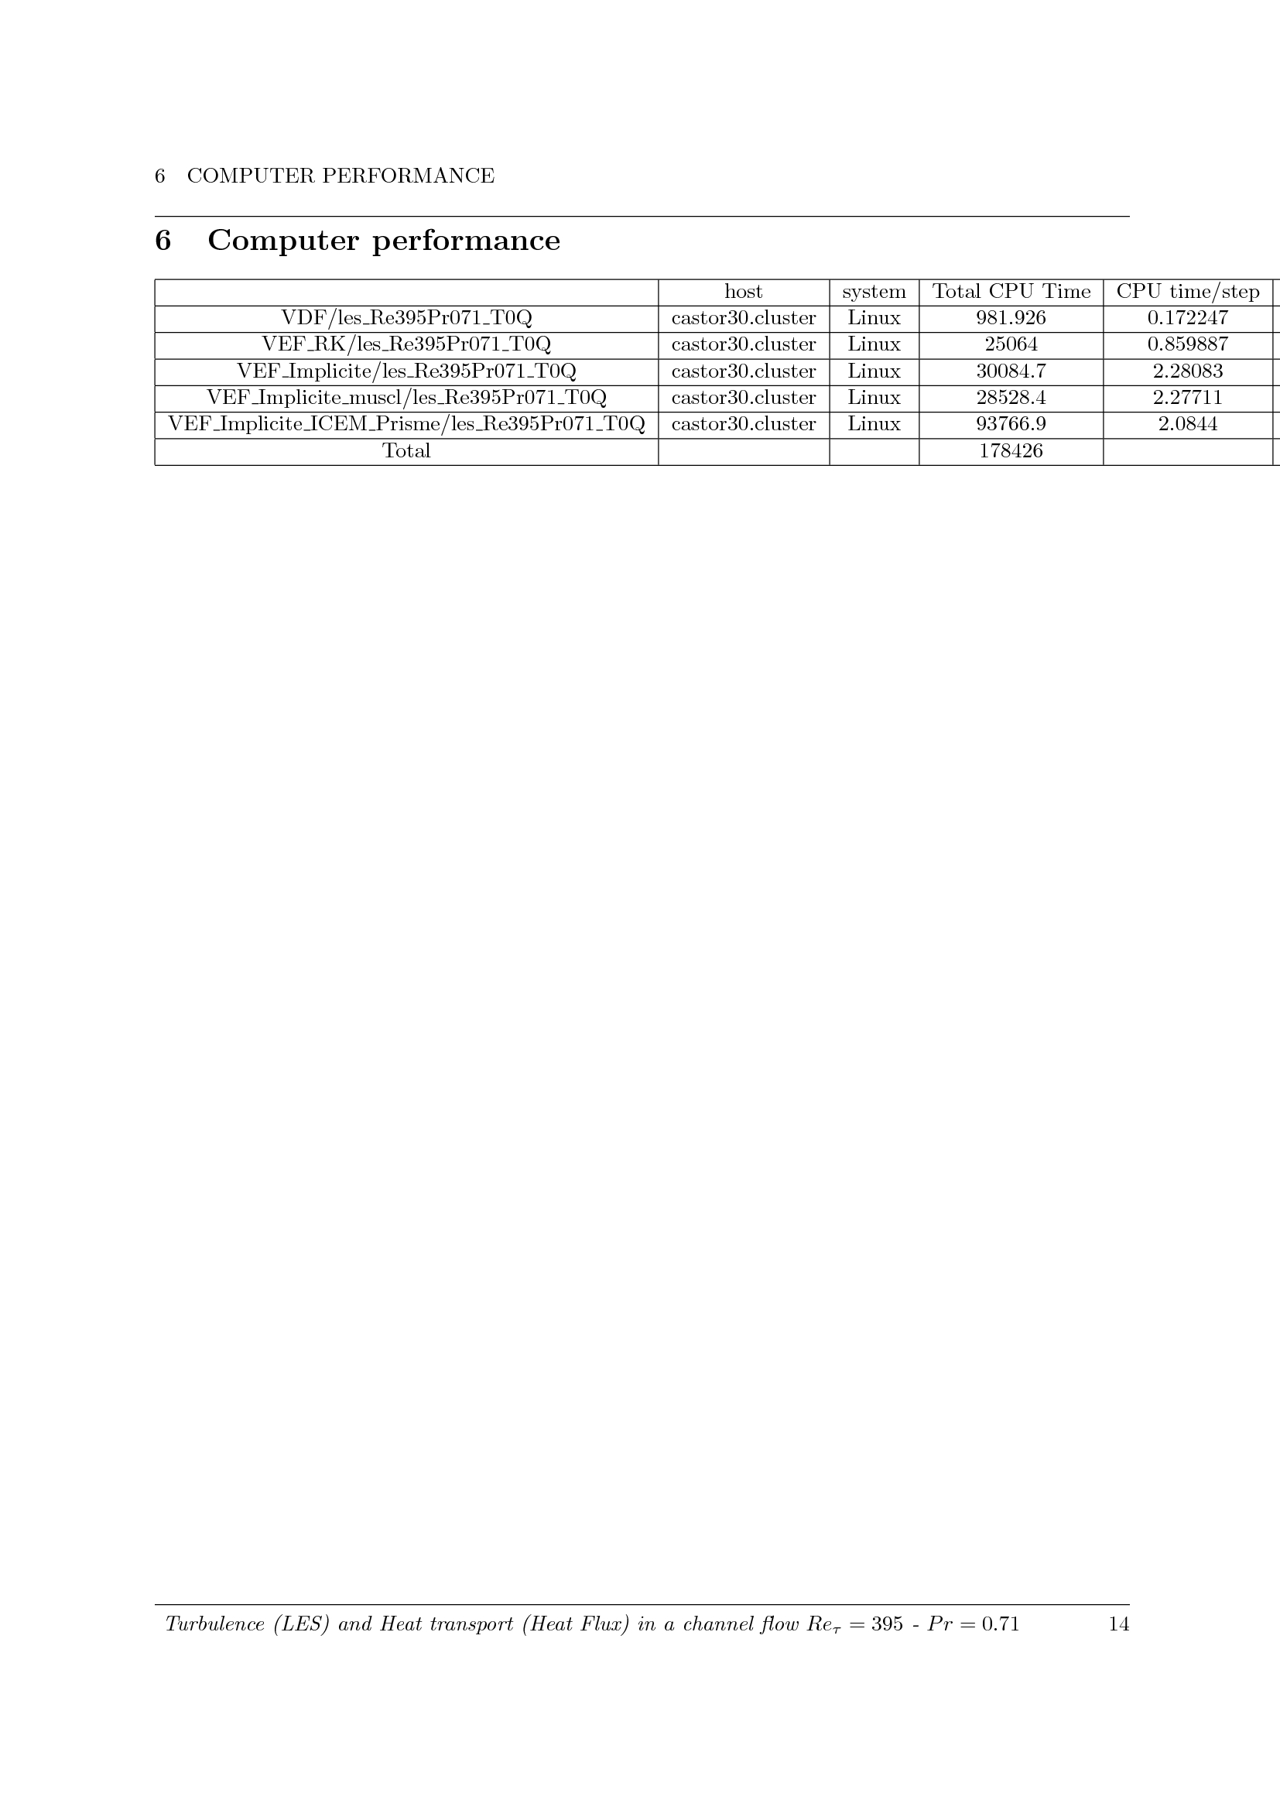
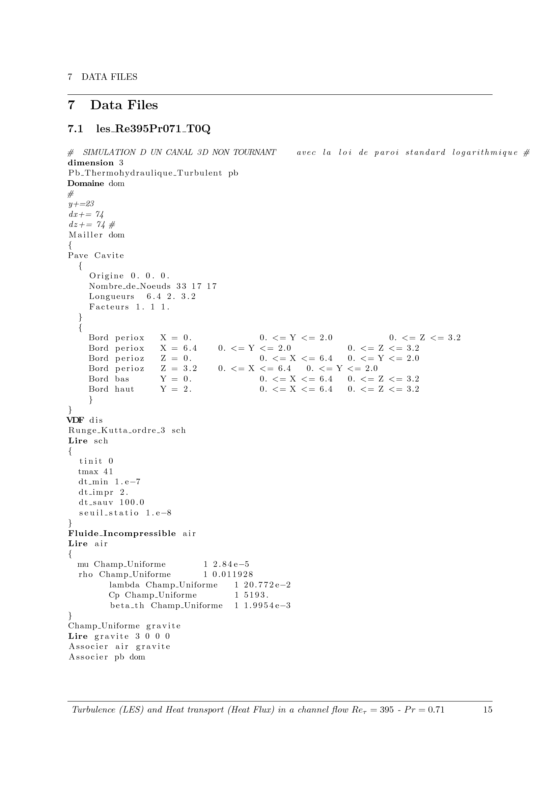
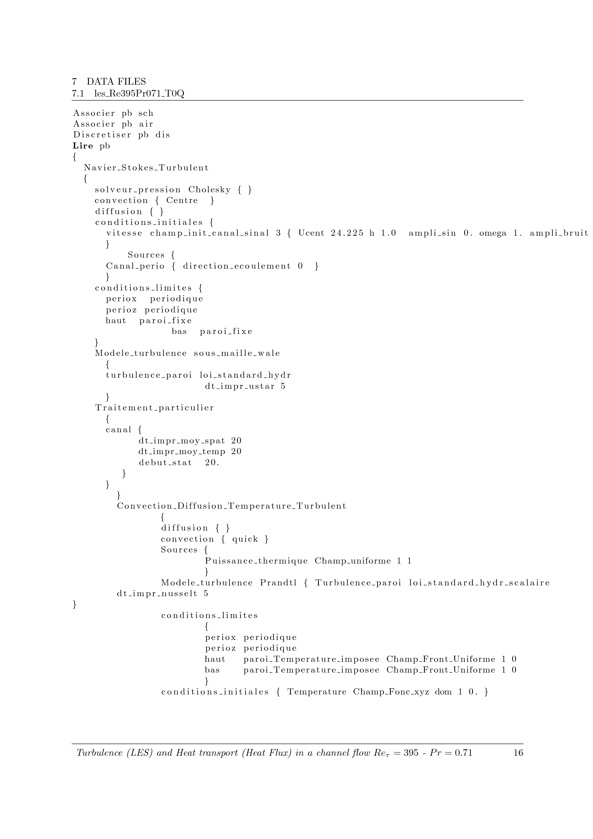
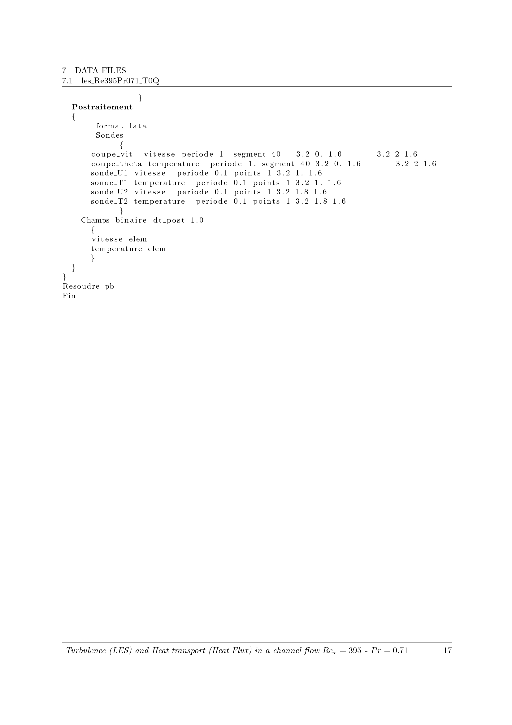

The VEF discretization means that the Navier-Stokes equations are solved on an unstructured mesh by Finite Element Volume method. Since several discretizations are possible, the default one is the “P1NC/P1-Buble” one.

