Brown Dog NCHC Site Installation

Clowder http://brown-dog.nchc.org.tw:9000/

Polyglot http://brown-dog.nchc.org.tw/service/polyglot/

RabbitMQ http://brown-dog.nchc.org.tw:15672/

Elasticsearch http://brown-dog.nchc.org.tw:9200/_plugin/head/

Reference
- https://clowder.ncsa.illinois.edu/docs/installation.html
- https://opensource.ncsa.illinois.edu/bitbucket/projects/CATS/repos/clowder/browse
- http://browndog.ncsa.illinois.edu/

NCSA demo site : https://clowder-dev.ncsa.illinois.edu/clowder/

Brown Dog Overview & Concept
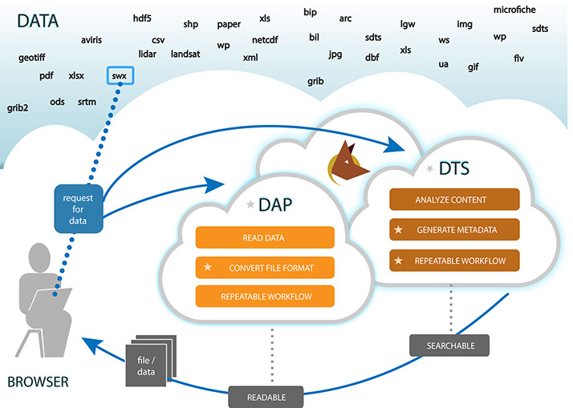
DAP - Data Access Proxy
The objective of the DAP is to make the Internet agnostic to file formats. The DAP could be seen as a DNS for data. It fills a similar role, but instead of serving up web pages it will serve up data.

Convert file format : Super Mutt of Software
Based on the source format and the target format that the user specifies, the proxy will send the request to a software server somewhere through a chain of applications that will run the conversion and seamlessly present the converted data back to the user

DTS - Data Tilling Service
The DTS will serve as a framework for storing and running analysis tools. These tools will be used to examine the contents of a file for the purpose of automatically creating metadata or numerical signatures capturing some aspect of the file’s contents.

Metadata Enables Searching
Think “keywords” or “tags” on an image. The purpose of this tool is to automatically generate some of that for data of all types. This metadata can then be used to index or search through the data, or enable some other form of analysis over the data.

Repeatable Workflow Proces
Because reproducibility is critical to scientific study, Brown Dog maintains a digital signature for each request for data that can be re-run to produce the same, exact results

Installation: DTS – Clowder

Reference
- https://clowder.ncsa.illinois.edu/docs/
- https://opensource.ncsa.illinois.edu/bitbucket/projects/CATS/repos/clowder/browse

- System environment :
  - Add group , service user , required packages
$ sudo groupadd ncsa
$ sudo adduser --disabled-password --gecos "Clowder service runner" --ingroup ncsa clowder
$ sudo adduser --disabled-password --gecos "Polyglot service runner" --ingroup ncsa ployglot

$ sudo apt-get install openjdk-7-jdk mongodb rabbitmq-server curl
$ sudo apt-get install scala

  - Add packages for extractors
$ sudo apt-get install python-setuptools
$ sudo easy_install pip
$ sudo pip install pika requests

- Packages version check
$ mongod --version
db version v2.4.10
Fri Jan 29 17:10:19.191 git version: nogitversion

$ sudo netstat -tlpn | grep 27017
tcp 0 0 127.0.0.1:27017 0.0.0.0:* LISTEN 22920/mongod

$ java -version
java version "1.7.0_111"
OpenJDK Runtime Environment (IcedTea 2.6.7) (7u111-2.6.7-2~deb8u1)
OpenJDK 64-Bit Server VM (build 24.111-b01, mixed mode)

$ sudo rabbitmqctl status
Status of node 'rabbit@jessie-amd64' ...
[{pid,9005},
{running_applications,[{rabbit,"RabbitMQ","3.3.5"},

# list rabbitmq-plugins
$ sudo rabbitmq-plugins list
$ sudo rabbitmq-plugins list
[e] amqp_client 3.3.5
[ ] cowboy 0.5.0-rmq3.3.5-git4b93c2d
[ ] eldap 3.3.5-gite309de4
[e] mochiweb 2.7.0-rmq3.3.5-git680dba8
[ ] rabbitmq_amqp1_0 3.3.5
[ ] rabbitmq_auth_backend_ldap 3.3.5
[ ] rabbitmq_auth_mechanism_ssl 3.3.5
[ ] rabbitmq_consistent_hash_exchange 3.3.5
[ ] rabbitmq_federation 3.3.5
[ ] rabbitmq_federation_management 3.3.5
[E] rabbitmq_management 3.3.5
[e] rabbitmq_management_agent 3.3.5
[ ] rabbitmq_management_visualiser 3.3.5
[ ] rabbitmq_mqtt 3.3.5
[ ] rabbitmq_shovel 3.3.5
[ ] rabbitmq_shovel_management 3.3.5
[ ] rabbitmq_stomp 3.3.5
[ ] rabbitmq_test 3.3.5
[ ] rabbitmq_tracing 3.3.5
[e] rabbitmq_web_dispatch 3.3.5
[ ] rabbitmq_web_stomp 3.3.5
[ ] rabbitmq_web_stomp_examples 3.3.5
[ ] sockjs 0.3.4-rmq3.3.5-git3132eb9
[e] webmachine 1.10.3-rmq3.3.5-gite9359c7

# enable rabbitmq_management
$ sudo rabbitmq-plugins enable rabbitmq_management

# restart rabbitmq
$ sudo systemctl restart rabbitmq-server.service

# check management
$ sudo netstat -tlpn | grep 15672
[sudo] password for ceasar:
tcp 0 0 0.0.0.0:15672 0.0.0.0:* LISTEN 41548/beam.smp
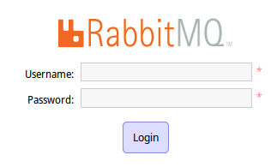
Web UI check :
http://localhost:15672/
Accout/PW: guest / guest (Only allowed in localhost)

# Edit for Clowder configuration:
# base path : ~/clowder/ , e.g: /op/clowder-1.0.0

# enable in ~/conf/application.conf
clowder.rabbitmq.managmentPort=15672

# enable in play.plugins
9992:services.RabbitmqPlugi

# service log checking :
$ sudo tail -f /var/log/rabbitmq/rabbit@brown-dog.log

- MonDB web management tool: RockMongo
  - Installation:
Download : https://github.com/iwind/rockmongo/releases
$ wget https://github.com/iwind/rockmongo/archive/1.1.7.tar.gz
$ sudo tar xzvf 1.1.7.tar.gz -C /var/www/html && sudo mv /var/www/html/rockmongo-1.1.7 /var/www/html/rockmongo
$ sudo apt-get install php5-mongo ; sudo systemctl restart apache2.service

  - 變更管理認証與帳號
- http://localhost/rockmongo/ 使用 admin/admin 登入
- 新增帳號：Databases » admin » More » Authentication ：Add User
- 停用 Rockmongo 自身認証，改為 mongodb 內部認証：
$ vi ~/rockmongo/config.php
$MONGO["servers"][$i]["control_auth"] = true
$ sudo systemctl restart apache2.service

- Fix for : MongoDB start error in a small filesystem
$ sudo service mongodb start|status
# Sat Jan 30 09:10:24.356 [initandlisten] ERROR: Insufficient free space for journal files
# Sat Jan 30 09:10:24.356 [initandlisten] Please make at least 3379MB available in /var/lib/mongodb/journal or use --smallfiles

  - Solution :
    - Ref : http://okomestudio.net/biboroku/?p=2468
# Edit : mongodb.conf
smallfiles=true
Noe:
A good refernece for MongoDB :
- https://docs.mongodb.org/ecosystem/tools/http-interfaces/

- Elasticsearch
  - Install
$ wget -qO - https://packages.elastic.co/GPG-KEY-elasticsearch | sudo apt-key add -
$ echo "deb http://packages.elastic.co/elasticsearch/2.x/debian stable main" | sudo tee -a /etc/apt/sources.list.d/elasticsearch-2.x.list
$ sudo apt-get update && sudo apt-get install elasticsearch

  - Enable and start service
$ sudo systemctl enable elasticsearch.service
$ sudo systemctl start elasticsearch.service
$ sudo systemctl status elasticsearch.service
● elasticsearch.service - Elasticsearch
Loaded: loaded (/usr/lib/systemd/system/elasticsearch.service; enabled)
Active: active (running) since 一 2016-02-01 15:32:42 CST; 1s ago
Docs: http://www.elastic.co
Process: 4326 ExecStartPre=/usr/share/elasticsearch/bin/elasticsearch-systemd-pre-exec (code=exited, status=0/SUCCESS)
Main PID: 4328 (java)
CGroup: /system.slice/elasticsearch.service
└─4328 /usr/bin/java -Xms256m -Xmx1g -Djava.awt.headless=true -XX:+UseParNewGC -XX:+UseConcMarkSwee.

  - Service check
$ curl -XGET 'localhost:9200'
{
"name" : "Victor Strange",
"cluster_name" : "elasticsearch",
"version" : {
"number" : "2.1.1",
"build_hash" : "40e2c53a6b6c2972b3d13846e450e66f4375bd71",
"build_timestamp" : "2015-12-15T13:05:55Z",
"build_snapshot" : false,
"lucene_version" : "5.3.1"
},
"tagline" : "You Know, for Search"
}

# List installed plugins
$ sudo /usr/share/elasticsearch/bin/plugin list

# Install a plugin
$ sudo /usr/share/elasticsearch/bin/plugin install mobz/elasticsearch-head

# /etc/elasticsearch/elasticsearch.yml for outside and inside accessible
network.host: ["127.0.0.1", "_eth0_", "[::1]"]
$ sudo systemctl restart elasticsearch.service

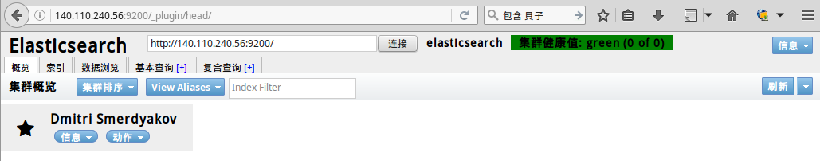
# Edit for Clowder configuration:
# base path : ~/clowder/ , e.g: /op/clowder-1.0.0

# For Clowder
# enable in ~clowder/conf/application.conf
elasticsearchSettings.clusterName="clowder"
elasticsearchSettings.serverAddress="localhost"
elasticsearchSettings.serverPort=9300

# enable in ~clowder/conf/play.plugins
10700:services.ElasticsearchPlugin

- Clowder
  - Stable: use clowder-1.0.0.zip
  - Download :
https://opensource.ncsa.illinois.edu/projects/artifacts.php?key=CATS

  - Install :
$ sudo chown -R clowder.ncsa ~[clowder-path]/

  - Star service [test mode]:
~[clowder-path]/bin/clowder

** Star Clowder service in systemd :

# Clowder service for systemd
# File : /etc/systemd/system/clowder.service
# Usage : systemctl daemon-reload; systemctl enable clowder.service
# Author : Ceasar Sun

[Unit]
Description=Clowder Server
After=network.target

[Service]
User=clowder
Environment=HOME=/home/clowder
ExecStart=/home/clowder/clowder/bin/clowder -DMONGOUPDATE=1 -DPOSTGRESUPDATE=1 -Dhttp.port=9000
#ExecStopPre=-/bin/kill `cat /home/clowder/clowder/RUNNING_PID`
#ExecStopPre=-/bin/rm /home/clowder/clowder/RUNNING_PID
KillMode=process

[Install]
WantedBy=multi-user.target

  - Enable/Star service in systemd [real mode]:
$ sudo systemctl daemon-reload ; sudo systemctl enable clowder.service ; sudo systemctl start clowder.service

$ sudo systemctl status clowder.service
● clowder.service - Clowder Server
Loaded: loaded (/etc/systemd/system/clowder.service; enabled)
Active: active (running) since 一 2016-02-01 11:27:47 CST; 4h 36min ago
Main PID: 450 (java)
CGroup: /system.slice/clowder.service
└─450 java -Xms1024m -Xmx1024m -XX:MaxPermSize=256m -XX:ReservedCodeCacheSize=128m -Duser.dir=/opt/...

2月 01 11:28:17 brown-dog clowder[450]: [info] application - [securesocial] loaded identity provider: userpass
2月 01 11:28:17 brown-dog clowder[450]: [debug] application - Staging Area Plugin started

  - Check via TCP listening port :
$ sudo netstat -ltpn | grep 9000
tcp6 0 0 :::9000 :::* LISTEN 450/java
  - Check via web interface:
http://localhost:9000/
  - Check service log :
$ tail -f ~[clowder-path]/logs/application.log
2016-12-23 09:55:50,206 - [DEBUG ] - from application in main
SwaggerPlugin.onStart
2016-12-23 09:55:50,831 - [DEBUG ] - from application in main
/api/logos/{id}
2016-12-23 09:55:50,833 - [DEBUG ] - from application in main
/api/logos
2016-12-23 09:55:50,837 - [DEBUG ] - from application in main
/api/logos/{path}/{name}
2016-12-23 09:55:50,839 - [DEBUG ] - from application in main
/api/logos/{id}/blob
2016-12-23 09:55:50,840 - [DEBUG ] - from application in main
/api/logos/{path}/{name}/blob
2016-12-23 09:55:50,842 - [DEBUG ] - from application in main
/api/logos/{path}/{name}
2016-12-23 09:55:50,844 - [DEBUG ] - from application in main
/api/logos/{id}
2016-12-23 09:55:50,846 - [DEBUG ] - from application in main
/api/logos
2016-12-23 09:55:50,847 - [DEBUG ] - from application in main
/api/logos/{id}
2016-12-23 09:55:50,849 - [DEBUG ] - from application in main
/api/logos/{path}/{name}
2016-12-23 09:55:50,862 - [ERROR ] - from com.wordnik.swagger.core.util.TypeUtil$ in main
Unable to load class None
2016-12-23 09:55:50,871 - [DEBUG ] - from application in main
/api/spaces/{id}/follow
2016-12-23 09:55:50,875 - [DEBUG ] - from application in main
/api/spaces/{id}/update
2016-12-23 09:55:50,876 - [DEBUG ] - from application in main
/api/spaces/{spaceId}/removeDataset/{datasetId}
2016-12-23 09:55:50,878 - [DEBUG ] - from application in main
/api/spaces/canEdit
2016-12-23 09:55:50,880 - [DEBUG ] - from application in main
/api/spaces/{spaceId}/addCollectionToSpace/{collectionId}
2016-12-23 09:55:50,882 - [DEBUG ] - from application in main
/api/spaces/{spaceId}/addDatasetToSpace/{datasetId}
2016-12-23 09:55:50,884 - [DEBUG ] - from application in main
/api/spaces/{spaceId}/removeCollection/{collectionId}
2016-12-23 09:55:50,885 - [DEBUG ] - from application in main
/api/spaces/{id}/datasets
2016-12-23 09:55:50,887 - [DEBUG ] - from application in main
/api/spaces/{id}/collections
2016-12-23 09:55:50,888 - [DEBUG ] - from application in main
/api/spaces/{id}/updateUsers
2016-12-23 09:55:50,890 - [DEBUG ] - from application in main
/api/spaces/{id}/removeUser
...
2016-12-23 09:55:52,214 - [INFO ] - from application in main
[securesocial] loaded templates plugin: services.SecureSocialTemplatesPlugin
2016-12-23 09:55:52,302 - [INFO ] - from play in main
Starting application default Akka system.
2016-12-23 09:55:52,306 - [DEBUG ] - from application in play-akka.actor.default-dispatcher-4
[securesocial] calling deleteExpiredTokens()
2016-12-23 09:55:52,306 - [INFO ] - from application in main
[securesocial] loaded user service: class services.mongodb.MongoDBSecureSocialUserService
2016-12-23 09:55:52,307 - [INFO ] - from application in main
[securesocial] loaded password hasher bcrypt
2016-12-23 09:55:52,314 - [DEBUG ] - from application in main

---Server Start Time----Fri Dec 23 09:55:52 CST 2016

2016-12-23 09:55:52,356 - [DEBUG ] - from application in play-akka.actor.default-dispatcher-4
Loading custom mongodb context
2016-12-23 09:55:52,371 - [DEBUG ] - from application in play-akka.actor.default-dispatcher-4
Setting up URL Serializer
2016-12-23 09:55:52,379 - [DEBUG ] - from application in play-akka.actor.default-dispatcher-4
Setting up URI Serializer
2016-12-23 09:55:52,387 - [DEBUG ] - from application in main
Getting value for tos.text
2016-12-23 09:55:52,389 - [DEBUG ] - from application in main
Getting value for tos.date
2016-12-23 09:55:52,816 - [DEBUG ] - from application in main
Adding core metadata vocabulary definitions to database
2016-12-23 09:55:53,083 - [INFO ] - from application in main
Application has started
2016-12-23 09:55:53,084 - [INFO ] - from application in main
[securesocial] loaded identity provider: userpass
2016-12-23 09:55:53,085 - [INFO ] - from application in main
[securesocial] loaded event listener SecureSocialEventListener
2016-12-23 09:55:53,089 - [INFO ] - from play in main
Application started (Prod)
2016-12-23 09:55:53,203 - [INFO ] - from play in main
Listening for HTTP on /0:0:0:0:0:0:0:0:9000
2016-12-23 09:56:13,287 - [WARN ] - from application in play-akka.actor.default-dispatcher-2
[securesocial] IMPORTANT: Play is running in production mode but you did not turn SSL on for SecureSocial.Not using SSL can make it really easy for an attacker to steal your users' credentials and/or the authenticator cookie and gain access to the system.

- Clowder 常用參數
  - ~/clowder/conf/application.conf
    - registerThroughAdmins=false # 自動啟用帳號於使用者登錄完整資訊後
    - initialAdmins="ceasar@nchc.org.tw"

NOT Worked !
  - ~/clowder/conf/securesocial.conf
    - from="browndog@nchc.org.tw"
    - fromName="NCHC Brown-Dog"

Installation: DTS - Polyglot

Reference
- http://isda.ncsa.illinois.edu/drupal/software/Polyglot/
- https://opensource.ncsa.illinois.edu/projects/artifacts/POL/2.1.0-SNAPSHOT/documentation/manual/
- https://opensource.ncsa.illinois.edu/bitbucket/projects/POL/repos/polyglot/browse/src/main/documentation/LinuxInstall.txt

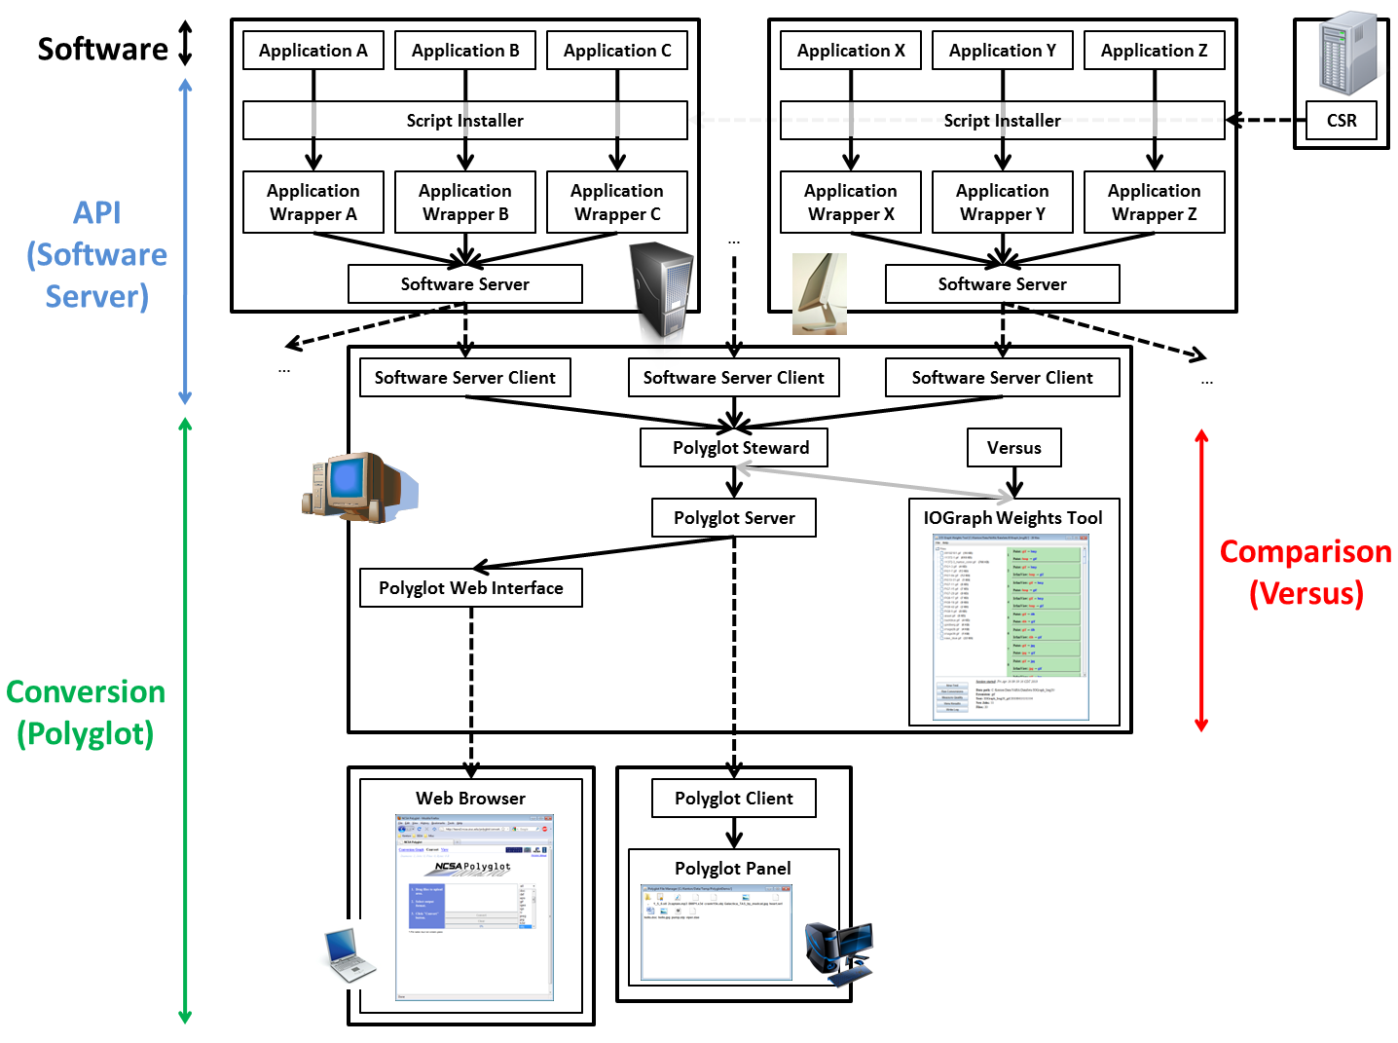

Installation
- System environment :
  - Add group , service user
$ sudo apt-get install apache2 libapache2-mod-php5
$ sudo adduser --disabled-password --gecos "Polyglot service runner" --ingroup ncsa ployglot
$ sudo addgroup polyglot www-data

- Download : use polyglot-2.1.0-bin.zip
https://opensource.ncsa.illinois.edu/projects/artifacts.php?key=POL

$ sudo adduser --disabled-password --gecos "Polyglot service runner" --ingroup ncsa ployglot

