SCHOOL OF COMPUTING STUDIES
Data Structures and Algorithms
Laboratory Activity 2: Implementing CRUD Operations on a Student Record Array System in C++

Specific Learning Outcomes
- Design and implement a structured data type (`struct`) in C++ to encapsulate complex student records (ID, name, course, and year level).
- Construct modular functions to handle Create, Read, Update, and Delete (CRUD) operations on a fixed-size or dynamic array structure.
- Apply algorithmic traversal, searching, and bounds-checking techniques to maintain data integrity within memory arrays.
Introduction
Data structures provide the foundational mechanisms for organizing, storing, and manipulating information efficiently in computer memory. One of the most fundamental linear data structures is the array, which stores elements in contiguous memory locations. In academic and enterprise information systems, managing entities like student records requires robust Create, Read, Update, and Delete (CRUD) operations.
This laboratory activity explores core linear data management by implementing an in-memory CRUD system using structures and arrays in C++. It is hypothesized that maintaining sequential array integrity during insertions and deletions requires explicit tracking of logical size versus physical capacity, coupled with element shifting algorithms to prevent data corruption or memory leaks.
Materials
- Personal computer or workstation running Windows, Linux, or macOS.
- C++ compiler environment.
Methods / Procedure
- Step 1: Open Visual Studio Code, open your workspace folder, and create a new source file named `StudentCRUD.cpp`.
- Step 2: Define a C++ `struct` named `Student` containing appropriate data fields: `int id`, `string name`, `string course`, and `int yearLevel`.
- Step 3: Declare a fixed-size array of `Student` objects with a maximum capacity (e.g., `MAX_SIZE = 50`) alongside an integer variable `currentCount` to track active records.
- Step 4: Implement a Create function (`addStudent`) that verifies array capacity limits before prompting the user for input and appending a new record to the next available index.
- Step 5: Implement a Read function (`displayStudents`) that iterates through the array using a `for` loop to format and output all active student records to the console.
- Step 6: Implement an Update function (`updateStudent`) that searches for a student record by ID number, locates the index, and allows modification of specific attributes.
CAUTION: Always perform rigorous bounds checking before array index access operations to prevent buffer overflows, segmentation faults, or memory corruption when deleting and shifting records.

- Step 7: Implement a Delete function (`deleteStudent`) that searches for a target student ID, removes the record, and shifts subsequent array elements leftward to eliminate memory gaps.
- Step 8: Construct a modular `main()` function providing a clean console menu loop (`switch-case`) allowing users to interactively test all CRUD operations.
References
- Malik, D. S. (2017). C++ Programming: From Problem Analysis to Program Design (8th ed.). Cengage Learning.
- J.H. Cerilles State College. (2025). Instructional Materials Development Manual: Guidelines for School of Computing Studies Laboratory Manuals. Pagadian City, Philippines.
- Weiss, M. A. (2013). Data Structures and Algorithm Analysis in C++ (4th ed.). Pearson.

LABORATORY ACTIVITY WORKSHEET
Data Structures and Algorithms

Activity No.: | 02 | Date Performed:
Title of Activity: | Implementing CRUD Operations on a Student Record Array System in C++
Student's Name/s: | Ceasar Ryan G. Eduave
Program & Year: |  | Group No.:
Date Submitted: |  | Score:
QR link: | No QR Required for this activity.
Instructor's Initials: | Efraim Arocha Barcela

Instructions:
Complete all sections of this worksheet based on the laboratory activity performed. Answer all questions thoroughly and provide syntax, query outputs, or diagrams where required. Secure your instructor's initials upon completion.

I. SCREENSHOTS (attach image of the final result)
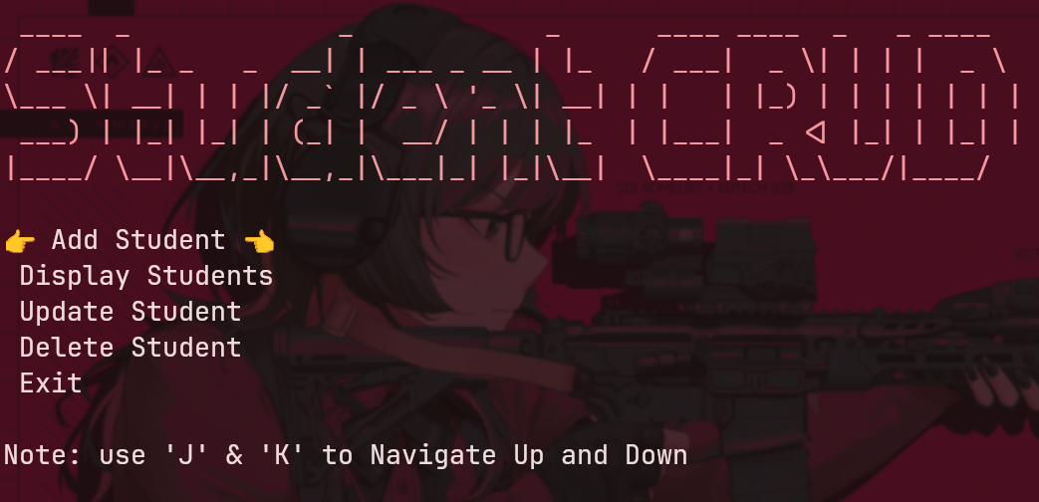
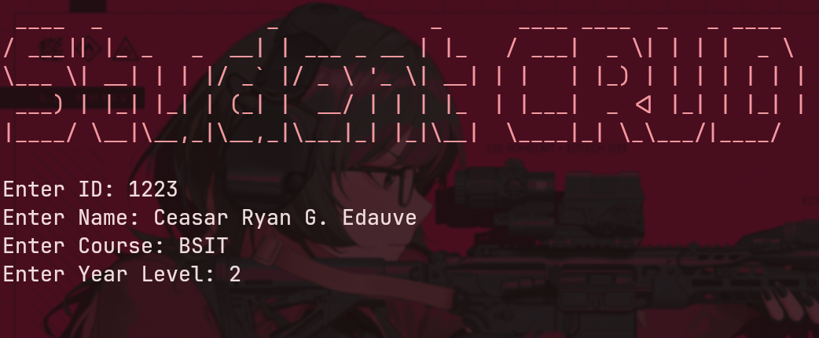
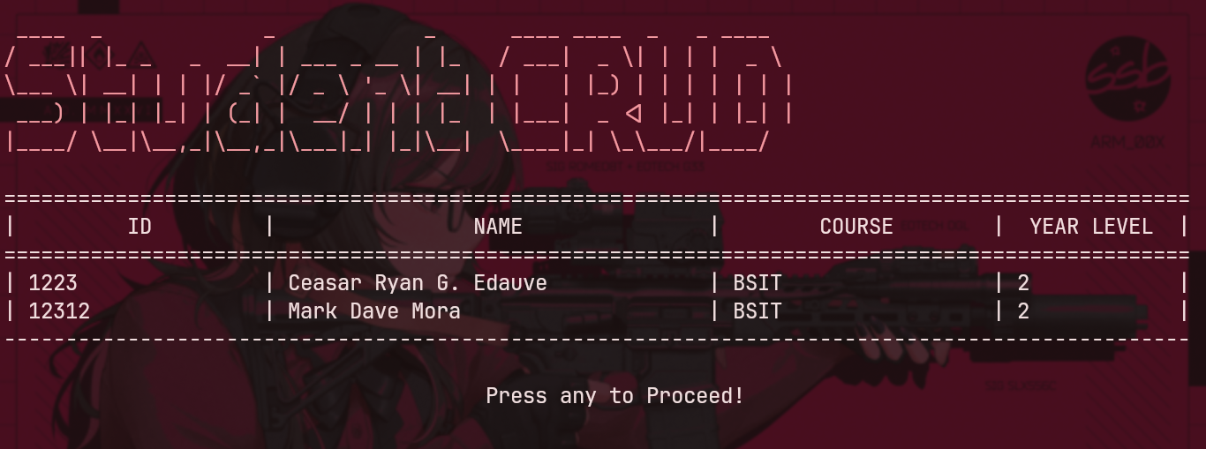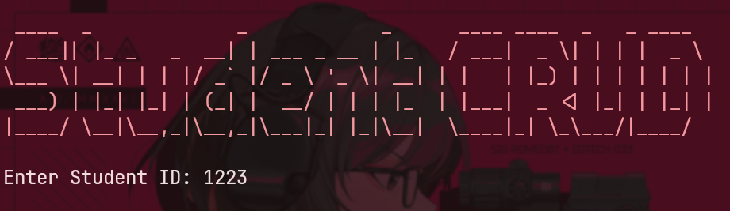
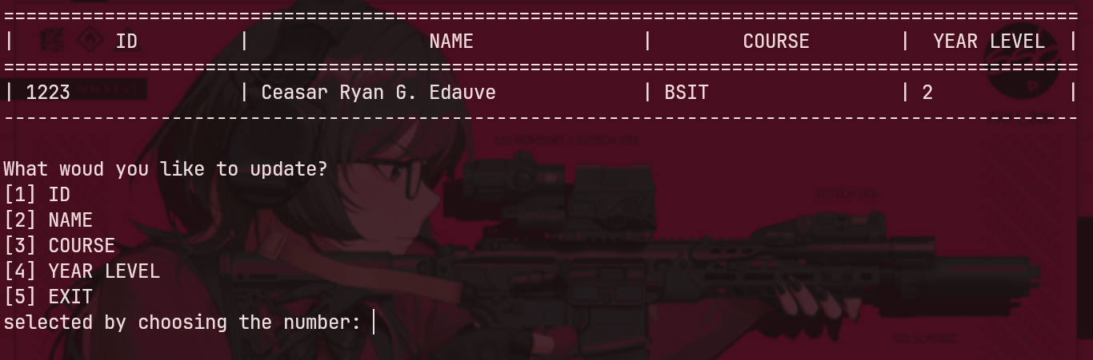
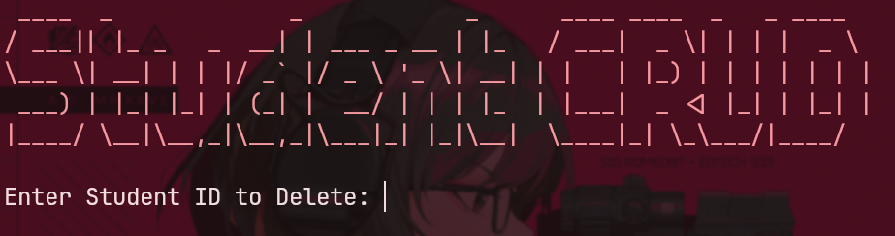
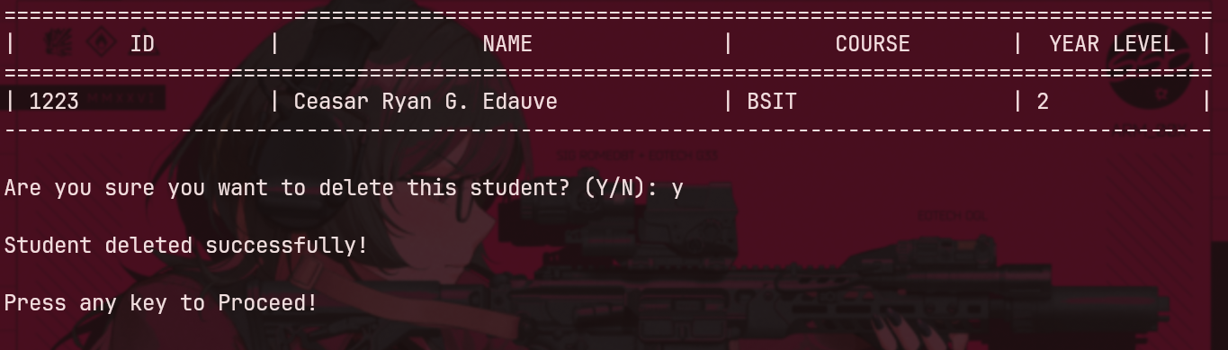
II. What did you discover?
While working on this activity, I discovered several important things about managing memory and linear arrays in C++:
Tracking Capacity vs. Active Size: I realized that keeping track of `MAX_SIZE` (the physical limit) and `currentCount` (the actual number of items) is essential. This prevents memory buffer overflows and stops the program from reading uninitialized array elements.
Element Shifting for Deletion: When deleting a record, I learned that we cannot simply "erase" an index in a fixed array. Instead, we have to shift all the remaining elements one step to the left to fill the gap, and then reset the last element to keep the array organized.

Handling Terminal I/O in C++: I discovered how to build a custom menu using Terminal Raw Mode (`stty -icanon`) so users can navigate options using 'J' and 'K' keys (Vim-style) without hitting Enter every time.
Input Validation & Buffer Clearing: I found out that non-numeric inputs (like letters typed into an integer prompt for ID) can crash the program or cause infinite loops unless we regularly clear `std::cin` errors with `clearCin()`.

III. Conclusion / Summary of Learning
In conclusion, this laboratory activity gave me practical experience in designing a structured `Student` data type and implementing full CRUD (Create, Read, Update, and Delete) operations in memory using array traversal and searching algorithms.
I learned how crucial bounds checking is when modifying contiguous memory, as improper index handling can easily lead to segmentation faults or data corruption. Additionally, building a dynamic terminal user interface taught me how standard input and output streams behave in C++. Overall, this task improved my understanding of basic data structures and showed me how algorithms maintain data integrity in real-world C++ applications.

